Project | IEEE 802.16 Broadband Wireless Access Working Group <http://ieee802.org/16>
Title | Frequency reuse with asymmetrical RS deployment in relay network
Date Submitted | 2008-1-16
Source(s) | Weiwei Wang  Wenchao Ma  Zihua Guo  Lenovo Limited | Voice: 86-10-5886 1598  E-mail: {mawc,guozh}@lenovo.com
Re: | IEEE 802.16m-07/047 Call for Contributions on Project 802.16m
Abstract | As per the requirement of 16m system, the contribution proposes solution for the frequency reuse in the relay network with asymmetrical RS deployment
Purpose | For 802.16m discussion, adoption into the SDD and eventual adoption for standardization
Notice | This document does not represent the agreed views of the IEEE 802.16 Working Group or any of its subgroups. It represents only the views of the participants listed in the “Source(s)” field above. It is offered as a basis for discussion. It is not binding on the contributor(s), who reserve(s) the right to add, amend or withdraw material contained herein.
Release | The contributor grants a free, irrevocable license to the IEEE to incorporate material contained in this contribution, and any modifications thereof, in the creation of an IEEE Standards publication; to copyright in the IEEE’s name any IEEE Standards publication even though it may include portions of this contribution; and at the IEEE’s sole discretion to permit others to reproduce in whole or in part the resulting IEEE Standards publication. The contributor also acknowledges and accepts that this contribution may be made public by IEEE 802.16.
Patent Policy | The contributor is familiar with the IEEE-SA Patent Policy and Procedures:  <http://standards.ieee.org/guides/bylaws/sect6-7.html#6> and <http://standards.ieee.org/guides/opman/sect6.html#6.3>.  Further information is located at <http://standards.ieee.org/board/pat/pat-material.html> and <http://standards.ieee.org/board/pat>.
Frequency reuse in with asymmetrical RS deployment in relay network
Weiwei Wang, Zihua Guo, Wenchao Ma
Lenovo Limited

Introduction
In the SRD[1], relay, is proposed for IEEE 802.16m to provide high data rate coverage over a wide area as well as to avoid coverage holes in the deployment areas. According to the possible usage models, a typical topology will be formed in the real world, as in Fig.1, where several relay stations (RSs) are established asymmetrically in each cell to overcome the coverage holes or shadowing areas where base station (BS)can’t serve. Therefore, the frequency allocation between BS and RSs plays an important role on the system capacity improvement. In this contribution, an isolation band based frequency reuse method is proposed for the relay network with the asymmetrical deployment of RSs.
- The typical topology of relay network

Frequency reuse scheme
For simplicity, the hexagonal cell is used to denote the area covered by BS and RS. The RS cluster in the following includes single RS or several adjacent RSs. As shown in Fig. 2, the frequency reuse method follows four rules:
- Each RS cluster has an isolation band (red area);
- All the users are served by the BS except those in the RS cluster coverage areas;
- The RSs in each RS cluster could reuse the resource out of its isolation band.
- The RSs in each RS cluster could reuse the resource in its isolation band selectively depending on the interference measurement or throughput decreasing.
- Illustration of frequency reuse scheme
In Fig.2, a RS cluster (green area) includes four adjacent RSs and is surrounded by its isolation band (red area). The area served by BS (red and white areas) could use the whole system band; while the RS cluster could definitely reuse the frequency used by the area out of its isolation band (white area). As a result, the users served by BS and close to the edge of RS cluster wouldn’t be interfered by the RSs therein, and the interference is mitigated for the users out of the isolation band due to the large distance from the RSs. Meanwhile, depending on the interference measurement, the resource in the isolation band could be reused selectively by the RSs in the RS cluster as long as the interference from the RS cluster or throughput decreasing is less than certain threshold.

Analysis
The determination of the isolation band of each RS cluster is the key issue to the performance of the system. First, some variables are defined in the following:
: the area served by BS, its acreage is ;
: the isolation band with the acreage of ;
: the area served by BS and out of the isolation band, its acreage is ;
: system bandwidth;
(bit/s/Hz): the spectrum efficiency of when no frequency reuse between BS and RS cluster;
(bit/s/Hz): the spectrum efficiency of the RS cluster.
Assume the spectrum efficiency of would be decreased by at most after the RSs reuse the frequency out of its isolation band. Thus both and are the function of, and can be written as and. The throughput of,, should be
(1)
The throughput of the RS cluster after the frequency reuse should be calculated as
(2)
Therefore, the system throughput is written as
(3)
Obviously, maximizing the right of (3) could improve the system capacity; therefore, we could obtain the optimal value of as
(4)
In (4), and could be calculated by using the similar method in [2]. More details could refer to [3]
In Fig.3, the isolation band of a RS cluster and the correspondingis illustrated for a sample topology. The area enclosed by the contour except the coverage area of the RS cluster is the isolation band and the number on the contour denotes the corresponding; obviously, with the decrease of the area of the isolation band, is increased since RS cluster will interfere with the users out of the isolation band more severely. After determining the isolation band and the corresponding of a certain topology, the optimalcould be derived by (4).
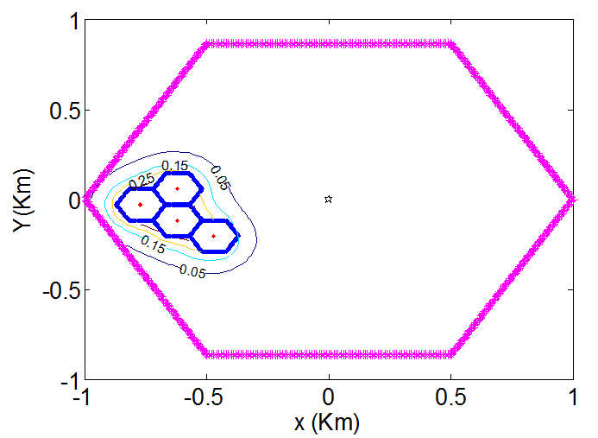
- The isolation band sample

Simulation
The system-level simulation is performed in this section. In each BS cell, at most 3 RS clusters are placed randomly and each RS cluster includes 5 RSs at most. The users are distributed uniformly in the BS cell and RS cell. The other simulation parameters are shown in Table I.
Table I Simulation parameters
Carrier frequency | 2.5GHz
System bandwidth | 10MHz
Number of sub-channels | 30
BS cell radius | 1Km
BS TX power | 38dBm
BS pathloss | , is the distance in Km
RS cell radius | 0.1Km
RS TX power | 5dBm
RS pathloss | , is the distance in Km
Shadowing | Lognormal variable with mean 0 dB, and standard variance 8 dB.
The method of determining the reusable resource in the isolation band is the implementation-dependent. In our simulation, the optimal is used as the threshold; in other words, after resource reuse, if the throughput decreasing percentage of each user in the isolation band is smaller than, its resource could be reused by the RS cluster.
For comparison purpose, the scheme without frequency reuse between BS and RS, which means BS and RSs in the RS cluster use different resource to serve the respective users, is also emulated and we call it as the traditional scheme. For simplicity, each user is allocated one sub-channel, so both BS and RS cluster could serve 30 users at most. Fig.4 (a)-(b) give the simulation results. For traditional scheme, 30 users are generated which means the system is full load; therefore in Fig.4 (a), only one point for the traditional scheme. Due to frequency reuse between BS and RS clusters, the throughput is improved largely with the increase of the number of users. In Fig.4 (b), the average throughput of each user is shown, which means the ratio of the system throughput to the number of users. For traditional scheme, the maximum system throughput is achieved when the number of users is 30, so the average throughput of each user is decreased with the increase of the number of users; while in the proposed method, due to the frequency reuse, no apparent decreasing could be observed.
(a)
(b)
Figure.4 Simulation results ((a) system throughput, (b) average throughput of each user)

Conclusion
In this contribution, a frequency reuse method of relay network is proposed for IEEE 802.16m, and the analysis method for deriving the isolation band of each RS cluster is given. Through the simulation, the system performance could be improved largely by the proposed method.

References
[1] IEEE 802.16m-07/002r4, “IEEE 802.16m system requirements”.
[2] W. Choi and J. G. Andrews, “Downlink performance and capacity of distributed antenna systems in a multicell environment,” IEEE Trans. Wireless commun., Vol 6, No. 1, pp 69-73, Jan. 2007.
[3] W. Wang, Z. Guo, and C. Chen, “Isolation band based frequency reuse scheme of wireless relay network on IEEE 802.16j”.

