Project | IEEE 802.16 Broadband Wireless Access Working Group <http://ieee802.org/16>
Title | Security and Robustness Enhancement for 802.16e - A SDD Proposal for 802.16m
Date Submitted | 2008-01-16
Source(s) | D. J. Shyy  MITRE  McLean, VA, USA | djshyy@mitre.org
Re: | IEEE 802.16m-07/047, Call for Contributions on Project 802.16m System Description Document (SDD) (2007-12-17)  Proposed 802.16m Protocol Architecture and main functionalities per protocol layer
Abstract | The document proposes enhancement in Security Layer for 802.16m
Purpose | Request consideration of functionalities contained herein for the 802.16m SDD
Notice | This document does not represent the agreed views of the IEEE 802.16 Working Group or any of its subgroups. It represents only the views of the participants listed in the “Source(s)” field above. It is offered as a basis for discussion. It is not binding on the contributor(s), who reserve(s) the right to add, amend or withdraw material contained herein.
Release | The contributor grants a free, irrevocable license to the IEEE to incorporate material contained in this contribution, and any modifications thereof, in the creation of an IEEE Standards publication; to copyright in the IEEE’s name any IEEE Standards publication even though it may include portions of this contribution; and at the IEEE’s sole discretion to permit others to reproduce in whole or in part the resulting IEEE Standards publication. The contributor also acknowledges and accepts that this contribution may be made public by IEEE 802.16.
Patent Policy | The contributor is familiar with the IEEE-SA Patent Policy and Procedures:  <http://standards.ieee.org/guides/bylaws/sect6-7.html#6> and <http://standards.ieee.org/guides/opman/sect6.html#6.3>.  Further information is located at <http://standards.ieee.org/board/pat/pat-material.html> and <http://standards.ieee.org/board/pat>.

Security and Robustness Enhancement for 802.16e - A SDD Proposal for 802.16m

1. Introduction
IEEE 802.16m has requirements on security
- Section 6.5: “IEEE 802.16m shall include a security function which provides the necessary means to achieve: protection of the integrity of the system (e.g. system access, stability and availability), protection and confidentiality of user-generated traffic and user-related data (e.g. location privacy, user identity), and secure access to, secure provisioning and availability of services provided by the system”
In this proposal, we present our proposal to enhance security and robustness of 802.16e security layer as a SDD proposal for 802.16m.

2. Security
We develop a security and robustness suite for the improvements of security layer in 802.16e. The improvements target:
- Robust operation in the presence of interference
- Efficient security algorithms and protocols for inter- and intra-cell roaming
- Management message protection
- MAC header protection
- Key management enhancement with secure and efficient key establishment and distribution
- Certificate revocation enhancement
- Mitigations of network attacks including authentication attacks (BS and SS impersonations and passive eaves dropping attack), replay attacks (key reuse attack), denial of service (packet forgery), weak key attack, and man-in-the-middle-attack

The 802.16e network entry steps are described in Figure 1. The following describes the security enhancement required for each of the 802.16e network entry steps.

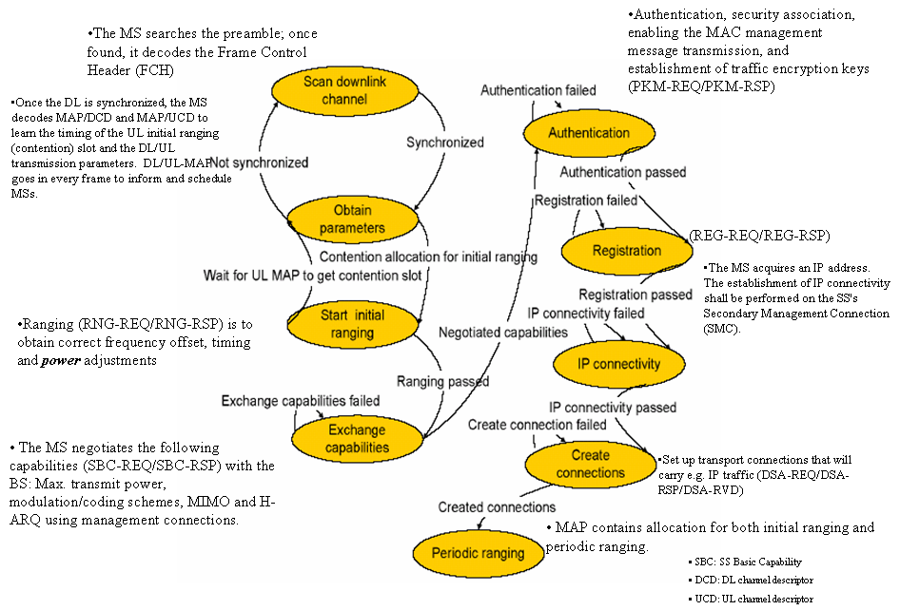
Figure 1: 802.16e Network Entry Steps
Scanning and Obtaining Parameters
The MAP and FCH can be protected. This protection is optional. We propose to use the pre-shared key (via vendor or user certificate). Once the pre-shared key is installed, the user is able to scan the DL. If the user does not perform this step initially, follow the 802.16e default.
Initial Ranging
There is no need to encrypt RNG-REQ. However, signature is required to be added to protect malicious flooding attack. There is a need to protect RNG-RSP since the basic CID and primary management CID uniquely identify the station.
Exchanging Parameters
There is no need to encrypt SBC-REQ. However, signature is required to be added to protect malicious flooding attack. There is a need to protect SBC-RSP since it carries basic CID.
Authentication
There is no change for this step (as compared to 802.16e) since the contents of PKM are already protected.
Registration
There is no change for this step since the contents of REG are already protected
Creating Transport Connection (Adding Service)
DSA messages are required for path set up and admission control. The DSA messages can be protected. This protection is optional
Periodic Ranging
The protection for periodic ranging is the same as initial ranging.
MAC Header
The 802.16e MAC header has only CRC. Integrity protection is needed for 802.16m MAC header.

3. Interference Mitigation

The interference can be handled using coexistence techniques. Please see contribution: C802.16m-07/251r3 for more details.

4. Conclusion

We have presented our main functionalities for security layer in 802.16m. We would like these functionalities to be considered by 802.16m SDD.
.

