Project | IEEE 802.16 Broadband Wireless Access Working Group <http://ieee802.org/16>
Title | Frame Structure for IEEE 802.16m
Date Submitted | 2008-01-16
Source(s) | Sungho Moon,  Jin Sam Kwak,  Wookbong Lee,  Youngsoo Yuk  LG Electronics | Voice : +82-31-450-1852  E-mail: msungho@lge.com,  samji@lge.com,  wbong@lge.com,  sixs@lge.com
Re: | Proposed 802.16m Frame Structure with Special Attention to Legacy Support
Abstract | The contribution describes and proposes many consideration points and some candidates for IEEE 802.16m frame structure design
Purpose | To be discussed and adopted by TGm for use in the IEEE 802.16m SDD
Notice | This document does not represent the agreed views of the IEEE 802.16 Working Group or any of its subgroups. It represents only the views of the participants listed in the “Source(s)” field above. It is offered as a basis for discussion. It is not binding on the contributor(s), who reserve(s) the right to add, amend or withdraw material contained herein.
Release | The contributor grants a free, irrevocable license to the IEEE to incorporate material contained in this contribution, and any modifications thereof, in the creation of an IEEE Standards publication; to copyright in the IEEE’s name any IEEE Standards publication even though it may include portions of this contribution; and at the IEEE’s sole discretion to permit others to reproduce in whole or in part the resulting IEEE Standards publication. The contributor also acknowledges and accepts that this contribution may be made public by IEEE 802.16.
Patent Policy | The contributor is familiar with the IEEE-SA Patent Policy and Procedures:  <http://standards.ieee.org/guides/bylaws/sect6-7.html#6> and <http://standards.ieee.org/guides/opman/sect6.html#6.3>.  Further information is located at <http://standards.ieee.org/board/pat/pat-material.html> and <http://standards.ieee.org/board/pat>.

Frame Structure for IEEE 802.16m
Sungho Moon, Jin Sam Kwak, Wookbong Lee, and Youngsoo Yuk
LG Electronics

Introduction
In this contribution, we propose three-layered frame structures consisting of super-frames, frames, and sub-frames based on OFDMA DL and UL. In order to determine a proper frame dimensioning and TTI, we compare possible candidates in terms of 5 metrics, i.e., commonality with the WirelessMAN-OFDMA reference system, legacy-support operation, DL/UL allocation configuration, latency, and control overhead. In legacy-support disabled mode, we also propose another structure with a CP length of 1/16 Tu because the legacy CP length of 1/8 Tu is quite long in the current channel models as well as even the MBSFN case. While designing the IEEE 802.16m frame structure, we will discuss legacy-support mechanisms and wider bandwidth supports, which can help smooth migration to new 16m system.

Basic Transmission Scheme & Duplex Modes
Basically, OFDM-based transmissions should be considered for DL and UL in the IEEE 802.16m in order to meet the legacy-support requirements in the 802.16m system requirement document (SRD) [1] and maintain the consistency with the reference frame structure. Though we may consider other precoded- or spread-OFDM multiple access techniques as a candidate for the UL transmission with low PAPR/CM, we prefer to adopt the OFDMA as in the reference system due to its several advantages rather than DFT-S-OFDM as shown in [2]. In addition, according to the 16m SRD in [1], the TDD and FD-/HD FDD modes should be considered in the 16m frame structure design and the commonality between TDD and FDD should be also maintained as much as possible.

Basic OFDM Parameters
In order to support the system scalability without physical layer impacts, the sampling frequencies, FFT sizes, and sub-carrier spacing of IEEE 802.16m should follow those of the WirelessMAN-OFDMA reference system. For legacy-support scenarios, the number of OFDM symbols has to be set to 48 in the viewpoint of the commonality, and thus a CP length is 11.42 us which is 1/8 of an OFDM symbol. However, since the 1/8 Tu CP case is quite long to tolerate the delay spread in the current channel models as well as even the MBSFN case [3], shorter CP length should be included for the legacy-support disabled mode, which is directly related to the throughput enhancement for the IEEE 802.16m. Table I shows a basic OFDM parameter set with the candidates of CP length for IEEE 802.16m.

Table I. Basic OFDM parameter set with the CP length candidates of IEEE 802.16m

Transmission Bandwidth (MHz) |  | 5 | 10 |  | 20
Sampling Frequency (MHz) |  | 5.6 | 11.2 |  | 22.4
FFT Size |  | 512 | 1024 |  | 2048
Sub-Carrier Spacing (kHz) |  | 10.94 | 10.94 |  | 10.94
Tu (us) |  | 91.4 | 91.4 |  | 91.4
Usage | Cyclic Prefix (CP) | Ts (us) |  | OFDM Symbols per Frame |  | Idle Time (us)
Legacy Support Mode  / 16m MBS | Tg=1/8 Tu | 91.4 + 11.42=102.82 |  | 48 |  | 64.64
Legacy-Support Disabled 16m Mode | Tg=1/16 Tu | 91.4 + 5.71=97.11 |  | 51 |  | 47.39

Basic Frame Structure for IEEE 802.16m
It would be desirable to address the multi-dimensional frame structure for allowing the latency improvement and overhead reduction with inherent enhanced features in directly related scopes such as HARQ/CQI/ scheduling latency, L1/L2 control signaling overhead, and multi-antenna operation, etc., while meeting the requirements in the IEEE 802.16m SRD [1]. Basically, we start with the 3-layered architecture partitioned by super-frame, frame and sub-frame as shown in Fig. 1. In order to maintain a commonality with the WirelessMAN-OFDMA reference system [4], it is a natural way to adopt the size of a frame as 5 msec. Therefore, the frame dimensioning or granularity such as the number of frames per super-frame and sub-frames per frame should be determined with 5 msec frames and within a single frame.

Fig. 1 Basic frame structure of the IEEE 802.16m

    - Super-Frame Size
The size of super-frame depends on the initial network entry time. In 3G systems and B3G, the initial network entry time is recommended to be approximately 20~80 (ms) and the faster is the better. Therefore, a proper size of super-frame seems to be 20 (ms), which is four frames of the reference system [4].

    - Sub-Frame Size
Sub-frame is the minimum unit of frame configurations and is defined as multiples of OFDM symbols. Basic time parameters in IEEE 802.16m, e.g., transmission time interval (TTI) and DL/UL duration, can be defined as multiples of sub-frames.

To find a proper granularity of a sub-frame, i.e., the number of OFDM symbols, the following points should be considered:

- Supports of the reference system
- Flexible DL/UL resource allocations in TDD mode
- Numerology for unicast/multicast transmission
- Maintaining the commonality of TDD/FDD frame structure
- DL and UL granularities in a frame
      - DL/UL Configuration in TDD mode

A new IEEE 802.16m frame structure and the legacy frame structure may coexist between adjacent cells in legacy-support scenarios, and we have to strongly consider the DL and UL interference problem between adjacent MSs in the different cells. To determine a proper DL/UL configuration in TDD, this coexistence problem should be taken into account.

Two candidates can be considered for DL/ UL allocation configurations. The first scheme can be called “one TTG/RTG configuration” in which we allow one DL/UL switching point in a frame, and the other scheme is “multiple TTG/RTG configurations.” The one TTG/RTG configuration can be set up to have no interference between adjacent cells because the legacy frame structure has one TTG/RTG configuration. Moreover, this scheme has smaller resource waste from TTG/RTG durations. However, in the multiple TTG/RTG configurations, the dead zone, in which no transmission at MSs, should be considered to avoid the DL/UL interference problem. In a deployment scenario, there exist several cells with one TTG/RTG configuration at the same RF carrier, i.e., WirelessMAN-OFDMA Reference System. Therefore, the one TTG/RTG configuration seems to be better in the viewpoints of resource utilization and adjacent cell interference in the legacy-support mode.

Under the assumption of one TTG/RTG configuration with 48 OFDM symbols, we can summarize possible DL and UL ratio for various sub-frame options:

- 3 OFDM symbols/sub-frame à DL : UL = 8:8, 9:7, 10:6, 11:5, 12:4, 13:3, 14:2, 15:1
- 4 OFDM symbols/sub-frame à DL : UL = 6:6, 7:5, 8:4, 9:3, 10:2, 11:1
- 6 OFDM symbols/sub-frame à DL : UL = 4:4, 5:3, 6:2, 7:1
- 8 OFDM symbols/sub-frame à DL : UL = 3:3, 4:2, 5:1
- 12 OFDM symbols/sub-frameà DL : UL = 2:2, 3:1

Two configurations of 12 and 8OFDM symbols per sub-frame are not enough to support various DL/UL allocations, and three configurations of 6, 4, and 3 OFDM symbols per sub-frame can provide sufficient DL/UL granularities compared to other options.

      - Commonality with the WirelessMAN-OFDMA Reference System

For legacy supports, switching points in a new TDD frame shall be aligned with the reference system. To align DL and UL switching points in TDD, it is required that the number of OFDM symbols of a UL zone has to be multiple number of 3 since the basic slot for the UL subchannelization is based on 3 OFDM symbols in the reference system. For the commonality of the TDD/FDD frame structure and legacy-support requirements, therefore, sub-frame dimensioning candidates are as follows:

- 3 OFDM symbols/sub-frame
- 6 OFDM symbols/sub-frame
- 12 OFDM symbols/sub-frame

      - Proposed Frame Structures

The size of sub-frame can be configured with multiple of 3 OFDM symbols in accordance with the commonality with the reference system in a CP length of 1/8 Tu. Therefore, it’s better to use 3 or 6 OFDM symbols per sub-frame according to the flexibility of DL/UL configuration. Since the minimum TTI size is one sub-frame and 3 OFDM symbols per sub-frame is so small that this option can make larger control overhead, an option with 6 OFDM symbols per sub-frame could be a potential candidate configuration for the legacy-support mode.

The usage of sub-frames can be summarized as:

- A basic unit of TTI configuration (one TTI = multiple of sub-frames )
- A boundary of the DL/UL split in TDD mode
- Zone division between legacy and 16m regions

Fig. 2 shows TDD and FDD frame structure with a CP length of 1/8 Tu. The first sub-frame and idle times can be used for preamble, DL/UL control, or TTG/RTG. The usage of these symbols can be varying according to duplex modes.

Fig. 2 TDD/FDD frame dimension for a CP length option of 1/8 in the legacy-support mode

For the legacy-support disabled mode, we can choose another CP length. Based on the delay spread characteristics, the rms delay spread is approximately 3 us and some channel energy can exist beyond RMS delay spread. Even including some margin for implementation, a proper CP length is 5~6 us for unicast with less than 10% CP overhead loss. Therefore, an option with a CP length of 1/16 will be probably better considering resource utilization because we can get three more OFDM symbols compared to the CP length of 1/8. Here, we propose a frame structure for a CP length option of 1/16 as shown in Fig 3. With the 51 OFDM symbols in the option of 1/16 CP length, the first three OFDM symbols can be used for the transmission for non-data associated signals such as preamble, midamble, DL common/dedicated control signaling, sounding, or UL control, etc. In a TDD case, one OFDM symbol among the first three symbols should be located in the middle for TTG/RTG gaps with an idle time. The remaining 48 OFDM symbols can be then used for configuration of sub-frames as the multiple of 6 OFDM symbols. The 3 OFDM symbols can be also used for the UL transmission for feedback channel as the current Reference system, which also offers additional gain than the 1/8 CP case in the support of coexistence with other TDD networks specified in the 16m SRD [1]. Fig. 8 in the appendix shows the DL/UL ratio of 16m with the puncturing OFDM symbols for DL/UL alignment with TD-SCDMA and LTE TDD cases.
The shorter CP configurations can enhance 5.9 % spectral efficiency in the viewpoint of available resources and also can provide additional gains from supporting channels, e.g., midamble and sounding, compared to the case of 1/8 Tu CP length. The details on the utilization of the 3 OFDM symbols are FFS.

Fig. 3 TDD/FDD frame dimension for a CP length option of 1/16 in the legacy-support disabled mode

      - Legacy and New Regions

Fig. 4 shows a mixed method of legacy and new regions in the legacy-support mode. The DL/UL split and zone boundary between the legacy and 16m regions can be determined by a sub-frame of 6 OFDM symbols.

Fig. 4 Mixed method of legacy and new regions in the legacy-support mode

    - Transmission Time Interval

Transmission time interval (TTI) is a basic scheduling and resource allocation unit, and in this contribution, TTI can be defined as multiple of sub-frame (6 OFDM symbols). To find a proper granularity of a TTI, i.e., the number of sub-frames, the following points should be considered:

- Latency improvement
- Control overhead reduction

With an assumption of 48 OFDM symbols per frame with 1/8 CP length, we can consider following three TTI configurations:

- 1/2 sub-frames per TTI = 3 OFDM symbols per TTI
- 1 sub-frames per TTI = 6 OFDM symbols per TTI
- 2 sub-frames per TTI = 12 OFDM symbols per TTI

In this subsection, the above configurations are compared each other in the viewpoints of data latency and overhead, and we will choose the best TTI option. Moreover, various TTI options in a frame can be applicable for short packets, e.g., VoIP.

      - Data Latency
The data latency is defined in terms of the one-way transit time between a packet being available at the IP later in either the MS/Radio access network and the availability of this packet at IP layer in the Radio Access Network/MS [1]. TTI configurations strongly affect the data latency performance since H-ARQ latency is included in this latency calculation. A shorter TTI guarantees better latency performance, and specifically in TDD, DL/UL allocations also affect the latency performance. In this document, to compare latency performance of possible TTI configurations, we use the one-way PHY-to-PHY latency, in which IP-to-PHY latency parameters are not specified due to the ambiguity. However, the PHY-to-PHY latency results can be interpreted as a portion of the IP-to-IP and can be calculated by D_{PHY-to-PHY} +2*D_{IP-to-PHY}, where D_{PHY-to-PHY} and D_{IP-to-PHY} are the PHY-to-PHY latency and the PHY-to-IP (or IP-to-PHY) latency, respectively. In downlink and uplink cases, the PHY-to-PHY latency is calculated from two parts as follows:

- One way latency from an initial data transmission to an ACK/NACK transmission
- Round trip time (RTT) from an initial data transmission to the first retransmission

In the above terms, we focus on parameters which are closely related to TTI configurations, and simplify other parameters for a fair comparison. The following parameters are assumed:

- Assumptions
- DL and UL MAP (resource allocation) in each DL TTI
- ACK/NACK in each UL TTI
- Maximum number of retransmissions : 1
- Retransmission ratio : 30%
- DL and UL allocation : one or two switching point in TDD
- DL and UL ratio : approximately 2:1 in TDD
- Processing time, Tp : 1~3 ms
  - Tp in RX : Data decoding time + ACK/NACK generation time
  - Tp in TX : ACK/NACK decoding time + Scheduling time
- Propagation delay : 0 ms

Tables II and III show the comparison results of the radio access network transmission latency in TDD and FDD modes, respectively. The results show that configurations with the smaller size of TTIs have the better latency performance. This is mainly caused by TTI granularity.

Table II. Latency performance according to TTI configurations in TDD mode

Latency and RTT | Reference System | 3 OFDM Symbols/TTI | 6 OFDM Symbols/TTI | 12 OFDM Symbols/TTI
Downlink (ms)  (Tp :1ms/2ms/3ms) | 5.417 / 6.167 / 6.167 | 1.353 / 1.934 / 2.712 | 1.675 / 2.650 / 3.250 | 2.875 / 3.750 / 5.000
Uplink (ms)  (Tp :1ms/2ms/3ms) | 5.667 / 5.667 / 5.667 | 1.484 / 1.719 / 3.000 | 1.750 / 2.875 / 3.313 | 2.375 / 3.875 / 4.25
DL MAX RTT (TTI) | 9 / 11 / 11 | 16 / 26 / 32 | 8 / 15 / 17 | 7 / 9 / 12
DL MIN RTT (TTI) | 8 / 9 / 9 | 10 / 16 / 22 | 6 / 10 / 12 | 4 / 6 / 10

Table III. Latency performance according to TTI configurations in FDD mode

Latency and RTT | 3 OFDM Symbols/TTI | 6 OFDM Symbols/TTI | 12 OFDM Symbols/TTI
Downlink (ms)  (Tp :1ms/2ms/3ms) | 1.156 / 1.719 / 2.281 | 1.563 / 2.312 / 5.188 | 2.375 / 3.125 / 3.875
Uplink (ms)  (Tp :1ms/2ms/3ms) | 1.156 / 1.719 / 2.281 | 1.563 / 2.312 / 5.188 | 2.375 / 3.125 / 3.875
DL RTT (TTI) | 10 / 16 / 22 | 6 / 10 / 12 | 4 / 6 / 8

Table IV shows the latency performance with various DL/UL configurations in TDD. With cases of one TTG/RTG, downlink and uplink performance shows approximately 3.3~3.5 ms regardless of DL and UL ratios. Compared to one TTG/RTG configurations, two TTG/RTG configurations guarantee slightly better latency performance due to scattered DL and UL TTIs. However, two TTG/RTG configurations can be used only if all adjacent cells are deployed as legacy-support disabled mode with the same TTG/RTG configuration.

Table IV. Latency performance with various DL/UL configurations (6 OFDM symbols/TTI and Tp = 3ms)

Latency (ms) | One TTG/RTG  6DL:2UL | One TTG/RTG  5DL:3UL | One TTG/RTG  4DL:4UL | Two TTG/RTGs  3DL:1UL:3DL:1UL | Two TTG/RTGs  2DL:2UL:2DL:2UL
Downlink | 3.343 | 3.250 | 3.438 | 3.063 | 2.688
Uplink | 3.343 | 3.313 | 3.344 | 2.688 | 2.688

      - Control Signaling Overhead

The WirelessMAN-OFDMA reference system has various MAP IEs to provide flexible usages of radio resources, which complicates the control signaling in the reference system. Thus, for the new IEEE 802.16m system, we should include only essential and practical information for DL controls. Moreover, we categorize these essential control messages into two types, i.e., common control and dedicated control. The main role of common control is to broadcast system control information, such as the indication or the description of the TTI configuration and the dedicated control information and so on. On the other hand, dedicated control which is located in each TTI can be used for radio resource allocation information in the IEEE 802.16m system. Compared to the reference system, we can optimize and reduce dedicated control overhead at each TTI.

For fair overhead comparisons between the reference system and the new designed system, we assume essential control signal based on the reference system and compare TTI configuration options to each other. The basic assumptions can be summarized as follows:

- MAP Configuration
- One Compressed DL MAP
- Two STC Zone IE
- One HARQ MAP Pointer IE for SUB-DL-UL-MAP
- 1 SUB DL-UL MAP / TTI (IEEE 802.16m)
- 3 SUB DL-UL MAP/frame (Reference system)
- Burst Configuration
- 12 DL bursts per frame and 3 sub-bursts per DL burst
- 6 UL bursts per frame with 3 sub-bursts per UL burst
- Modulation and coding
- Common control : QPSK and 1/2 with 6 repetitions
- Dedicated control : All MCSs from QPSK to 16 QAM

Table V shows an overhead comparison between various TTI options. The number of dedicated control block is set to one per TTI in new systems, and is set to 3 per frame in the Reference system. The required subcarriers for common control is determined to 48 since modulation and coding schemes are fixed, but in case of dedicated control, we assume different modulation and coding schemes based on a MCS table in IEEE 802.16 evaluation methodology [5], and the required subcarriers are obtained from system-level simulations. Therefore, the dedicated control overhead can be reduced for MSs located near a BS. The result shows that a configuration of 6 OFDM symbols per TTI is better than other options. The detailed assumptions and overhead calculations are shown in [6].

Table V. Overhead comparison according to the number of sub-frames per frame

 | Reference System | 3 OFDM Symbols/TTI | 6 OFDM Symbols/TTI | 12 OFDM Symbols/TTI
# of DL TTIs | 1 | 10 | 5 | 3
# of UL TTIs | 1 | 6 | 3 | 1
# of dedicated control blocks | 3 | 10 | 5 | 3
Common control (byte) | 30 | 44 | 34 | 30
Dedicated control (byte) | 429 | 468 | 440 | 429
Req. subcarriers per byte (Common control) | 48 | 48 | 48 | 48
Req. subcarriers per byte (Dedicated control) | 6.47 | 4.61 | 4.79 | 6.47
Total required subcarriers | 4216 | 4269 | 3740 | 4216

      - Summary : TTI Length and Configuration

To find a proper TTI length, we compared two considerations, i.e. data latency, and control overhead. Based on these results, the default option for TTI is better to set to 6 OFDM symbols per TTI.

- 6 OFDM symbols/TTI

Moreover, various TTIs can be considered in a frame or in a super-frame.

- Legacy Support Operations

The requirement document [1] defines the following five legacy-support requirements:

- An IEEE 802.16m MS shall be able to operate with a legacy BS, at a level of performance equivalent to that of a legacy MS.
- Systems based on IEEE 802.16m and the WirelessMAN-OFDMA Reference System shall be able to operate on the same RF carrier, with the same channel bandwidth; and should be able to operate on the same RF carrier with different channel bandwidths.
- An IEEE 802.16m BS shall support a mix of IEEE 802.16m and legacy MSs when both are operating on the same RF carrier. The system performance with such a mix should improve with the fraction of IEEE 802.16m MSs attached to the BS.
- An IEEE 802.16m BS shall support handover of a legacy MS to and from a legacy BS and to and from IEEE 802.16m BS, at a level of performance equivalent to handover between two legacy BSs.
- An IEEE 802.16m BS shall be able to support a legacy MS while also supporting IEEE 802.16m MSs on the same RF carrier, at a level of performance equivalent to that a legacy BS provides to a legacy MS.

In the mixed scenarios of the legacy and 802.16m BSs, there exist three kinds of BS deployments as follows:

- Legacy-support disabled mode (16m BS)
- Legacy-support mode (16m BS)
- Legacy mode (legacy BS)

We should design a frame structure for satisfying following operation requirements:

- A legacy MS should operate with a 16m BS in the legacy-support mode and with a legacy BS in the legacy mode.
- An IEEE 802.16m MS should operate with a 16m BS in the both legacy-support and legacy-support disabled modes, and additionally with a legacy BS in the legacy mode.

Therefore, in order to satisfy the above first requirement, an IEEE 802.16m frame structure for the legacy-support mode should include basic control information, i.e., legacy preamble, FCH and DL/UL MAP. For a legacy MS, new zones in an IEEE 802.16m frame will be ignored. For the second requirement, an IEEE 802.16m MS has a capability to detect an operation mode among three modes when entering an arbitrary cell coverage or performing a handover, and thus, a new IEEE frame structure should includes cell status detection mechanisms. Two kinds of legacy-support operation methods can be considered:

- FCH-based legacy-support operation
- Preamble-based legacy-support operation

Fig. 5 shows an example of FCH-based legacy-support operation with the TDD frame structures. An IEEE 802.16m system reuses the same preamble and modified FCH of the reference system. The modified FCH should be seen as the original FCH of the reference system in the viewpoints of legacy MSs. The design of FCH depends on detailed control mechanisms. In this scheme, the preamble of the reference system has to be used in the same bandwidth, and channel encoding and modulation scheme should have commonality with the reference system. Thus, the FCH-based scheme restricts flexibility in designing a new IEEE 802.16m frame structure, while simply adapting IEEE 802.16m to the reference system.

Fig. 5 FCH-based legacy-support operation for the TDD frame

Fig. 6 shows an example of preamble-based legacy-support operation for the TDD frame. An IEEE 802.16m MS can detect both legacy and new preambles, and thus, can distinguish current deployment status only according to preambles. Moreover, since preamble and control channels can be completely divided by zones, this operation is easy to provide smooth migration scenario from the Reference to a new system. Thus, the preamble-based scheme has better flexibility in designing a new frame structure, while new preamble should be designed considering the legacy preamble of the WirelessMAN-OFDMA Reference System.

Fig. 6 Preamble-based legacy-support operation for the TDD frame

- Larger Bandwidth Supports

In this subsection, we consider larger bandwidth support methods when the IEEE 802.16m system has a larger bandwidth than the WirelessMAN-OFDMA Reference System. The IEEE 802.16m should be capable of operating in bandwidths up to 20 MHz.

Here, we can summarize design features according to larger bandwidth:

- Location of the embedded bandwidth
- Usage of guard subcarriers
- Legacy-support operation

The basic bandwidth capability for legacy supports is to embed the bandwidth of reference system within the larger bandwidth of IEEE 802.16m.

Fig. 7 shows an example of the frame structure with 20 MHz bandwidth considering legacy supports. As described in the previous subsection, an appropriate time mix of the legacy and new zones maintains one TTG/RTG in a frame, and thus, the first part in the upper bandwidth can be used for downlink of IEEE 802.16m. There are guard tones that should not be used for the reference system since it is assumed that a different system operates in the adjacent bandwidth. However, in this scenario, the additional guard tones for upper and lower bands cannot be necessary for the IEEE 802.16m because the whole 20 MHz is filtered and processed while maintaining the orthogonal property in the viewpoint of the IEEE 802.16m system. The available tones for IEEE 802.16m are illustrated as area ‘d₁’ and ‘d₂’ in the downlink and ‘u₁’ and ‘u₂’ in the uplink.
Fig. 7 Example of the frame structure with 20 MHz bandwidth

For larger bandwidth supports, an IEEE 802.16m BS should inform current operating bandwidths of IEEE 802.16m MSs. With the preamble-based legacy-support operation, the operating bandwidth can be broadcasted by a 16m control signaling. After getting system information, IEEE 802.16m MSs can use all of the 802.16m regions in Fig. 7. The legacy MSs operate with a new IEEE 802.16m as the same as with the legacy BS.

Conclusion

In this contribution, we propose three-layered frame structures consisting of super-frame, frame, and sub-frame based on OFDMA DL and UL transmissions. For the commonality, the sampling frequencies, FFT sizes, and sub-carrier spacing of the new designed IEEE 802.16m should be the same with the WirelessMAN-OFDMA Reference System. For legacy-support scenarios, a CP length of 1/8 Tu is seems to be proper, but we should consider other CP length of 1/16 Tu for the legacy-support disabled mode in order to achieve a competitive peak data rate and spectral efficiency in accordance with the 16m SRD. For legacy supports, a new frame structure should include cell status detection mechanisms. Two kinds of legacy-support operation methods can be considered; FCH-based legacy-support operations and preamble-based legacy-support operations. In the preamble-based legacy-support operations, we need a new preamble which has a minimum bandwidth of 5 MHz. For larger bandwidth supports, we consider an embedded reference system bandwidth within the maximum bandwidth of 20 MHz and utilization of some part guard tones between the legacy and the new system.

References
[1] IEEE 802.16m-07/002r4 - TGm System Requirements Document (SRD)
[2] IEEE 802.16m-08/084, “Multiple Access for 802.16m”
[3] IEEE 802.16m-08/098, “MBS Frame Structure Considerations”
[4] IEEE P802.16Rev2/D2, IEEE Standard for Local and metropolitan area networks, Part 16: Air Interface for Fixed and Mobile Broadband Wireless Access Systems.
[5] 80216m-07_037r1 – IEEE 802.16m Evaluation Methodology Document (EMD)
[6] IEEE 802.16m-08/091, “Downlink Control Signaling for Frame Structure Design of IEEE 802.16m”

Text Proposal for the 802.16m SDD

============================== Start of Proposed Text =================================

11. 1 Basic Transmission Scheme

The basic transmission schemes are OFDMA in downlink and uplink with TDD, FDD, and H-FDD.

11.2 Basic OFDM parameters

For the commonality, the sampling frequencies, FFT sizes, and sub-carrier spacing of the new designed IEEE 802.16m shall be the same with the WirelessMAN-OFDMA Reference System. While, for legacy-support scenarios, a CP length of 1/8 Tu should be used, another CP length option of 1/16 Tu shall be used for the legacy-support disabled mode to increase spectral efficiency.

Table I. Basic OFDM parameter set with the CP length candidates of IEEE 802.16m

Transmission Bandwidth (MHz) |  | 5 | 10 |  | 20
Sampling Frequency (MHz) |  | 5.6 | 11.2 |  | 22.4
FFT Size |  | 512 | 1024 |  | 2048
Sub-Carrier Spacing (kHz) |  | 10.94 | 10.94 |  | 10.94
Tu (us) |  | 91.4 | 91.4 |  | 91.4
Usage | Cyclic Prefix (CP) | Ts (us) |  | OFDM Symbols per Frame |  | Idle Time (us)
Legacy Support Mode / 16m MBS | Tg=1/8 Tu | 91.4 + 11.42=102.82 |  | 48 |  | 64.64
Legacy-Support Disabled 16m Mode | Tg=1/16 Tu | 91.4 + 5.71=97.11 |  | 51 |  | 47.39

11. 3 Basic Frame Structure

The basic frame structure is shown in Fig. 1. Three-dimensional frame structure for allowing the latency improvement and overhead reduction with inherent enhanced features in directly related scopes such as HARQ/CQI/ scheduling latency, L1/L2 control signaling overhead, and multi-antenna operation, etc., while meeting the requirements in the IEEE 802.16m SRD [1].

Fig. 1 Basic frame structure of the IEEE 802.16m

11.3.1 Super-Frame and Frame Configurations

The default super-frame size is 20~80 ms and super-frame controls are located every 4 or 8 frames. The super-frame controls include basic system configuration information, and the size and period of super-frame controls can be varied.

11.3.2 Sub-Frame and TTI Configurations

The size of sub-frame can be configured with multiple of 3 OFDM symbols in accordance with the commonality with the reference system in a CP length of 1/8 Tu. The default TTI size is 6 OFDM symbols. Moreover, various TTIs can be considered in a frame or in a super-frame.

11.4 Frame Structure for Legacy-Support Disabled Mode

The unified TDD/ FDD frame structure is illustrated in Fig. 2. With the 51 OFDM symbols in the option of 1/16 CP length, the first three OFDM symbols can be used for the transmission for non-data associated signals such as preamble, midamble, or DL common/dedicated control singling in FDD DL, and for sounding or UL control in FDD UL. In TDD, one OFDM symbol among the first three symbols should be located in the middle for TTG/RTG gaps with an idle time. The remaining 48 OFDM symbols can be then used for configuration of sub-frames as the multiple of 6 OFDM symbols.

Fig. 2 TDD/FDD frame dimension for a CP length option of 1/16 in the legacy-support disabled mode

11.5 Frame Structure for Legacy-Support Mode

The unified TDD/FDD frame structure is illustrated in Fig. 3. The first sub-frame and idle times can be used for preamble, DL/UL control, or TTG/RTG. The usage of these symbols can be varying according to duplex modes.

Fig. 3 TDD/FDD frame dimension for a CP length option of 1/8 in the legacy-support mode

11.5.1 Legacy and New Regions

The legacy regions and new regions are mixed in time domain. Fig. 4 shows TDD frame structures in the legacy-support mode. The DL/UL split and zone boundary between the legacy and 16m regions shall be determined by a sub-frame of 6 OFDM symbols. There are two options according to positions of the legacy DL and new DL zones.
Fig. 4 Mixed method of legacy and new regions in the legacy-support mode

11.5.2 Legacy-Support Operations

Two kinds of legacy-support operation methods shall be considered:

- FCH-based legacy-support operation
- Preamble-based legacy-support operation

In FCH-based legacy-support operation, an IEEE 802.16m system reuses the same preamble and modified FCH of the reference system. The modified FCH should be seen as the original FCH of reference system in the viewpoints of legacy MSs. In preamble-based legacy-support operations, an IEEE 802.16m MS can detect both legacy and new preambles, and thus, can distinguish a current deployment status only according to preambles.

11.5.3 Larger Bandwidth Supports

In the embedded scenarios, the additional guard tones for upper and lower bands with the reference bandwidth cannot be necessary for the IEEE 802.16m because the whole 20 MHz is filtered and processed with maintaining the orthogonal property in the viewpoint of the IEEE 802.16m system.

============================== End of Proposed Text =================================

Appendix: Coexistence with other TDD networks: TD-SCDMA & LTE TDD Cases

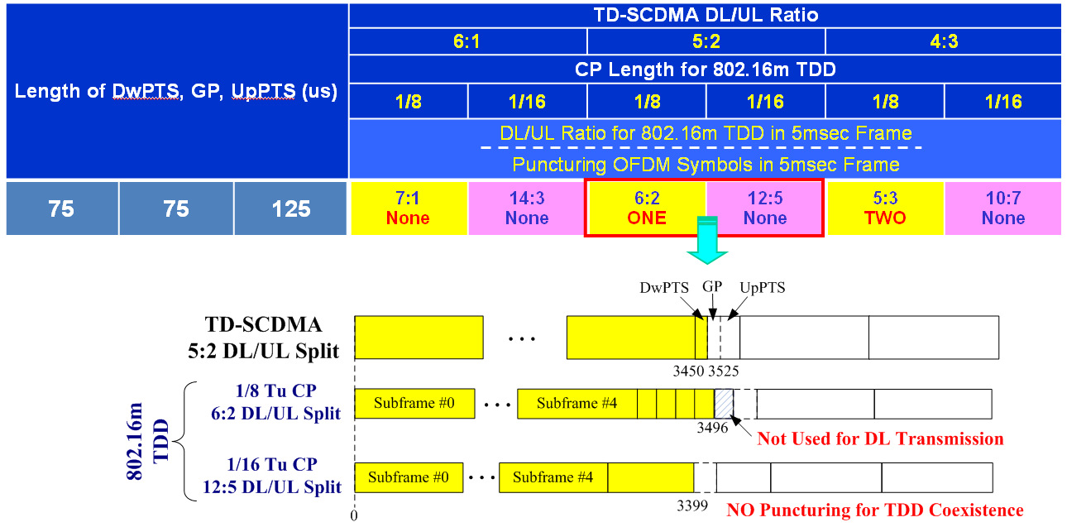
- TD-SCDMA

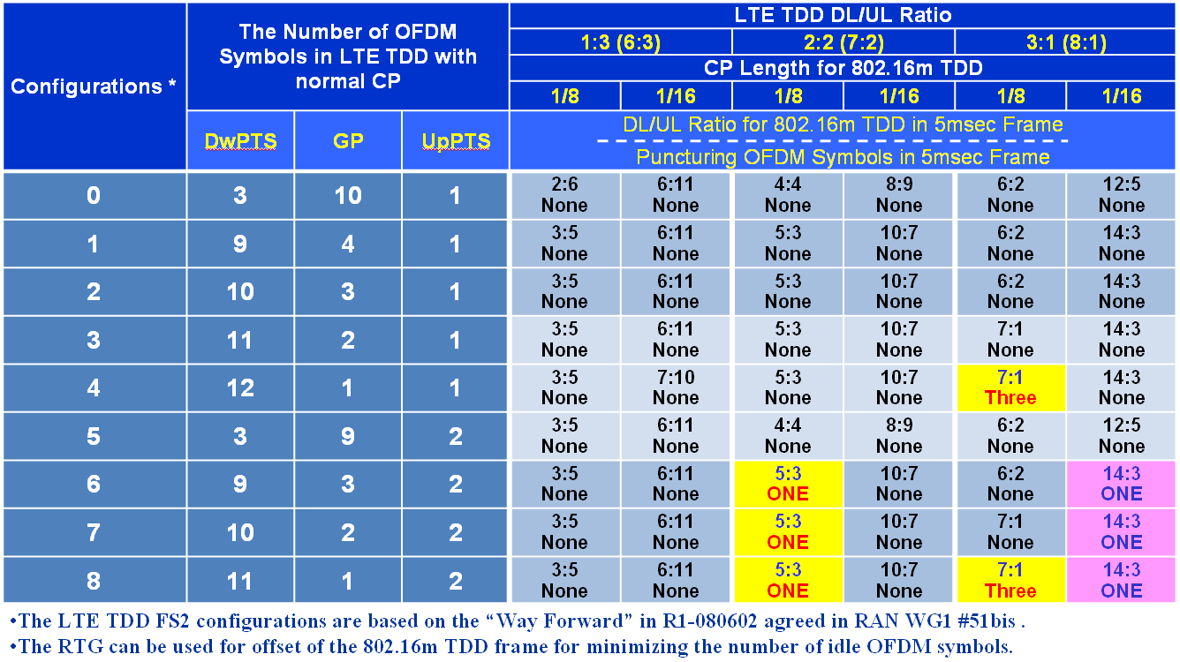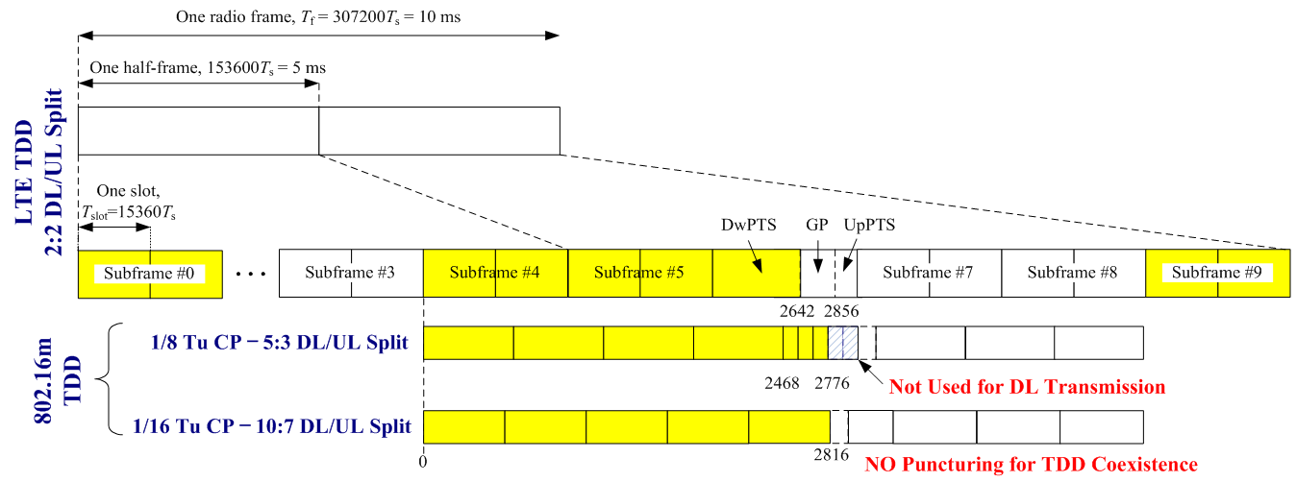
- LTE TDD

Fig. 8. Coexistence with other TDD networks such as TD-SCDMA and LTE TDD.

In the legacy-support disabled mode, all adjacent BSs are assumed to be operated as IEEE 802.16m only mode. Thus, DL/UL switching point alignment with the reference system doesn’t have to be mandated in TDD.

