Project | IEEE 802.16 Broadband Wireless Access Working Group <http://ieee802.org/16>
Title | Frame structure related to MIMO for 802.16m
Date Submitted | 2008-01-17
Source(s) | Bin-Chul Ihm, Jinyoung Chun, Wookbong Lee  LG Electronics, Inc. | Voice: +82-31-450-7187  E-mail : bcihm@lge.com.
Re: | IEEE 802.16m-07/047 Call for Contributions on Project 802.16m System Description Document, specifically on “Proposed 802.16m Frame Structure with special attention to legacy support.”
Abstract | This contribution provides the design aspect of frame structure for 802.16m from MIMO point of view.
Purpose | For discussion and approval by TGm
Notice | This document does not represent the agreed views of the IEEE 802.16 Working Group or any of its subgroups. It represents only the views of the participants listed in the “Source(s)” field above. It is offered as a basis for discussion. It is not binding on the contributor(s), who reserve(s) the right to add, amend or withdraw material contained herein.
Release | The contributor grants a free, irrevocable license to the IEEE to incorporate material contained in this contribution, and any modifications thereof, in the creation of an IEEE Standards publication; to copyright in the IEEE’s name any IEEE Standards publication even though it may include portions of this contribution; and at the IEEE’s sole discretion to permit others to reproduce in whole or in part the resulting IEEE Standards publication. The contributor also acknowledges and accepts that this contribution may be made public by IEEE 802.16.
Patent Policy and Procedures | The contributor is familiar with the IEEE-SA Patent Policy and Procedures:  <http://standards.ieee.org/guides/bylaws/sect6-7.html#6> and  <http://standards.ieee.org/guides/opman/sect6.html#6.3>.  Further information is located at <http://standards.ieee.org/board/pat/pat-material.html> and  <http://standards.ieee.org/board/pat>.

Frame structure related to MIMO for 802.16m
Bin-chul Ihm, Jinyoung Chun and Wookbong Lee
LG Electronics
- Introduction

MIMO scheme can be used under various conditions as mobility, CINR and so on, and BS adaptively transforms the MIMO scheme per these environments. The legacy system [1-2] used to separate a frame into multiple zones which are for each MIMO scheme and this separation of zones causes inefficient resource usage. Even though the frame is divided, feedback information such as CQI and bitmap for the best sub-bands is reflected later than one frame duration. This large feedback delay comes from the fact that there is only one MAP message announcing assignment in the middle of the frame and can be reduced when the sub-frame is introduced.

In this contribution, we discuss the necessity of introduction of sub-frame and efficient usage of sub-frame regardless of user mobility from MIMO point of view. In addition, we propose the transmit diversity scheme for FCH and MAP message, the corresponding pilots and the general MIMO schemes for data burst.

- Structure considering feedback delay

For low mobility user, closed-loop MIMO or beamforming is the most beneficial approach to obtain the throughput gain. These precoding schemes require the feedback from user such as precoding matrix index, rank information, best sub-bands indices and CINR to achieve the dedicated beamforming to the user with the most proper MCS. These kinds of information can be gathered in periodic or non-periodic manner and used for scheduling at BS. The longer become feedback delay or time difference between the scheduling at BS and measurements at MS, the larger become the performance loss. Therefore, the shorter feedback delay is desirable and this can be achieved by reducing the frame size.

However, to keep the backward compatibility with the legacy system, we suggest maintain the frame size as the legacy system but introduce sub-frame that is the unit of schedule and feedback period. Figure 1 shows the example of sub-frames within a frame. If the system consumes very short time for schedule, the shorter sub-frame can give more performance gain, but practical system requires scheduling time around 3ms. This constraint prevents the system from scheduling and assigning the data as soon as receiving the feedback information. In TDD system, the introduction of sub-frame can reduce the feedback delay for half portion of DL regardless of sub-frame size as shown in Figure 1-(a). Top of Figure 1-(a) describes the feedback delay in the legacy system as large as 7.5ms unless UL portion exceeds 3ms. When the sub-frames are inserted, BS can assign the DL data based on feedback information received 3ms before as shown in bottom of Figure 1-(a). FDD system also can obtain the reduced feedback delay by adopting the sub-frame as shown in Figure 1-(b).
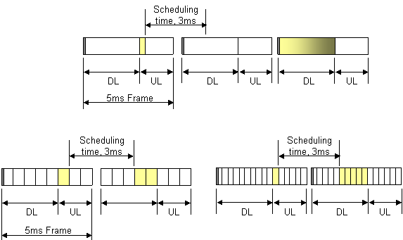
(a)

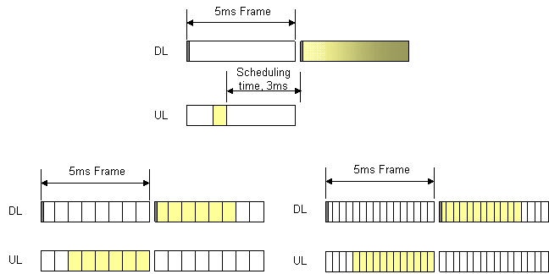
(b)
Figure 1. Sub-frames in a frame: (a) TDD and (b) FDD.
Top: w/o sub-frame, Bottom left: w/ larger sub-frame and Bottom Right : w/ smaller sub-frame

TDD system with sub-frame reduces the feedback delay without increasing the feedback overhead as shown in Figure 1-(a), however, FDD system with sub-frames provides the small feedback delay with large feedback overhead when MS feedbacks every sub-frame as shown in Figure 1-(b). Even though the feedback overhead increases in FDD, it is desirable to introduce the sub-frame to reduce the feedback delay as long as UL data throughput under this overhead can meet the requirement.

- Resource assignment related structure

3.1 Coexistence of localized and distributed assignment

It is desirable for high mobility users to assign the resources as distributed over whole band with space time diversity like STBC/SFBC or CDD. On the other hand, low mobility users should be assigned the resources as localized with precoding or beamforming scheme to maximize the link quality. In the legacy system, the distributed assignment as in PUSC or FUSC and the localized assignment as in Band-AMC are distinguished by separate zone. This clear split of distributed and localized assignment zone brings out inefficient resource usage as Figure 2 and more signaling overhead to indicate the zone division. For example, when there are MS 1~4 of high mobility and MS 5~6 of low mobility, the legacy system allocates the resource as in Figure 2-(a), which has resources not assigned to MS4 in Band-AMC zone. However, if BS assigns the resources as shown in Figure 2-(b), there is no waste of the resources.
PUSC
PUSPUS
Band-AMC
Sub-channel
Time

MS1 |  |  | MS5
MS2
MS3
 |  |  | MS6
MS5
MS2 |  |  | MS1
MS3 |  |  | MS4
MS6

- (b)

Figure 2. (a) Zone split and its inefficient usage of resources and (b) Coexistence of localized and distributed assignment
3.2 Common pilot and dedicated pilot

As mentioned above, localized and distributed assignment for low and high mobility users should be performed within a sub-frame for the purpose of efficient use of resources. For the localized assignment, BS can use the precoding scheme based on codebook [3] or sounding channel [4]. In a case based on the codebook, BS can announce directly precoding matrix index used for DL precoding through DL MAP message or indicate implicitly by dedicated pilots. On the other hand, the non codebook based precoding scheme such as SVD can not announce the precoding information through DL MAP message since its information is too large, and the dedicated pilots are only useful.

Taking this into account, it is desirable for one sub-frame to have common pilot and dedicated pilot for their own usage in the sub-channel. For the low mobility users, the common pilots are the reference for selection of the best sub-bands, rank adaptation, selection of the optimal precoding matrix within codebook as well as channel estimation while the dedicated pilots precoded as data burst can indicate which precoding matrix is used in downlink data burst or can be used for demodulation of data burst.

Figure 3 illustrates Band-AMC structure including common and dedicated pilots. Figure 3-(b) structure can be used for low mobility users requesting rank 1 and Figure 3-(c) can be employed for low mobility users reporting rank 2.

Common pilot for antenna 1
Common pilot for antenna 2
Dedicated pilot for beam 1
Dedicated pilot for beam 2

(a) (b) (c)

Figure 3. Example of pilot location within sub-frame for 2Tx:
(a) common pilots only in the legacy system, (b) common pilots with dedicated pilots for rank 1,
and (c) common pilot with dedicated pilots for rank 2.

Coexistence of common and dedicated pilots promotes the sub-band based precoding without signaling overhead in DL MAP message. Table 1 shows the system level results according to the precoding granularity on B-AMC zone. From this initial result, we observe the sub-band based precoding scheme gives the significant throughput gain.

Table 1 Spectral efficiency according to precoding granularity of 2Tx codebook based precoding scheme
Spatial Correlation | Precoding granularity | Spectral Efficiency (bps/Hz) | Relative Spectral Efficiency
Zero correlation | One Precoding on 5 best sub-bands | 1.36 | 1.00
Zero correlation | 12 precoding on 12 sub-bands | 1.56 | 1.15
Spatial correlation  4 lambda | One Precoding on 5 best sub-bands | 1.42 | 1.00
Spatial correlation  4 lambda | 12 precoding on 12 sub-bands | 1.59 | 1.12

- MIMO schemes for FCH and MAP

The legacy system uses the single antenna transmission for FCH and MAP messages regardless of number of Tx antenna on BS. However, the practical system employs the transmit diversity scheme transparent to MS and one of the most popular transparent diversity scheme is CDD (cyclic delay diversity). The same CDD parameters are also applied to the preamble prior to FCH and MAP messages, therefore, the estimated channel from the preamble can be used for demodulation of FCH and MAP with better performance than the demodulation with pilot only [5].

FCH and MAP in the sub-frame are classified into two types, one follows the preamble and the other does not. CDD for FCH and MAP in the sub-frame following the preamble gives the better performance than STBC. On the other hand, STBC or SFBC is better than CDD for the sub-frame which is far from preamble and cannot use the preamble for channel estimation.

Figure 4 shows examples for 2Tx schemes. In the first sub-frame after the preamble, FCH and MAP can be decoded with the preamble, and CDD can be used for transmit diversity. FCH and MAP in the sub-frame without the preamble are decoded with the pilots only of which pattern is known through the first FCH in the frame. For these FCH and MAP, SFBC or STBC can be used.

Frame

Sub-frame

Preamble

Common pilot for antenna 1
Common pilot for antenna 2

Dedicated pilot for beam1
Dedicated pilot for beam2

FCH using CDD
FCH using STBC or SFBC
MAP using CDD
MAP using STBC or SFBC

Resource for data burst

Figure 4. Example of pilot location within sub-frame of 2Tx and transmit diversity for FCH and MAP messages.

- Conclusions

In this contribution, we discussed the frame structure, resource assignment and pilot usage for 802.16m from MIMO point of view. Our proposals are summarized as follows:
- In TDD and FDD, sub-frame in a frame should be introduced to minimize the feedback delay especially for precoding scheme.
- In a sub-frame, data assignments for high and low mobility users should be performed at the same time without zone separation.
- For low mobility users in the precoding scheme, sub-band based precoding should be supported to maximally utilize the frequency selectivity and BS should announce the precoding information through dedicated pilots within the sub-channels allocated to the user.
- FCH and MAP message following the preamble should be coded with CDD as in the preamble regardless of the number of transmit antenna N_{TX} because the use of channel estimation from the preamble is very helpful and N_{TX} is not known to MS that is trying to decode FCH at the first time. On the other hand, FCH and MAP messages far from the preamble should be coded with STBC or SFBC and their sub-frame should include the pilot pattern corresponding to N_{TX}.
- N_{TX} can be announced through the first FCH after the preamble.

- Proposed Text
[Insert the following into section 11 of [6]]
--------------------------------------- Text start ---------------------------------------------
11.x Frame Structure
11.x.y Sub-frame
11.x.y.z Diversity
The first downlink control channel after 802.16m preamble uses the single antenna transmit format regardless of the number of transmit antenna on BS.
11.x.a Resource Block
11.x.a.b Common and dedicated pilots
The resource block has common pilots according to the number of transmit antenna. When the precoding is used for the data sub-carriers, then the dedicated pilots are added in that resource block. The dedicated pilots are precoded with the identical precoding weight used for the data sub-carriers.

--------------------------------------- Text end ---------------------------------------------

References

- IEEE P802.16Rev2/D2, IEEE Standard for Local and metropolitan area networks, Part 16: Air Interface for Fixed and Mobile Broadband Wireless Access Systems.
- WiMAX Forum™ Mobile System Profile, Release 1.0 Approved Specification (Revision 1.5.0: 2007-11-17), http://www.wimaxforum.org/technology/documents
- LG Electronics, “Rel.1.x CL-MIMO: Operational Scenario and SLS results”, WiMAX Forum, 20 December 2007.
- Motorola, “Analog feedback further discussion”, WiMAX Forum, 5 December 2007.
- Amicus, “Release 1.x HFDD: Option 3 A simple and effective approach”, WiMAX Forum, 17 December 2007.
- IEEE C802.16m-07/320r1, “Draft Table of Content for the IEEE 802.16m System Description Document”

