Project | IEEE 802.16 Broadband Wireless Access Working Group <http://ieee802.org/16>
Title | MBS Frame Structure Considerations
Date Submitted | 2008-01-16
Source(s) | Wookbong Lee  Dongcheol Kim  Jaho Koo  LG Electronics Inc. LG R&D Complex, 533 Hogye-1dong, Dongan-gu, Anyang, 431-749, Korea | Voice: +82-31-450-1931  E-mail: wbong@lge.com  DongCheol.Kim@lge.com  Jaho9@lge.com  *<http://standards.ieee.org/faqs/affiliationFAQ.html>
Re: | Call for Contributions IEEE 80216m-07_047 - Proposed 802.16m Frame Structure with special attention to legacy support
Abstract | We propose multicast/broadcast numerology and frame structure as well as MBS feedback.
Purpose | For discussion and approval by TGM
Notice | This document does not represent the agreed views of the IEEE 802.16 Working Group or any of its subgroups. It represents only the views of the participants listed in the “Source(s)” field above. It is offered as a basis for discussion. It is not binding on the contributor(s), who reserve(s) the right to add, amend or withdraw material contained herein.
Release | The contributor grants a free, irrevocable license to the IEEE to incorporate material contained in this contribution, and any modifications thereof, in the creation of an IEEE Standards publication; to copyright in the IEEE’s name any IEEE Standards publication even though it may include portions of this contribution; and at the IEEE’s sole discretion to permit others to reproduce in whole or in part the resulting IEEE Standards publication. The contributor also acknowledges and accepts that this contribution may be made public by IEEE 802.16.
Patent Policy | The contributor is familiar with the IEEE-SA Patent Policy and Procedures:  <http://standards.ieee.org/guides/bylaws/sect6-7.html#6> and <http://standards.ieee.org/guides/opman/sect6.html#6.3>.  Further information is located at <http://standards.ieee.org/board/pat/pat-material.html> and <http://standards.ieee.org/board/pat>.
MBS Frame Structure Consideration
Wookbong Lee, Dongcheol Kim, Jaho Koo
LG Electronics

Introduction
Generally, the single frequency network (SFN) configuration is one of the major features in achieving the high spectral efficiency and coverage of multicast/broadcast service systems. When working in MBSFN, all BSs are transmitting same signal using same modulation and coding rate, permutation, and subchannelization at the same resources. In this case, an equivalent channel delay profile is the sum of the individual channels from all BSs in the MBS zone to a MS. The delay in the signals that come from a distant BS translates to a delayed impulse response, which increase the delay spread of the equivalent channel and generate ISI when the signal is exceeding cyclic prefix (CP). Therefore MBS CP duration should be longer than that of unicast, and long enough to obtain the macro-diversity gain (SFN gain). However, longer CP will reduce number of data resources, so we have to consider these two factors simultaneously.
Another thing we have to consider is MBS feedback. Usually MBS’s MCS level is determined when MBS zone is set and the performance is dominated by worst case users. However, even for same deployment, user statistics are changing through time. With this property, the performance of MBS can be enhanced by feedback techniques such as link adaptation in IEEE 802.16 reference system. So, we propose MBS feedback to increase performance.

MBS numerology
In MBSFN, a longer CP will result in a higher SINR. However, the spectral efficiency considering the CP overhead is decreased as a sacrifice. Therefore, we should optimize CP duration in balancing the trade-off between SINR gain and CP overhead.
Also, when we determine what optimal OFDM numerology for mixed MBS scenario is, where BS transmitting MBS data as well as unicast data within a frame, one has to consider unicast frame structure as well. For example, if MBS numerology is determined without consideration of unicast numerology, there will be large idle time which ruins system performance/utilization of system.

Parameter | Value : 802.16e Reference System | Additional simulation assumptions
CP length | 128 | 64 | 256
CP ratio | 1/8 | 1/16 | 1/4
CP duration | 11.43 μs | 5.71 μs | 22.86 μs
OFDM symbol duration | 102.86 μs | 97.14 μs | 114.29 μs
# of samples per symbol | 1152 | 1088 | 1280
# of OFDM symbols per frame | 48.61 | 51.47 | 43.75
# of data OFDM symbols per frame | 44 | 48 | 40
# of data slots | 660 | 720 | 600
Effective frame duration (for fair comparison) | 4.8343 ms | 4.9543 ms | 4.9143 ms
Table 1 OFDM numerology with different CP length

Table 1 is for 10MHz, but for other bandwidth such as 1.25MHz, 5MHz, 20MHz, etc, it will be similarly set.
All other simulation assumptions are found in appendix.

Fig. 1 CDF of last sample number in MBSFN, threshold of [-30dB]

Fig. 1 shows the CDF of sample numbers of an effective channel model in MBSFN assuming effective power threshold is -30dB. As you can see in the figure, for 0.5km inter site distance (ISD), most of delay samples are delivered within 64 samples, and for 1.5km ISD, those are transmitted within about 128 samples.
However, for larger ISD, larger number of delayed samples is reached after 128 samples which exceed reference system’s CP size.

CP length ISD | 64 samples | 128 samples | 256 samples
ISD 0.5 km | 3.9064 | 3.6698 | 3.2819
ISD 1.5 km | 3.1391 | 3.2766 | 2.9302
ISD 3.0 km | 1.0464 | 1.1650 | 1.0418
ISD 5.0 km | 0.2325 | 0.2184 | 0.1953
Table 2 Spectral efficiency: effect of CP length

Fig. 2 MBS performance: effect of CP length

Table 2 and Fig. 2 show MBS performance according to different CP length. For examining exact effect of different CP length, we use about 1 dB granularity MCS level rather than use reference system’s MCS set. MCS set used in the simulation can be found in appendix. As you can see in the results, very short CP length is enough (CP ratio of 1/16) for very small cell radius. However, for medium to large cell size, medium size CP length (CP ratio of 1/8) is better comparing with small CP size and very large CP size.

Proposed MBS frame structure for mixed scenario

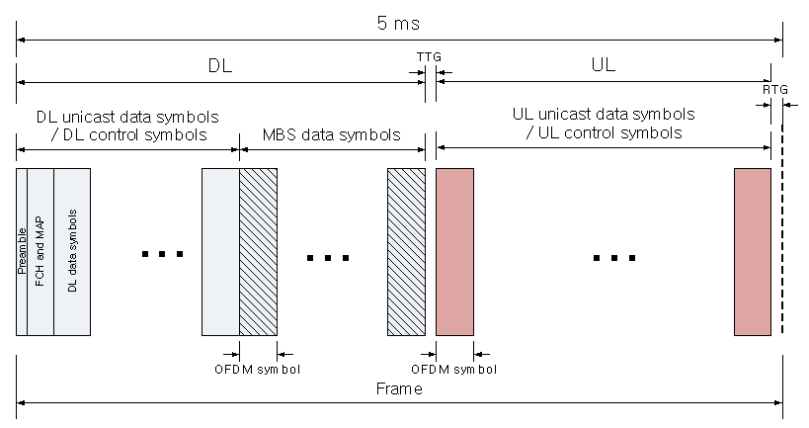
Fig. 3 reference system’s basic frame structure

Fig. 3 shows reference system’s basic frame structure. For MBS data transmission, some of downlink data symbols are used for MBS data symbols. In this case, CP ratio is set to 1/8, which is same as unicast’s CP length.

Since subframe concept is proposed and it has many good properties, we assumed frame/subframe concept is used for IEEE 802.16m frame structure. If we adopt frame/subframe concept in unicast frame structure, it is desirable to adopt frame/subframe concept in MBS also to make scheduling easy.
Here we consider two different unicast CP ratios. First one is CP ratio of 1/8. This is for legacy support modes. Second one is CP ratio of 1/16. Since 1/8 CP ratio is too long for unicast data transmission, we think it is better to use small CP ratio for legacy disabled mode [1].

1. Unicast CP length option: 1/8, figure 3 in [1].
For legacy support mode, OFDM numerology should be same as reference system. So, the basic CP duration for this case is 11.43 μs. As shown in above section, 11.43 μs CP length is enough for most of cases, so we propose no change in MBS frame structure compare to unicast frame structure in this case.

2. Unicast CP length option: 1/16, figure 5 in [1]
Since more than CP ratio of 1/8 is redundant based on our above simulation results, here we want to discuss switching CP ratio of 1/16 to CP ratio of 1/8.
Assume 15 data slots per one OFDM symbol (PUSC has 30 slots per two OFDM symbol for 10MHz system), and borrow one or two OFDM symbols to extend CP size for CP ratio of 1/8.
Following figure shows MBS performance for CP ratio of 1/16 and 1/8 when ISD is 1.5km.
Fig. 4 MBS performance comparison

As seen in the figure, more than 12 OFDM symbol allocations, which is two subframes in our proposal [1], CP ratio of 1/8 is better than CP ratio of 1/16, so we propose CP ratio of 1/8 for this case.

Here is our final proposed MBS numerology.
Unicast’s CP ratio | MBS CP size option /  CP ratio (G) | Number of unicast OFDM symbols per MBS subframes | Number of MBS OFDM symbols per MBS subframes | Number of borrowed OFDM symbols | Idle time
G_{uni}=1/8 | 11.43 μs (G_{MBS}=1/8) | N | N-K | K = 0 | K*N_{FFT*}(1+G_{MBS})/F_{s}-N_{FFT*}(G_{MBS}-G_{uni})/F_{s}*N [s]
G_{uni}=1/16 | 11.43 μs (G_{MBS} =1/8) | N | N-K | K = ceil(N/18) | K*N_{FFT*}(1+G_{MBS})/F_{s}-N_{FFT*}(G_{MBS}-G_{uni})/F_{s}*N [s]
Table 3 Summary of proposed MBS numerology

For the location of MBS frame, we think MBS frame should be at the end of DL frame rather than located at any position in a frame, i.e. between DL and UL for TDD or between DL and preamble for FDD. Since uplink start time for TDD system or preamble start time is well known by MS and BS, so if we put MBS frame at the end of DL frame, MS or BS do not need to do anything with MBS idle time.

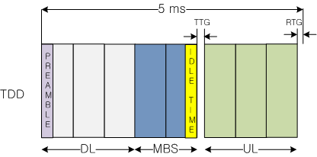
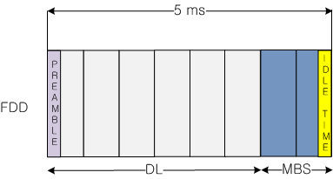
Fig. 5 proposed system’s basic frame structure

Proposed MBS frame structure with uplink feedback
In reference system, uplink feedback information increases system performance. For example, downlink HARQ is enabled with ACKCH and CQICH. For MBSFN, feedback is not frequently needed. However, with helping from MBS feedback, we can also increase MBS performance. Here are two examples which show how MBS feedback can be used and improve system performance.
First example is similar to unicast’s adaptive modulation and coding (AMC) scheme, but much slowly adapted compare to unicast’s case. We assume that MBS feedback, ACK/NACK or NACK only, is ideally transmitted to BSs. How to transmit MBS feedback efficiently is for further study (FFS). After receiving MBS feedback, BSs collect these statistical information from every MBS users and determine which MCS level should be used.
The following table shows performance gain when we use AMC type of technique.
 | Number of MBS user in a sector
 | 1 | 3 | 5 | 7 | 10
Throughput gain | 47% | 11.40% | 14.26% | 11.60% | 8.30%
Table 4 AMC gain with respect to fixed MCS

Second example is hierarchical modulation scheme. In hierarchical modulation, two separate data streams are modulated together. "High Priority" (HP) stream is transmitted with "Low Priority" (LP) stream. Usually, high priority stream is modulated with larger minimum distance than low priority stream. Receivers with "good" reception conditions can receive both streams, while those with poorer reception conditions may only receive the "High Priority" stream. Since hierarchical modulation itself makes signal performance poorer for bad conditioned user, if there are many bad conditioned MBS users in the BS, it is better not to transmit HM scheme. In this case, if each BS knows how many MSs, which is connected to the BS, are in bad condition, and the number of bad conditioned MS is not exceeding a certain threshold, the BS can transmit with hierarchical modulation mode. The following figure shows the concept.

Fig. 6 Application of HM (Hierarchical Modulation) to cell which has good channel condition in MBSFN zone

Generally, the home cell signal is much higher than other cell’s MBS signal, the HM turn off cells’ bad conditioned user’s performance will be increased comparing with ‘always HM turn on case,’ and system performance will be increased comparing with ‘always HM turn off case.’

Conclusions
Here is a summary of our proposals.
- MBS CP duration: 11.43μs for all cases
- MBS subframes shall be located at the end of DL frame
- MBS feedback channel shall be considered to improve performance

Text Proposal for the 802.16m SDD

============================== Start of Proposed Text =================================

Section 11.x.y. MBS frame structure

Unicast’s CP ratio | MBS CP size /  CP ratio (G) | Number of unicast OFDM symbols per MBS subframe | Number of MBS OFDM symbols per MBS subframe | Number of borrowed OFDM symbols | Idle time
G_{uni}=1/8 | 11.43 μs (G_{MBS}=1/8) | N | N-K | K = 0 | K*N_{FFT*}(1+G_{MBS})/F_{s}-N_{FFT*}(G_{MBS}-G_{uni})/F_{s}*N [s]
G_{uni}=1/16 | 11.43 μs  (G_{MBS} =1/8) | N | N-K | K = ceil(N/18) | K*N_{FFT*}(1+G_{MBS})/F_{s}-N_{FFT*}(G_{MBS}-G_{uni})/F_{s}*N [s]
Table x MBS frame numerology

MBS subframes shall be at the end of DL, i.e. between DL and UL for TDD or between DL and preamble for FDD.

Fig. y MBS frame structure

Section 11.x.z. MBS feedback
MBS feedback channel shall be considered for MBS to increase system performance.

=============================== End of Text Proposal ===============================

Appendix

1. SINR calculation due to delays exceeding the CP duration
Correct modeling of a per-subcarrier SINR under ISI is critical in MBS system simulations. A per-subcarrier SINR can be represented in a simplified form similar to the one described in [2]. For example, a simplified representation for the OFDM receiver is
${\text{SINR}}_{k}=\frac{{\left|\tilde{H}(k)\right|}^{2}}{P_{i}+{N_{0}}/{E_{d}}}$ (1)
where $\tilde{H}(k)$ are simply the frequency domain coefficients of the “useful channel”, which is defined as
$\tilde{h}(t)=\sum_{m=1}^{P}{c(τ_{m})h_{m}δ(t−τ_{m})}$
The factor c(τ) is a tapered window, with an amplitude characteristic of
and also shown plotted in below figure
Fig. 7 Bias factor c(∙)

The term P_{i} represents the difference between the energy in the channel impulse response h(t) and the windowed channel impulse response $\tilde{h}(t)$, i.e. . The term $E_{d}$ is the transmit energy per symbol.
Fig. 8 Post-processed SNR vs. PER with ISI comparing with SNR vs. PER without ISI

Fig. 9 average SNR when ISI exists vs. SNR

2. Doppler and channel estimation effect
The equivalent channel model for OFDM can be calculated as follows [3]:
Step 1. Coherent Loss due to Doppler : SNR degradation in the presence of Doppler spread
where SINR is per tone SINR for perfect channel estimation and without Doppler loss which can be obtained from equation (1),f_{d} is the Doppler frequency and NT is the OFDM symbol duration.

Step 2. Inter-tone Interference (ITI) due to Doppler : SNR degradation accounts for non-orthogonality of adjacent tones due to
where E_{H}{x,y} is the harmonic sum of x and y.

Step 3. Channel estimation loss
where ζ is the noise suppression gain of pilot in frequency domain, α is the gain from averaging the channel estimation across multiple OFDM symbols and β models the inter-symbol coherence loss due to Doppler. c_{j} is channel estimation averaging weight, and For least squares channel estimation, ζ is (number of pilot tones/estimated channel impulse response samples).

Step 4. MRC combining: for SIMO transmission, SINR per tone can be calculated as
where Nr is number of receive antenna.

Fig. 10 Channel estimation loss and ζ

3. Additional Simulation Assumptions
Changed simulation assumptions are color coded in red.

Parameter | Description | Value : 802.16e Reference System | Simulation Assumptions
$$f_{c}$$ | Carrier frequency | 2.5 GHz | 2.5 GHz
$$\text{BW}$$ | Total bandwidth | 10 MHz | 10 MHz
$$N_{\text{FFT}}$$ | Number of points in full FFT | 1024 | 1024
$$F_{S}$$ | Sampling frequency | 11.2 MHz | 11.2 MHz
$$T_{o}=1/{Δ_{f}}$$ | OFDMA symbol duration without cyclic prefix | 91.43 us | 91.43 us
$$T_{F}$$ | Frame length | 5 ms | 5 ms
$${\text{DL}}_{\text{Perm}}$$ | DL permutation type | PUSC | PUSC
Table 5 Basic OFDM numerology : other parameters are in above simulation assumptions

Topic | Description | Baseline Simulation Assumptions | Proposal Specific Assumptions  (To be provided by Proponent )
Basic modulation | Modulation schemes for data and control | QPSK, 16QAM, 64QAM | QPSK, 16QAM, 64QAM
Duplexing scheme | TDD, HD-FDD or FD-FDD | TDD | MBSFN
Subchannelization | Subcarrier permutation | PUSC | PUSC
Resource Allocation Granularity | Smallest unit of resource allocation | PUSC: Non-STC: 1 slot, STC: 2 slots (1 slot = 1 subchannel x 2 OFDMA symbols) | 1 slot
Downlink Pilot Structure | Pilot structure, density etc. | Specific to PUSC subchannelization scheme | Specific to PUSC subchannelization scheme
Multi-antenna Transmission Format | Multi-antenna configuration and transmission scheme | MIMO 2x2  (Adaptive MIMO Switching Matrix A & Matrix B)  Beamforming (2x2) | SIMO
Receiver Structure | MMSE/ML/MRC/  Interference Cancellation | MMSE (Matrix B data zone)  MRC (MAP, Matrix A data zone) | MRC
Data Channel Coding | Channel coding schemes | Convolutional Turbo Coding (CTC) | Turbo Code
Control Channel Coding | Channel coding schemes and block sizes | Convolutional Turbo Coding  (CTC), Convolutional Coding (CC) for FCH only | N/A
Scheduling | Demonstrate performance / fairness criteria in accordance to traffic mix | Proportional fairness for full buffer data only *, 10 active users per sector, fixed control overhead of 6 symbols, 22 symbols for data,  5 partitions of 66 slots each, latency timescale 1.5s | N/A
Link Adaptation | Modulation and Coding Schemes (MCS), CQI feedback delay / error | QPSK(1/2) with repetition 1/2/4/6, QPSK(3/4), 16QAM(1/2), 16QAM(3/4), 64QAM(1/2), 64QAM(2/3), 64QAM(3/4) 64QAM(5/6),  CQI feedback delay of 3 frames, error free CQI feedback ** | See below simulation assumptions
Link to System Mapping | EESM/MI | MI (RBIR) *** | RBIR
HARQ | Chase combining/ incremental redundancy, synchronous/asynchronous, adaptive/non-adaptive ACK/NACK delay, Maximum number of retransmissions, retransmission delay | Chase combining asynchronous, non-adaptive, 1 frame ACK/NACK delay, ACK/NACK error, maximum 4 HARQ retransmissions, minimum retransmission delay 2 frames**** | N/A
Power Control | Subcarrier power allocation | Equal power per subcarrier | Equal power per subcarrier
Interference Model | Co-channel interference model, fading model for interferers, number of major interferers, threshold, receiver interference awareness | Average interference on used tones in PHY abstraction | N/A
Frequency Reuse | Frequency reuse pattern | 3 Sectors with frequency reuse of 1 ***** | MBSFN
Control Signaling | Message/signaling format, overheads | Compressed MAP with sub-maps | 1 preamble with 2 OFDM symbols for MAP
Table 6 System-level simulation assumptions for the MBMS

Scenario/ Parameters | Baseline  Configuration  (Calibration & SRD) TDD and FDD
Requirement | Mandatory
Site-to-Site Distance | Varying
Carrier Frequency | 2.5 GHz
Operating Bandwidth | 10 MHz
BS Height | 32 m
BS Tx Power per sector | 46 dBm
MS Tx Power | 23 dBm
MS Height | 1.5 m
Penetration Loss | 10 dB
Path Loss Model | Loss (dB) = 130.62+37.6log₁₀(R)  (R in km) **
Lognormal Shadowing Standard Deviation | 8 dB
Correlation Distance for Shadowing | 50m
Mobility | 0-120 km/hr
Channel Mix | ITU Ped B  3 km/hr – 60%  ITU Veh A 30 km/hr – 30%  ITU Veh A 120 km/hr – 10% (Refer to Section 3.2.9 in 16m EMD)
Spatial Channel Model | ITU with spatial correlation (Refer to Section 3.2.9 in 16m EMD)
EVM | N/A
Table 7 Test Scenarios

Parameter | Description | Value
$$P_{\text{BS}}$$ | MAX transmit power per sector/carrier | 46 dBm @ 10 MHz bandwidth
$$H_{\text{BS}}$$ | Base station height | 32m
$$G_{\text{BS}}$$ | Gain (boresight) | 17 dBi
$$S$$ | Number of sectors | 3
$$θ_{\text{BS}}$$ | 3-dB beamwidth | $S=3$:$θ_{\text{BS}}={\text{70}}^{0}$
$$G_{\text{FB}}$$ | Front-to-back power ratio | 20 dB
$$M_{\text{TX}}$$ | Number of transmit antennas | 1
$$M_{\text{RX}}$$ | Number of receive antennas | 2
$$d_{\text{BS}}$$ | BS antenna spacing | $4λ$
$${\text{NF}}_{\text{BS}}$$ | Noise figure | 5 dB
$${\text{HW}}_{{\text{BS}}^{}}$$ | Cable loss | 2 dB
Table 8 BS equipment model

Parameter | Description | Value
$$P_{\text{SS}}$$ | RMS transmit power/per SS | 23 dBm
$$H_{\text{SS}}$$ | Subscriber station height | 1.5 m
$$G_{\text{SS}}$$ | Gain (boresight) | 0 dBi
$$\left\{θ_{\text{SS}}\right\},G(\left\{θ_{\text{SS}}\right\})$$ | Gain as a function of Angle-of-arrival | Omni
$$N_{\text{TX}}$$ | Number of transmit antennas | 1
$$N_{\text{RX}}$$ | Number of receive antennas | 2
$$d_{\text{SS}}$$ | SS antenna spacing | $$λ/2$$
$${\text{NF}}_{\text{SS}}$$ | Noise figure | 7 dB
$${\text{HW}}_{{\text{SS}}^{}}$$ | Cable Loss | 0 dB
Table 9 MS equipment model

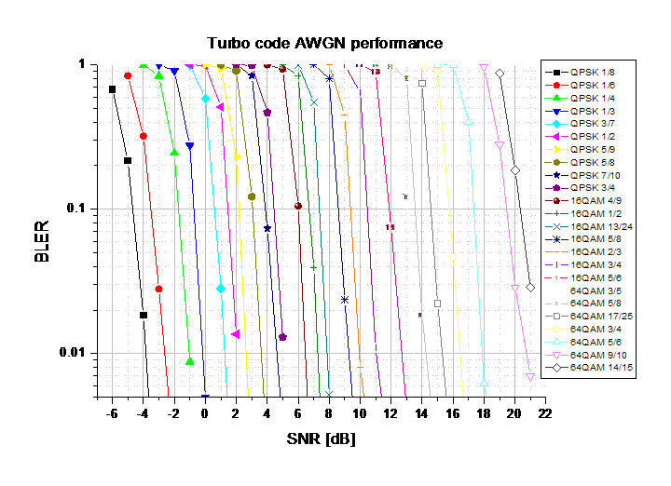
Fig. 11 Turbo code AWGN reference curve

Reference
- Sungho Moon, et al., “Frame Structure for IEEE 802.16m,” IEEE C802.16m-08/087, Jan., 2008
- M. D. Batariere, K. L. Baum, T, P. Krauss, “Cyclic Prefix Analysis for 4G OFDM Systems,” IEEE VTC2004-Fall.
- 3GPP2/TSG-C30-20061204-062A, “cdma2000 Evaluation Methodology (V6)”, Maui, HI., December 2006.

