Project | IEEE 802.16 Broadband Wireless Access Working Group <http://ieee802.org/16>
Title | SDD Text Proposal for PBCH in IEEE 802.16m
Date Submitted | 2008-09-07
Source(s) | Xiaoyi Wang, Shashikant Maheshwari, Yousuf Saifullah  Nokia Siemens Networks  Zexian li  Nokia | E-mail:xiaoyi.wang@nsn.com  E-mail: zexian.li@nokia.com
Re: | Re: PHY: Text; in response to the TGm Call for Contributions and Comments 802.16m-08/033 for Session 57
Abstract | This contribution proposes SDD text proposal for power control.
Purpose | Comments to SDD
Notice | This document does not represent the agreed views of the IEEE 802.16 Working Group or any of its subgroups. It represents only the views of the participants listed in the “Source(s)” field above. It is offered as a basis for discussion. It is not binding on the contributor(s), who reserve(s) the right to add, amend or withdraw material contained herein.
Release | The contributor grants a free, irrevocable license to the IEEE to incorporate material contained in this contribution, and any modifications thereof, in the creation of an IEEE Standards publication; to copyright in the IEEE’s name any IEEE Standards publication even though it may include portions of this contribution; and at the IEEE’s sole discretion to permit others to reproduce in whole or in part the resulting IEEE Standards publication. The contributor also acknowledges and accepts that this contribution may be made public by IEEE 802.16.
Patent Policy | The contributor is familiar with the IEEE-SA Patent Policy and Procedures:  <http://standards.ieee.org/guides/bylaws/sect6-7.html#6> and <http://standards.ieee.org/guides/opman/sect6.html#6.3>.  Further information is located at <http://standards.ieee.org/board/pat/pat-material.html> and <http://standards.ieee.org/board/pat>.

PBCH Design

Xiaoyi Wang, Shashikant Maheshwari, Yousuf Saifullah
Nokia Siemens Networks
Zexian Li
Nokia

1 Purpose

In last meeting, tgm has decided to use PBCH to carry deployment wide common broadcasting information and SBCH is carrying sector specified information. This contribution gives some detail consideration on PBCH design and with proposed modified text to SDD.

2 PHY resource

Since PBCH carried the common broadcasting information among sectors, we want to give the same phy resource for PBCH transmission at different BSs to achieve macro diversity gain. But for SBCH and data, different permutation scheme is given and FR=3 is used. So PHY resource for PBCH is actually located in a special frequency partition, see following figure. We propose to have PHY resource of PBCH located in a pre-determined frequency (distributed) so that PBCH decoding doesn’t rely on any other channels.

The PHY resource size, MCS, repetition number of PBCH is pre-determined. So the payload bits number for PBCH is pre-determined. The detail RB number is still FFS.

3 Broadcasting Message

Since the pay load bits for PBCH are fixed, we need a mechanism to cover messages with different transmission periodicity.
PBCH information is further divided into PBCH sub-packet. For each super-frame, BS transmits only one sub-packet which may only include a part of broadcast information. The first 2-3 bits in PBCH subpacket indicates the sub-packet number. A simple example is if we have total 80 bits broadcast messages, we can have 4 sub-packet each with 20 bits.
PBCH sub-packet format: (example)
Syntax | Size | Notes
Subpacket Type | 2-3bits
if (Subpacket Type = 000) {
Subpacket 0 | 20 bits
} else
if (Subpacket Type = 001) {
Subpacket 1 | 20 bits
} else
……
}

MS may need to decode multiple subpackets then to have the full PBCH information. How to map the message to different subpacket is TBD.
The possible information transmitted in PBCH is variable according to scenario and deployment.
Message | Size | Periodicity | Note
DL/UL ration | 3 bits | 80 ms | The same among sectors. Essential information for access
TTG | 16 bits | 20ms or 40ms | Without TTG/RTG, it’s not possible for MS to detect the start point of UL sub-frame.
RTG | 8 bits | 20ms or 40ms
OperatorID | 24 bits | 80ms | Common among sectors. Maybe MS could have some pre-knowledge on that
Switching point number | 20 bits | 80ms | MS needs this to detect UL sub-frame starting point.
System Bandwidth | 3 bits | 80ms
PHY mode | 8bits | 20ms or 40 ms | FFT size, etc. Maybe not need if dynamic FFT size detecting is implemented.
Super frame number | 12/24 bits | 20ms | Super frame number is needed to detecting starting point.
MAC Version | 8 bits | 40ms | Common among sectors
Cell Type | 2 bits | 20ms | Femto, Macro or Micro cell
NSP ID | 16bits | 40 ms
Burst Profile | 8 bits | 20ms
UL frequency(FDD only) | 8 bits | 20ms

3 Simulation results

Simulation Scenarios:

FR=1
FR=3
Case 1: boundary of PBCH areas split sectors in one BS. (Sectors in one BS may belong to different region)
Case 2: boundary doesn’t split sectors in one BS.

FFT Size | 1024
Number of sectors per BS site | 3
Pathloss method | okumuraHata
Antenna height for MS | 1.5m
Antenna height for BS | 32m
Maximum Tx power for BS | 40 mW
Maximum Tx power for MS | 0.25 mW
Frame length | 5 ms
Number of sectors | 57

We only statistic SINR of MS in central 7 BSs.
Case1 boundary is across the BS.
Case 2, boundary is not across BS.

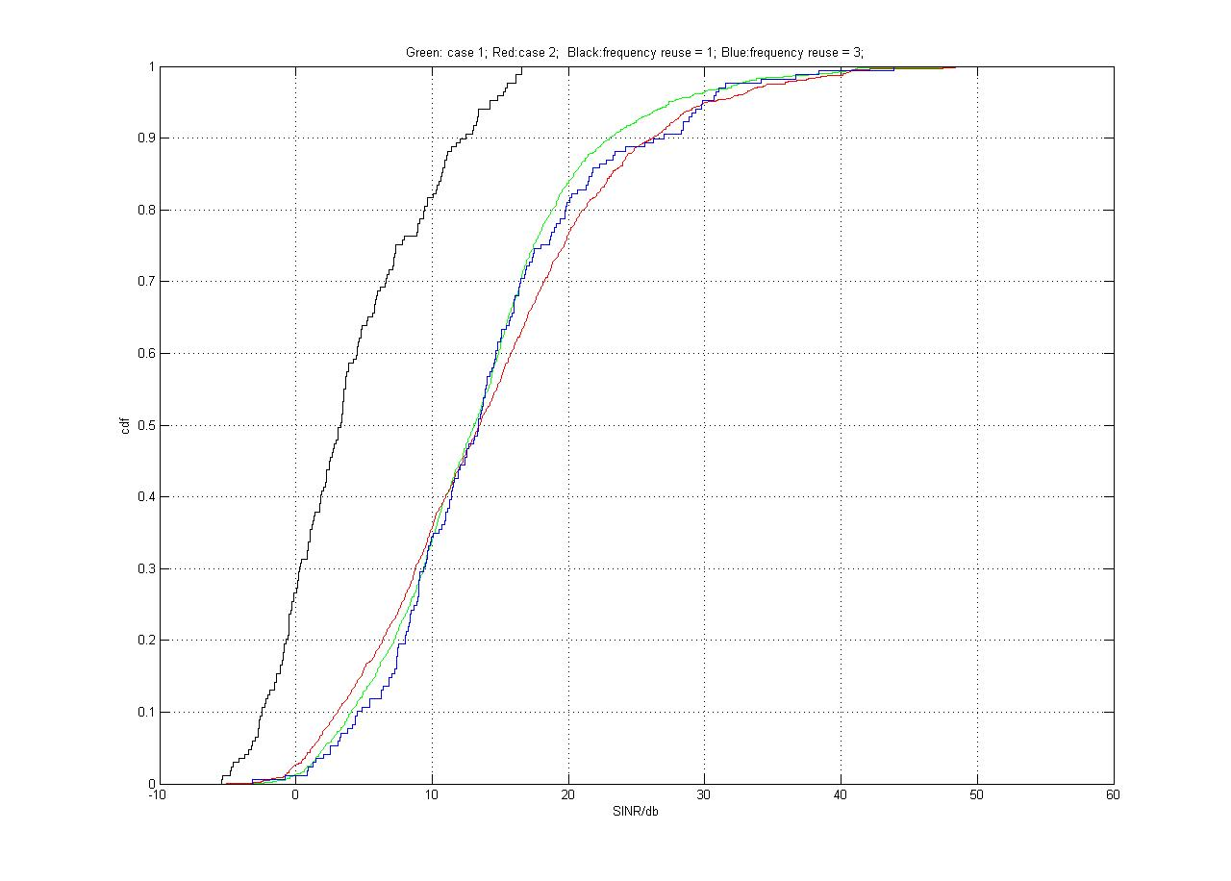
Conclusion:
From the SINR distribution, the receiving SINR doesn’t have significant drop even when MS is at the boundary of different PBCH areas (compares to FR=3 case), when MS is in the center of PBCH area, the SINR is even higher than FR=3 case.

4 Proposed Text for SDD

-------------------------------------------------------Start of the text------------------------------------------------------------
11.7.2.2.1 Primary Broadcast Channel (PBCH) and Secondary Broadcast Channel (SBCH)
The Primary Broadcast Channel (PBCH) and the Secondary Broadcast Channel (SBCH) carry essential system
parameters and system configuration information. The PBCH carries deployment wide common information.
The SBCH carries sector specific information the information in the PBCH and SBCH may be transmitted over
one or more superframes. The deployment wide common information is further divided into sub-packets according to the frequency requirements of each message.
11.7.2.2.2 Location of the BCH
PBCH is located in a set of pre-determined distributed PHY resources.

-------------------------------------------------------End of the text------------------------------------------------------------

