Project | IEEE 802.16 Broadband Wireless Access Working Group <http://ieee802.org/16>
Title | SDD Text Proposal for PBCH in IEEE 802.16m
Date Submitted | 2008-10-31
Source(s) | Xiaoyi Wang, Shashikant Maheshwari, Yousuf Saifullah  Nokia Siemens Networks  Zexian li  Nokia  Jinsoo Choi, Bin-chul Ihm, Jeongki Kim, Sunam Kim  LG Electronics | E-mail:xiaoyi.wang@nsn.com  E-mail: zexian.li@nokia.com  E-mail: emptylie@lge.com
Re: | The TGm Call for Contributions and Comments 802.16m-08/040
Abstract | This contribution proposes SDD text proposal for power control.
Purpose | Comments to SDD
Notice | This document does not represent the agreed views of the IEEE 802.16 Working Group or any of its subgroups. It represents only the views of the participants listed in the “Source(s)” field above. It is offered as a basis for discussion. It is not binding on the contributor(s), who reserve(s) the right to add, amend or withdraw material contained herein.
Release | The contributor grants a free, irrevocable license to the IEEE to incorporate material contained in this contribution, and any modifications thereof, in the creation of an IEEE Standards publication; to copyright in the IEEE’s name any IEEE Standards publication even though it may include portions of this contribution; and at the IEEE’s sole discretion to permit others to reproduce in whole or in part the resulting IEEE Standards publication. The contributor also acknowledges and accepts that this contribution may be made public by IEEE 802.16.
Patent Policy | The contributor is familiar with the IEEE-SA Patent Policy and Procedures:  <http://standards.ieee.org/guides/bylaws/sect6-7.html#6> and <http://standards.ieee.org/guides/opman/sect6.html#6.3>.  Further information is located at <http://standards.ieee.org/board/pat/pat-material.html> and <http://standards.ieee.org/board/pat>.

PBCH Design

Xiaoyi Wang, Shashikant Maheshwari, Yousuf Saifullah
Nokia Siemens Networks
Zexian Li
Nokia
Jinsoo Choi, Bin-chul Ihm, Jeongki Kim, Sunam Kim
LG Electronics

1 Purpose

There are two different BCHs in current SDD, but there is no specific design for it. This contribution provides detail design on PBCH, mainly on the carried information and transmission manner.

2 Broadcasting messages

Name | Type  [Network common (N)/  sector specified (S) ] | size (bit)
Super frame number | N | 24
Number of BS’s antennas | S | 2
TTG | N | 16
RTG | N | 8
DL/UL ratio | N | 3
Operator ID | N | 4
System bandwidth | N | 4
UL center frequency (FDD/HFDD) | N | 8
UL bandwidth (FDD/HFDD) | N | 4
Multiple TTI information | S | 8
PHY Version info | N | 3
MAC Version info | N | 3
NSP ID | N | 16
Sector ID | S | 8
Burst profile | S | 8
Legacy system information  (E.g.) Indicator, center frequency, bandwidth, DL/UL ratio, etc.) | S | FFS
Multi-carrier configuration information  ( E.g.) carrier index, Fully/partially MC info, center frequency, bandwidth, etc. ) | S | FFS
E-MBS information  ( e.g. )MBS zone information, Zone ID, MBSFN information, etc.) | S | FFS
Configuration information for additional system information  (E.g.) Inclusion, scheduling info, version info, etc.) | S | FFS
Inter-RAT support information  (E.g.) Support indicator, Presence or scheduling info of neigbor BS information, etc.) | S | FFS
UL control channel information  (E.g.) Ranging region information, sequence information, etc. ) | S | FFS

3 Single Frequency Networks

There are a lot of common message among neighboring sectors, it’s necessary to classify them out and transmitted independent. In that case, since the payload bits are exactly the same among sectors, SFN could be used to reduce the PHY resource usage and reduce interference.

Since PBCH carried the common broadcasting information among sectors, we want to give the same phy resource for PBCH transmission at different BSs to achieve macro diversity gain. But for SBCH and data, different permutation scheme is given and FR=3 is used. So PHY resource for PBCH is actually located in a special frequency partition, see following figure. We propose to have PHY resource of PBCH located in a pre-determined frequency (distributed) so that PBCH decoding doesn’t rely on any other channels.

The PHY resource size, MCS, repetition number of PBCH is pre-determined. So the payload bits number for PBCH is pre-determined. The detail RB number is still FFS.

4. Simulation

4.1 Estimate the interference at deployment wide area boundary

Simulation Scenarios:

FR=1
FR=3
Case 1: boundary of PBCH areas split sectors in one BS. (Sectors in one BS may belong to different region)
Case 2: boundary doesn’t split sectors in one BS.

FFT Size | 1024
Number of sectors per BS site | 3
Pathloss method | okumuraHata
Antenna height for MS | 1.5m
Antenna height for BS | 32m
Maximum Tx power for BS | 40 W
Maximum Tx power for MS | 0.25 mW
Frame length | 5 ms
Number of sectors | 57

We only statistic SINR of MS in central 7 BSs.
Case1 boundary is across the BS.
Case 2, boundary is not across BS.

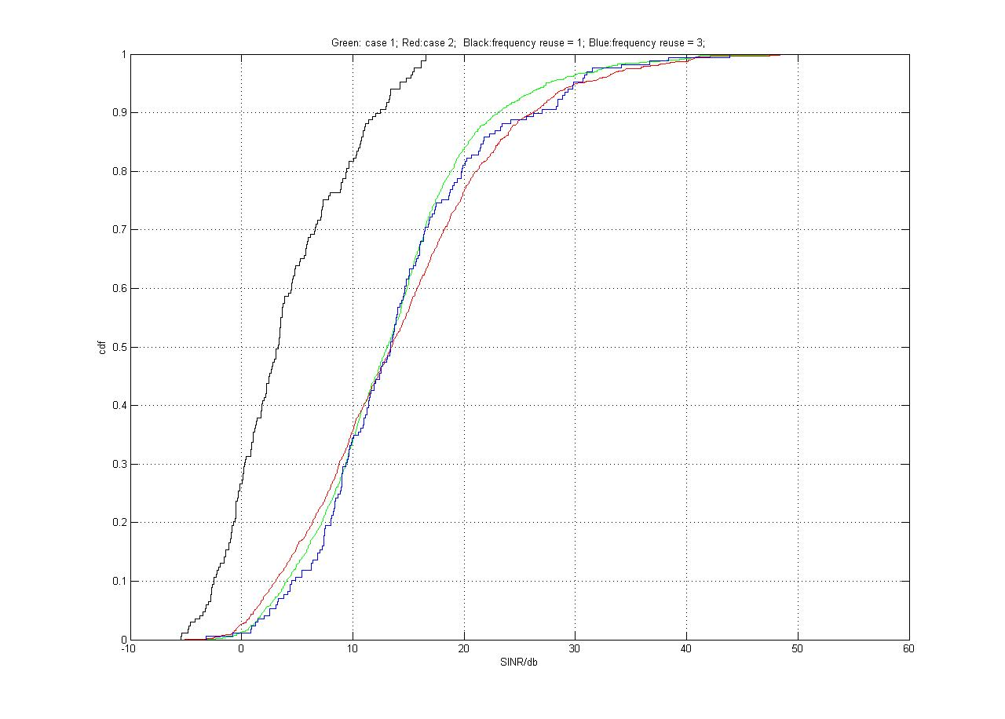
Conclusion:
From the SINR distribution, the receiving SINR doesn’t have significant drop even when MS is at the boundary of different PBCH areas (compares to FR=3 case), when MS is in the center of PBCH area, the SINR is even higher than FR=3 case.

4.2 Required MCS considering coverage in SFN

<Simulation assumption>
- Basic modulation: QPSK, 16QAM, 64QAM
- Subchannelization: 16e PUSC
- Antenna configuration: SIMO
- Receiver structure: MRC
- Channel coding: Turbo code
- Power control: Equal power per subcarrier
- Site-to-site distance (SSD): 1.5km and 3.0km
- Users: 10 users per sector
- Other system assumption: Most based on the test scenarios in EVM document [1]

SSD/MCS* | MCS18 | MCS19 | MCS20 | MCS21 | MCS22
1.5km | 98.60% | 97.70% | 96.14% | 93.50% | 83.68%
SSD/MCS | MCS8 | MCS9 | MCS10 | MCS11 | MCS12
3.0km | 96.50% | 95.30% | 94% | 93.10% | 91.70%
<Table 1: MCS according to coverage (successfully received with 1% FER)>
*
- MCS8 = QPSK 7/10, MCS9 = QPSK 3/4, MCS10 = 16QAM4/9
- MCS11 = 16QAM1/2, MCS12 = 16QAM13/24, MCS18 = 64QAM5/8
- MCS19 = 64QAM17/25, MCS20 = 64QAM3/4, MCS21 = 64QAM5/6
- MCS22 = 64QAM9/10

In SFN environment, the required MCS considering MS coverage is relatively high compared to non-SFN cases. So, it is not need to apply low MCS level for robust transmission, which means we can transmit the PBCH with small amount of resource unit if the PBCH carries only network common information. Because high MCS level can be applied, it is good to transmit the total common information in one PBCH for efficient resource utilization.

5 Proposed Text for SDD

-------------------------------------------------------Start of the text------------------------------------------------------------
11.7.2.2.1 Primary Broadcast Channel (PBCH) and Secondary Broadcast Channel (SBCH)

The Primary Broadcast Channel (PBCH) and the Secondary Broadcast Channel (SBCH) carry essential system
parameters and system configuration information. The PBCH and the SBCH is transmitted over one or more superframe. The PBCH is transmitted every superframe. The SBCH may also be transmitted. When present, SBCH may be transmitted over one or more superframes. The information contents of PBCH and SBCH is FFS “PBCH carries essential broadcast information that are deployment wide common information and transmitted using frequency reuse factor of 1. SBCH carries essential broadcast information that may not be common information across BSs. Transmission format of PBCH/SBCH is FFS..

11.7.2.2.2 Location of the BCH
The SFH includes PBCH and the SBCH, and is located in the first subframe within a superframe. PBCH is located in a set of pre-determined distributed PHY resources. The location of SBCH can be indicated by PBCH.

Modify table 3 on page 74 :
Information |  | Channel | Location
Synchronization information |  | Synchronization Channel (SCH) | FFS
Essential system parameters and system configuration information | Deployment-wide common information | Primary Broadcast Channel (PBCH) | Inside of SFH
 | Downlink sector-specific information | Secondary Broadcast Channel (SBCH) | Inside of SFH
 | Uplink sector-specific information | Secondary Broadcast Channel (SBCH) | Inside of SFH
Extended system parameters and system configuration information |  | FFS | Outside of SFH
Control and signaling for DL notifications |  | FFS | FFS
Control and signaling for traffic |  | Unicast Service Control Channel | Outside of SFH

-------------------------------------------------------End of the text------------------------------------------------------------

6 Reference
[1] IEEE 802.16m-08/004r3, “Project 802.16m Evaluation Methodology Document (EMD)”

