Project | IEEE 802.16 Broadband Wireless Access Working Group <http://ieee802.org/16>
Title | Link Adaptation with the Feedback of Rician Channel k-factor
Date Submitted | 2008-09-05
Source(s) | Rong-Terng Juang, Yu-Tao Hsieh, Pang-An Ting, Richard Li  ITRI  Hsin-Piao Lin  NTUT | Voice: + 886 3 5914854  E-mail: ythsieh@itri.org.tw
Re: | “Intermediate Draft: Harmonized SDD Text on Link Adaptation”, C80216m-Link-08/003r2; "Updated Work Plan for Project 802.16m Rapporteur Group for Link Adaptation, Power Control, and Interference Mitigation" C80216m-Link-08/001r1
Abstract | Comment on Intermediate Draft of Link Adaptation SDD
Purpose | For review and discussion in the Project 802.16m Link Rapporteur Group
Notice | This document does not represent the agreed views of the IEEE 802.16 Working Group or any of its subgroups. It represents only the views of the participants listed in the “Source(s)” field above. It is offered as a basis for discussion. It is not binding on the contributor(s), who reserve(s) the right to add, amend or withdraw material contained herein.
Release | The contributor grants a free, irrevocable license to the IEEE to incorporate material contained in this contribution, and any modifications thereof, in the creation of an IEEE Standards publication; to copyright in the IEEE’s name any IEEE Standards publication even though it may include portions of this contribution; and at the IEEE’s sole discretion to permit others to reproduce in whole or in part the resulting IEEE Standards publication. The contributor also acknowledges and accepts that this contribution may be made public by IEEE 802.16.
Patent Policy | The contributor is familiar with the IEEE-SA Patent Policy and Procedures:  <http://standards.ieee.org/guides/bylaws/sect6-7.html#6> and <http://standards.ieee.org/guides/opman/sect6.html#6.3>.  Further information is located at <http://standards.ieee.org/board/pat/pat-material.html> and <http://standards.ieee.org/board/pat>.

Link Adaptation with the Feedback of Rician Channel k-factor

Rong-Terng Juang, Yu-Tao Hsieh, Pang-An Ting, Richard Li
ITRI
Hsin-Piao Lin
NTUT

Introduction
In a typical wireless communication environment, a transmitter and receiver are surrounded by objects which reflect and scatter the transmitted energy, causing several waves to arrive at the receiver via different routes. This is multipath propagation. When the direct wave from the transmitter to receiver is blocked by buildings, walls, and etc, the propagation is termed as non-line-of-sight (NLOS) propagation. On the contrary, if there is a direct path between transmitter and receiver, then it is called line-of-sight (LOS) propagation. In the LOS situation, the received signal is composed of a random multipath component, which amplitude is described by the Rayleigh distribution plus a coherent LOS component that has essentially constant power. The power of this component is usually greater than the total multipath power. The theoretical distribution which applies in this case is Rician distribution with k-factor indicating the strength of LOS component. Therefore, the Rician k-factor is an indicator for channel status and should be used as one of parameters for link adaptation.
Figure 1 shows the BER performance of transmit diversity in fading channel with different k-factors while Fig. 2 shows the BER performance of spatial multiplexing in fading channel with different k-factors. Clearly, system performance varies in fading channel with different k-factors. Therefore, this contribution proposes a link adaptation considering the channel k-factor and makes comments on 16m Link Adaptation SDD. The proposed text in red and underline represent text additions.

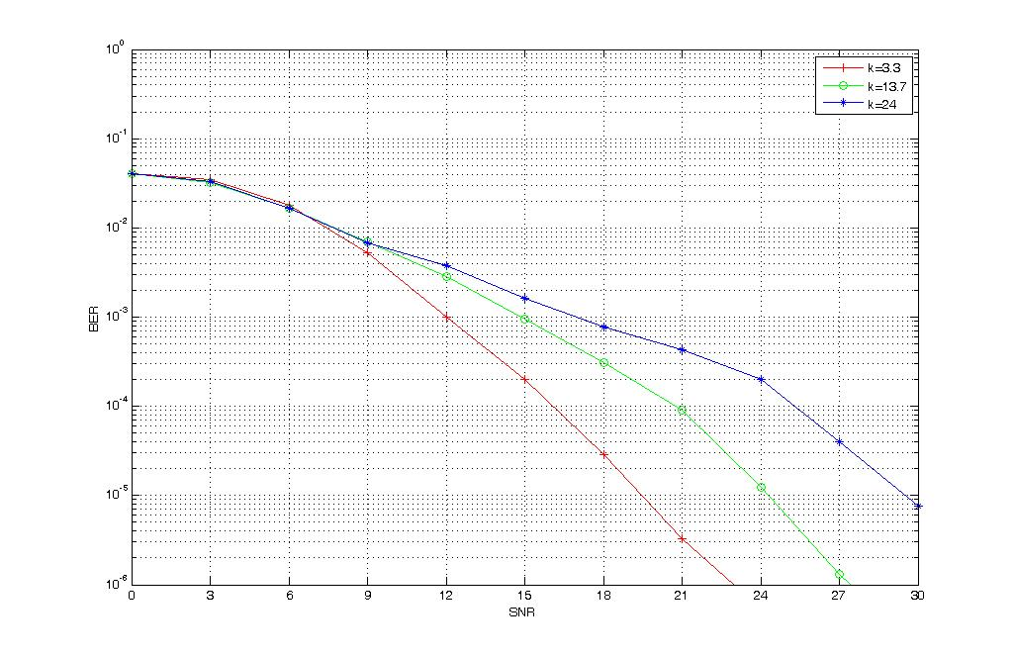
Figure 1. BER performance of transmit diversity in fading channels.
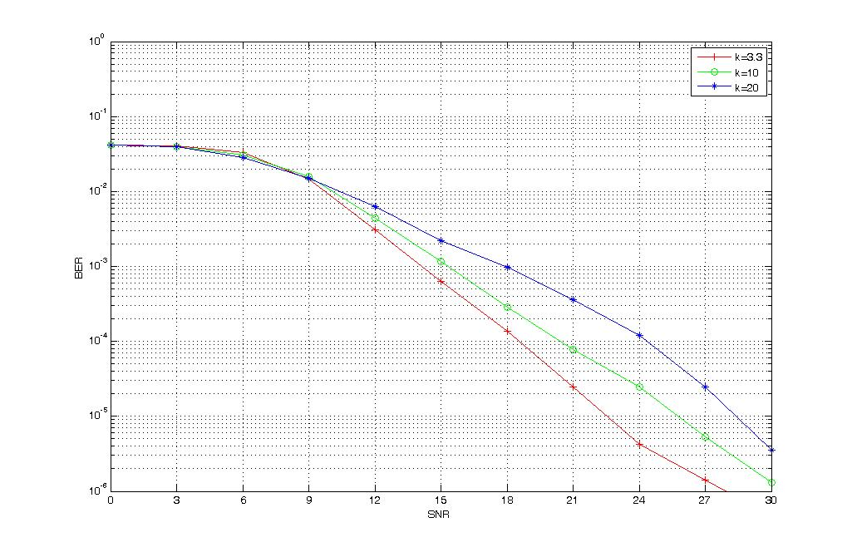
Figure 2. BER performance of spatial multiplexing in fading channels.

Proposed Text
------------------------------------------------------- Start of the proposed text ------------------------------------------------
11. x Link Adaptation

This section introduces the Link Adaption schemes which will adaptively adjust radio link transmission formats in response to change of radio channel for both downlink and uplink. .

11. x.1 DL Link Adaptation

11. x.1.1 Adaptive modulation and channel coding scheme
IEEE 802.16m shall support the adaptive modulation and channel coding (AMC) scheme for DL transmission. The serving BS can adapt the modulation and coding scheme (MCS) level based on the DL channel quality indicator (CQI) reported from MS for closed-loop link adaptation or based on the UL CQI estimation for open-loop link adaptation.
The CQI could be one of the Physical CINR, Effective CINR, rank, and k-factor or their combination. The definition of CQI is FFS.

11. x.2 UL Link Adaptation

11. x.2.1 Adaptive modulation and channel coding scheme
IEEE 802.16m shall support the adaptive modulation and channel coding (AMC) scheme for UL transmission. The serving BS can adapt the modulation and coding scheme (MCS) level based on the UL channel quality estimation and the maximum transmission power by MS. The UL channel quality indicator could be one of the Physical CINR, Effective CINR, rank, and k-factor or their combination. The definition of UL channel quality indicator is FFS. Note that the UL AMC may be integrated with UL power control and interference mitigation schemes to further achieve higher spectral efficiency.

11. x.3 Transmission Format
[Note: The content of this section shall not contradict with the transmission format determined by HARQ RG and PHY text RG]
IEEE 802.16m should support the transmission used in legacy system as the baseline. For example,
- The modulation schemes like QPSK, 16QAM and 64QAM for DL and QPSK, 16QAM for UL,
- The channel coding scheme like Convolutional Turbo Code (CTC) with 1/2 and 1/4 nominal code rate.
New transmission format is FFS.
------------------------------------------------------- End of the proposed text ------------------------------------------------

References
[1] Fu, I-Kang, et al., “Intermediate Draft: Harmonized SDD Text on Interference Mitigation,” IEEE C80216m-Link-08/003r2, August 2008.
[2] Fu, I-Kang, et al. “Updated Work Plan for Project 802.16m Rapporteur Group for Link Adaptation, Power Control, and Interference Mitigation,” IEEE C80216m-Link-08/001r2, August 2008.

