Project | IEEE 802.16 Broadband Wireless Access Working Group <http://ieee802.org/16>
Title | PHY Structure Design of Non-synchronized Ranging Sequence for IEEE 802.16m
Date Submitted | 2008-09-05
Source(s) | Kuhn-Chang Lin and Yu T. Su  NCTU/ MediaTek Inc.  Yih-Shen Chen, Pei-Kai Liao, I-Kang Fu and Paul Cheng  MediaTek Inc. | Voice:  E-mail: tony.cm95g@nctu.edu.tw  ytsu@mail.nctu.edu.tw  yihshen.chen@mediatek.com  Paul.Cheng@mediatek.com
Re: | PHY: SDD Session 56 Cleanup; in response to the TGm Call for Contributions and Comments 802.16m-08/033 for Session 57
Abstract | The contribution proposes a ranging code sequence design and the associated channel assignment scheme for OFDMA systems. Our design allows an efficient initial ranging method which is capable of detecting single and multiple ranging codes, estimating the corresponding timing offsets and power levels without the aid of side information such as SNR or SINR. And also, the proposed design can meet ranging channel evaluation criteria.
Purpose | For 802.16m discussion and adoption
Notice | This document does not represent the agreed views of the IEEE 802.16 Working Group or any of its subgroups. It represents only the views of the participants listed in the “Source(s)” field above. It is offered as a basis for discussion. It is not binding on the contributor(s), who reserve(s) the right to add, amend or withdraw material contained herein.
Release | The contributor grants a free, irrevocable license to the IEEE to incorporate material contained in this contribution, and any modifications thereof, in the creation of an IEEE Standards publication; to copyright in the IEEE’s name any IEEE Standards publication even though it may include portions of this contribution; and at the IEEE’s sole discretion to permit others to reproduce in whole or in part the resulting IEEE Standards publication. The contributor also acknowledges and accepts that this contribution may be made public by IEEE 802.16.
Patent Policy | The contributor is familiar with the IEEE-SA Patent Policy and Procedures:  <http://standards.ieee.org/guides/bylaws/sect6-7.html#6> and <http://standards.ieee.org/guides/opman/sect6.html#6.3>.  Further information is located at <http://standards.ieee.org/board/pat/pat-material.html> and <http://standards.ieee.org/board/pat>.

PHY Structure Design of Non-synchronized Ranging Sequence for IEEE 802.16m
Kuhn-Chang Lin, Yu T. Su, Yih-Shen Chen, Pei-Kai Liao, I-Kang Fu and Paul Cheng
NCTU/MediaTek

Introduction
In the July meeting, the ranging channel design was discussed. According to the current version of IEEE 802.16m system requirements document [1], the UL ranging channel for non-synchronized MSs is FDM with other UL control channels and data channels. And, the ranging sequence design and the mapping to subcarriers are TBD. In this contribution, we propose a frequency-domain interleaved polyphase (FDIP) code for the ranging sequence. FDIP ranging sequence is distributed over the subcarriers of ranging channels.

Ranging Channel and Ranging opportunity
The inter-carrier interference (ICI) is introduced by the subcarriers between ranging channels and other UL control channels and data channels. Because the asynchronous ranging station (RSS) are randomly distributed over the coverage area, the maximum (worst-case) initial timing offset is the sum of the round-trip delay (RTD) from a BS to the cell boundary and the maximum delay spread. For a 5 km radius cell with 3.84 μs maximum delay spread the worst-case initial timing offset is less than .5 $T_{o}$, where $T_{o}$ is the CP-less OFDM symbol duration. The CP length of a ranging symbol should be longer than the RTD so CP is larger than 1/8 symbol duration for 802.16m. And, the last part of ranging signal shall be reserved as guard time (GT) to avoid the inter-symbol interference to next OFDMA symbol due to longer delay of ranging signal. The GT shall be not shorter than RTD.

The RSS timing misalignment not only results in SNR loss but also affects other existing synchronous data users. Therefore, the ICI would occur if the data channels and ranging channels are directly multiplexed without any protection. Two protection schemes, guard-band scheme and time-aligned scheme, are proposed in [12]. In this contribution, we consider the guard-band scheme. As shown in the figure 1, the guard-band scheme reserves the some bandwidth ($G_{g}$) to split the ranging channels and data channels. That is, the ranging channels are locally allocated.
Figure 1: example of guard-band scheme for multiplexing of ranging channels and data channels

To accommodate ranging sequences (codes) in the ranging channels, the ranging opportunity for FDIP is defined first. Subcarriers assigned for ranging purpose are physically adjacent and partitioned into Ngp groups (ranging opportunity). The partition principles are:
- Partition subcarriers into series of subbands and each subbands consists of Nc subcarriers.
- Pick out one subband for every Ngp subbands and compose into logically adjacent subcarrier set; that is, ranging opportunity.
Figure 2: partition of ranging opportunity in the ranging channels
As shown in Fig. 2, each ranging opportunity consists of Nb*Nc subcarriers. Each ranging opportunity can support a maximum of M RSSs. Note that the bandwidth of a subband is less than coherent bandwidth to ensure the channel gain of each subcarrier within a subband is approximately the same. On the other hand, the subbands of a group are interleaved so that the frequency spacing between subbands, $D_{b}$, is larger than the coherent bandwidth to guarantee that channel responses of subbands are uncorrelated and diversity gain is achieved at the receiving end.

Therefore, in the contribution, we recommended that the subcarriers for non-synchronized ranging MSs are locally allocated while ranging subcarriers are grouped into ranging opportunities in a distributed manner.

Ranging Code
Instead of using orthogonal codes or pseudo random sequence (e.g., PRBS) to distinguish the M RSSs in the same ranging opportunity, a frequency-domain interleaved polyphase (FDIP) code is employed. For the i-th RSS choosing the p-th ranging opportunity, its FDIP code, $\left\{C_{\text{ip}}(v)\right\}$, is represented by
$C_{\text{ip}}(ν)=r_{\text{ip}}(ι)b_{v}e^{−j2{πiν}/M}\text{, }i\text{=0, 1,}⋯\text{, }M−1,ν=0,1,2,⋯,N_{c}−1$
where $r_{\text{ip}}(ι)$ is modification term for PAPR reduction and $b_{v}$is cell-specific randomization seed which can be derived from BS ID.

The same ranging code sequence maybe be transmitted in different ranging opportunity, but it doesn't cause any mutual interference because the subcarriers allocated to the different ranging opportunities are disjoint. When a ranging code is chosen to transmit, the phase difference between two adjacent subcarriers are forced to rotate $−2{πi}/M$. The phase rotation caused by round-trip delay and channel impulse response is between 0 and $−2π/M$, and it implies that the overall frequency-domain phase shifts of all RSSs in the same group are non-overlapping over $(\frac{−2iπ}{M}\text{, }\frac{−2(i+1)π}{M})$, where $i\text{=0, 1,}⋯\text{, }M−1$. When the MUSIC algorithm is employed, the overall phase shifts of RSSs in the same group could be one to one mapping into corresponding RSSs according the positions of peaks. Simultaneously we could get the delay information of $R_{\text{ip}}$ by the overall phase shift without additionally complicated computations. Hence, the RSSs in the same group can be detected and decoupled easily without using multiple OFDMA symbols.

Note that the FDIP can be successfully decoded without nicer correlation properties by transferring the frequency-domain data into the null space domain. Therefore, the worsened auto-correlation property due to distributed subcarrier usage would not have negative effect on FDIP. For the detail description of decoding, please refer to Appendix A.

Simulation Result and Discussion
The OFDMA system parameter values used in the simulations and reported in this section are the same as those defined in [9] and [13]. The uplink bandwidth is 10 MHz, and the subcarrier spacing is 10.9375 KHz. The number of subcarriers used for initial ranging is 144. For the proposed ranging structure $N_{c}$=6, $N_{b}$=6, $N_{\text{gp}}$=4 and $D_{b}$=140. The ITU Vehicular A channel model with 24 paths is used and the sampling interval, $T_{s}$, is 89.285 ns. The number of sample-spaced channel taps, $L$, is set to be 30. We consider a cell size of radius 5 km so that the round-trip delay $d_{\text{max}}$=33.34 $μs$ = 373 samples. $N_{g}\text{=512}$ samples is assumed to satisfy the condition $N_{g}>d_{\text{max}}+L$. Each group can support 2 RSSs,i.e., $M$=2. The speed of each RSS is 120 km/hr and carrier frequency is 2.5 GHz, hence the normalized residual frequency offsets of RSSs are assumed to be i.i.d. within the range [-0.05,0.05]. Some or all of the following RSS distributions are considered in each figure. They are (i) 1 RSS, (ii) 2 RSSs in 1 group, (iii) 2 RSSs in 2 groups, (iv) 4 RSSs in 4 groups, (v) 4 RSSs in 2 groups and (vi) 8 RSSs within one 802.16e ranging time-slot.

PAPR control performance
The rotation (mapping) vector $\left\{r_{\text{ip}}\left(ι\right)\right\}$ consists of a sequence of constant modulus numbers that rotates the phases of the ranging code sequences. Elements of a binary rotation vector are BPSK signals, i.e., $r_{\text{ip}}(ι)∈\left\{\text{1,}−1\right\}$, and those of a quaternary rotation vector are drawn from the QPSK constellation, i.e., $r_{\text{ip}}(ι)∈\left\{\text{1,}−\text{1,}j,−j\right\}$. We calculate the mean PAPR by averaging over all possible BS seeds. Fig. 3a shows that increasing the constellation size of $r_{\text{ip}}(ι)$ reduces the PAPR of a ranging code. The performance of legacy can be found in [11], and Fig. 3b shows the CDF of ranging code PAPR of CELL_ID=0 and Subchan=0. When the quaternay rotation vector is employed in FDIP, the mean PAPR averaged over all possible BS seeds and all ranging codes is about 7 dB. The PAPR of ranging codes defined in legacy system are larger than 7 dB, and the average PAPR is about 8.5 dB. And also, FDIP can also meet the PAPR criterion for all Db.

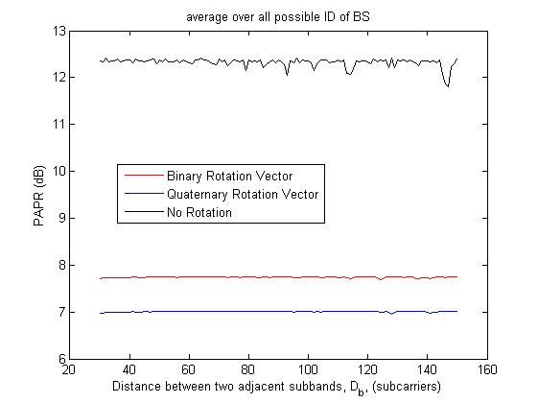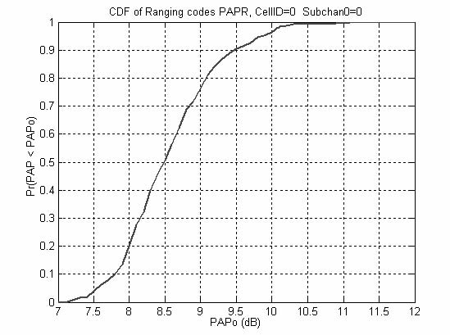
Fig. 3a. PAPR reduction by using binary Fig. 3b. CDF of 16e ranging codes’ PAPR [11]
and quaternary rotation vectors.

Multi-User detection performance
Fig. 4 shows the probability of correct detection ($P_{D}$) performance versus average SNR. It can be seen that $P_{D}$ is close to 1 even if SNR is as small as -10 dB. The performance degrades slightly if there are two RSSs in the same group. When SNR is larger than -7 dB, the performance loss is less than 0.005. Obviously, the performance of the proposed ranging signal and algorithm is insensitive to the RSSs' interference and residual frequency offsets. In [10], the required mis-detection probability is 1%. Obviously, our scheme can meet the requirement.

Fig. 5 plots the probability of false alarm ($P_{F}$) as a function of the average SNR. We find that at high SNR, the RSSs in the different groups do not cause an increase of false alarm probability even if the residual frequency offset is nonzero. At lower SNR, the false alarm probability for the case when there is only one RSS per group will be higher than that if there are more than one RSS in each group due to the use of the same group of subcarriers. Both signal and null spaces are influenced by relative strong noise. When the SNR exceeds 5 dB, the noise effect becomes insignificant. However, even if SNR is smaller than 5 dB, the false alarm probability is always less than 0.02. In [10], the required false alarm rate is 1%. Obviously, our scheme can meet the requirement.

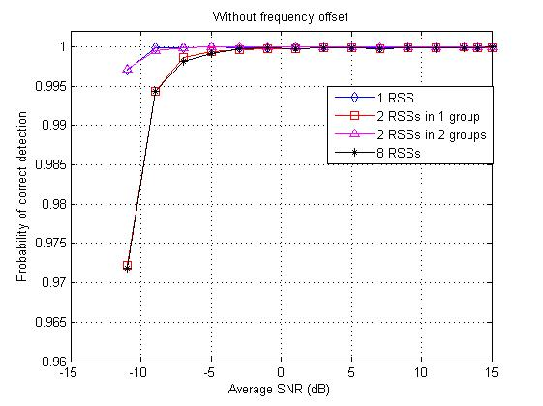
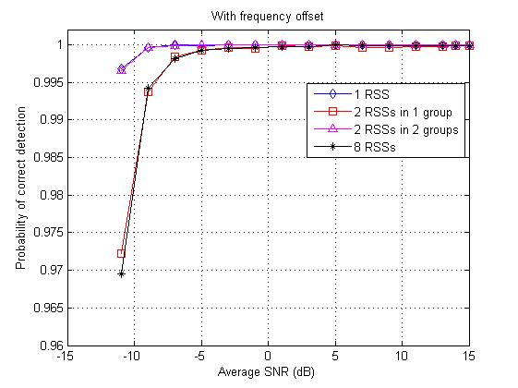
Fig. 4. Detection probability performance as a function of average SNR

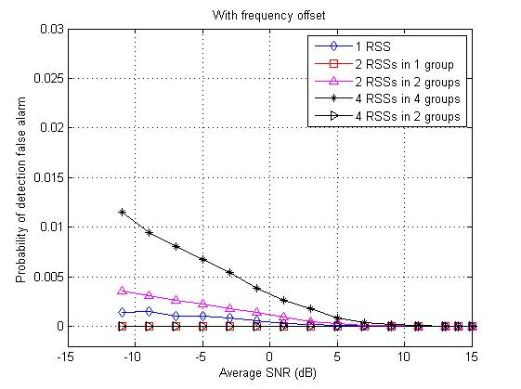
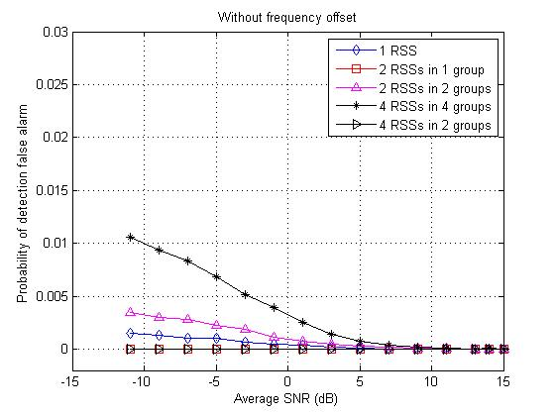

Fig. 5. Probability of false alarm as a function of the average SNR.

Performance of the timing estimate
Fig. 6 shows the performance of timing jitter, defined as the root mean squared error of the timing offset estimator, as a function of the average SNR for various RSS distributions. In each simulation run, the transmission delays are taken randomly from the interval $[\text{0,}d_{\text{max}}]$. It can be observed that one RSS in one group yields better performance than two RSSs in one group. The performance loss, however, is but one sampling interval. After each RSS has adjusted its timing offset, the BS can increase the number of RSSs in one group to support more RSSs provided that the dimension of the null space is larger than one. Therefore, our scheme has small timing offset.

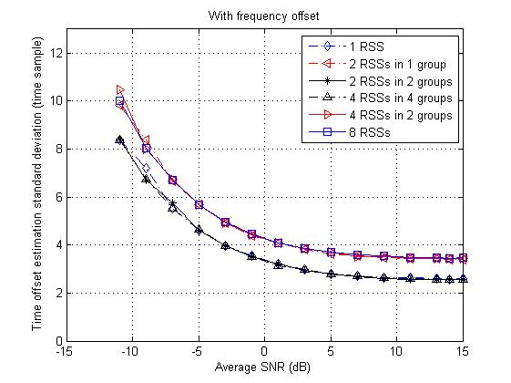
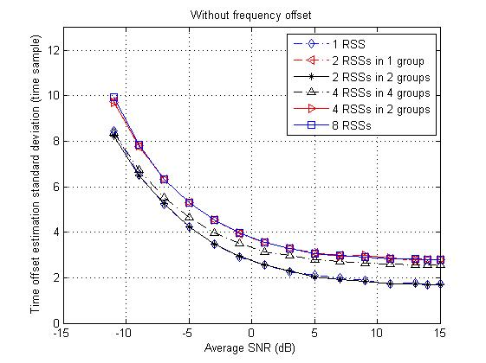
Fig. 6. Timing jitter behavior as a function of the average SNR.

Power estimator performance
Fig. 7 shows the normalized MSE performance of our power estimation scheme as a function of average SNR. The performance of the power estimate is rather insensitive to the number of RSSs and suffers little or no performance loss in the presence of a residual frequency offset. The MSE curves flatten out at high SNR's due to the limitation of the approximation (7).

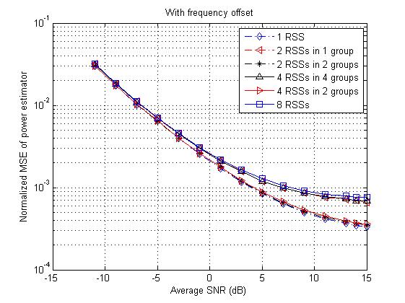
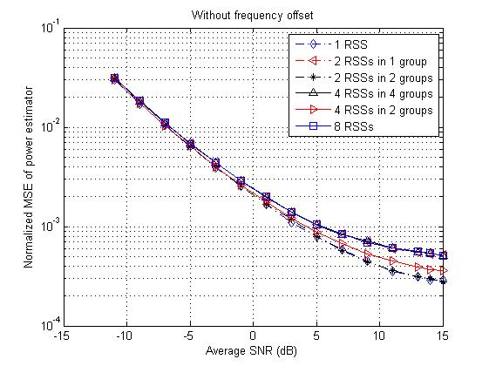

Fig. 7. Normalized MSE performance of the proposed power estimate.

Bandwidth efficiency
In our simulation, the ranging opportunity of FDIP requires only 36 subcarriers, compared to 144 subcarriers in the legacy system. The above simulation results show that the detection performance meets the uplink evaluation requirement for M=2. That is, the space of the legacy ranging opportunity can accommodate 8 FDIP RSSs at most. Actually, the number of RSS supported in the legacy system is far less 8 [13]. Therefore, our scheme can provide better bandwidth efficiency.

Conclusions
We propose a single OFDM symbol based ranging signal design called FDIP code for initial ranging process in an IEEE802.16m-based OFDMA system. The FDIP code makes it possible to devise a ranging algorithm that needs no information about the noise power spectrum density nor powers of active RSSs. Our ranging scheme is based on the idea of projecting the received multiple ranging signals onto the null space, and it can also be extended for use in periodic ranging process in an OFDMA system. The simulation results demonstrate that the proposed method is more robust to multipath fading and multiuser interference than those using the frequency domain CDMA ranging codes used by IEEE802.16e. Not only multiple initial ranging waveforms can be detected and separated but their individual timing offsets and power levels can be accurately estimated.

Proposed Text for the System Description Document (SDD)
------------------------------------------------------- Start of the Text -----------------------------------------------------------
11.9.2.4.2. PHY structure
To avoid ICI, the length of the cyclic prefix (CP), must be larger than the RTD. The last part of ranging signal for non-synchronized MSs shall be reserved as guard time (GT) to avoid the inter-symbol interference to next OFDMA symbol due to longer delay of ranging signal. The GT shall be not shorter than RTD.
The subcarriers for non-synchronized ranging MSs are locally allocated while ranging subcarriers are grouped into ranging opportunities in a distributed manner.
------------------------------------------------------- End of the Text -----------------------------------------------------------

References
[1] IEEE 802.16m-08/003r4, “The Draft IEEE 802.16m System Description Document”

J. Krinock, M. Singh, A. Lonkar, L. Fung and C.-C. Lee, ``Comments on OFDMA ranging scheme described in IEEE 802.16ab01/01r1," document IEEE 802.abs-01/24

X. Fu, and H. Minn, ``Initial uplink synchronization and power control (ranging process) for OFDMA system," in Proc. Globecomm 2004, pp. 3999 - 4003

X. Zhuang, K. Baum, V. Nangia, and M. Cudak ``Ranging improvement for 802.16e OFDMA PHY," document IEEE 802.16e-04/143r1

X. Fu, Y. Li, and H. Minn, ``A New Ranging Method for OFDMA Systems," IEEE Trans. Wireless Commun, vol. 6, no. 2, pp. 659 - 669, February 2007

R. O. Schmidt, ``Multiple emitter location and signal parameter estimation," in Proc. RADC spectral Estimation Workship, 1979, pp. 243 - 258

Z. Cao, U. Tureli, and Y. D. Yao, ``Deterministic Multiuser Carrier-Frequency Offset Estimation for Interleaved OFDMA Uplink," Tran. commun, vol. 52, no. 9, pp. 1585 - 1594, September 2004

M. Morelli, C.-C. Jay Kuo, and M. O. Pun, ``Synchronization techniques for orthogonal frequency division multiple access (OFDMA): A tutorial review," Proceedings of the IEEE, vol. 95, no. 7, pp. 1394 - 1427, July 2007

IEEE 802.16m-08/004r2, “Project 802.16m Evaluation Methodology Document (EMD)"

[10] IEEE 802.16m-08/726r2 , “Project 802.16m UL Control Structure Rapporteur Group Chairs’ Report”

[11] IEEE C802.16e-05/261, “Ranging Code Power Enhancement for 802.16e OFDMA PHY”

[12] IEEE C802.16mUL_ctrl-08/024r1, “UL Ranging Design Consideration for IEEE 802.16m”

[13] IEEE 802.16e-2005, “Air Interface for Fixed and Mobile Broadband Wireless Access Systems”

[14] IEEE C802.16e-04/143, “Ranging Improvement for 802.16e OFDMA PHY”

Appendix A

A.1 Ranging Signal Structure
Let $S_{p}$ be the set of indices of the subcarriers allocated to the $p$th group (ranging opportunity) and denote by $R_{\text{ip}}$ the $B=\left\{b_{0}, ⋯,b_{l}⋯,b_{N_{c}−1}\right\}$th RSS in the $p$th group which employs the frequency domain ranging code $\left\{C_{\text{ip}}(u):u\text{=1,}⋯,N_{b}N_{c}\right\}$. Let $f_{s}$ be the lowest subcarrier index allocated for RSSs. For $0≤p≤N_{\text{gp}}−1$, $S_{p}$ is defined as
$S_{p}=\left\{f_{s}+{\text{pN}}_{c}+{ιD}_{b}+ν: 0≤ι≤N_{b}−\text{1,} 0≤ν≤N_{c}−1\right\}\text{.}$ (1)

The frequency domain ranging signal $X_{\text{ip}}(k)$ for $R_{\text{ip}}$ is defined as
$X_{\text{ip}}(k)=\left\{\begin{matrix}A_{\text{ip}}C_{\text{ip}}(u), & k∈S_{p}\text{, }u\text{=1,2,}⋯N_{b}N_{c} & \\ \text{0,} & \text{otherwise}\text{.} & \end{matrix}\right.$ (2)
where $|C_{\text{ip}}(u)|\text{=1}$ and $A_{\text{ip}}$ is the relative amplitude of $R_{\text{ip}}$.
With the CP inserted, the time domain ranging signal for $R_{\text{ip}}$ is given by
$x_{\text{ip}}(n)=\left\{\begin{matrix}x_{\text{ip}}(n), & \text{if}n\text{=0,}⋯,N−1 & \\ x_{\text{ip}}(n+N), & \text{if}n=−N_{g},⋯,−1 & \\ \text{0,} & \text{otherwise}\text{.} & \end{matrix}\right.$ (3)
Assuming the uplink channels remain static within a symbol duration and ignoring the presence of noise for the moment, we express the received ranging waveform $y_{\text{ip}}^{R}(n)$ for $R_{\text{ip}}$ as
$L−1h_{\text{ip}}(l)x_{\text{ip}}(n−l)$ (4)
where $h_{\text{ip}}(l)\text{, }l\text{=0,}⋯,L−1$ are the associated channel tap weights. The remaining $N−N_{\text{gp}}N_{c}N_{b}$ subcarriers are used for data transmission and are assigned to $N_{\text{DSS}}$ data subscriber stations (DSSs) which have already completed their initial ranging process and are assumed to be perfectly synchronized to the BS time and frequency scales. $y_{i}^{D}(n)$ denotes the signal of the $i$th DSS. The received signal at the BS thus becomes
$N_{\text{DSS}}−1y_{i}^{D}(n)+w(n)$ (5)
where $\left\{w(n)\right\}$ are independent and identical distributed (i.i.d.) complex circular symmetric Gaussian random variables with zero mean and variance $σ_{w}^{2}=E[|w(n)|^{2}]$ and $d_{\text{ip}}$ and $ε_{\text{ip}}$ represent round-trip delay and normalized frequency offset of $R_{\text{ip}}$ .

For the i-th RSS choosing the p-th ranging opportunity, its FDIP code, $\left\{C_{\text{ip}}(v)\right\}$, is represented by
$C_{\text{ip}}(ν)=r_{\text{ip}}(ι)b_{v}e^{−j2{πiν}/M}\text{, }i\text{=0, 1,}⋯\text{, }M−1,ν=0,1,2,⋯,N_{c}−1$ (6)
where $r_{\text{ip}}(ι)$ is modification term for PAPR reduction and $b_{v}$is cell-specific randomization seed which can be derived from BS ID.

A.2 Ranging method
Let the timing estimation error for $R_{\text{ip}}$ be denoted by ${Δd}_{\text{ip}}'$. It was found [9] that whenever ${Δd}_{\text{ip}}'∈[−N_{g}+L−\text{1,}≤0]$ it only results in a cyclic phase shift of the received OFDMA symbol. But if ${Δd}_{\text{ip}}'$ is outside $[−N_{g}+L−\text{1,0}]$, then the loss of orthogonality among subcarriers will result in ICI. Our estimate thus assume that the timing offset $d_{\text{ip}}$ for $R_{\text{ip}}$ is equal to the sum of the transmission delay and the channel group delay. When a RSS receives the timing offset estimate from the BS, it adjusts its timing accordingly and retransmit its ranging code with both cyclic prefix and postfix to avoid inter carrier interference (ICI).

The code structure of (6) and the assumption that the subband bandwidth is smaller than the uplink channel's coherent bandwidth implies that the equivalent channel gains within a the $ι$th subband of $R_{\text{ip}}$ is related by
$H_{\text{ip}}^{ι}(ν)≈H_{\text{ip}}^{ι}(0)e^{−j2\text{πν}(\frac{i}{M}+\frac{d_{\text{ip}}}{N})},$ (7)
where $ν\text{=0, 1,}⋯\text{, }N_{c}−1$.

After removing the BS seed $\left\{b_{l}\right\}$ (see eq.(6)), $Y_{p}^{ι}$ the $N_{c}$-dimensional vector that collects the DFT outputs corresponding to the $ι$th subband of the $p$th group. Since the DSSs are assumed to be perfectly synchronized to the BS references, their signals will not contribute to $Y_{p}^{ι}$.
$M−1F(ε_{\text{ip}})v_{\text{ip}}H_{\text{ip}}^{ι}(0)+n_{p}^{ι}$ (8)
where $n_{p}^{ι}$ is the sum of white Gaussian noise and the interference from the nearby groups and $v_{\text{ip}}$ is defined as
$v_{\text{ip}}={\left(\text{1,}e^{−j2π(\frac{i}{M}+\frac{d_{\text{ip}}}{N})},⋯,e^{−j2π(N_{c}−1)(\frac{i}{M}+\frac{d_{\text{ip}}}{N})}\right)}^{T}\text{.}$ (9)

$F(ε_{\text{ip}})$ is a $N_{c}$ by $N_{c}$ Toeplitz matrix and the entry [9], $f_{a,b}(ε_{\text{ip}})$, is defined as
$f_{a,b}(ε_{\text{ip}})=\frac{\text{sin}(π(a−b+ε_{\text{ip}}))}{\text{Nsin}(π(a−b+ε_{\text{ip}})/N)}e^{jπ(a−b+ε_{\text{ip}})(N−1)/N}$ (10)

The RSS which intents to start the ranging process should compute initial frequency and timing estimates on the basis of a downlink control signal broadcast by the BS. The estimated parameters are then employed by each RSS as synchronization references for the uplink ranging transmission. This means the CFOs are only due to Doppler shifts and/or small estimation errors and, in consequence, they are assumed to lie within a small fraction of the subcarrier spacing. Thus we assume that the CFOs are adequately smaller than the subcarrier spacing, i.e., $|ε_{\text{ip}}|≈0$, and $F(ε_{\text{ip}})$ in (8) could be replaced with $I_{N_{c}}$, where $I_{N_{c}}$ is a identical matrix with order $N_{c}$. When $|ε_{\text{ip}}|\text{<<}$ $1$, $F(ε_{\text{ip}})$ could be viewed as a tri-diagonal matrix. In this case, $F(ε_{\text{ip}})v_{\text{ip}}H_{\text{ip}}^{ι}(0)≈v_{\text{ip}}{\tilde{H}}_{\text{ip}}^{ι}(0)$ and the slight difference could be combined with $n_{p}^{ι}$ to form ${\tilde{n}}_{p}^{ι}$. To simplify the notations, the equation (8) could be rewritten as
$M−1v_{\text{ip}}{\tilde{H}}_{\text{ip}}^{ι}+{\tilde{n}}_{p}^{ι}\text{.}$ (11)
We gather all received subbands within the $p$th group to form $Y_{p}$ which is defined as
$$Y_{p}=\left(\begin{matrix}Y_{p}^{0} & Y_{p}^{1} & ⋯ & Y_{p}^{N_{b}−1}\end{matrix}\right)$$
$=V_{p}{\tilde{H}}_{p}+{\tilde{N}}_{p}$ (12)
where
$V_{p}=\left(\begin{matrix}v_{0p} & v_{1p} & ⋯ & v_{(M−1)p}\end{matrix}\right),$ (13)

${\tilde{H}}_{p}=\left(\begin{matrix}{\tilde{H}}_{0p}^{0} & {\tilde{H}}_{0p}^{1} & ⋯ & {\tilde{H}}_{0p}^{N_{b}−1} \\ {\tilde{H}}_{1p}^{0} & {\tilde{H}}_{1p}^{1} & ⋯ & {\tilde{H}}_{1p}^{N_{b}−1} \\ ⋮ & ⋮ & ⋱ & ⋮ \\ {\tilde{H}}_{1p}^{0} & {\tilde{H}}_{(M−1)p}^{1} & ⋯ & {\tilde{H}}_{(M−1)p}^{N_{b}−1}\end{matrix}\right)$ (14)
and
${\tilde{N}}_{p}=\left(\begin{matrix}{\tilde{n}}_{p}^{0} & {\tilde{n}}_{p}^{1} & ⋯ & {\tilde{n}}_{p}^{N_{b}−1}\end{matrix}\right)\text{.}$ (15)

A.3 Multi-user Ranging Signal Detection and Timing Offset Estimation
The energy leakage from the nearby group due to the fractional frequency offset almost influences the adjacent one subcarrier of each subband. Therefore the subcarrier which is the lowest one or the highest one could be viewed as guard bands. We collect the subcarriers which belong to the $p$th group excluding the highest and the lowest subcarriers of each subband to compute the energy in the $p$th group, $E_{p}$. In noise only case, $E_{p}$ is a chi-square distribution with degree of order $2N_{b}(N_{c}−2)$. When the noise variance is known, we could design the threshold, $η_{0}$, which is a function of the desired false alarm rate and noise variance. We check whether $E_{p}$ is larger than $η_{0}$ first to avoid the unnecessary computations to decouple the RSSs in the $p$th group.

The covariance matrix of $Y_{p}$ defined by
$Φ_{p}=\frac{1}{N_{b}}Y_{p}Y_{p^{H}}\text{.}$ (16)
is a Hermitian matrix whose eigenvalues values are non-negative. Let $λ_{1}≥λ_{2}≥⋯≥λ_{N_{c}}$ be the $N_{c}$ eigenvalues of $Φ_{p}$ in descending order. When there are $κ_{p}$ RSSs in the $p$th group, $κ_{p}≤M$, we have $N_{c}−κ_{p}$ basis vectors which span the null space $U_{w_{p}}$ and can be obtained by performing singular value decomposition (SVD) of $Φ_{p}$. We set the ${\hat{κ}}_{p}$ equal to $M$ and compute $ϒ(d)$, which is denoted as
$ϒ(d)=\frac{|α^{H}(d)α(d)|}{|α^{H}(d)U_{\text{wp}}U_{\text{wp}}^{H}α(d)|}\text{, }d\text{=0,1,}\text{.}\text{.}\text{.},N−1\text{.}$ (17)
where $α(d)=(\text{1, }e^{−j2{πd}/N},⋯\text{, }e^{−j2πd(N_{c}−1)/N})^{T}$. The peaks are the local maximums of $ϒ(d)$. The peak's value is the ratio of total energy to energy projecting onto the null space and it symbolizes the reliability of the peak. We should examine peaks' values and judge them whether are the real peaks. The position of a peak is one to one mapping to which RSS is active and its delay is. Therefore, we could make a decision about $R_{\text{ip}}$ according to whether there is a peak located $d∈\left\{{\text{Ni}}/M,N(i+1)/M\right\}$. At the same time, ${\hat{d}}_{\text{ip}}$, the timing offset associated with $R_{\text{ip}}$ is estimated by subtracting ${\text{Ni}}/M$ from the peak's position without complicated computations.

To summarize our proposed algorithm, the vector ${\hat{d}}_{p}=({\hat{d}}_{0p},{\hat{d}}_{1p},⋯,{\hat{d}}_{(M−1)p})^{T}$ which represents the delay estimates of the delays of the active RSSs in the $p$th group is obtained by using the received samples in one OFDMA symbol and following the steps given below.
- Check whether $E_{p}$ is larger than $η_{0}$. If $E_{p}<η_{0}$, the procedure is stopped.
- Arrange the received frequency domain samples in matrix form $Y_{p}$. Set ${\hat{κ}}_{p}$ equal $M$.
- Apply SVD to $Φ_{p}$ to find the $N_{c}×(N_{c}−{\hat{κ}}_{p})$ matrix $U_{\text{wp}}$.
- Find the largest ${\hat{κ}}_{p}$ peaks of (17) to estimate $d$ for ${\hat{κ}}_{p}$ RSSs. Check the ${\hat{κ}}_{p}$ peaks' values with the threshold, ${η_{1}(N_{c}\text{, }N_{b}\text{, \{}\hat{κ}}_{p})$. If there exist $l$ peaks below the threshold, ${\hat{κ}}_{p}←{\hat{κ}}_{p}−l$ and go back to the step 3.
- Based on the peak's position, we could decide whether or not the RSS is active and its delay is.

A.4 Power Estimation

Rewriting (12) as
$Y_{p}={\hat{V}}_{p}({\hat{d}}_{p}){\tilde{H}}_{p}+{\tilde{N}}_{p}$ (18)
where ${\hat{V}}_{p}({\hat{d}}_{p})$ is obtained by replacing the delays in (9) by their estimated version ${\hat{d}}_{p}$. The LS estimate ${\tilde{H}}_{p}$ can be obtained by
${\tilde{H}}_{p}={\hat{V}}_{p^{†}}({\hat{d}}_{p})Y_{p},$ (19)
where $V_{p^{†}}({\hat{d}}_{p})={\left[V_{p^{H}}({\hat{d}}_{p})V_{p}({\hat{d}}_{P})\right]}^{−1}V_{p^{H}}({\hat{d}}_{p})$. The power of the $i$th RSS in the $p$th group can be represented as
$P_{\text{ip}}=N_{c}{\tilde{H}}_{\text{ip}}{\tilde{H}}_{{\text{ip}}^{H}}$ (20)
where ${\tilde{H}}_{\text{ip}}$ denote the row vector in ${\tilde{H}}_{p}$ corresponding to the $i$th RSS in the $p$th group. Note that channel knowledge is not required in the proposed algorithm.

