Project | IEEE 802.16 Broadband Wireless Access Working Group <http://ieee802.org/16>
Title | MAC header design for IEEE 802.16m system
Date Submitted | 2008-09-05
Source(s) | Jeongki Kim, Kiseon Ryu, Youngsoo Yuk, and Ronny Yongho Kim  LG Electronic Inc. LG R&D Complex, 533 Hogye-1dong, Dongan-gu, Anyang, 431-749, Korea | Voice: +82-31-450-2067  E-mail: chegal@lge.com, ksryu@lge.com, sixs@lge.com, and ronnykim@lge.com
Re: | MAC: Data plane; IEEE 802.16m-08/033 - Call for Contributions on Project 802.16m System Description
Abstract | This contribution provides the formats of generic MAC header, extended subheader, and compressed MAC header for IEEE802.16m systems.
Purpose | To be discussed and adopted by TGm for use in the IEEE 802.16m SDD
Notice | This document does not represent the agreed views of the IEEE 802.16 Working Group or any of its subgroups. It represents only the views of the participants listed in the “Source(s)” field above. It is offered as a basis for discussion. It is not binding on the contributor(s), who reserve(s) the right to add, amend or withdraw material contained herein.
Release | The contributor grants a free, irrevocable license to the IEEE to incorporate material contained in this contribution, and any modifications thereof, in the creation of an IEEE Standards publication; to copyright in the IEEE’s name any IEEE Standards publication even though it may include portions of this contribution; and at the IEEE’s sole discretion to permit others to reproduce in whole or in part the resulting IEEE Standards publication. The contributor also acknowledges and accepts that this contribution may be made public by IEEE 802.16.
Patent Policy | The contributor is familiar with the IEEE-SA Patent Policy and Procedures:  <http://standards.ieee.org/guides/bylaws/sect6-7.html#6> and <http://standards.ieee.org/guides/opman/sect6.html#6.3>.  Further information is located at <http://standards.ieee.org/board/pat/pat-material.html> and <http://standards.ieee.org/board/pat>.
MAC header design for IEEE802.16m system
Jeongki Kim, Kiseon Ryu, Youngsoo Yuk, and Ronny Yongho Kim
LG Electronics

Introduction

As shown in figure 1, the generic MAC header (GMH) in 802.16e is 6 bytes including several fields. Some fields in GMH can be removed to optimize the GMH in 802.16m. For example, a EC field is set to 1 only when MAC PDU is encrypted. A CI field is set to 1only when MAC CRC is appended in MAC PDU. However, in most cases, PHY CRC is enabled so that CI field is usually set to 0. And a HCS can be omitted when HARQ is enabled in the physical layer. Therefore, the generic MAC header in 802.16m can be more optimized than the GMH in 802.16e.
The GMH in 802.16e has fixed format regardless of packet size. The GMH results in MAC overhead for short packets such as 802.16m should design the Compressed MAC header for short packets to reduce MAC overhead.
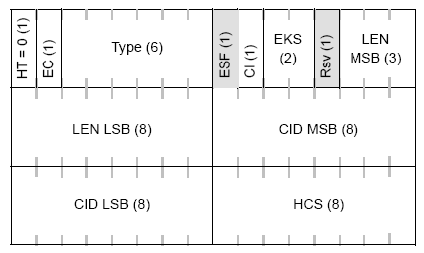
Figure 1. Generic MAC header format

Proposed MAC header design
2.1 Generic MAC header (GMH)

The Figure 2 shows the proposed 16m GMH format. HT and CH field in GMH is set to 0. The 3 bits subheader indicator is used in 16m GMH instead of 6 bits type fields in 16e GMH. CI field indicating MAC CRC appendage and HCS field can be removed in GMH when the HARQ CRC is used. The description of GMH fields is shown in the table 1.

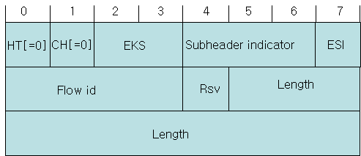
Figure 2. Generic MAC header format for IEEE 802.16m

Table 1. The description of GMH fields

Field (bit) | Description
HT (1) | * Indicates whether the current MAC header is signaling header or not
CH (1) | * Indicates whether the MAC header is compressed MAC header or not
EKS(2) | Encryption key sequence
Subheader indicator (3) | - Bit #2 and #1: presence of fragmentation, packing and/or extended packing subheader  - 00: fragmentation subheader  - 01: packing subheader  - 10: extended packing subheader  - 11: reserved  - Bit #0: presence of FFSH (DL) or GMSH (UL)
ESI(1) | Extended subheader indicator
Flow id | Flow identifier
Length | The length in bytes of the MAC PDU including the MAC header and the CRC if present.
Rsv | Reserved field

2.2 Exended Subheader (ESH)
If the ESI field in the generic MAC header is set to 1, the extended subheader header follows the GMH. Figure 3 shows the extended subheader format. The Ext field indicates whether another ESH follows the current ESH. Type filed indicates the type of extended subheader. Contents of ESH body and the size of ESH body (ESHB) part depend on the ESH type.
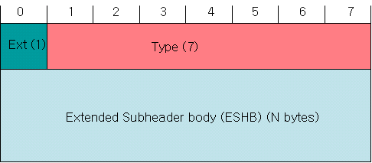
Figure 3. Extended subheader format

Figure 4 shows the example of using a extended subheader .
Figure 4. Example of MAC PDU with a extended subheader
Because one ESH is included in the MAC PDU, Ext field in ESH is set to 0.

Figure 5 shows the example of using multiple extended subheaders.
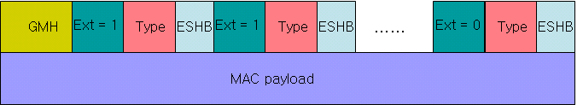
Figure 5. Example of MAC PDU with multiple extended subheaders
When multiple ESHs are included in MAC PDU, Ext fields of all ESHs except for last ESH are set to 1. Ext field of last ESH is set to 0.

2.3 Compressed MAC header (CMH)
The compressed MAC header (CMH) is used for transmitting the short packets (MAC payload) like VoIP packets or MAC management messages. A subheader indicator is omitted in the CMH because packing and fragmentation don’t occur at short packets and extended subheader can be used for GMSH and FFSH. The CMH should contain the EKS field to prevent illegal overhearing for Voice traffic. The CMH has shorter length field than the GMH because it is used for the short MAC PDUs. SI (State indicator) field indicates whether the state of the current service flow is active (0) or inactive (1). If a flow has two states such as VoIP service (active and inactive) and BS can obtain the state of the flow as soon as possible, BS can perform efficient scheduling by QoS parameter set according to the state of the flow. Figure 6 shows the compressed MAC header format.

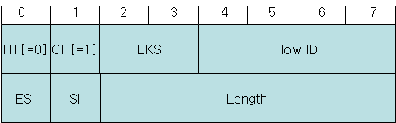
Figure 6. Compressed MAC header format

Text Proposal for the 802.16m SDD

============================== Start of Proposed Text =================================

10.x MAC header design
10.x.1 Generic MAC header
The Figure A shows the proposed 16m GMH format. HT and CH field in GMH is set to 0. The 3 bits subheader indicator is used in 16m GMH. CI field indicating MAC CRC appendage and HCS field can be removed in GMH when the HARQ CRC is used. The description of GMH fields is shown in the table A.

Figure A. Generic MAC header format for IEEE 802.16m

Table A. The description of GMH fields

Field (bit) | Description
HT (1) | * Indicates whether the current MAC header is signaling header or not
CH (1) | * Indicates whether the MAC header is compressed MAC header or not
EKS(2) | Encryption key sequence
Subheader indicator (3) | - Bit #2 and #1: presence of fragmentation, packing and/or extended packing subheader  - 00: fragmentation subheader  - 01: packing subheader  - 10: extended packing subheader  - 11: reserved  - Bit #0: presence of FFSH (DL) or GMSH (UL)
ESI(1) | Extended subheader indicator
Flow id | Flow identifier
Length | The length in bytes of the MAC PDU including the MAC header and the CRC if present.
Rsv | Reserved field

10.x.2 Exended Subheader (ESH)

If the ESI field in the generic MAC header is set to 1, the extended subheader header follows the GMH. The Ext field indicates whether another ESH follows the current ESH. Type filed indicates the type of extended subheader. Contents of ESH body and the size of ESH body (ESHB) part depend on the ESH type. Figure B shows the extended subheader format.

Figure B. Extended subheader format

10.x.3 Compressed MAC header (CMH)
The compressed MAC header (CMH) is used for transmitting the short packets (MAC payload) like VoIP packets or MAC management messages. In CMH, HT is set to 0 and CH is set to 1. SI (silence indicator) field indicates whether the status of the current flow is active or inactive. Figure C shows the compressed MAC header format.

Figure C. Compressed MAC header format

============================== End of Proposed Text =================================

