Project | IEEE 802.16 Broadband Wireless Access Working Group <http://ieee802.org/16>
Title | MS Identity Protection in Security
Date Submitted | 2008-09-05
Source(s) | Libra Xiao, Zhengzheng Li, Jianjun Yang, Lei Jin  Huawei Technologies | Voice: [Telephone Number (optional)]]  E-mail: jinlei60020191@huawei.com  *<http://standards.ieee.org/faqs/affiliationFAQ.html>
Re: | IEEE 802.16m-08/33– Call for Contributions on Security
Abstract | This contribution proposes the security solution for the MS identity protection.
Purpose | For discussion and approval by TGm
Notice | This document does not represent the agreed views of the IEEE 802.16 Working Group or any of its subgroups. It represents only the views of the participants listed in the “Source(s)” field above. It is offered as a basis for discussion. It is not binding on the contributor(s), who reserve(s) the right to add, amend or withdraw material contained herein.
Release | The contributor grants a free, irrevocable license to the IEEE to incorporate material contained in this contribution, and any modifications thereof, in the creation of an IEEE Standards publication; to copyright in the IEEE’s name any IEEE Standards publication even though it may include portions of this contribution; and at the IEEE’s sole discretion to permit others to reproduce in whole or in part the resulting IEEE Standards publication. The contributor also acknowledges and accepts that this contribution may be made public by IEEE 802.16.
Patent Policy | The contributor is familiar with the IEEE-SA Patent Policy and Procedures:  <http://standards.ieee.org/guides/bylaws/sect6-7.html#6> and <http://standards.ieee.org/guides/opman/sect6.html#6.3>.  Further information is located at <http://standards.ieee.org/board/pat/pat-material.html> and <http://standards.ieee.org/board/pat>.
MS Identity Protection in Security
Libra Xiao, Zhengzheng Li, Jianjun Yang, Lei Jin
Huawei Technologies

Motivation
In IEEE 802.16e, the identity of the MS is its MAC Address, namely the MSID, and during the communication, the MS and the BS will exchange the messages with the MSID in plaintext on wireless.
If some others obtain the MSID corresponding to the MS by any way, which the irregular BS will steal the MS’s MSID, then they can track the MS by the MSID and the impaction is listed as below:
- Leak out the MS’s privacy, especially the MS information
- Track the MS’s status and service
Therefore, the ID protection in 16m is necessary in the wireless system.

Discussion
In IEEEE 802.16e/d, there is no protection mechanism for the MS identity, such as MAC Address of the MS, etc, so there exists some hidden trouble for the MS identity, example for leaking out the MS’s privacy, especially the MS information, or the MS’s status and service to be tracked, etc.
About the ID protection, there are some existed solutions about it in current systems.
For example, there is a solution for the MS identity protection from RFC 4187(EAP-AKA) that the MS will use the TMSI (temp identity) in follow-up network entry, instead of the IMSI (permanent identity) that is used in first network entry and some abnormal states, so that by the random TMSI the MS identity is protected and avoids the leaking out the MS’s privacy, or the MS’s status and service, etc.
For the solution above, it has some security leak, for instance in the firstly network entry and some abnormal states the MS identity will still be transmitted in plaintext in some messages, so if some destroyer obtains the information about the MS identity, they will can track the MS and the MS will lose the privacy.
For the issue above, considering the MS privacy protection in IEEE 802.16m the issue need to be solved.
In our opinion, there may use the tunnel mechanism to solve the issue, such as the tunnel mechanism with the DH algorithm or the RSA algorithm. The mapping procedures are listed as below:
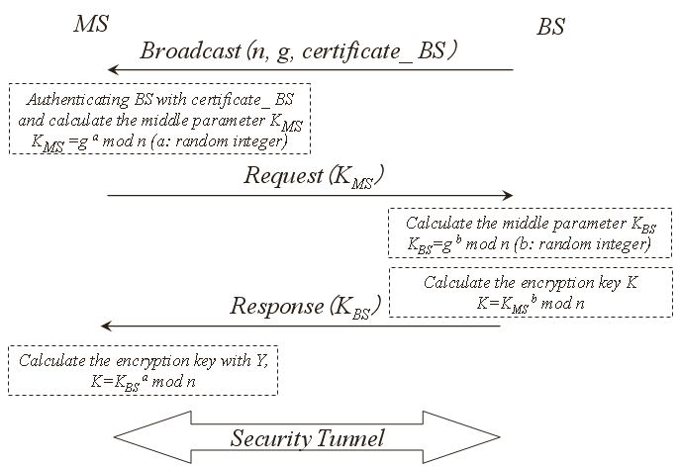
Figure 1 The tunnel creation procedure by DH algorithm
The detailed procedure by DH algorithm is listed as below:
Step 1 – In network operation, the BS will send out termly the broadcast messages with the its certification, the parameters of n, g which are used to calculate the middle parameter K_{MS} in the MS and the encryption key by DH algorithm;
Step 2 – If the MS wants to enter the network, it will authenticate the BS by the certification in the broadcast message, and if the BS is legal, then the MS will calculate the middle parameter K_{MS,} and the expressions is as below:
K_{MS} = gª mod n (a: random integer which is generated in the MS);
Step 3 – After finishing the authentication and the calculation, the MS will send the request message with K_{MS} to the BS and want to obtain the middle parameter K_{BS} in the BS;
Step 4 – After receiving the request messages from the MS, then the BS will generate the random integer b and calculate the middle parameter K_{BS}, and the expressions is as below:
K_{BS} = g^{b} mod n (b: random integer which is generated in the BS)
According to the middle parameter K_{MS} in MS, the BS will calculate the encryption key which is used to encrypt the MS identity, and the expressions is as below:
K=K^{b}_{MS} mod n
Then the BS will send the response message with the K_{BS} to the MS;
Step 5 – After receiving the response from the BS, then the MS will calculate the encryption key which is used to encrypt the MS identity, and the expressions is as below:
K=Kª_{BS} mod n
Step 6 – The security tunnel is created between the MS and the BS, and then the MS ID will be transmitted while encrypted by encryption key K.
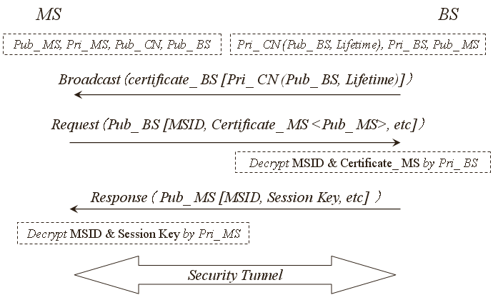
Figure 2 The tunnel creation procedure by RSA algorithm
The detailed procedure by RSA algorithm is listed as below:
Step 1 – The MS should obtain Pub_ BS(the public key of the BS) and Pub_ CN(the public key of the core network), and own pair keys from CA like Pub_ MS(the public key of the MS) and Pri_ MS(the privacy key of the MS). And the BS should obtain Pri_ CN(Pub_ BS, lifetime)(the encrypted public key of the BS and the lifetime of the key by the privacy of the CN), and own pair keys from CA like Pub_ BS(the public key of the BS) and Pri_ BS(the privacy key of the BS).
Step 2 – The BS will send out termly the broadcast message with the certification of the BS including the Pri_ CN(Pub_ BS, lifetime);
Step 3 – The MS authenticates the BS according the broadcast messages from the BS, if the MS want to enter the network.
Step 4 – If the BS has been authenticated, the MS will send the BS the request message with the parameters encrypted by Pub_ BS, such as MSID, the certification of the MS including the Pub_ MS, etc;
Step 5 – Receiving the request message from the MS, the BS will decrypt the MSID and certification of the MS in the request message by Pri_ BS, and obtain the Pub_ MS.
Step 6 – After the BS finishes the exchange with the core network (out of the scope in 16m), then the BS will send the response message with the parameters encrypted, such as the MSID, the session key, etc;
Step 7 – The MS will decrypt the MSID, the session key, etc, in the response message by Pri_ MS;
Step 8 – The security tunnel have be created between the MS and the BS and the MSID exchange between the MS and the BS is based on the RSA algorithm.

Proposal
Add the text into section 12 security:
------------------------------------------- Start of Proposed SDD Text ------------------------------------------------------
12.x MS identity protection
In IEEE 802.16m system, the MS identity needs to be protected. The scheme for MS identity protection should be designed in the IEEE 802.16m security architecture.
------------------------------------------- End of Proposed SDD Text ------------------------------------------------------

