Project | IEEE 802.16 Broadband Wireless Access Working Group <http://ieee802.org/16>
Title | MULTI-USER RESOURCE ALLOCATION AND MAC OVERHEAD REDUCTION FOR IEEE 802.16m
Date Submitted | 2008-09-05
Source(s) | Sassan Ahmadi (sassan.ahmadi@intel.com)  Muthaiah Venkatachalam  Xiangying Yang  Intel Corporation
Re: | MAC: Data Plane; IEEE 802.16m-08/033 Call for Comments and Contributions on Project 802.16m System Description Document (SDD) for Session 57
Abstract | This contribution introduces a new concept that is capable of significantly reducing the MAC header overhead for small payload applications and thereby significantly increasing the performance and capacity and reducing the end-to-end latency. The proposed scheme schedules, combines, and transmits downlink user data belonging to a number of users having similar channel conditions using a new multi-user MAC header structure. The proposed scheme does not impose any additional complexity on the BS (Base station) scheduler, rather reduces the scheduling delay for delay sensitive user traffic.
Purpose | Discussion and Approval
Notice | This document does not represent the agreed views of the IEEE 802.16 Working Group or any of its subgroups. It represents only the views of the participants listed in the “Source(s)” field above. It is offered as a basis for discussion. It is not binding on the contributor(s), who reserve(s) the right to add, amend or withdraw material contained herein.
Release | The contributor grants a free, irrevocable license to the IEEE to incorporate material contained in this contribution, and any modifications thereof, in the creation of an IEEE Standards publication; to copyright in the IEEE’s name any IEEE Standards publication even though it may include portions of this contribution; and at the IEEE’s sole discretion to permit others to reproduce in whole or in part the resulting IEEE Standards publication. The contributor also acknowledges and accepts that this contribution may be made public by IEEE 802.16.
Patent Policy | The contributor is familiar with the IEEE-SA Patent Policy and Procedures:  <http://standards.ieee.org/guides/bylaws/sect6-7.html#6> and <http://standards.ieee.org/guides/opman/sect6.html#6.3>.  Further information is located at <http://standards.ieee.org/board/pat/pat-material.html> and <http://standards.ieee.org/board/pat>.

MULTI-USER RESOURCE ALLOCATION AND MAC OVERHEAD REDUCTION FOR IEEE 802.16m
Sassan Ahmadi, Muthaiah Venkatachalam, Xiangying Yang

Intel Corporation

Introduction and Background
The MAC PDU in IEEE 802.16e-2005 standard consists of a header followed by a payload and an optional CRC. The CRC consists of four octets and is based on IEEE 802.3 and is calculated on the entire MAC PDU including the header. As shown in Figure 1, there are two types of MAC headers namely GMH and BW-REQ header.

Generic MAC Header Format
BW Request MAC Header Format
Header Type
Payload Length
Connection ID
Encryption Control
BW Request
Header Check Sequence
Payload Type
Encryption Key Sequence
CRC Indicator
BW Request Type
Figure 1: Structure of MAC Header in IEEE 802.16e-2005 (courtesy of IEEE)

The size of MAC header (six octets) is considered a significant overhead for certain applications such as VoIP and interactive gaming, which consist of small payloads. As an example, the size of VoIP RTP payloads depending on the type of the voice codec is typically less than 40 octets; therefore, each VoIP packet encapsulated in a MAC PDU has more 25% overhead (typically 50%) overhead due to the size of the MAC header and the trailing CRC. Most of the fields in the MAC header are usually not used in VoIP and interactive gaming.

The IEEE 802.16 was originally designed for data applications and with maximal flexibility. Nevertheless, the increasing demand from cellular operators for increased VoIP capacity and the emergence of new applications such as interactive gaming (both characterized as having frequent small payloads) requires considering efficient alternatives for the MAC header overhead reduction.

This contribution introduces a new concept that has a great potential for significantly reducing the MAC header overhead for small payload applications and thereby significantly increasing the performance and capacity and reducing the end-to-end latency.

The proposed scheme schedules, combines, and transmits downlink user data belonging to a number of users having similar channel conditions using a new multi-user MAC header structure. The proposed scheme does not impose any additional complexity on the BS (Base station) scheduler, rather reduces the scheduling delay for delay sensitive user traffic.

Description of the Proposed Scheme
The multi-user MAC header and packet formation can be described as follows:

The users; i.e., the mobile stations in the serving sector of a base station, are grouped according to their reported channel conditions (usually through CQI reports), requested MCS in the downlink, or other scheduling considerations not limited to the above mentioned.

The number of users in each group varies between zero and max(N_{user}), where the value max(N_{user}) is determined based on some pre-determined link-level criteria considering the type of MCS used for the group of users and the target PER as well as operating conditions of the network.

The grouping may change over time and that if user_{i} belongs to group_{k} at time t₀, the same user depending on varying channel conditions may belong to group_{m} at time t₁. Therefore, the grouping procedure is dynamic and adaptive to the user channel condition or other scheduling or QoS requirements.

A multi-user MAP_IE (or equivalently a specific control element in a DL control block) is assigned to each group of users. It must be noted that a set of multi-user MAP_IEs (MU-MAP_IE) must be reserved for this purpose. The cardinality of this set is equal to the number of available MCS levels used by the BS in the downlink (described as part of system configuration information). Each multi-user MAP_IE corresponds to a specific MCS that contains information about baseband modulation, type of FEC, coding rate, and repetition rate. Depending on the operating conditions, some of the multi-user MAP_IEs may be reused (see Figure 2). When MU-MAP_IEs (or equivalently multi-user control elements) are used, this is an indication that multi-user packet scheme is utilized. This is how multi-user MAC header is distinguished from GMH. The structure of the MU-MAP_IE is similar to the single-user MAP_IE; however, the usage is different.

The user groups may be updated frequently, but the update period should not be shorter than a radio frame to minimize the impacts on scheduling complexity at the base station. This can change depending on implementation considerations.

To support QoS and prior to any data transmission a logical connection is established. Each connection is identified by a CID, which serves as a unique address for data and MAC management transmissions over the air-interface. The CID corresponding to GMH is 16 bits (2 octets). To simplify the contents of the new MAC header and remove redundancies for small-packet applications such as VoIP and interactive gaming, a compact CID is introduced which contains fewer number of bits (m) compared to the full 16-bit CID (see Figure 3). A value of $4≤m≤8$ is recommended. However, other values may also be utilized, provided that m << 16 to reduce the size of the header. It must be noted that the compact CID is primarily used to replace transport CIDs. The compact CID may also be used to replace the management connection identifiers; i.e., basic, primary, and secondary CIDs.

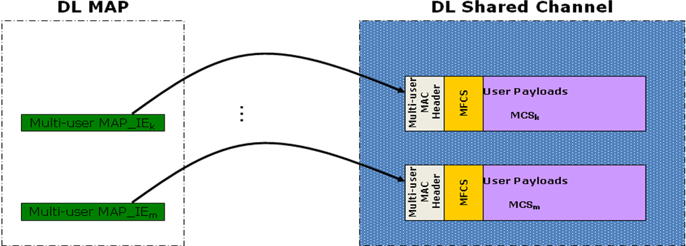
Figure 2: The multi-user resource allocation in the downlink

By reducing the size of the compact CID, the number of unique transport connections are also reduced which could be a drawback. To mitigate this drawback, the set of compact CIDs are chosen according to certain provisions. In IEEE 802.16e-2005 standard, the notion of Reduced CID (RCID) was introduced where the RCID is the LSB portion of the set of CIDs that have been currently assigned to the MS and are in use. The same concept can be used to overcome the limitation of the number of unique CCIDs that can be simultaneously assigned to the user traffic. The BS can assign the CIDs to the user transport connections in the serving sector according to a certain mapping. When the users are grouped prior to formation of a multi-user packet at each time instance, their full CIDs can be truncated and only the m bit LSB portion of the CID can be maintained (see Figure 4).

As shown in Figure 4, the compact CCID is the LSB of the CID that is split into User-ID and User-Connection-ID. Therefore, for all connections corresponding to user_{i}, the User-ID is the same and only User-Connection-IDs need to be communicated.

The structure of the new MAC header is illustrated in Figure 3. As shown in the figure, the multi-user MAC header consists of M Packet Information Fields followed by an optional delimiter to identify the size of the multi-user MAC header. Since the size of the Packet Information Fields are fixed; i.e., (n+m+2) bits, a delimiter may not be necessary, if the number of users per multi-user packet is a constant.

Each Packet Information Field (PIF) contains (n+m+2) bits and includes the following fields; m bits for CCID, n bits for Packet Length, 1 bit for encryption control field, and 1 bit for CRC (corresponding to each user payload) indicator. The encryption control bit if set to 1 indicates that the user payload is encrypted; otherwise, user payload is not encrypted. The CRC indicator bit if set to 1 indicates that the user payload is followed by CRC. The size of the CRC can be specified in the standard or during system configuration. The above PIF fields are protected using a k-bit CRC as shown in Figure 3. A value of k=4 is recommended; however, other values may also be used as long as the total length of the PIF does exceed two bytes to ensure efficiency of the multi-user header. Information on CRC-4 can be obtained in the appendix. The structure of the PIF is similar to the single-user MAC header that was previously proposed by the authors.

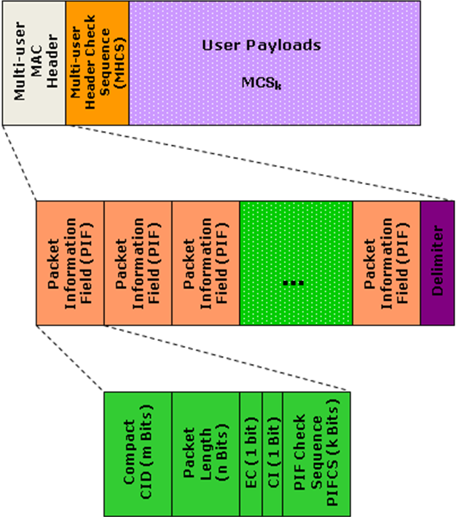

Figure 3: Structure of the multi-user MAC header

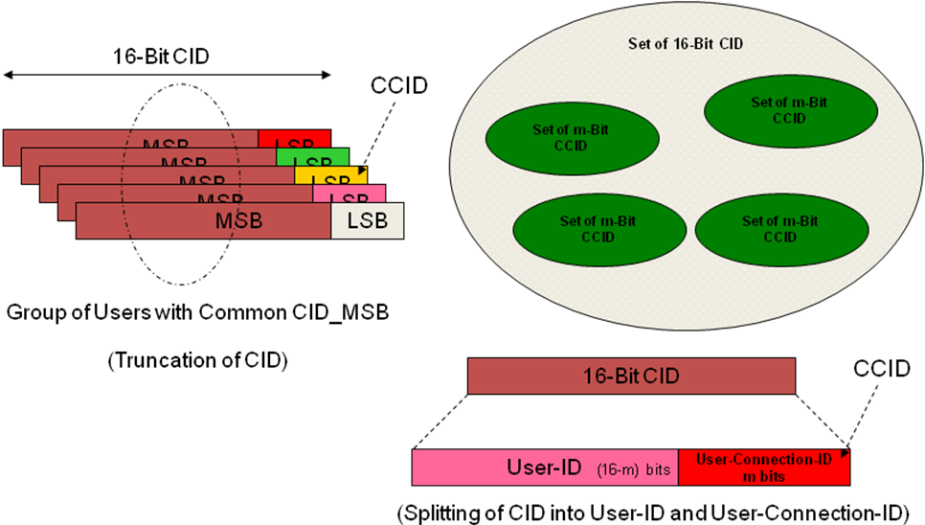
Figure 4: CCID selection from the set of 2¹⁶ possible codes

The number of user payloads per multi-user packet (M) is determined based on some pre-determined link-level criteria considering the type of MCS used for the group of users and the target PER as well as operating conditions of the network.

Since the larger the multi-user packet, the higher the probability of error, it is imperative to limit M to a value that corresponds to an acceptable probability of error (P_{e}) for the multi-user packet decoding (e.g., PER=1%).

A statistical analysis (based on available traffic models) of the VoIP and interactive gaming payloads suggest that the average length of each VoIP user packet (in octets) is less than 40 (e.g., 7 to 33 octets for 3GPP AMR voice codec) and for interactive gaming is less than 64. Therefore, the length field (n) can be a small as 6 bits. The size of the length field (n) is set to 6. In the event that the number of octets in the user payload is greater than 2^{n}, additional (contiguous or non-contiguous) payloads can be assigned to the same user to accommodate the large size of the payload. In this case, multiple CCIDs or the same CCID may be assigned to the same user’s packets to enable distinction of the payloads.

The entire multi-user header can be further protected by a multi-user header check sequence (MHCS) as shown in Figure 3. The size of MHCS and the type of protection can be specified in the standard specification. A value of two bytes for MHCS length is recommended (i.e., 16-bit CRC).

It can be seen that the original 10 octet overhead corresponding to GMH and CRC for each user packet is reduced to 2 ¼ octets (i.e., 2 octet for the Packet Information Field and 2 octets for an overall MHCS that is used to protect the multi-user header for M=8 user, which is approximately 75% overhead reduction that further translates into increased capacity (e.g., VoIP capacity) and lower latency. The reduction in the latency comes from the fact that instead of sequentially scheduling M user packets, M user packets are scheduled and transmitted simultaneously.

The mobile stations detect the multi-user MAP_IEs (or equivalently multi-user control elements) and understand that there could be a downlink packet for them in the multi-user packet addressed by the multi-user MAP_IE. Depending on the channel condition or the requested MCS by the mobile station, the mobile station may ignore certain multi-user MAP_IEs that correspond to MCSs that are not usable by the mobile station. This would decrease the amount of processing that a mobile station should perform in order to detect data packets belonging to the user associated with that mobile station.

The Packet Information Field in the multi-user MAC header shall not be encrypted.

The optional delimiter field may consist of j bits and shall be a unique j-bit sequence. The value of j shall be small to lower the overhead. Based on an earlier statement, usually no delimiter is necessary, if a fixed number of user payloads are packed in a multi-user packet.

It must be noted that M Packet Information Fields (i.e., 2M octets) followed by an optional delimiter precede M user packets as shown in Figure 3.

Once the CCID corresponding to user_{i} has been detected by user_{i}, the location of the payload corresponding to this user can be easily calculated and the data be extracted. Since the Packet Information Fields are not encrypted and the length of each user packet is known, the users can calculate the location of their corresponding packets.

The power consumption (due to DL control channel examination in each radio frame) can be reduced in VoIP application by using discontinuous transmission (DTX) mechanism and statistical characteristics of speech signals (i.e., in silence intervals, the user does not expect any DL transmission). Consequently, frequent examination of the DL control channel may be not necessary.

The multi-user packets do not limit the link-adaptation or data-rate adaptation in the downlink since the users are adaptively grouped based on their channel quality reports, requested data rate, or other link-level or system-level parameters. Therefore, the multi-user scheduling and resource allocation scheme can be adapted to the varying radio channel conditions of the users in the serving sector.

HARQ Operation with Multi-user Packets
It must be understood that the multi-user packet reception by the users in a specific multi-user group varies. That means, one user may correctly receive the multi-user packet, check the CRC, and correctly decode its own packet whereas another user in the same group may not be able to correctly receive the packet and therefore may require retransmission, if ARQ or HARQ retransmissions are permitted.

The incorrectly received packets within a multi-user packet may be retransmitted, if ARQ or HARQ retransmissions are allowed, within another multi-user packet or a single-user packet.

It must be understood that the HARQ operation, if enabled, neither interferes nor impacts the performance of the multi-user packets since the reception of the multi-user packets by each user is usually different and is dependent on the varying channel conditions experienced by that user. For further clarity, example Chase Combing and Incremental Redundancy HARQ operation modes are illustrated in Figures 5 and 6.
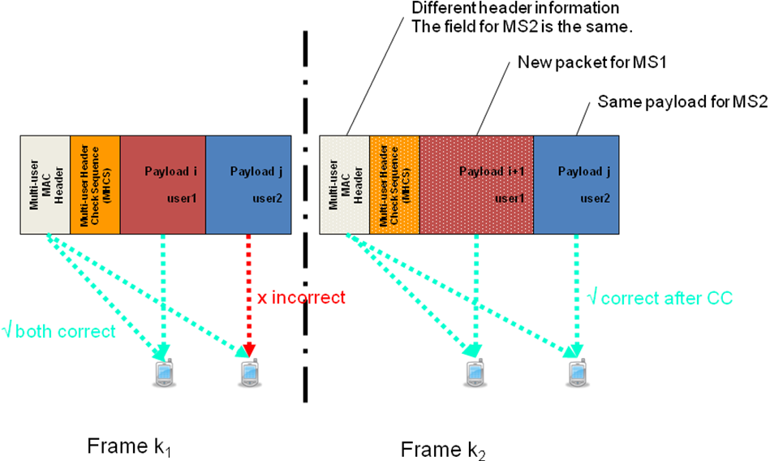
Figure 5: HARQ operation with multi-user packets – Chase Combining
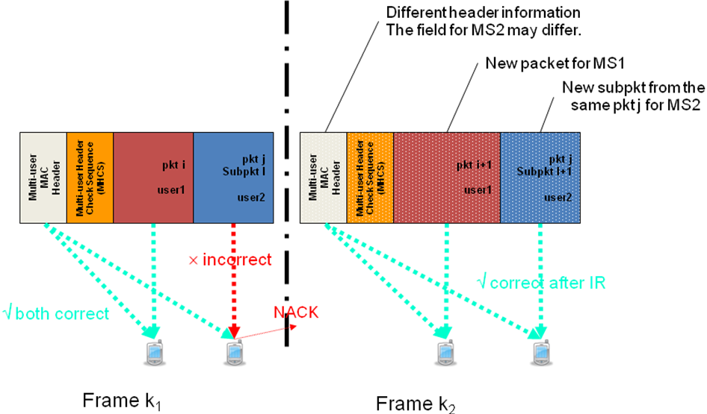
Figure 6: HARQ operation with multi-user packets – Incremental Redundancy. Note: if the header is incorrect for user2 at frame k₁, user2 does not send any HARQ feedback. The BS shall perform fresh transmission for user2 in frame k₂.

Multi-User Resource Allocation: Operation
The detection and decoding of a multi-user packet includes the following procedures:

- The CRC must be calculated based on the multi-user header and compared to MHCS.
- If MHCS check is successful, the user must check if CCID matches its own pre-assigned connections IDs.
- If MHCS check fails, no NACK shall be transmitted. Note that BS only schedules ACK/NACK uplink transmission for the users with downlink traffic in the multi-user packet.
- If user’s CCID is detected, the user payload is extracted and checked for errors.

  - If no error is detected, send ACK to acknowledge successful transmission.
  - If error is detected, send NACK to request for retransmission.

    - If HARQ Incremental Redundancy (IR) is used, the BS will transmit additional redundancy in the following single-user or multi-user packet for this user.
    - If HARQ Chase Combining (CC) is used, the BS will retransmit the same payload in the following single-user or multi-user packet for this user.

- During HARQ process, if the user fails to detect the multi-user packet, it shall wait for the next successful retransmission (additional delay for HARQ combining process)
- The user combines the packets that it has received via multi-user packet and attempts detection until successful or maximum number of retransmissions is reached.
- Note that users shall successfully detect multi-user packet and extract their own packet (if any) before being able to decode their own packets.

Analysis of Multi-user Resource Allocation Benefits
The multi-user resource allocation facilitates efficient utilization of the available resources. In order to illustrate the benefit of this scheme, we compare the packing efficiency of scheduling multiple users with single user MAC PDUs and multi-user MAC PDUs.

As shown in Table 1, a typical size of a single user 802.16m MAC PDU with a VoIP payload from an AMR speech codec operating at full rate is 40 bytes.

Table 1: Size of Single User MAC PDU for VoIP
Field | Size (bytes)
VoIP Payload (AMR 12.2Kbps) | 33
Compressed RTP/UDP/IP header | 3
802.16m MAC Header | 2
HARQ CRC | 2
Total single user MAC PDU size | 40

We define the packing efficiency as the ratio of the number Physical Resource Units (PRUs) needed to the number of PRUs used expressed as a percentage.

Using the definition of the 802.16m PHY structure on the downlink as outlined in the SDD, we compute the packing efficiency for a single user VoIP MAC PDU when various modulation and coding schemes (MCS) are used for transmission. By way of example in Table 2, we consider the MCSs defined in 802.16e for the downlink with adaptive MIMO switching between Matrix A (STBC) and Matrix B (SM) using a 2x2 antenna configuration.

Number of subcarriers per 802.16m DL PRU = (18*6) = 108
Number of pilot subcarriers (2 streams) per 802.16m DL PRU = 2*6 = 12
Number of data subcarriers per 802.16m DL PRU = 96

Table 2: Packing Efficiency for a Single User MAC PDU
MCS | No of slots with 40 byte packet =  ceil(bits per packet/bits per PRU) | Packing efficiency (%)
QPSK (1/2) STBC | ceil(320/96) = ceil(3.33) = 4 | 83.25
QPSK (3/4) STBC | ceil(320/144) =ceil(2.22) = 3 | 74
16 QAM(1/2) STBC | ceil(320/192) = ceil(1.67) = 2 | 83.5
16 QAM(3/4) STBC | ceil(320/288) = ceil(1.11) = 2 | 55.55
64 QAM(1/2) STBC | ceil(320/288) = ceil(1.11) = 2 | 55.55
64 QAM(2/3) STBC | ceil(320/384) = ceil(0.833) = 1 | 83.3
64 QAM(3/4) STBC | ceil(320/432) = ceil(0.741) = 1 | 74.1
64 QAM(5/6) STBC | ceil(320/480) = ceil(0.667) = 1 | 66.7
QPSK(1/2) SM | ceil(320/192) = ceil(1.67) = 2 | 83.5
QPSK (3/4) SM | ceil(320/288) = ceil(1.11) = 2 | 55.55
16QAM(1/2) SM | ceil(320/384) = ceil(0.833) = 1 | 83.3
16QAM(3/4) SM | ceil(320/576) = ceil(0.5556) = 1 | 55.56
64QAM(1/2) SM | ceil(320/576) = ceil(0.5556) = 1 | 55.56
64QAM(2/3) SM | ceil(320/768) = ceil(0.417) = 1 | 41.7
64QAM(3/4) SM | ceil(320/864) = ceil(0.3704) = 1 | 37.04
64QAM(5/6) SM | ceil(320/960) = ceil(0.333) = 1 | 33.3
Now consider the multiuser MAC PDU defined in this contribution. For a multiuser MAC PDU with VoIP payloads from M users,the size of the multi-user MAC PDU can be computed as shown in Table 3.
Table 3: Size of Multi-user MAC PDU for VoIP
Field | Size (bytes)
Packet Information Field | 2 bytes
Multi-user Header Checksum | 2 bytes
Delimiter | 0.25 bytes
VoIP Payload (AMR 12.2Kbps) | 33 bytes
Compressed RTP/UDP/IP header | 3 bytes
HARQ CRC | 2 bytes
Total multi-user MAC PDU size | 2*M + 2+ 0.25+ M*(33+3+2)

As can be seen from the example in Table 4, the packing efficiency for the multi-user MAC PDU typically increases as the number of users packed increases. In comparison with the packing efficiency for single user MAC PDUs in Table 2, the packing efficiency multi-user MAC PDUs in Table 4 can be seen to provide more efficient use of the available resource, thereby improving system capacity.

For any given MCS, the maximum number of users that may be packed in a multi-user MAC PDU can be determined from link level simulations parameterized by the desired target PER and user mobility (channel model).
Table 4: Packing Efficiency for a Multi-user MAC PDU

MCS | Packing Efficiency with 3 VoIP payloads  (%) | Packing Efficiency with 4 VoIP payloads  (%) | Packing Efficiency with 5 VoIP payloads  (%)
QPSK (1/2) STBC | 92.6136 | 96.5774 | 99.1422
QPSK (3/4) STBC | 97.0238 | 90.1389 | 93.6343
16 QAM(1/2) STBC | 84.8958 | 96.5774 | 93.6343
16 QAM(3/4) STBC | 84.8958 | 90.1389 | 93.6343
64 QAM(1/2) STBC | 84.8958 | 90.1389 | 93.6343
64 QAM(2/3) STBC | 84.8958 | 84.5052 | 84.2708
64 QAM(3/4) STBC | 75.4630 | 75.1157 | 93.6343
64 QAM(5/6) STBC | 67.9167 | 90.1389 | 84.2708
QPSK(1/2) SM | 84.8958 | 96.5774 | 93.6343
QPSK (3/4) SM | 84.8958 | 90.1389 | 93.6343
16QAM(1/2) SM | 84.8958 | 84.5052 | 84.2708
16QAM(3/4) SM | 84.8958 | 75.1157 | 93.6343
64QAM(1/2) SM | 84.8958 | 75.1157 | 93.6343
64QAM(2/3) SM | 63.6719 | 84.5052 | 70.2257
64QAM(3/4) SM | 56.5972 | 75.1157 | 93.6343
64QAM(5/6) SM | 50.9375 | 67.6042 | 84.2708

Summary
We present a multi-user resource allocation method comprising grouping users in a cellular network according to their channel condition reports and simultaneous scheduling and downlink transmission of the user payloads within a multi-user group via a multi-user packet.

The immediate advantage of this concept is to reduce the MAC header overhead for small-packet applications such as VoIP and interactive gaming. It is shown that the overhead can be reduced by a factor of 75% or more, depending on the system configuration. This directly translates into higher application capacity and lower end-to-end latency for delay sensitive applications without significantly increasing the complexity of the air-interface.

Proposed Text for SDD

Insert the following text into Section 10.x in [1]:
------------------------------- Text Start ---------------------------------------------------

10.x Multi-user MAC Header and Multi-user Packets

Insert the contents of section 2, 3, and 4 of this contribution here.

------------------------------- Text End ---------------------------------------------------

References

[1] IEEE C802.16m-08/003r4, “The Draft IEEE 802.16m System Description Document.”

Appendix: Background on CRC-4
CRC-4 (Cyclic Redundancy Check 4) is a form of cyclic redundancy checking (a method of checking for errors in transmitted data) that is used on E-1 trunk lines. In E-1, CRC-4 is structured in a multi-frame consisting of 16 frames numbered 0 to 15.

The CRC-4 multi-frame is then divided into two eight frame Sub-Multi-frames (SMF) called SMF I and SMF II. Each SMF contains four CRC-4 bits designated C1, C2, C3, and C4. Through multiplication and division processes, the CRC-4 bits sent in each SMF are compared to each other and if they match, the frame is considered error free. Bit 1 is used for the CRC-4 bits. CRC-4 support is required for all network switches in Europe. However, some older switches including private branch exchanges (PBXs) do not support CRC-4.

Generation of CRC-4 is performed either per ITU-T Recommendation G.704 (Generator polynomial x⁴ + x + 1) or based on CRC-4 Generator polynomial x⁴+x³+x²+x+1.

