Project | IEEE 802.16 Broadband Wireless Access Working Group <http://ieee802.org/16>
Title | Cognition zone to support coexistence among IEEE 802.16m and other RATs
Date Submitted | 2008-9-5
Source(s) | Feng YANG, Jigang QIU, Binyang XU, Hongwei YANG  Alcatel Shanghai Bell Co., Ltd. | Voice: + 86-21-50554550; Fax:+ 86-21-50554554  mail to: Hongwei.Yang@alcatel-sbell.com.cn
Re: | IEEE 802.16m-08/033 Call for Contributions and Comments on Project 802.16m System Description Document (SDD)  Contribution on topic: Multi-Radio Coexistence
Abstract | This contribution proposes to support coexistence among IEEE 802.16m and other RATs, which enables the coexistence of 802.16m with other RATs and improves the spectrum usage efficiency.
Purpose | To be discussed and adopted by TGm for use in the IEEE 802.16m SDD
Notice | This document does not represent the agreed views of the IEEE 802.16 Working Group or any of its subgroups. It represents only the views of the participants listed in the “Source(s)” field above. It is offered as a basis for discussion. It is not binding on the contributor(s), who reserve(s) the right to add, amend or withdraw material contained herein.
Release | The contributor grants a free, irrevocable license to the IEEE to incorporate material contained in this contribution, and any modifications thereof, in the creation of an IEEE Standards publication; to copyright in the IEEE’s name any IEEE Standards publication even though it may include portions of this contribution; and at the IEEE’s sole discretion to permit others to reproduce in whole or in part the resulting IEEE Standards publication. The contributor also acknowledges and accepts that this contribution may be made public by IEEE 802.16.
Patent Policy | The contributor is familiar with the IEEE-SA Patent Policy and Procedures:  <http://standards.ieee.org/guides/bylaws/sect6-7.html#6> and <http://standards.ieee.org/guides/opman/sect6.html#6.3>.  Further information is located at <http://standards.ieee.org/board/pat/pat-material.html> and <http://standards.ieee.org/board/pat>.

Cognition zone to support coexistence among IEEE 802.16m and other RATs
Feng YANG, Jigang QIU, Binyang XU, Hongwei YANG
Alcatel Shanghai Bell Co., Ltd.

1. Introduction

In IEEE 802.16m system requirement document (SRD), it is explicitly mentioned that 802.16m system shall be deployed in the same or overlapping geographic areas with other wireless networks based on different RATs (radio access technologies). The co-deployed networks may or may not have the same topology. Depending on the bands where IEEE 802.16m is expected to be deployed, different coexistence requirements should be envisaged.
- IEEE 802.16m and non 802.16m systems may be deployed in the same licensed band. Adjacent channels may be used for deployment of 802.16m and non-802.16m systems.
- IEEE 802.16m may be deployed in a licensed band adjacent to an unlicensed band in which non 802.16m systems are deployed. Hence additional coexistence mechanisms may be required to reduce interference.
- IEEE 802.16m may be required to share bands:
  - on a co-channel basis with other 802.16m systems
  - on a co-channel basis with non 802.16m systems, where 802.16m is either a primary or non-primary systems
  - on a non co-channel basis with non 802.16m systems, where 802.16m is either a primary or non-primary systems

2. Cognition zone to support coexistence among IEEE 802.16m and other RATs

To enable coexistence of IEEE 802.16m with other RATs, we propose to add a cognition zone in the 801.16m frame structure to facilitate the coexistence. In the cognition zone, a special designed beacon is thrown. In the beacon, coexistence related information is carried, which can be utilized for different coexistence scenarios. The beacon can be utilized to discover the coexisting systems, synchronize with the coexisting systems, communicate with the coexisting systems, cooperate with the coexisting systems, optimize the spectrum usage, etc. The beacon can be designed to be easily detected by other systems. To facilitate the coexistence among systems with different PHY profiles, the beacon profile can be designed to be generic and other new coexisting RATs can also adopt the beacon profile. This enables the smooth communication between 802.16m and other RATs. The special designed beacon can be applied under different coexistence scenarios. 802.16m can be deployed as primary systems or non-primary systems. When 802.16m is primary system, the cognition zone in frame structure is optional. However, if a cognition zone is added, the beacon carries least info to indicate its presence, which facilitates secondary systems to discover the presence of 802.16m. This would reduce the sensing complexity of secondary systems and improve the sensing reliability. Then, 802.16m as primary system can be better protected. When 802.16m is deployed as a secondary system, it can synchronize/communicate/cooperate with other secondary systems efficiently. By throwing a coexistence beacon in the newly added cognition zone, 802.16m can be deployed with other wireless networks by different RATs.

In Fig. 1, we demonstrate the cognition zone in 802.16m frame. In 802.16m, four frames form a superframe and the superframe begins with preamble and a superframe control header (SCH). In the SCH, some basic system information is contained. Then, frame control header (FCH) and MAP info are included in each frame. At the end of the fourth frame in 802.16m superframe, a cognition zone is added to enable coexistence. The length of cognition zone is defined in MAP. In the cognition zone, a special designed beacon is thrown with a random starting point and leaves the other space in the cognition zone blank. This can avoid the beacon collisions with other secondary systems when 802.16m is deployed as secondary system. The beacon is consists of preamble, which is used to help coexisting system to capture the beacon, and beacon MAC PDU, which is used to contain the coexistence related information. By exchanging the coexistence information, 802.16m can coexist with other networks efficiently. The beacon waveform is specially designed, which is easy to be detected and is easy to be implemented by other new emerging RATs.

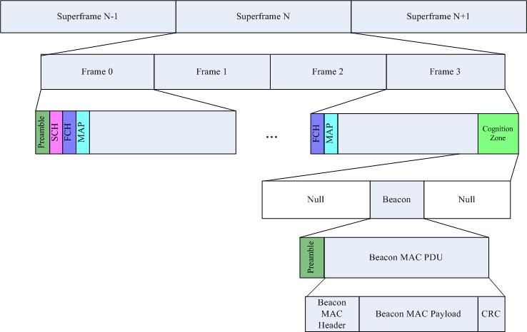
Figure 1: Frame structure of 802.16m with cognition zone

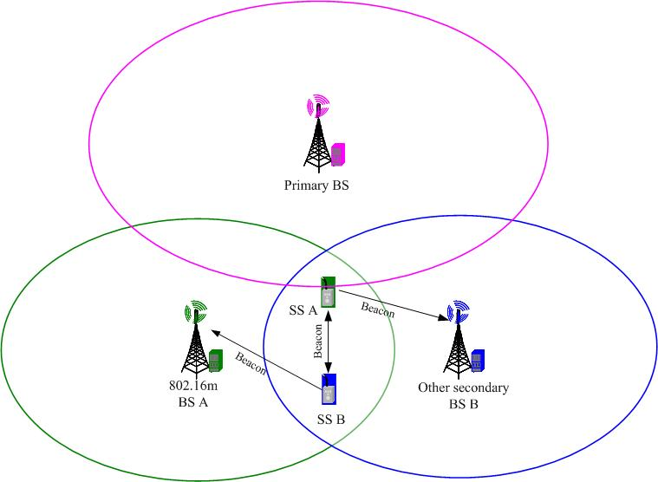
Figure 2: Beacon illustration in 802.16m

In Fig. 2, a simple example of beacon throwing mechanism is demonstrated. In this scenario, BS A belongs to 802.16m, which is a secondary system, and SS A is associated with BS A. BS B belongs to another secondary system and SS B is served by BS B. Both networks coexist with a primary system. Here, the other secondary system can be other 802.16m network or other networks based on new emerging RATs, which also support cognition zone as 802.16m. Thus, it enables the inter-communication between 802.16m and other secondary systems. In the cognition zone, the serving BS A will guide some SSs, which are located in the overlapping area, to throw beacons to indicate its presence. Also, BS A and SSs associated with BS A scan the beacons from other secondary SSs. If any SS receives a beacon, it reports to BS A by its uplink traffic. Based on the collected beacon information, BS A can cooperate with other secondary systems efficiently.

Next, we briefly show how beacon works in 802.16m in initialization phase and operating phase. During the initialization phase of 802.16m, BS A shall monitor the channel to capture the beacon thrown by other secondary SSs. If no beacon is captured, it implies that this particular channel is not used by other secondary systems and BS A can operate in this channel to provide service. If a beacon is received, it indicates that other secondary systems are occupying the channel. Then BS A shall avoid using this channel. During the operating phase, BS A and SS A shall obtain the synchronization info from other secondary systems and monitor the channel periodically. If SS A receives the beacon from other secondary SS B, it conveys the received beacon to its associated BS A. BS A will also scan for beacons. Based on the beacon info, BS A can make the scheduling decision to avoid the interference with other secondary systems or throw beacons in its own cognition zone to negotiate with the coexisting secondary systems to share the channel peacefully.

To support coexistence, the beacon IE shall be properly defined. In Table 1, we briefly define some beacon IEs as an example. According to different coexistence scenario, the beacon IEs are variable.
Table 1: Beacon IEs
Syntax | Size | Notes
Coexistence mode | 2 bits | Indicate current coexistence scenario  0: 802.16m as primary system in licensed band  1: 802.16m as secondary system in licensed band  2: 802.16m as secondary system in unlicensed band  3: Reserved
System type | 4 bits | Indicate current system type:  0: 802.16m  1-15: Reserved
Operator ID | 4 bits | Identify the operator
BS ID |  | Identify the BS
BS IP address |  | Indicate the BS IP address
Channel bandwidth |  | Indicate the occupied channel bandwidth
Time stamp of frame header |  | Indicate the time stamp of frame header of 802.16m
Duration of cognition zone |  | Indicate the duration of cognition zone
Channel contention IEs |  | Enable channel contention among 802.16m and other secondary systems
Channel renting/offering IEs |  | Enable channel renting/offering among 802.16m and other secondary systems
Resource allocation IEs |  | Enable resource negotiation among 802.16m and other secondary systems
Reserved IEs

The usage of cognition zone in 802.16m can be flexible. Next, we demonstrate different functionalities of cognition zone under different conditions.
- 802.16m system as primary system
When 802.16m system is primary system, they have the privilege to access the channel anytime they want. However, 802.16m system does not occupy the channel all the time at any locations. If some other secondary systems want to use the vacant channels of 802.16m, they have to sense the availability of the channel periodically to protect 802.16m system. In existing situation, primary systems cannot be modified. It makes secondary systems difficult to sense the primary systems. To tackle this problem, 802.16m can throw a beacon in cognition zone to indicate its occupation of channels. It reduces the sensing complexity of secondary systems because the beacon is designed to be easily detected. From another point of view, 802.16m system helps secondary systems to increase the sensing reliability, which better protects its own usage and avoids harmful interference from secondary systems due to the mis-detection. As 802.16m is primary system, the beacon throwing is not contention-based. Thus, the beacon can fully utilize the cognition zone as shown in Fig. 3 and no null space is reserved for avoiding collision. Because the beacon only indicates the occupation of the channels and no cooperation info is needed, the beacon conveys the least info, such as coexistence mode, system type, duration of cognition zone, etc. Then, the duration of cognition zone is very short, which reduces the system overhead of 802.16m.

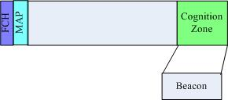
Figure 3: Cognition zone in 802.16m when it is primary system

- 802.16m system as secondary system
To meet 802.16m system requirement and IMT-advanced requirement, 802.16m shall have the capability to coexist with other RATs as a secondary system. Utilizing the beacon in cognition zone, 802.16m can achieve coexistence with other RATs (primary and other secondary systems) efficiently. Next, we show some simple examples how the beacon in the cognition zone helps the 802.16m system coexist with other RATs.
  - Synchronization: For coexisting systems, it requires the synchronization among systems. However, it is not easy to synchronize, especially when coexisting systems do not have the same PHY profile. Through the beacon in cognition zone, it facilitates other secondary system to synchronize with 802.16m. The time stamp of frame header can be included in the 802.16m beacon IEs. As the frame duration of 802.16m is 5ms, which is prior known, the coexisting secondary systems can achieve synchronization precisely with 802.16m. Here, it is assumed that the coexisting systems have the GPS. To reduce the transmission resource, the time stamp of frame header only requires starting from ms-level since the beacon can be detected by other systems immediately.
  - Cooperation: For coexisting systems, cooperation with each other is essential. Through cooperation, secondary systems can optimize the usage of vacant channel resources.
    - If secondary systems support coexistence protocol via IP, the beacon in 802.16m carriers IP address of the serving 802.16m BS. By receiving the IP address of the BS, other secondary BSs can communicate with the 802.16m BS via backbones. In this case, the overhead of inter-system communication is small.
    - For some secondary systems, cooperation shall be performed by air interface. Thus, the beacon in 802.16m shall define various suits of IEs to support different level of cooperation. For example, when 802.16m finds a vacant channel and it does not have heavy traffic at current moment, 802.16m can broadcast the unused channel, duration, etc. to other secondary systems. If other secondary systems receive this info, they can negotiate with 802.16m to borrow the unused channel. In this manner, the spectrum efficiency can be improved. Also, 802.16m can throw the occupation of spectrum usage via the beacon. When other secondary systems receive the information, these systems can optimize its own actions, such as avoiding using the occupied spectrum by 802.16m, contending the resource with 802.16m, etc. That is, channel renting/offering, channel contention, spectrum negotiation, etc., can be completed efficiently. In a word, cooperation among 802.16m and other secondary systems can be completed by the throwing beacons in cognition zone. Thus, 802.16m can achieve better coexistence with other secondary systems and increase the spectrum efficiency.

3. Text proposal
-----------------------------------------------Start of Text Proposal for SDD-------------------------------------------
[Insert the following into section 17 Solutions for Co-deployment and Co-existence]
To enable coexistence of IEEE 802.16m with other RATs, a cognition zone can be added in 802.16m frame structure. With the coexistence beacon thrown in the added cognition zone, the coexisting systems can synchronize/communicate/cooperate with each other efficiently. Then 802.16m can be efficiently co-deployed with other 802.16m network or other wireless networks with different RATs.

---------------------------------------------- End of Text Proposal for SDD---------------------------------------------

