Project | IEEE 802.16 Broadband Wireless Access Working Group <http://ieee802.org/16>
Title | New bit-rearrangement method to enhance HARQ performance
Date Submitted | 2008-09-05
Source(s) | Chien-Yu Kao, Jen-Yuan Hsu, Yu-Tao Hsieh, Pang-An Ting, Yan-Xiu Zheng, Richard Li  ITRI | E-mail: Eric_Kao@itri.org.tw  Voice: +886-3-5917539
Re: | Re: PHY: HARQ; in response to the TGm Call for Contributions and Comments 802.16m-  08/033 for Session 57
Abstract | A new bit-rearrangement rearranges transmitted coded-bits by using a bit-allocation in accordance with bit-significance and a simple circular-shift mechanism to improve the performance of HARQ system.
Purpose | Discussion and approval by the task group.
Notice | This document does not represent the agreed views of the IEEE 802.16 Working Group or any of its subgroups. It represents only the views of the participants listed in the “Source(s)” field above. It is offered as a basis for discussion. It is not binding on the contributor(s), who reserve(s) the right to add, amend or withdraw material contained herein.
Release | The contributor grants a free, irrevocable license to the IEEE to incorporate material contained in this contribution, and any modifications thereof, in the creation of an IEEE Standards publication; to copyright in the IEEE’s name any IEEE Standards publication even though it may include portions of this contribution; and at the IEEE’s sole discretion to permit others to reproduce in whole or in part the resulting IEEE Standards publication. The contributor also acknowledges and accepts that this contribution may be made public by IEEE 802.16.
Patent Policy | The contributor is familiar with the IEEE-SA Patent Policy and Procedures:  <http://standards.ieee.org/guides/bylaws/sect6-7.html#6> and <http://standards.ieee.org/guides/opman/sect6.html#6.3>.  Further information is located at <http://standards.ieee.org/board/pat/pat-material.html> and <http://standards.ieee.org/board/pat>.
New bit-rearrangement method to enhance HARQ performance

Chien-Yu Kao, Jen-Yuan Hsu, Yu-Tao Hsieh,
Pang-An Ting, Yan-Xiu Zheng, Richard Li
ITRI

1. Introduction
According to the contribution [1] proposed by ZTE, the Bit Priority Mapping (BPM) method changes the mapping order to allocate the bits into high reliable bit position of high-order modulation symbols firstly. This method can improve system performance in CTC IR-HARQ of 16e [2]. Because these different orders of (re)transmitted coded-bits selected from bit-selection can get different reliability distributions through BPM method. In other words, the reliable positions of some bits in current transmission are different from they transmitted in past transmission.
In CC-HARQ of 16e [2], using the BPM method can also improve system performance compared with reference system [2]. But the order of each transmitted coded-bits selected from bit-selection is always the same. Therefore, the reliable positions of each transmitted coded-bits are always the same. In order to get the same advantage that the different reliability distributions in IR-HARQ and keep the same content of transmitted coded-bits in CC-HARQ, a simple circular-shift mechanism is proposed to change the bit-allocation of coded-bits in CC-HARQ in accordance with the characteristics and reliable positions of coded-bits. In following sections of this contribution, we will describe this circular-shift mechanism in detail.

2. Characteristics of Coded-Bits in CTC of 16e [1]
Figure-1 shows the subblock interleaver and bit-grouping method in CTC of 16e system [2]. The coded-bits after CTC encoder are . Then the six subblocks will insert into respective subblock interleaver. After the subblock interleaver, the subblock interleaved sequences and are interlaced as and , meanwhile, the subblock interleaved sequences and are interlaced as and . Therefore, the input sequence order of bit-selection is.
We find that the bit-sequences of and must be selected to transmit in each transmission for CC-HARQ. Based on the structure of CTC, the bit-sequences of and are belong to systematic bit. Its significance is superior to the parity bit for CTC decoder. So, we call the systematic bit as significant bit and parity bit as non-significant bit. Then according to the BPM method, the bit-sequences of and will be mapped to high reliable bit position of high-order modulation symbols completely if the length of the bit-sequences of and is match to the length of high reliable bit position. Therefore, based on the CTC CC-HARQ of 16e [2] and the BPM method, it can make sure one thing that significant bits will be mapped to high reliable bit position of high-order modulation symbol to the utmost and non-significant bits will be mapped to low reliable bit position of high-order modulation symbol to the utmost.

Figure-1 Subblock interleaver and bit-grouping method in CTC of 16e system [2]

3. Proposed Method for Bit-Rearrangement in CC-HARQ System
According to the BPM method, the coded-bits can be classified several groups with different reliability in accordance with different QAM mapping. For example, the number of group could be two for 16QAM and three for 64QAM. As long as the number of group has been known, the length of each group can be calculated. If the length of significant bits is greater than the length of the group, some significant bits will be mapped to lower reliable positions. On the contrast, if the length of non-significant bits is greater than the length of group, some non-significant bits will be mapped to higher reliable positions. Therefore, we change the bit-allocation of these out-of-length bits in retransmission time. In other words, we use a simple circular-shift mechanism to shift the out-of-length bits into another group. Now, we take three MCS as examples to describe the circular-shift mechanism how to work.
Firstly, take 16QAM 3/4 as an example. This case is that the length of group is greater than the length of non-significant bits but smaller than the length of significant bits. Figure-2 shows the diagram of this case clearly. In the first transmission for CC-HARQ, some significant bits shown as a block with red-slash in Figure-2 will be allocated into weak group. But when the second transmission (the first retransmission) occurs, these significant bits in weak group of the first transmission need to be rearranged into strong group and some significant bits in strong group of the first transmission need to be rearranged into weak group. It is just a right-circular-shift for bit-allocation and simple to implement. Therefore, in following (re)transmission, it shifts out-of-length bits in previous (re)transmission to form current (re)transmission.

Figure-2 Example of circular-shift mechanism for 16QAM, rate=3/4
Secondly, take 64QAM 1/2 as an example. This case is that the length of group is smaller than the length of non-significant bits and significant bits. Figure-3 shows the diagram of this case clearly. In the first transmission, some significant bits shown as a block with red-slash will be allocated into middle group and some non-significant bits shown as a block with blue-slash will be allocated into middle group. But when the second transmission occurs, these significant bits in middle group of the first transmission need to be rearranged into strong group and some significant bits in strong group of the first transmission need to be rearranged into middle group. Then these non-significant bits in middle group of the first transmission also need to be rearranged into weak group and some non-significant bits in weak group of the first transmission need to be rearranged into middle group.

Figure-3 Example of circular-shift mechanism for 64QAM, rate=1/2

Thirdly, take 16QAM 1/2 as an example. This case is a special case because the length of group is equal to the length of significant bits and non-significant bits. Therefore, no out-of-length bits occur in significant bits and non-significant bits. The circular-shift mechanism doesn’t work in this case. But only using the BPM method also can get performance gain in this case. Figure-4 shows this special case clearly.

Figure-4 Example of circular-shift mechanism for 16QAM, rate=1/2

Other cases are shown in appendix. Figure-5 shows the proposed block diagram and detail operation for each block. Besides, Table-1 describes the parameters of Bit Circular-Shift block clearly.
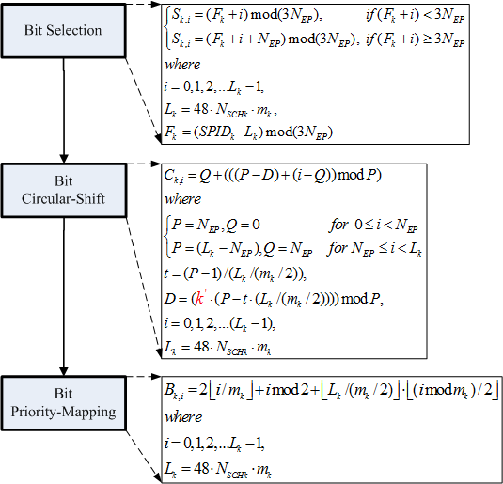
Figure-5 The block diagram and detail operation for the proposed method
in Bit Circular-Shift block represents that the shifting length is equal to times the length of out-of-length bits. The initial value of is “0”. In CC-HARQ system, this value increases by one if the AI_SN of one AC_ID is not change. Once the AI_SN of one AC_ID is change, the value initializes as “0”. But in IR-HARQ system, this value could increases by one as the same as CC-HARQ or always sets as “0”. Besides, in IR-HARQ system, prior selecting parity bits after all coded bits in a circular buffer are selected by once could also bring additional performance improvement in the bit selection block. Modified selection mechanism is described in the Figure-5.
Table-1 Parameters for the proposed method
be the subpacket index when IR HARQ is enabled. k = 0 for the first transmission and increases by one for the next subpacket. k = 0 when IR HARQ is not used. When there are more than one FEC block in a burst, the subpacket index for each FEC block shall be the same.
be the number of bits in the encoder packet (before encoding).
be the number of the concatenated slots for the subpacket defined in Table 522 of [2] for the non-HARQ and Chase HARQ CTC scheme defined in 8.4.9.2.3.1 of [2] and be the same as the Nsch that is indicated in the Allocation IE for the HARQ CTC scheme defined in 8.4.9.2.3.5 of [2].
be the modulation order for the k-th subpacket (mk = 2 for QPSK, 4 for 16-QAM, and 6 for 64-QAM).
be the subpacket ID for the k-th subpacket, (for the first subpacket, SPIDk=0 = 0).

4. Reliability Distributions of Out-Of-Length Bits
We illustrate the Figure-6 to show the comparison of reliability distribution between the BPM method and proposed method for CC-HARQ. In Figure-6, the red rectangle represents the bits are belong to higher reliable position, on the contrast, the blue rectangle represents the bits are belong to lower reliable position. In the left side of Figure-6, based on the BPM method, these out-of-length bits are always allocated into the same reliable positions in each transmission. But in the right side of Figure-6, based on proposed method, these out-of-length bits will be shifted to different reliable positions in each transmission.

Figure-6 Comparison of reliability distributions between BPM and proposed method for CC-HARQ

5. Simulation Results
In this contribution, different simulation results for CC-HARQ are present. The simulation results for IR-HARQ are shown in [1]. In following simulations, we compare the BER performances of proposed method with BPM method and conventional method. The simulation parameters are set as in Table-2.
Table-2 Simulation Setting
Carrier Frequency | 2.5GHz
FFT Size (N) | 1024
Guard Interval | 1/8
MS Velocity | VA 0 km/hr
Channel Coding | CTCs
N_{EP} | 16QAM 1/2 : 480 bits  64QAM 1/2 : 432 bits
HARQ Type | Chase Combining (CC)
Transmission Times | 1TX, 2TX
Retransmission Delay | 2 frames

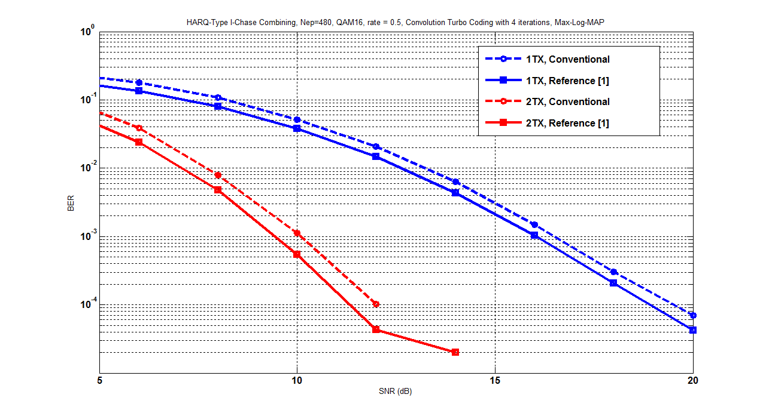
Figure-7 Simulation results for CC-HARQ, 16QAM, rate=1/2
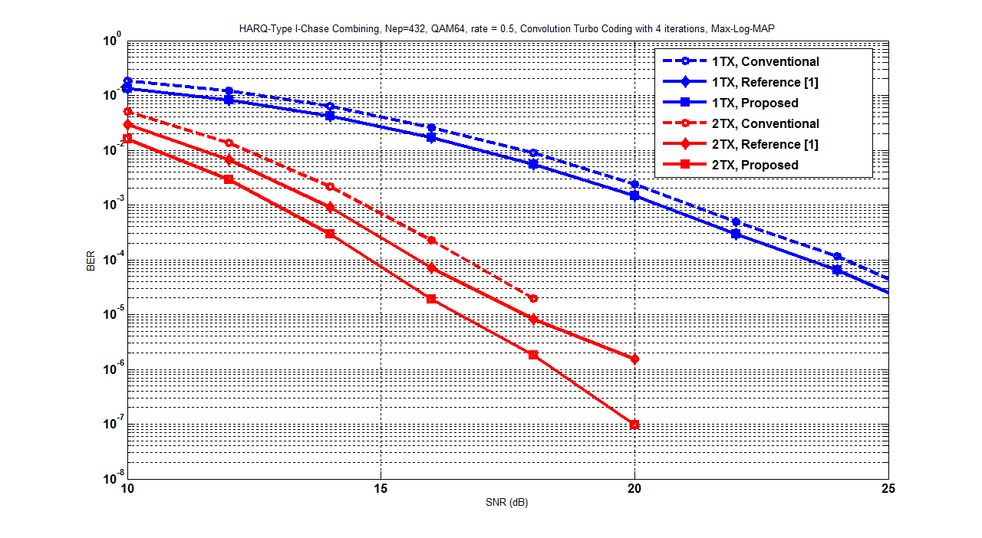
Figure-8 Simulation results for CC-HARQ, 64QAM, rate=1/2

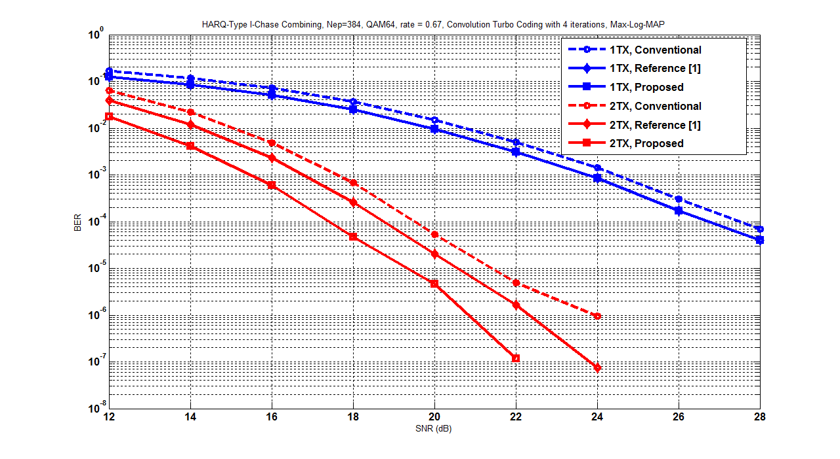
Figure-9 Simulation results for CC-HARQ, 64QAM, rate=2/3

6. Proposed SDD Text
============== Start of proposed texts =================================================
[Chapter] 11 Physical Layer
………
[Section] 11.x.1 Channel coding and HARQ
………
[subsection] 11.x.1.2 HARQ

11.x.1.2.2 Constellation re-arrangement

Co-Re shall be supported to improve the performance of retransmissions.
Allocating the beginning coded-bits into high reliable bit position of high-order modulation symbols and using a circular shift mechanism to rearrange transmitted bits in accordance with bit-significance and reliability of high-order-modulation can balance the bit-reliability during retransmissions. The following Figure-XXX shows the block diagram.
Figure-XXX The block diagram for bit-rearrangement.

============== End of proposed texts ================================================

7. Reference

[1] IEEE C802.16m-08/685r2, Bit Priority Mapping to enhance CTC IR HARQ performance

[2] IEEE 802.16e_Rev2_D5, “Part 16: Air interface for fixed broadband wireless access systems,” June, 2008.

8. Appendix

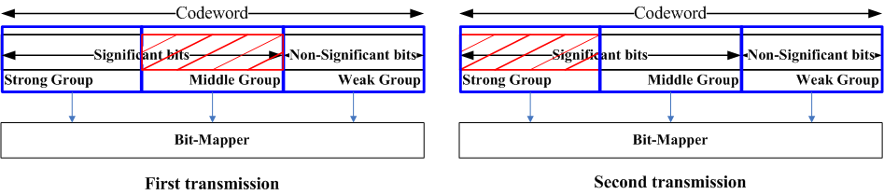
Figure-10 Example of circular-shift mechanism for 64QAM, rate=2/3

Figure-11 Example of circular-shift mechanism for 64QAM, rate=3/4

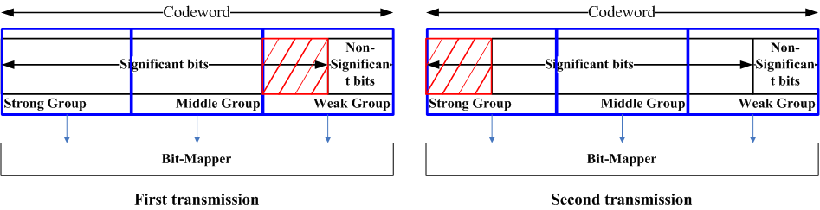
Figure-12 Example of circular-shift mechanism for 64QAM, rate=5/6

