Project | IEEE 802.16 Broadband Wireless Access Working Group <http://ieee802.org/16>
Title | Power Efficient Burst Data QoS Mode
Date Submitted | 2008-09-17
Source(s) | Hung Yu-Wei, Chin-Chun Chou  Department of Electrical Engineering, National Taiwan University  No. 1, Sec. 4, Roosevelt Road, Taipei, 10617 Taiwan(R.O.C)  Chun-Yen Wang,  Richard Li,  ITRI | Voice: [Telephone Number (optional)]]  E-mail: hywei@cc.ee.ntu.edu.tw  ChunYen@itri.org.tw  richard929@itri.org.tw
Re: | MAC: Data Plane; in response to the TGm Call for Contributions and Comments 802.16m-08/033 for Session 57
Abstract | This contribution proposed the burst transmission mode for QoS enhancement and power saving.
Purpose | To be discussed and adopted by TGm for use in the IEEE 802.16m SDD
Notice | This document does not represent the agreed views of the IEEE 802.16 Working Group or any of its subgroups. It represents only the views of the participants listed in the “Source(s)” field above. It is offered as a basis for discussion. It is not binding on the contributor(s), who reserve(s) the right to add, amend or withdraw material contained herein.
Release | The contributor grants a free, irrevocable license to the IEEE to incorporate material contained in this contribution, and any modifications thereof, in the creation of an IEEE Standards publication; to copyright in the IEEE’s name any IEEE Standards publication even though it may include portions of this contribution; and at the IEEE’s sole discretion to permit others to reproduce in whole or in part the resulting IEEE Standards publication. The contributor also acknowledges and accepts that this contribution may be made public by IEEE 802.16.
Patent Policy | The contributor is familiar with the IEEE-SA Patent Policy and Procedures:  <http://standards.ieee.org/guides/bylaws/sect6-7.html#6> and <http://standards.ieee.org/guides/opman/sect6.html#6.3>.  Further information is located at <http://standards.ieee.org/board/pat/pat-material.html> and <http://standards.ieee.org/board/pat>.
Power Efficient Burst Data QoS Mode
Hung Yu-Wei, and Ching-Chun Chou
Department of Electrical Engineering, National Taiwan University
Chun-Yen Wang, and Richard Li
ITRI

Introduction
This contribution focuses on providing a new class of QoS service in the 802.16m system. The proposed “burst QoS mode” is to transmit a large chunk of data traffic to the MS in a short period of time when channel condition is good. In addition, the MS could enter power saving operation after the burst data transmission. This QoS class designed to applications with moderate delay tolerance (e.g. file download, email, advertisement, etc).

Burst transmission versus non-burst transmission
For better channel efficiency, opportunistic data transmission should be scheduled under excellent channel condition. Besides, power consumption is also an important factor on mobile communication. The burst QoS mode is designed to achieve both high spectral efficiency and power efficiency. The central idea is to transmit the data traffic under excellent channel condition, and the MSs should enter sleep mode in non-transmitting time.
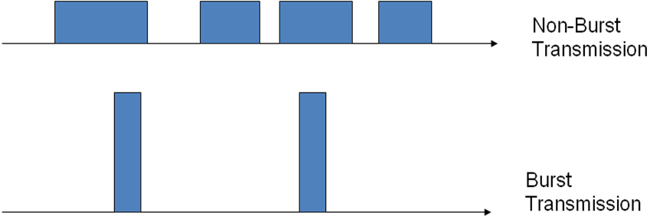
Figure 1: burst transmission v.s. non-burst transmission

Burst Data QoS Mode Operation
Channel-aware opportunistic transmission dynamically adjusts MCS (Modulation and Coding Scheme) to achieve higher data rate. The BS sends pilot signal every T_monitor period, and the MS estimates the CSI based on the received pilot. If the MS detects that the CSI is better than a predefined threshold, then MS sends CSI feedback to BS, and BS transmit downlink data burst if there are available radio resources. After the data burst, the MS should go to power saving mode in the remaining T_allocation Period.
At the beginning of burst data QoS mode operation, signaling messages are required for such operation mode. The MS must be able to make the request for burst QoS mode to the BS, and the BS should be capable of responding to such request and configuring the operation details. The T_monitor, T_allocation, CSI feedback threshold, and the RRM/QoS allocation quantity are primary parameters for the burst mode. The T_monitor defines the frequency of the BS sending pilot signal, indicating the degree of importance of gathering the CSI data. The T_allocation defines the length of the maximum possible allocated channel time. The BS could transmit to the MS using the burst mode at most T_allocation time unless the CSI is under the threshold. The setting of CSI threshold would affect the efficiency of the burst QoS mode. Too large threshold value would result in few burst mode and low channel efficiency, but inadequately low threshold might cause unfair channel access and nodes in really excellent channel state might be given less radio access. The quantity of the QoS & RRM is also important as the setting might be implemented by some kind of weighting mechanism and this will determine the final throughput.

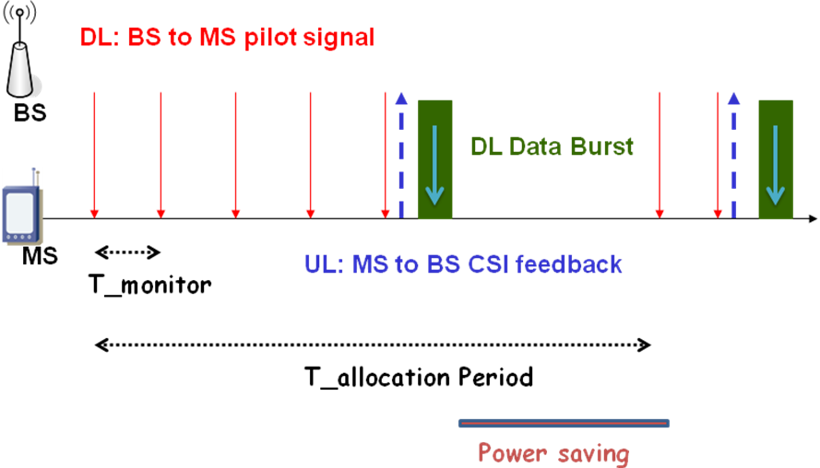
Figure 2: Power efficient burst data QoS mode operation

Design Issues
The power saving and the user throughput are the two main factors in the burst QoS mode. Two variants, “pure power saving burst mode” and “QoS guaranteed burst mode”, can be implemented to meet the respective design goals. In the pure power saving mode, the MS usually has a shorter T_duration(MS_i) value and a longer T_allocation Period value. The data burst transmission in each allocation period is not guaranteed. MS might not be allocated any data burst transmission due to its poor channel condition or heavy traffic load in the cell.
When radio resource management or Quality of Service guarantee is needed, we must provide some periodic or semi-periodic guaranteed QoS with the QoS guaranteed burst mode. The QoS guaranteed nodes should be allocated resources with higher priority. To achieve the guaranteed allocation within the possible burst transmission duration T_duration(MS_i), the Th_feedback could be dynamically adjusted. An extreme case is Th_feedback=0, so that the MS always send CSI feedback. It is also possible that the CSI threshold Th_feedback for MS with different QoS requirements and the average channel conditions.
The parameter setting for T_allocation Period and T_duration(MS_i) parameters can also be different to provide different levels of QoS services. The BS may even skip the periodic monitoring mechanism and allocate the channel for the specific high-order node unless the node reports that its CSI is under a quite low level. This kind of flexibility is appropriate for multimedia streaming.
By MS grouping, MSs could be divided into several groups. By adjusting the T_begin(MS_i) for MS in each group, the MS could be active alternatively. In a given time period, only a few MS needs to wake up to monitor and to receive data burst. The probability that an MS is scheduled to receive a data burst after sending CSI feedback is increased. The duration of operating in power saving mode is extended to achieve better power efficiency with the MS grouping. Moreover, the BS might consider give a higher scheduling priority when

System Parameters
  - T_allocation Period: transmission and allocation period. Burst QoS transmission allocation is conducted periodically with period of T_allocation Period.
  - Q_burst_allocation (MS_i): the quantity of data burst to be transmitted during T_allocation Period. MS_i enters power saving mode when Q_burst_allocation of data burst has been transmitted to MS_i.
  - [T_begin(MS_i), T_duration(MS_i)]: The starting time and the time duration parameters for the periodic data burst allocation. The possible data burst transmission could occur during time duration T_duration(MS_i). The start time offset is T_begin(MS_i). The possible data burst transmission time is T_duration(MS_i) among the allocation period T_allocation.
  - Th_feedback: Threshold for sending the CSI feedback. Usually, data burst transmission will be initiated when the wireless channel quality is greater than a threshold Th_feedback.

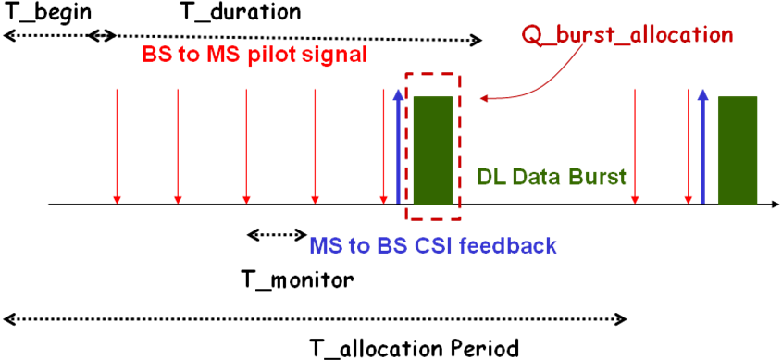
Figure 3: Illustrative example for system parameters in the burst QoS operation

Burst QoS mode with ACK/NACK
There should also be a signal format for the MS to report its CSI. After the BS receives the CSI, the transmission might start immediately. However, there should be some indication for the receiver of the DL data, as the BS might serve multiple MS groups, no indication would cause trouble for the receiving MSs.
For the robustness of the data transmission, the ACK/NACK mechanism is also needed in this case. The type of ACK/NACK might be immediate or some kind of lazy ACK/NACK. Immediate ACK/NACK means that the BS allocates the ACK/NACK channel for the burst MS right after the DL data transfer. This is to ensure the correctness of data and speed up the retransmission. Lazy ACK/NACK means that the acknowledgement could be done only when there are errors or even no ACK/NACK is transmitted. This is to reduce the latency and saves more bandwidth for data transmission. The HARQ retransmission could be like the figure above. The MS has to signal the BS for data retransmission.
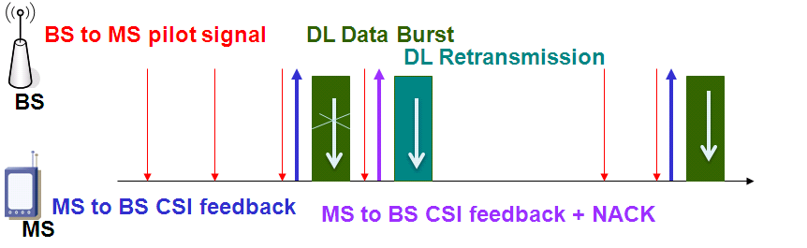
Figure 4: Burst QoS mode with NACK
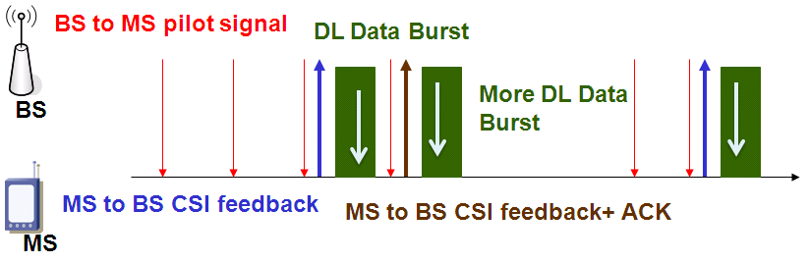
Figure 5: Burst QoS mode with ACK (and more burst data transmission)

Advantages of Burst QoS Mode
For the burst QoS mode, the MS could go to sleep in case that there is no transmission for it. With proper setting of T_monitor and T_allocation, it could save great power. The signaling cost is also reduced as the CSI feedback is selective before the data burst transmission while there is no CSI feedback needed after the data burst transmission. System throughput is also improved in this case as the transmissions are conducted only in excellent channel conditions. Besides, if we implement periodic or semi-periodic resource allocation, some degree of QoS or RRM guarantee could also be met.

Proposed Text

----------------------------------------------------Start of the Proposed Text--------------------------------------------------
10.x.x Burst Data QoS Mode
Burst Data QoS Mode is a QoS class to transmit non-real-time data traffic with moderate delay tolerance. In Burst Data QoS mode, data blocks are transmitted in high data rate during a short period of time. To achieve better power efficiency, an MS wakes up in a pre-configured time duration for possible Burst Data QoS transmission while staying in power saving mode otherwise. To achieve high-rate transmission, burst Data QoS Mode might transmit data blocks only when a minimum CSI threshold is met.
----------------------------------------------------End of the Proposed Text---------------------------------------------------

