Project | IEEE 802.16 Broadband Wireless Access Working Group <http://ieee802.org/16>
Title | Reliable Multicast Broadcast Service Protocol Design
Date Submitted | 2008-09-13
Source(s) | Hung Yu-Wei, Chin-Chun Chou  Department of Electrical Engineering, National Taiwan University  No. 1, Sec. 4, Roosevelt Road, Taipei, 10617 Taiwan(R.O.C)  Chun-Yen Wang,  Richard Li,  ITRI | Voice: [Telephone Number (optional)]]  E-mail: hywei@cc.ee.ntu.edu.tw  ChunYen@itri.org.tw  richard929@itri.org.tw
Re: | MAC aspect of enhanced MBS; in response to the TGm Call for Contributions and Comments 802.16m-08/033 for Session 57
Abstract | This contribution focuses on the MBS with reliability in IEEE 802.16m. Reliable MBS mechanism is provided and the signaling for downlink and uplink is specified. HARQ mechanisms are especially contributed for supplement of reliable MBS.
Purpose | To be discussed and adopted by TGm for use in the IEEE 802.16m
Notice | This document does not represent the agreed views of the IEEE 802.16 Working Group or any of its subgroups. It represents only the views of the participants listed in the “Source(s)” field above. It is offered as a basis for discussion. It is not binding on the contributor(s), who reserve(s) the right to add, amend or withdraw material contained herein.
Release | The contributor grants a free, irrevocable license to the IEEE to incorporate material contained in this contribution, and any modifications thereof, in the creation of an IEEE Standards publication; to copyright in the IEEE’s name any IEEE Standards publication even though it may include portions of this contribution; and at the IEEE’s sole discretion to permit others to reproduce in whole or in part the resulting IEEE Standards publication. The contributor also acknowledges and accepts that this contribution may be made public by IEEE 802.16.
Patent Policy | The contributor is familiar with the IEEE-SA Patent Policy and Procedures:  <http://standards.ieee.org/guides/bylaws/sect6-7.html#6> and <http://standards.ieee.org/guides/opman/sect6.html#6.3>.  Further information is located at <http://standards.ieee.org/board/pat/pat-material.html> and <http://standards.ieee.org/board/pat>.
Reliable Multicast Broadcast Service Protocol Design
Hung-Yu Wei, Ching-Chun Chou
Department of Electrical Engineering, National Taiwan University
Chun-Yen Wang, and Richard Li
ITRI

Introduction
This contribution describes the signaling and process for downlink (DL) and uplink (UL) in the reliable MBS. MBS is crucial technique for transmitting data from one end to numerous nodes. Well-tuned MBS could reduce signaling overhead and provide data reliability. With reliability, QoS level could be improved and spare radio resources could be saved for other usage. To guarantee data correctness in MBS, the design of feedback mechanism to integrate with HARQ mechanism is critical. With the contributed NACK and ACK feedback and signaling process, reliable MBS could be supported. This provides additional flexibility to the MBS in 802.16m system.

Reliable MBS
For reliable MBS, the critical point is to guarantee data transmission. If the functions of the MBS could be maintained and extra data reliability could be provided simultaneously, this could improve the QoS for the MS. Therefore it is necessary to ensure that data blocks are successfully transmitted to the MS. To support this feature, certain mechanisms should be provided for reliable MBS operation. DL traffic should be capable of transmitting data blocks with high reliability, and the UL signaling should serve as reporting mechanism for MS feeding back information back to BS. The adjustment of the level of reliability could provide flexible MBS service.
Reliable MBS requires the cooperation of control signaling and the actual data blocks transmission/retransmission. The signaling messages setup the MBS, configure the transmission method, and adjust the MBS to adapt to the environments variation or transmission errors. For the data transmission, we need HARQ retransmission to ensure reliable reception.

Reliable MBS Data Reception and HARQ
The reliability feedback mechanism could be distinguished using positive acknowledgement (ACK) or negative acknowledgement (NACK). We proposed two ACK and NACK schemes: Busy Tone/NACK-Preamble NACK and periodic/polling ACK. The design goal of the feedback mechanism is to provide efficient signaling.

NACK Design for Reliable MBS
As usual ACK reports the reception of every packet which is expected to be received from the BS by the MS, the NACK mechanism only gives out acknowledgement for the data which are not successfully received. The design goal of NACK is to reduce signaling cost and use only negative ACK to trigger re-transmission.
The BS would trigger retransmission only when receiving NACK, and other data packets are dimmed as correctly transmitted. The NACK scheme gains advantages over normal ACK when there are fewer transmission failures than success. This causes less number of ACK transmissions, and thus results in less signaling cost.
In this contribution, we proposed 2 NACK schemes: Busy Tone NACK scheme and NACK-preamble NACK scheme. These two schemes could be used separately or combined with other mechanisms to provide more data accuracy, resulting in reliable MBS.
- Busy Tone NACK Scheme
Busy Tone is a predefined sequence (or a time-frequency resource block) to be transmitted at a given time using preconfigured wireless channel. 1 MBS group uses 1 NACK code for Busy Tone NACK.
Let’s use CDMA code as an example. In fact, we could use non-CDMA code, like IE or other signaling message formats for the Busy Tone NACK. If an MS within the MBS group does not receive an anticipated data block, the MS will send Busy Tone NACK back to the BS for the missing data. For the BS, it may receive 1 or more Busy Tone NACK. This is because that there could be more than 1 MS not receiving the data block. If the BS gets at least 1 negative feedback, it will know that certain MBS data block is not received by at least 1 MS. This would trigger the BS’s retransmission immediately.
The core of the Busy Tone NACK is to use only a single code for all the members of an MBS group. This code indicates certain data block is lost for at least 1 MS or more. Its advantage is that Busy Tone NACK is simple and has low signaling overhead. For the classification of HARQ, the Busy Tone NACK is suitable for synchronous and non-adaptive HARQ.
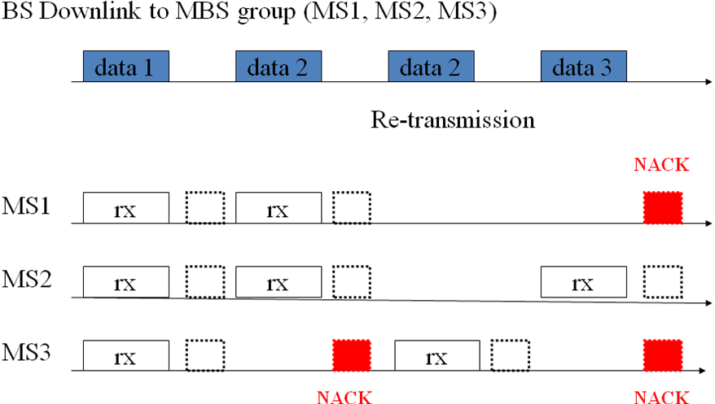
The above figure is the illustration of the Busy Tone NACK scheme in MBS. In this illustration, the Busy Tone is implemented using the prior scheme, a predefined sequence/code to be transmitted at a given time. As we could see, in the BS downlink transmission of data 1, there is no transmission error in the MBS group. Therefore no Busy Tone is transmitted in the dashed-line block, and no retransmission is done. In data 2’s transmission, the MS #3 does not receive it, pushing out the Busy Tone in the red block, and the BS performs retransmission accordingly. For data 3, both MS #1 and #3 do not receive the data, and two Busy Tones are sent. As the lost packet is the same, even if the BS might receive two Busy Tones or some collided/corrupted Busy Tone, the BS still knows that it has to retransmit data 3.
- NACK-preamble NACK Scheme
The NACK-preamble NACK scheme is to use NACK-preamble into the NACK design. The NACK-preamble is a predefined sequence, indicating the NACK message which is transmitted successively. 1 MBS group uses 1 NACK code for NACK-preamble NACK scheme. As previously mentioned, we just use CDMA code as an example. Other signaling message format could still be used in NACK-preamble scheme.
MS would use the NACK CDMA code to code the message of data block reception error. If the BS receives exactly 1 NACK, then it knows that an MBS data block is not received and the BS also knows which MS does not receive it. If the BS receives more than 1 NACK, then it knows that an MBS data block is not received in several MSs, and re-transmission for these MSs should be triggered.
This scheme has the advantages of moderate signaling overhead and it could obtain more information than Busy Tone NACK in some cases. If there is only 1 MS lost the data, NACK-preamble scheme could know which MS in the MBS group lost the certain data block, while Busy Tone NACK only knows that at least 1 MS missed the data. In case that multiple MSs didn’t receive the data successfully, NACK-preamble works as well as to Busy Tone NACK. The NACK-preamble scheme is suitable for synchronous and non-adaptive HARQ.
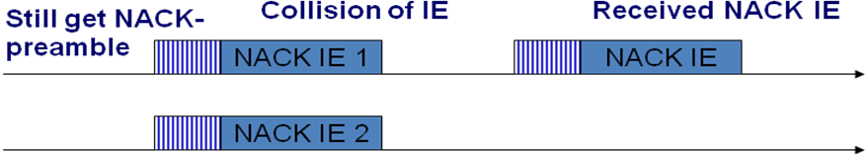
The figure above is the illustration of the NACK-preamble NACK scheme. In NACK-preamble scheme, the NACK mechanism is done by the NACK-preamble and NACK IE. The NACK-preamble indicates that there is a following NACK IE after the preamble, and the NACK IE contains the details information of the NACK. If there is only 1 MS in the MBS group does not receive the data, just as the case in the right side, the NACK-preamble can be decoded and the BS knows which MS fails to receive it. If there several MSs missed the data, resulting in collisions or loss of the NACK-preamble or NACK IE, the BS still knows that there are more than 1 MSs didn’t receive the transmitted data, and could trigger the retransmission for reliability.

ACK Design for Reliable MBS
ACK stands for Acknowledgement, and it serves better than NACK in certain conditions. We propose 2 ACK design schemes: Polling ACK and Periodic ACK.
- Polling ACK
In Polling ACK, the network should ask users to report their data reception status. That is, the BS should ask the MSs whether they have received the data block or not. The frequency of polling could be determined by the BS.
- Periodic ACK
In Periodic ACK, the users should report to the network according to a given period. MSs transmit ACK periodically back to the BS for data reception states. The reporting period could be configured by the BS and could be static or be adjust dynamically.
The ACK should use IE for ACK reporting. The usage of IE could transmit full information back to the BS for reliable MBS, as NACK only gives partial information. The contents of full information in IE would be beneficial for the configuration of MBS group. This is called cumulative ACK. We could use both ACK and NACK for better reliability and flexibility. The ACK schemes are most suitable for asynchronous adaptive HARQ.

Probabilistic Reliable MBS (P% reliable MBS)
The degree of the reliability of data transmission is a topic worth discussing. Failure of transmission would reduce the QoS level of users. However, if we insist on retransmitting the failed packets, the overhead might consumes the scarce radio resources and thus resulting in worse conditions. This is a tradeoff between reliability and signaling overhead. Besides, to further utilize the characteristics of NACK, the degree of reliability could be considered. Therefore we introduce the idea of reliability probability. That is, p% reliable MBS could be used for system with NACK design.
For example, if we need 100% reliable MBS, the BS should always re-transmit MBS data block if Busy Tone NACK or preamble NACK is received. That means all data blocks which fail to reach the MSs in the MBS group will be retransmitted by the BS to ensure data reliability. This could be a necessary mechanism for highly critical or human-life-related data.
If we need only p-% reliable MBS, which means that the transmitted data within the MBS group is not so crucial, then the BS could decide whether the retransmission is necessary or not. For the Busy Tone NACK, judging from the signal strength of the NACK message, we could estimate the number of MS reporting Busy Tone and thus decide whether to trigger retransmission. For NACK-preamble scheme, we could first find out which MS reports the data loss, or if there are more than 1 MS which has not receive the data. This could help BS distinguish the necessity of retransmission. With the setting of the p value, we could adjust the reliability of the data considering the setting of the MBS group, like delay, number of MSs, the characteristics of the traffic flow, etc.

Integrated ACK/NACK Scheme for Reliable MBS
Using the combination of ACK and NACK is a complete solution for HARQ in MBS. This kind of integrated scheme is suitable for different design goals and HARQ systems, and provides flexibility in the tradeoff of reliability and signaling overhead.
For example, here we provide a combined NACK&ACK scheme of Busy Tone NACK and Periodic ACK. They could cooperate and achieve better system performance in many aspects.
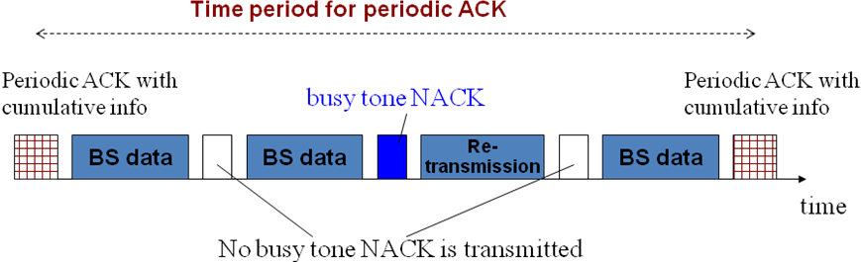
The above figure illustrates the combined scheme. With the Busy Tone NACK, the MS could receive the lost packet as soon as possible while the BS would perform data retransmission on receiving the Busy Tone NACK. The periodic ACK contains the cumulative info of all the transmission within the period. This would give BS more helpful information on adjusting the length of the ACK period and BS data. With better channel state, BS might gather the ACK less frequently and utilize the radio resource for data transmission.

Signaling in Reliable MBS
For the reliable MBS, in addition to data reliability, the signaling control of the MBS is also critical. In this section, we provide the signaling method of the MBS in DL and UL.
DL and UL transmissions are of different usages. The purpose of DL transmission is for data transmission and BS giving instructions to the MSs, while UL is used for MS sending information feedback back to BS. For data block reliability, the HARQ would hold the responsibility. Therefore the signaling method here focuses on the controlling and adjustment of the MBS signaling. For example, MCS adaptation should be categorized here.
- DL signaling
For the adjustment of the MBS, BS has to give instructions to the MS. For correct instructions, the BS has to gather information from the MSs. Therefore the BS should poll the MSs for information. The polling method could be on-demand polling or periodic polling.
- On-demand Polling
It means that the BS polls the subordinate MSs only when necessary. Whenever BS needs to gather information from the MSs, BS gives out signals for polling, and the MSs should report in the UL signaling. The query contents of the polling should contain reception status of the MS. Reception status, for example, contains the channel states of the transmission between two polls, CSI or PSNR, the power of the transmission, the expected battery life of the MS, etc. The information could serve as configuration references for the BS.
The pros of the on-demand polling is that it is easy to implement, but in contrary, it has the disadvantages of consuming more radio resources, as the MS has to keep monitoring the channel and waiting for the polling message.
- Periodic Polling
In periodic polling, the BS should poll the MBS group with certain period to gather information from MS. The BS should configure the periodic polling before the polling phase, or the MS would not be able to send out the requested data. MS also sends the feedback information accordingly.
This mechanism is more complicated but provides more flexibility and saves more power than on-demand polling. Due to the fact that the MS transmits feedback info only on certain time slot, MS could go to power-saving mode in others. However, there should be a mechanism for the BS to instruct the MS when to wake up and transmit the data. The time period, time offset and expiration time should be specified in the BS’s mechanism. If it is allowed to setting the expiration time to infinity, then explicit stop signaling is needed to wake up the MS.
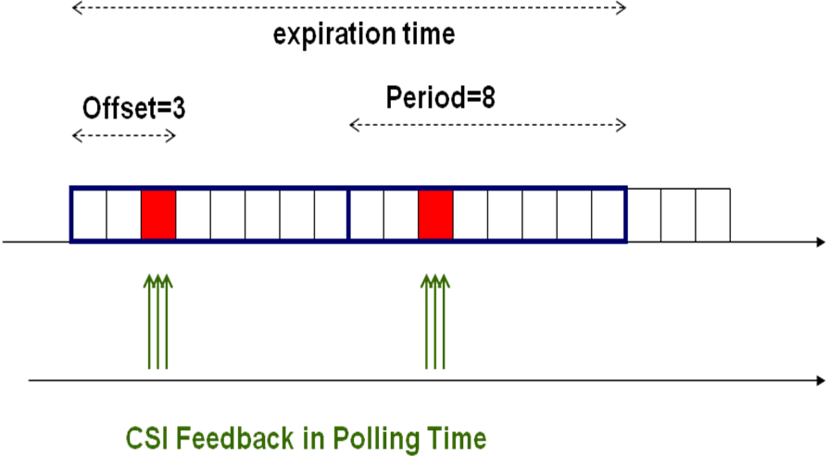
The above figure is the illustration for the BS mechanism. The MS has to report to the BS in the CSI feedback slot, with CSI values or other information, every preconfigured time period, which is marked as red ones in the figure. The CSI feedback slot is announced by the time offset, and is expired as the expiration time exceeds. The periodical operation could be done for every static period or dynamic one. This would add more flexibility for the system but resulting in more complexity.
- UL signaling
The UL signaling is the way for MS reporting to BS. Since BS should configure the transmission for the MBS operation, the MS major tasks is to conform to the instructions. For each poll, whether it could be periodic or on-demand, the MS should report to the BS with the specified data. In fact, the ACK of the HARQ could also be dimmed as UL signaling from the MS. Reception status data is the primary contents of the polling reporting data. In addition to reception states, the MS could also piggyback or send specific messages back to BS for MBS requirements or adjustments.

After the polling phase, the BS has to send instructions to the MS. The signaling messages, which serve as instructions, contain MBS configuration parameters, like the modulation and coding schemes, the order of nodes transmission, the future MS reporting details, etc. The value or contents of these parameters and messages could be deduced from the data previously gathered from the polling.

Summary
MBS requires the controlling and data transmission to succeed. Reliable MBS could improve the QoS of the service. The usage of Busy Tone or preamble NACK would benefit the MBS, and if we integrate Periodic or Polling ACK with NACK schemes, the MBS could become reliable and provides more flexibility. With the NACK and ACK schemes, the reliability of data blocks could be guaranteed. Depending on the tradeoff of signaling cost and precision of the information, the configuration of the NACK and ACK could be done accordingly. The richness of the NACK message information, the frequency of ACK, the degree of the data reliability, etc, can be set in reference to the system requirements. This is a complete solution for reliable MBS and provides great flexibility for the system.
In addition to the reliability and flexibility, the ACK scheme could always be integrated with the NACK-like scheme. Due to the fact that ACK, with ACK IE signaling, provides full information of the data block transmission, it always results in certain degree of signaling overhead. The integration could mitigate such effect. Additionally, less frequent ACK and the usage of NACK for data loss could also reduce the overhead.
The signaling of the MBS group could be distinguished by its directions. DL signaling is for BS to poll the MS reception states and to give instructions to the MS for MBS configuration. UL signaling is for the MS to report to the BS polling and gives additional MBS information back to BS.

Proposed Text for SDD
----------------------------------------------------Start of the Peoposed Text---------------------------------------------------15.x.1 Reliable Multicast and Broadcast
The multicast/broadcast mechanism within the system should be able to provide reliable transmission to all the MBS group members. The degree of reliability could be adjusted according to contents of the MBS traffic flows. Reliable multicast and broadcast operation is designed to provide better service in MBS. The HARQ operation and feedback mechanism are needed to facilitate re-transmission and to provide reliability.
15.x.1.1 P-Reliable MBS
To meet different levels of traffic flow requirements, the service reliability is configurable. In P-Reliable MBS scheme, re-transmission of data blocks will be conducted so that at least p% of packets will be correctly received.
15.x.1 ACK and NACK Design for Reliable MBS
Acknowledgement (ACK) and Negative Acknowledgement (NACK) are crucial for reliable MBS operation. The group members within the same MBS group are able to transmit feedback message simultaneously to report the delivery status of MBS data blocks. The design criterions for the ACK and NACK should be considered from the following aspects.
15.x.2 Acknowledgement Feedback Latency
The way of ACK and NACK design could be classified into immediate ACK/NACK, delayed ACK/NACK, and integrated scheme.
15.x.2.1 Immediate Acknowledgment Scheme
In immediate acknowledgment, the MS transmit the ACK/NACK immediately after the transmission of BS data. The fast feedback is used for immediate retransmission to enhance reliability of MBS.
15.x.2.2 Delayed Acknowledgement Scheme
In delayed acknowledgement, the ACK and NACK are sent after a certain period. The delayed ACK/NACK should contain cumulative information within the ACK/NACK period. The BS could poll the MBS group to gather reception states of the MSs. The polling could be periodic or on-demand. The MS reports to the poll and the BS uses the information for MBS configuration.
15.x.2.3 Integrated Scheme
The integrated scheme means that the operation of ACK and NACK contains both the characteristics of the immediate and delayed acknowledgement. More than one kinds of ACK/NACK may be used. ACK and NACK could be applied simultaneously for different feedback latency acknowledgment.
15.x.3 Channel Access and Allocation for Acknowledgement
The ACK and NACK mechanism should be able to operate on specific preconfigured channels. The number of preconfigured wireless channels could be the same as the node number or less. If the BS receives one or more acknowledgement indicating that certain data block is lost, the BS should trigger the retransmission for the specific data.
----------------------------------------------------End of the Peoposed Text---------------------------------------------------

