Project | IEEE 802.16 Broadband Wireless Access Working Group <http://ieee802.org/16>
Title | A Paging Indication Channel for 802.16m
Date Submitted | 2008-09-05
Source(s) | Havish Koorapaty, Per Ernström  Ericsson AB  SE-164 80 Stockholm, Sweden | Voice: +1 – 919-472-7524  mailto:havish.koorapaty@ericsson.com  *<http://standards.ieee.org/faqs/affiliationFAQ.html>
Re: | 80216m-08_033 Call for Contributions and Comments on Project 802.16m System Description Document (SDD) [Call for Detailed Physical Layer Comments]
Abstract | This contribution proposes a design for a paging indication signal and it’s location for IEEE 802.16m
Purpose | Discuss and Adopt for the SDD
Notice | This document does not represent the agreed views of the IEEE 802.16 Working Group or any of its subgroups. It represents only the views of the participants listed in the “Source(s)” field above. It is offered as a basis for discussion. It is not binding on the contributor(s), who reserve(s) the right to add, amend or withdraw material contained herein.
Release | The contributor grants a free, irrevocable license to the IEEE to incorporate material contained in this contribution, and any modifications thereof, in the creation of an IEEE Standards publication; to copyright in the IEEE’s name any IEEE Standards publication even though it may include portions of this contribution; and at the IEEE’s sole discretion to permit others to reproduce in whole or in part the resulting IEEE Standards publication. The contributor also acknowledges and accepts that this contribution may be made public by IEEE 802.16.
Patent Policy | The contributor is familiar with the IEEE-SA Patent Policy and Procedures:  <http://standards.ieee.org/guides/bylaws/sect6-7.html#6> and <http://standards.ieee.org/guides/opman/sect6.html#6.3>.  Further information is located at <http://standards.ieee.org/board/pat/pat-material.html> and <http://standards.ieee.org/board/pat>.

A Paging Indication Channel for IEEE 802.16m
Havish Koorapaty, Per Ernström
Ericsson AB

Summary
In this document, we propose a design for the paging indication signal in IEEE 802.16m. The design has previously been described in [4, 5, 8]. The paging indication signal notifies a subset of MS whether to read a full paging message in the near future. The shorter duration of the paging indication signal in comparison to the full paging signal helps improve standby time.
According to the current SDD [6] the SCH (non hierarchical case) and P-SCH (hierarchical case) is sent on every other subcarrier while the S-SCH (hierarchical case) is sent on every Nth subcarrier, where N is still TBD. We propose a paging indication signal design where the paging indication signal is sent on the unused subcarriers of the SCH (non hierarchical case) and P-SCH and/or S-SCH (hierarchical case) with an output power much lower than the SCH/P-SCH/S-SCH. Correct detection of the paging signal is assured by strong coding, e.g. based on a bi-orthogonal Walsh-Hadamard code. The performance of the paging signal design is evaluated based on the legacy preamble design, showing the viability of the concept. The legacy pre-amble is one option for the S-SCH. Note, however, that the paging indication signal design proposed here is applicable also in the case this option is not chosen.
We propose that the high level characteristics of a paging channel transmitted over the unused subcarriers of the SCH are adopted and captured in the SDD.

Background

Synchronization channel
In IEEE 802.16e the synchronization channel is sent in the first OFDM symbol in every frame and is referred to as the preamble. The preamble signal consists of a known binary signal sent every third OFDM sub-carrier. In the specification, the preamble signal is defined by the segment (i.e., one of the three sets of tones to be used), and the parameter IDCell. Mobile stations use the preamble for initial synchronization to the system, and to determine the location of the FCH message, which gives further information on the signal parameters. Mobile stations also use the preambles in neighbor cell signals in order to synchronize to them for purposes of measurement for handover. The use of every third tone for the preamble signal allows for a 1/3 reuse of the preamble signal, thereby improving its reception by mobile stations. The use of every third tone also implies a repetitive structure in the time domain, which can be used by mobile stations for initial acquisition. The structure of the preamble in the frequency domain for a 2048-FFT system is shown in Figure .
Figure 1 Structure of Preamble in Frequency Domain. Every third tone (or subcarrier) is occupied.

The design of the synchronization channel (SCH) for 16m has not yet been completed. In backwards compatible mode the preamble (i.e. the legacy synchronization channel) would have to be present, but could be sent in addition to a new 16m-specific SCH. In non-backwards compatible mode the legacy preamble would not have to be present.
It has not yet been decided whether to have a
- non-hierarchical SCH, or a
- hierarchical SCH, based on a
  - primary SCH (P-SCH) used for initial acquisition and common to all sectors and cells, and a
  - secondary SCH (S-SCH) used for fine synchronization and carrying sector/cell ID information
A working assumption has been made, as captured in the 802.16m system description document IEEE 802.16m-08/003r4, that the P-SCH (hierarchical case) and the SCH (non hierarchical case) is mapped on every other sub-carrier in the frequency domain. Similarly the S-SCH (hierarchical case) is mapped on every Nth sub-carrier, where N has however not yet been decided.
It has not yet been decided whether to utilize frequency reuse for the 16m SCH.

Paging indication
A paging indication signal is used in systems such as CDMA2000 and WCDMA in order to extend battery life. The paging indication signal provides an indication to selected mobiles to read the full paging message that occurs in a subsequent frame. Due to the significantly shorter duration of the paging indication message, the wake-up time of the MS is lowered, thereby saving battery life.
The paging indication mechanism is not available in the IEEE 802.16e-2005 standard [1]. In Draft #3 of the “SDD Text Proposal by AHG Chair for Idle Mode” [7] paging indication has, however, been included in section 10.x.2.1.1, as follows:

10.x.2.1.1 paging indication
Paging indications are transmitted at the pre-determined location. When paging indications are transmitted, BS transmits the list of PG IDs and associated paging indicator flag [The exact format of paging indicator is TBD] indicating the presence of full paging messages for the corresponding PGIDs.

In this contribution, we propose the use of the unused subcarriers in the SCH to transmit a paging indication signal. In order to demonstrate the viability of the proposal, a design for the paging indication signal using the unused subcarriers of the SCH is presented. We use a signal that is significantly lower in power than the SCH signal in order not to affect common functions for which the SCH is needed. The signal is designed to be received reliably in spite of the low signal level.

Performance Evaluation
The exact design of the 16m SCH has not yet been decided, but it shares with the legacy preamble the crucial feature that only every Nth subcarrier is utilized (with N=3 for the preamble). Therefore we verify the viability of the paging indication concept by a performance evaluation based on the legacy preamble design.
Note that the legacy preamble utilizes frequency reuse, which means that the “unused subcarriers” are used for preambles in neighbor cells. This results in inter cell interference between the preamble and the paging indicator. For the 16m SCH it has not yet been decided whether to utilize frequency reuse or not. If it is decided to utilize frequency reuse, we note that this harder case is tested by the preamble based evaluation given below.
Below we describe a signal design for the paging indicator transmitted on the unused subcarriers of the preamble. Next we perform a detailed performance analysis of the signal using link and system simulations, and demonstrate its efficacy.

Signal Design
In this section we describe a paging indication message that can be implemented during the duration of the preamble message. As discussed before the preamble shares crucial features with the 16m SCH, and may therefore be used to show the viability of the 16m paging indication design.
The preamble utilizes only every third OFDM tone, thus there are empty spaces available to utilize for the paging indication message. For example, in Figure 2, the paging indication message would be used on subcarriers 1, 2, 4, 5 and so on. However, care has to be taken not to affect any of the essential functions of the preamble, which are mainly for initial acquisition, and for neighbor cell measurement purposes. Thus, any paging indication signal implemented in the duration of the preamble needs to have very low power compared to the preamble signal. This will be the focus of the design of a paging indication signal.
The paging indication signal needs to operate at a very low signal to noise ratio. However, it can rely on good channel estimates that can be obtained using the preamble signal, and the significant amount of frequency coherence that can be expected even in a highly dispersive channel. In addition, the paging indication signal should be able to address a large number of users. For example, it should be possible to divide the pool of MS into many groups, and signal the identity of the group of the MS that needs to read the full paging message. By using many such groups, the number of users that need to read a full paging message can be minimized.
It is well known that orthogonal codes perform well at low signal to noise ratios [3]. In addition, an orthogonal code of a long length can provide many codewords that can be used to address multiple groups. For example, an orthogonal code of length 512 can address 512 groups of users. In addition, due to the presence of reliable channel information obtainable from the preamble, we can choose a bi-orthogonal code that uses both a code and its inverse. The distance between a codeword and its inverse is large, and the use of reliable channel information helps make discrimination between these codewords highly reliable. Thus, 1024 groups of users can be addressed using codewords of length 512.
Of the orthogonal codes, the best known are the Hadamard codes, which exist for all lengths that are multiples of 4, though lengths that are a power of 2 (i.e., the Walsh-Hadamard codes) are most popular. The use of a Walsh-Hadamard code permits the use of a Fast Walsh Transform in the decoding, so that the relative merit of many codewords can be assayed with low complexity.
We thus propose the use of a Walsh-Hadamard code as the signal for paging indication. With a 10 MHz WiMAX channel (using a FFT of length 1024), the preamble used is of length 284 bits. Thus, we have 568 unused positions that can be used for the paging indication signal, and a Walsh-Hadamard code of length 512 fits well. For a 5 MHz 802.16e channel, the FFT size is 512, the preamble used is of length 143, and 286 unused positions are available for the paging indication signal, thereby suggesting a Walsh-Hadamard code of length 256.
However, we also note that the Walsh-Hadamard codewords do not have particularly desirable spectral properties. For example, the all zeros codeword has a spectral line at zero frequencies. To whiten the spectrum, we suggest applying a pseudo-random masking sequence to the codeword. Sector-specific PN sequences already employed in IEEE 802.16e can be reused for this purpose.
The paging indication signal indicates the possible presence of a page in a subsequent frame to an MS that belongs to the group for which a paging indication signal is sent. The delay of one or more frames allows a further reduction in the wake-up time thereby enhancing the power savings that may be obtained using the paging indication signal.

Detection Performance
We characterize the performance of the proposed paging indication signal using a combination of link and system simulations. Using a system simulation, including path loss, antenna patterns and shadow fading, we obtain the path losses from all base stations (3 sectors per site) in the system to a set of mobile stations uniformly distributed through the system. A wrap-around procedure is used to eliminate edge-effects. The losses for segments of the base stations are also logged. For each mobile station, we generate the preamble with a randomly chosen IDCell, and a paging indication codeword at a specified power level below the preamble, and apply the composite path loss to the whole signal. For the interfering sectors, we generate different preambles at a signal level as obtained from the system simulation, in the corresponding segments, and paging indication signals in the rest of the tones at a similar power offset to that between the serving cell preamble and the serving cell codeword. Additive white Gaussian noise is also added at a level corresponding to a given noise figure. The signals from the different BS to the MS pass through different radio channels. This is assumed true for different sectors from the same site also, since the transmit antennas used are different. The channel is applied to the signal from each BS, and the combined signal is then received by the MS. Since the relative signal levels from the system simulation, corresponding to a BS transmit power, are used, the average CINR achieved is fixed. For each set of channel realizations from the different base stations, many noise realizations are used for averaging, and multiple sets of channel realizations are also used.
Three receiver algorithms are used in the evaluation: (1) A conventional receiver based on correlations, similar to an MRC receiver (2) An interference-cancelling MMSE-based receiver that exploits the structure of the signal and (3) An enhanced interference-cancelling receiver that uses knowledge of the two strongest neighbor cell preambles to subtract them before applying the MMSE-based receiver algorithm. A threshold can be used to determine if an assigned codeword has been detected. The relative power of the paging indication codeword to the preamble signal in the same cell is assumed to be known. This information can be sent in the DCD message.
The performance of the scheme is characterized in terms of the Missed Detection probability and the False Alarm probability. A missed detection occurs when the BS sends the assigned codeword to a MS, but the MS does not detect the codeword. Thus, the MS will not read the full page intended for it. A missed detection is detrimental to the paging performance of the system. A false alarm occurs when the MS detects that its assigned codeword has been sent when the BS sent a different codeword. A false alarm will cause the MS to read the full paging message. A false alarm is not detrimental to the paging performance of the system, though it does reduce the battery life savings obtained from use of the paging indication signal. The probability of missed detection and the probability of false alarm can be traded off by choosing appropriate thresholds for detection of the assigned codeword.
The parameters used in the simulation are shown in Table 1.
Aspect | Value
Number of Cells/Sites | 57/19
Reuse | 1/1 (1/3 for preamble)
Path Loss Model | 20 +35 log(d) (Similar to ITU Vehicular)
Site-to-Site Distance | 2.8km
Penetration Loss | None
Shadowing Standard Deviation | 8dB
Shadowing Correlation Distance | 100m
Bandwidth | 10 MHz
FFT Size | 1024
Transmit Power (for Preamble) | 20 W
Noise Figure | 9 dB
Channel Model | Pedestrian B
Relative Power of Paging Signal | -20dB
Codeword Size | 512
Table 1 Simulation Parameters

The geometry characteristics of the simulation are shown in Figure 1, assuming full occupancy of the signal and the noise. These geometry results are presented just as a validation of the simulation environment and are not completely relevant to the performance evaluation to be presented later since the reuse for the preamble is 1/3, whereas these results assume a 1/1 reuse. The interference-limited nature of the environment is clearly seen, the signal to noise ratio is quite high in most cases. It is to be noted that the preamble signal in IEEE 802.16-2005 is sent at a power level that is boosted compared to normal transmissions, thus it is highly likely that the preamble part of the downlink transmission is limited by interference rather than noise.
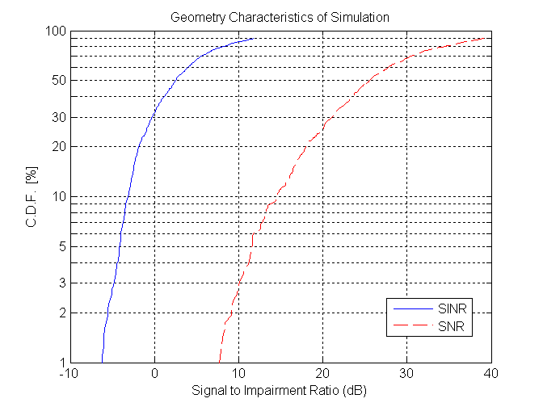
Figure 1 Geometry Characteristics of Simulation Used for Paging indication Evaluation

The results of this evaluation are shown in Figures 4-6. Figure 2 shows the CDF of the probability of missed detection and the probability of false alarm with the receiver using interference cancellation (the second type of receiver described above). The figure shows results with the use of two different detector threshold values. The figure illustrates that there is a trade-off between the missed detection probability and the false alarm probability that may be controlled using the detector threshold.
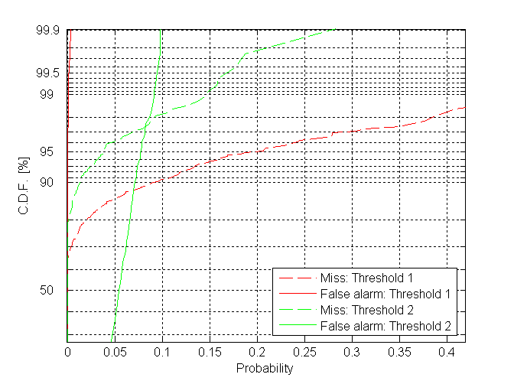
Figure 2: Variation of paging indication performance using the detection threshold. Interference suppression is used at the receiver.

Figure 3 shows the missed detection probability with the traditional receiver (denoted “AWGN” in the figure, since it makes an AWGN assumption for the impairment), the interference cancelling receiver (denoted “Blind IC” in the figure, since it assumes no knowledge of the interferer preambles), and the enhanced interference cancelling receiver. Figure 4 shows the corresponding false alarm probabilities.
Figure 3 and 6 show that the missed detection probability can be significantly reduced with the use of interference cancellation while keeping the false alarm probability more or less unchanged. With the traditional receiver, 95 percent of users experience a missed detection probability 12.5% or less. The probability of missed detection improves with the degree of interference cancellation used. With the blind interference cancelling receiver, we see that the missed detection probability experienced by 95 percent of the users reduces to 4% or less. With the enhanced interference cancelling receiver, we see that the 95th percentile missed detection probability further reduces to 2% or less. It is seen from the figure that the probability of false alarm does not get affected by the use of interference cancellation. Using different thresholds, the probability of missed detection can be traded off with the probability of false alarm.
Finally, we note that the improved performance of the enhanced interference cancelling receiver also indicates the benign effect of the paging indication signal on the performance of neighbor cell preamble measurements. The improvement indicates that the neighbor cell preamble can be detected reliably. The reliable detection leads to a reliable subtraction, which improves the performance.
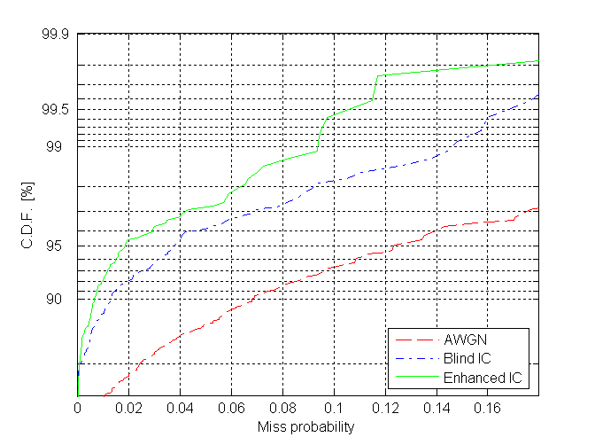
Figure 3: Miss probability of paging indication with various receivers
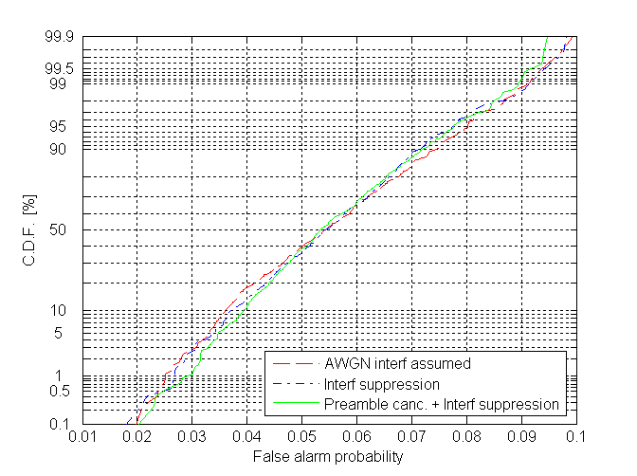
Figure 4: False alarm probability of paging indication with various receivers

Standby Energy Savings with Paging indication
We briefly explore the standby energy savings possible with the use of a paging indication signal as proposed in this contribution. When normal paging is used, the MS needs to wake up, read the preamble, the FCH, DL-MAP and some number of subsequent symbols, by which time it could verify whether it has an assignment. Let the number of symbols that the MS needs to wake up for be denoted by n. Note that n has to take into account the number of frames in the BS’s paging interval.

We denote the current drawn by the device when the receiver is on as I, and the current drawn when the receiver is idle by kI. For a one symbol interval, the corresponding energy consumed is denoted E and kE respectively. The energy expended in turning on the receiver including the RF portion is proportional to I times the number of symbols for which the receiver is on. Let the number of symbols in each paging interval be denoted by C. Thus, the total energy needed in receiving the full paging message is given by

E_{full} = C.kE + nE.

When Paging indication is used, the RF portion of the receiver needs to be awake only for one symbol if there is no indication of a full paging message, or for 1+n symbols if there is an indication of a full paging signal. If the probability that a MS will be paged in a paging slot is p, then the probability that at least 1 out of M mobiles will be paged is s=1 - (1-p)^{M}, where M is the number of MS in the paging group. For very small p, we have s~Mp. A reasonable p may be of the order of one thousandth or lower. Thus, the energy consumption with the paging indication signal is given by

E_{quick}= C.kE + E + nE.(s+f) ~ C.kE + E+nE(Mp+f),

where f is the false alarm probability. With n equal to 20 symbols, M of the order of 10, C of the order of 5000 symbols and k of the order of 0.004, and an average false alarm probability, f, of 0.055, we see that the energy consumption is about 40E without paging indication, and 22.3E with paging indication, a savings of a factor of 1.79. Note that this calculation has ignored other aspects of energy consumption at the MS.

If the total number of MS (in the paging area) was N, and the number of paging groups is P, then M=N/P. If an average of q mobiles is paged in every paging slot, then we have p= q/N. Thus, Mp = (N/P).(q/N) = q/P. In terms of the average number of MS paged per paging slot, the expression can be rewritten as

E_{quick}= C.kE + E + nE.(s+f) ~E+nE(q/P+f).

Improvements in standby time are computed as

Imp = ((1/E_{quick}) - (1/E_{full})) / (1/E_{full})

The total number of mobiles in the paging area is assumed to be N=250*57=14250. The probability that an MS will be paged is set to 0.001 and the number of paging groups P is set to 512.

Figure 5 shows potential standby time improvement as a function of the ratio k, which is the ratio of current drawn by the MS when idle to the current drawn when it is receiving. The improvement is shown for different values of the paging cycle length, with the assumption that the receive time for full paging is equal to 20 symbols, and thus 40 symbols over the default paging interval of two frames as specified in the WiMAX Mobile System Profile. The figure shows that approximately 35% improvement in battery life is obtained for a paging cycle of 1s length when the ratio k = 1%, i.e., when the current drawn during idle symbols is 1% of the current drawn when the receiver is on. When the ratio k reduces to 0.5%, we obtain about 65% improvement in battery life.
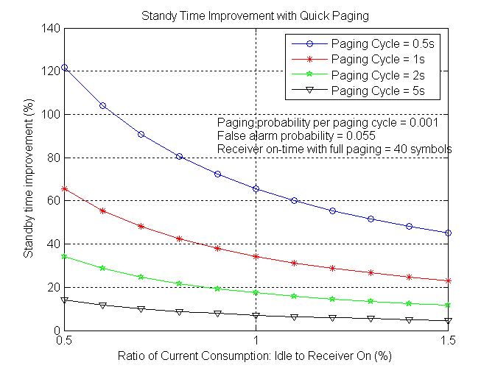
Figure 5: Standby Time Improvement with Paging indication
In Figure 6 , we show the standby time improvements as a function of the paging cycle length for various values of the ratio k of idle current to receiver on current.
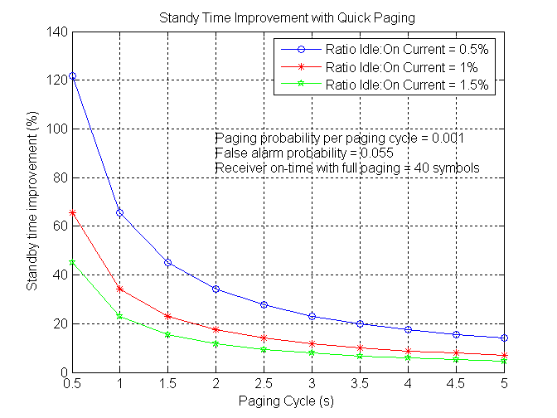
Figure 6: Standby Time Improvement due to Paging indication
Note that in sleep mode, the listening window can be much longer, in which case the improvements in standby time can be significantly higher.

System Impact
We show further system simulation results evaluating the CINR on the various preamble signals expected to be received by a MS, and how it may degrade due to the use of the paging indication signal. As seen in Figure 7, the degradation is minimal. Note that the CINRs seen here take the 1/3 reuse of the preamble into account. The CINR of the strongest BS is relevant for functions such as initial synchronization and network entry. As seen in the figure, the degradation of the CINR is negligible, thereby no impact to initial synchronization is seen. The CINR’s of the second and third strongest base stations are relevant to measurements on other cells/sectors for the purpose of handover. As seen in the figure, there is minimal degradation of these also. Also, it is seen that the degradation mainly occurs when the second and third strongest base stations are in the better CINR regime, thus it is not expected that measurements on other cells/sectors will exhibit any serious degradation due to the presence of the paging indication signal.

Figure 8 shows the CDF of the differences in CINR between the strongest BS and the second and third strongest BSs with and without paging indication. These differences are important since they are used to make decisions on handoffs. The figure illustrates that the presence of the paging indication signal has negligible impact on the distribution of these CINR differences. Thus there is no impact on handoff performance due to paging indication. The figure also shows the CDF of the difference in CINR of the strongest BS with paging indication and the strongest BS without paging indication. The figure illustrates that the impact of paging indication on the CINR of the preamble from the strongest BS is minimal.

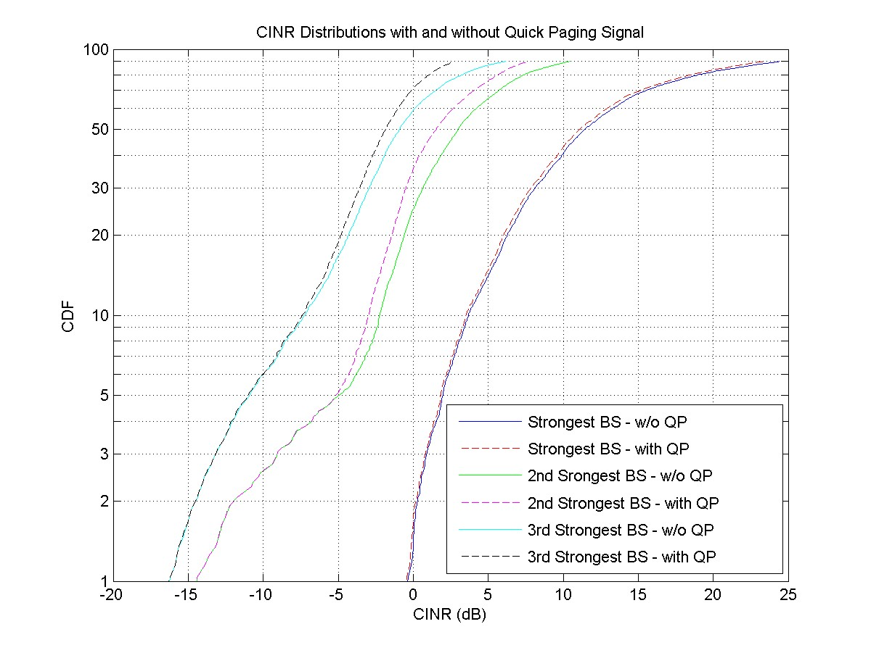
Figure 7: CINR Distribution for various Preambles

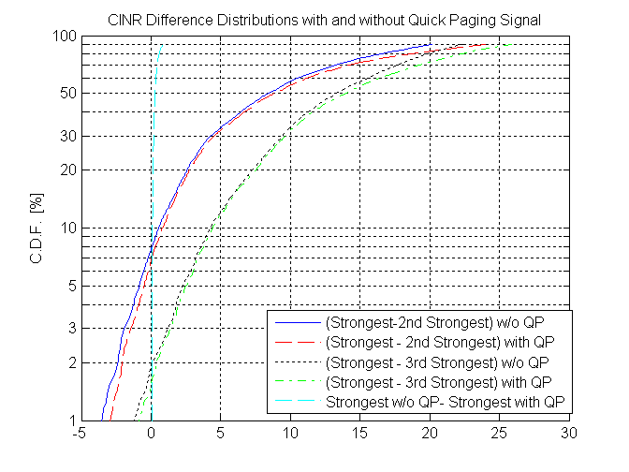
Figure 8: Impact of paging indication on relative differences of SINRs from surrounding base stations

Assignments of Codewords to Mobile Stations
The use of paging indication functionality as defined in this contribution requires the assignment of codewords to mobile stations so that they may determine whether to read the full paging functionality.
This may involve the classification of mobile stations into groups that can be identified using the codewords. Though these may be done based on MAC ID’s, however, the method to do so can be left unspecified and up to the implementation of the network provider. The signaling has been designed to communicate the actual codeword indices in point-to-point messages, thus the MS does not need the knowledge of the actual groups, but rather is just assigned the codewords it need to listen for, and act accordingly. Such a design follows the general philosophy of WiMAX, wherein network functionality is independent of the MAC & PHY layers.

Text Proposal
We propose that a new section 11.7.2.X is introduced in the 16m SDD [6] as follows:

11.7.2.X Paging Indication Channel (PICH)
The Paging Indication Channel (PICH) carries the paging indication information.
The PICH is transmitted over the unused subcarriers in the frequency domain of the S-SCH and P-SCH (hierarchical) or SCH (non-hierarchical).
The PICH is transmitted on a much lower power than the SCH.
A Walsh-Hadamard code is used to code the paging indication information.

Further more we propose that the following text change is adopted for section 11.7.2.1.3 in the 16m SDD [6]:

11.7.2.1.3 Synchronization channel Sequence Design Properties
The SCH enables timing synchronization by autocorrelation.
The power of synchronization channel can be boosted
The SCH (non-hierarchical) or P-SCH (hierarchical) is mapping with every other subcarrier on the frequency domain.
The S-SCH (hierarchical) is mapping with every [FFS] subcarriers on the frequency domain
The unused subcarriers in the frequency domain of the S-SCH and P-SCH (hierarchical) or SCH (non-hierarchical) may be used for a low power paging indication signal.

Conclusions
We have proposed the use of the unused subcarriers of the SCH in the frequency domain for a low power paging indication signal. In order to demonstrate the viability of using such a paging indication signal, we have presented a design for a paging indication signal in IEEE 802.16m that utilizes the unoccupied space available in the SCH to send an indication of a full paging signal in a succeeding frame. The performance of this scheme was evaluated using a combination of link and system simulations for multiple types of receivers. By utilizing the structure of the interferer, it is possible to achieve significant gains in performance and arrive at low probabilities of missed detection along with acceptable probabilities of false alarm. In addition, due to its low power, the proposed scheme has negligible impact on the other functionalities that require the SCH, a fact that was confirmed by the results of the simulations. Thus, the proposed scheme is a viable candidate for implementing paging indication functionality in IEEE 802.16m. Proposed text changes to the SDD to specify the location of the paging indication signal were provided.

References
[1] IEEE P802.16Rev2/D6, “Draft Standard for local and metropolitan area networks, Part 16: Air Interface for Fixed and Mobile Broadband Wireless Access Systems’’
[2] IEEE C802.16m07/217r1, S. Shawn Tsai, Stefan Lindgren, and Sten Sjöberg, “Wake-up Signal for 802.16m OFDMA Idle Mode”
[3] John G. Proakis, “Digital Communications”
[4] IEEE C802.16maint-08/139r6, Havish Koorapaty, Per Ernström , “Quick Paging”
[5] IEEE C80216m-08/222r1, Havish Koorapaty, Per Ernström, “802.16m Downlink Control Structures: Quick Paging Signal”
[6] 80216m-08_003r4, Shkumbin Hamiti (SDD editor), “The Draft IEEE 802.16m System Description Document”, 2008-07-29
[7] C80216m-MAC-08_008r2-idle-mode, Shashikant Maheshwari (IDLE Mode Ad-hoc Group Chair), “Draft #3, SDD Text Proposal by AHG Chair for Idle Mode”
[8] IEEE C80216m-MAC-08_046, Havish Koorapaty, Per Ernström , “Paging indication”

