Project | IEEE 802.16 Broadband Wireless Access Working Group <http://ieee802.org/16>
Title | Data Encryption PN Header Compression for IEEE 802.16m
Date Submitted | 2008-09-05
Source(s) | Kiran Thakare  Ericsson AB  SE-164 80 Stockholm, Sweden | Voice: +46 8 58532591  E-mail: kiran.thakare@ericsson.com
Re: | IEEE 802.16m-08/033 Call for Contributions on Project 802.16m System Description Document. For “Security: MAC”
Abstract | Specification [1] requires that the IEEE802.16m should be optimized for system performance. This contribution proposes PN header compression from 4-byte to 1-byte, thus achieving considerable (75%) reduction in the PN overhead in a robust manner. The PN compression is achieved using SCM method. .
Purpose | We propose to include the proposed text in the contributions in the security section of the SDD.
Notice | This document does not represent the agreed views of the IEEE 802.16 Working Group or any of its subgroups. It represents only the views of the participants listed in the “Source(s)” field above. It is offered as a basis for discussion. It is not binding on the contributor(s), who reserve(s) the right to add, amend or withdraw material contained herein.
Release | The contributor grants a free, irrevocable license to the IEEE to incorporate material contained in this contribution, and any modifications thereof, in the creation of an IEEE Standards publication; to copyright in the IEEE’s name any IEEE Standards publication even though it may include portions of this contribution; and at the IEEE’s sole discretion to permit others to reproduce in whole or in part the resulting IEEE Standards publication. The contributor also acknowledges and accepts that this contribution may be made public by IEEE 802.16.
Patent Policy | The contributor is familiar with the IEEE-SA Patent Policy and Procedures:  <http://standards.ieee.org/guides/bylaws/sect6-7.html#6> and <http://standards.ieee.org/guides/opman/sect6.html#6.3>.  Further information is located at <http://standards.ieee.org/board/pat/pat-material.html> and <http://standards.ieee.org/board/pat>.
Data Encryption: PN Header Compression Method for IEEE 802.16m
Kiran Thakare
Ericsson AB Sweden

Introduction
Specification [1] requires that the IEEE802.16m should be optimized for system performance. This contribution proposes PN header compression from 4-byte to 1-byte, thus achieving considerable (75%) reduction in the PN overhead in a robust manner. The PN compression is achieved using SCM method.

Background
IEEE 802.16e-2005 [2] uses AES CCM method for data encryption. The AES CCM mode with 128-bit used for data encryption provides the encrypted payload with a 4-byte PN (packet number) header. This is shown in figure 1. .

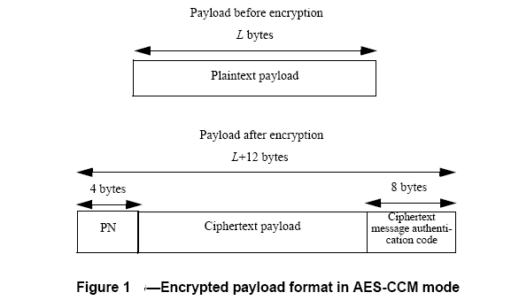
The 4bytes of PN header affects the efficiency and system throughput, thus wasting the precious air resources. [1] requires that IEEE 802.16m shall have optimized air resources. IEEE 802.16m technical MAC working group is already in the process of optimizing various radio resources use such as MAC header optimization. With all this in mind, we propose compression of PN header from 4bytes to 1 bytes SCM method.

3. Proposed PN header compression Method
A simple and effective compression method is proposed to reduce the size of the PN header. Figure 2 shows the PN header compression functionality-SCM method applied to PN header, thus optimization of the air resource use and making the PN compression more robust.
SCM method is described below.
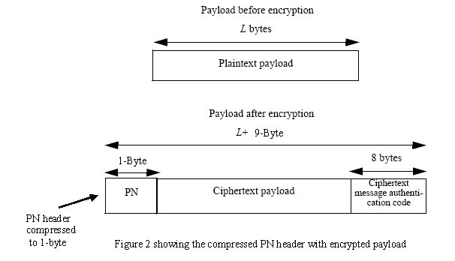

3.1 Simple Compression Method (SCM)
The SCM compresses the PN header from 4-bytes to 1-Byte. SCM transmits only a byte long LSB (least significant bits) of the PN header with each packet. This indexing scheme takes care of replay attack, packet reordering. Indexing scheme for packet sequencing is defined below.

3.1.1 SCM Indexing & Sequence estimation scheme
The transmitting end determines the indexing scheme and the receiver estimates the index of the packet based on received LSB bits (referred as ‘n’ bits, n = 8). .
Both the sender and receiver maintains a ROC, roll over counter. Number of bits in ROC is ‘r’
When the session starts the sender sets the ROC to zero. Each time the LSB sequence number LSB_seq, wraps modulo 2^n, the sender side MUST increment ROC by one, modulo 2^r.
The sender's packet index is then defined as follows:
i = 2^n * ROC + LSB_Seq
Receiver-side implementations use LSB sequence number LSB-Seq to determine the correct index of a packet, which is the location of the packet in the sequence of all packets. Out-of-order packets with sequence numbers close to 2^n or zero must be properly handled. The index estimate is based on the receiver's locally maintained ROC and S_1 values. At the setup of the session, the ROC MUST be set to zero. S_1 is the highest received and properly authenticated packet sequence number.
On consecutive packets, the receiver should estimate the index as
i = 2^n * v + LSB_Seq
where v is chosen from the set { ROC-1, ROC, ROC+1 } (modulo 2^r) such that it is closest to the value 2^n * ROC + S_1
This scheme only requires that the LSB-Seq is sent over the air /communication link. ROC is locally maintained at both receiver and transmitter end. Also S_1 is maintained at receiver end, for bidirectional traffic at both ends.

3.2 PN header compression support capability
The PN header compression capability (SCM support) may enabled and or disabled using the Service flow Creation/Change messages using a 1bit SCM support field. At the time of service flow creation UE requests either 8-bit header or full header based on MS capability and is granted by the BS in the service flow creation response message. MS may change its PN header capability using the service flow change message

4. Proposal

We propose that text of section 3.1 and 3.1.1 and 3.2 be added in the SDD Security section of PN header.

5. References
- IEEE 802.16m Requirements Specification
- IEEE 802.16e Standards
- IEEE C802.16m-08/201r2

SCM Simple Compression method
SCM Simple Compression method

