Project | IEEE 802.16 Broadband Wireless Access Working Group <http://ieee802.org/16>
Title | Considerations on the E-MBS in 802.16m : Physical Structure and MIMO Support
Date Submitted | 2008-09-17
Source(s) | Dongcheol Kim, Jin Sam Kwak, Sungho Moon, Wookbong Lee, Jaho Koo, Hyun- soo Ko  LG Electronics  LG R&D Complex, 533 Hogye-1dong, Dongan-gu, Anyang, 431-749, Korea | Voice : +82-31-450-1916  E-mail: dongcheol.kim@lge.com  samji@lge.com  msungho@lge.com  wbong@lge.com  jaho9@lge.com  hsko@lge.com
Re: | PHY aspects of enhanced MBS: In response to the TGm Call for Contributions and Comments 802.16m-08/033 for Session 57
Abstract | This contribution describes several considerations on the E-MBS physical structure and MIMO support in 802.16m.
Purpose | To be discussed and adopted by TGm for use in the IEEE 802.16m SDD
Notice | This document does not represent the agreed views of the IEEE 802.16 Working Group or any of its subgroups. It represents only the views of the participants listed in the “Source(s)” field above. It is offered as a basis for discussion. It is not binding on the contributor(s), who reserve(s) the right to add, amend or withdraw material contained herein.
Release | The contributor grants a free, irrevocable license to the IEEE to incorporate material contained in this contribution, and any modifications thereof, in the creation of an IEEE Standards publication; to copyright in the IEEE’s name any IEEE Standards publication even though it may include portions of this contribution; and at the IEEE’s sole discretion to permit others to reproduce in whole or in part the resulting IEEE Standards publication. The contributor also acknowledges and accepts that this contribution may be made public by IEEE 802.16.
Patent Policy | The contributor is familiar with the IEEE-SA Patent Policy and Procedures:  <http://standards.ieee.org/guides/bylaws/sect6-7.html#6> and <http://standards.ieee.org/guides/opman/sect6.html#6.3>.  Further information is located at <http://standards.ieee.org/board/pat/pat-material.html> and <http://standards.ieee.org/board/pat>.
Considerations on the E-MBS in 802.16m : Physical Structure and MIMO Support
Dongcheol Kim, Jin Sam Kwak, Sungho Moon, Wookbong Lee,
Jaho Koo,and Hyunsoo Ko

LG Electronics

Introduction
In general, the single frequency network (SFN) configuration is one of the major features in achieving high spectral efficiency and wide coverage of multicast/broadcast services. When working in MBSFN, all BSs are transmitting the same signal using the same modulation and coding rate, permutation, and sub-channelization at the same resources. In this case, an equivalent channel delay profile is the sum of the individual channels from all BSs in the MBS zone to a MS. The delay in the signals coming from a distant BS translates to a delayed impulse response, which increases the delay spread of the equivalent channel and generates ISI when the signal delay exceeds cyclic prefix (CP). Therefore, the frequency selectivity of MBSFN channels is much larger than that of unicast channels. This is caused by RF combining of the received signals from multiple transmitters with different propagation delays over the air. Considering the multi-antenna transmission modes for E-MBS in 802.16m, therefore, the pilot density for MBS resource blocks should be higher than that of unicast resource blocks. In this contribution, we investigate the MIMO supports for E-MBS and propose the MIMO schemes, i.e., cyclic delay diversity (CDD) for transmit diversity and spatial multiplexing (SM), depending on the cell size for E-MBS in the 802.16m system. In addition, the required pilot density and patterns for MIMO supports in both the time domain and the frequency domain are proposed. The MIMO schemes and several pilot structures for E-MBS are evaluated and compared by using the channel model proposed in [4].

MIMO Schemes for E-MBS Support
As defined in the 802.16m system requirements [1], the high quality-reception at the cell edge and wide area provisioning for E-MBS in the 802.16m are necessary. This can be achieved through soft-combining of the received signals transmitted from multiple cells with inter-cell synchronous operation, i.e., SFN operation, through high frequency diversity gain. In addition to the SFN gain, the multi-antenna transmission should be also considered for the E-MBS throughput/reliability enhancement. The 2-branch transmit diversity at the BSs may improve the received quality for the MBMS signal in the downlink. The substantial gains can be also achieved through the use of spatial multiplexing (SM) in the MBSFN environments. In this section, therefore, the impacts of the MIMO schemes on the E-MBS support in the 802.16m are investigated and proposed through the system-level simulation results in the MBS environments. Table 1 shows the SE (spectral efficiency) comparison between transmit diversity and spatial multiplexing with different ISDs. In Table 1, we assume that the 2-antenna transmission with the ideal channel estimation and the CDD & space-frequency block code (SFBC) for the transmit diversity are considered. It is shown that in terms of the coverage and throughput perspectives, the different types of improvement can potentially be obtained, i.e., the SM offers the significant SE improvements in the small cells as well as the CDD is more proper to support MIMO transmission as a transmit diversity scheme in the relatively large cell environment.
The system level simulation assumptions are in [5].
Table I. Performance comparison of MIMO schemes and Spatial Multiplexing scheme
 | Spectrum Efficiency with 95% coverage
 | ISD: 1.5km | ISD: 3.0km
CDD  (PilotOverhead:11.1%) | 3.59 bps/Hz | 2.31 bps/Hz
SFBC  (Pilot Overhead:22%) | 3.14 bps/Hz | 2.11 bps/Hz
SM  (Pilot Overhead:22%) | 5.05 bps/Hz | 1.57 bps/Hz

As a result, we propose the possible MIMO schemes to be considered in the 802.16m E-MBS as follows:
- Single-BS E-MBS operation
  - SM or CDD supports depending on the cell size, i.e, SM for small-cell case and CDD for large-cell case.
- Multi-BS E-MBS (MBSFN) operation
  - The CDD is default MIMO transmission scheme for E-MBS and SM can be considered for the throughput enhancement in the small-sized cells.

In the throughput comparison above, we need to consider the pilot overhead and its structure for MIMO supports in the E-MBS based on the DL physical structure for 802.16m unicast channels [3]. In the following section, the details of the E-MBS pilot overhead and structures are addressed.

Pilot Overhead and Pattern Design for E-MBS
The frequency selectivity of MBSFN channels is usually subject to the larger delay spread of the equivalent SFN channels than that of the unicast channels. This implies that the pilot density for MBSFN resource blocks should be higher than that of unicast resource blocks and the resultant patterns should be designed for the E-MBS under a consideration of multi-antenna transmission. Based on the MIMO schemes for E-MBS in the previous section, in this section, several pilot overheads are compared in terms of the achievable goodput and the details of the pilot patterns for the CDD transmit diversity scheme and spatial multiplexing are also proposed. In the case of the mixed scenario between unicast and MBS at the same carrier, the basic resource unit for E-MBS in the 802.16m is also a PRU as defined in [3], i.e., 18 subcarriers x 6 OFDM symbols. In accordance with the DL pilot design concept in the 802.16m unicast channels, we consider the pilot density around 9.26~16.67% for a single transmit antenna/CDD or around 14.81 ~ 22.22% for 2 transmit antennas.

Structure 1-a :  Pilot Overhead 9.26% | Structure 1-b :  Pilot Overhead 11.11% | Structure 1-c :  Pilot Overhead 16.67%
Figure1. Pilot patterns for single stream in E-MBS with Pilot density of 9.26, 11.11 and 16.67%

Structure 2-a :  Pilot Overhead 14.81% | Structure 2-b :  Pilot Overhead 18.50% | Structure 2-c :  Pilot Overhead 22.22%

Figure2. Pilot patterns for two streams in E-MBS with Pilot density of 11.41, 18.51 and 22.22%

Based on the MBSFN channel model in [4], the simulation parameters are shown in Table II.

Table II. Simulation assumptions
System bandwidth | 10MHz
Number of used subcarriers | 864+DC
Sub-carrier spacing | 10.94kHz
Symbol duration | Useful part | 91.43 μs
Symbol duration | CP length | 11.43 μs
Modulation and Coding Rate | QPSK 1/3
Antenna configuration | 1 Tx,2Tx, 2 Rx
UE speed | 3kph,
OFDM symbol timing | Ideal
Channel estimation | 2-D MMSE Interpolation

Figures 3, 4, and 5 show the Goodput performance of the MBMS channel for QPSK with R = 1/3 using the cell-common pilot structures in Figures 1 and 2. Figure 3 and 4 show that the Goodput performance of Structure 1-c is degraded compared to those for the other two structures due to a large pilot overhead. However, Structure 1-a with a small pilot overhead has good performance. Because the high channel coding gain obtained using the lower coding rate compensates for the large channel estimation error.
Figure 5 shows that Spatial Multiplexing scheme achieves the high spectral efficiency in high SNR due to the two stream transmission. In this case, structure 2-a with the smallest pilot overhead of 14.81% totally is worse than others in low SNR range. The channel coding gain doesn’t provide any performance gain for compensating the channel estimation error owing to the very low pilot overhead. The structure 2-b with pilot overhead of 9.26% per stream has better performance than others in SNR range between -10 and 10dB used in simulation. Thus, pilot overhead can provide the good channel estimation performance considering the spectral efficiency of E-MBS for IEEE802.16m.
In summary, we propose that Structure 1-a and Structure 2-b with the pilot overhead of 9.26% for SIMO/CDD and SM, respectively, provide the better Goodput performance for the E-MBS among the three structures, since a reasonable small pilot overhead is efficient and a higher channel coding gain compensates for the degraded channel estimation accuracy in this cases.

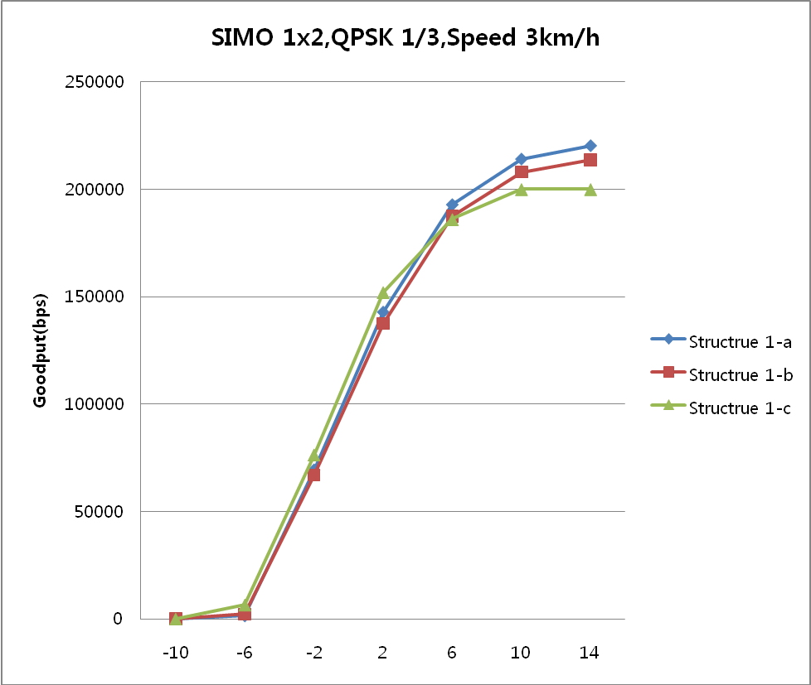
Figure 3 Comparison of pilot structres with QPSK1/3 at 3km/h in SIMO
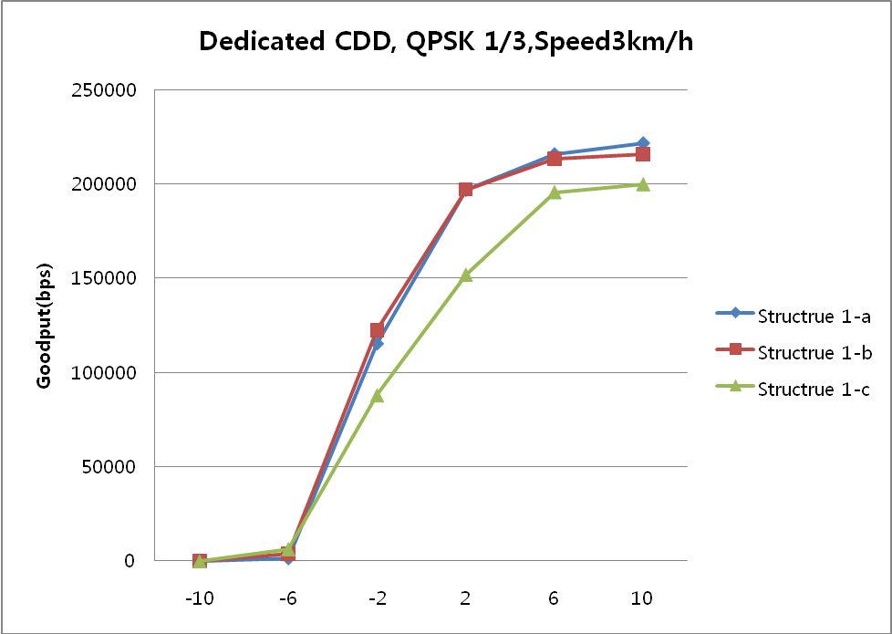
Figure 4 Comparison of pilot structures with QPSK1/3 at 3km/h in CDD
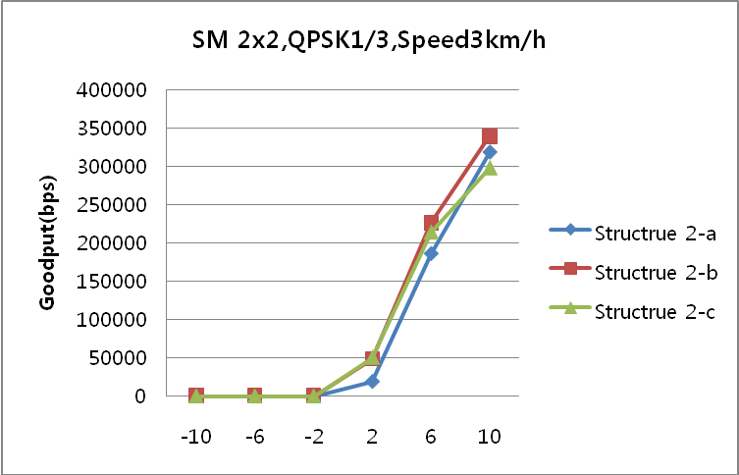
Figure 5 Comparison of pilot structures with QPSK1/3 at 3km/h in SM

In Figure 6, we see that CDD is better Goodput performance in low SNR range due to the additional transmit diversity gain. However, in high SNR range, SM provides the high Goodput performance among others.
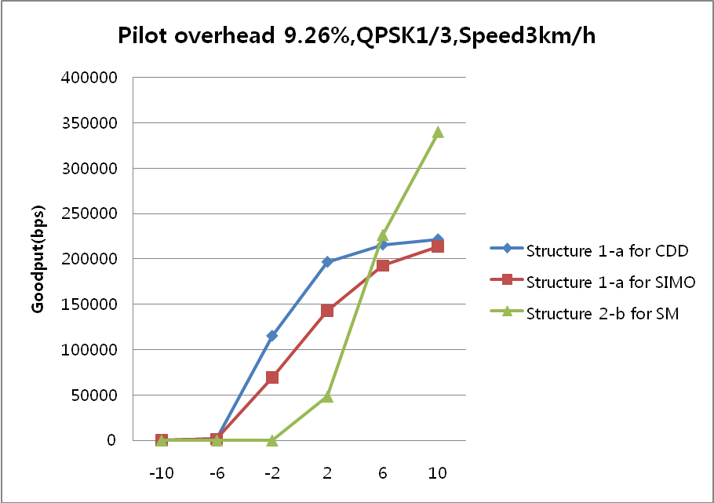
Figure 6 Comparison of SIMO, CDD, and SM with QPSK 1/3 at 3km/h in pilot overhead of 9.26% per stream

Conclusion
In this contribution, we propose the MIMO schemes and relevant pilot structures for E-MBS support in the 802.16m. Based on the comparison among the various MIMO schemes and pilot overheads/patterns for E-MBS, we suggest that the CDD for the transmit diversity scheme should be considered and the SM can be adopted for the throughput enhancement in the limited small-sized cell environment. The pilot overheads of 9.26% and 18.50% for single- and two-stream supports are necessary in the 802.16m E-MBS, respectively, i.e.,
- Pilot overhead of 9.26% per stream for E-MBS support

We propose the possible MIMO schemes to be considered in the 802.16m E-MBS as follows:
- Single-BS E-MBS operation
  - SM or CDD supports depending on the cell size, i.e, SM for small-cell case and CDD for large-cell case.
- Multi-BS E-MBS (MBSFN) operation
  - The CDD is default MIMO transmission scheme for E-MBS and SM can be considered for the throughput enhancement in the small-sized cells.
Additionally, we can consider Hierarchical Modulation based on basic transmission scheme to enhance the high data rates.

Reference
[1] IEEE 80216m-07/002r4, “IEEE 802.16m System Requirements”
[2] IEEE 80216m-08/004r1, “Project 802.16m Evaluation Methodology Document (EMD)”
[3] IEEE 802.16m-08/003r4 “The Draft IEEE 802.16m System Description Document”
[4] 3GPP LTE R4-080128 “LTE MBSFN channel model”
[5] IEEE C80216m-08/089 “MBS Frame Structure Considerations”

Text Proposal for the 802.16m SDD
============================== Start of Proposed Text =================================
x.y. E-MBS

x.y.1 MIMO schemes for E-MBS
The following MIMO schemes are considered in the 802.16m E-MBS:
- Single-BS E-MBS operation
  - SM or CDD supports depending on the cell size, i.e, SM for small-cell case and CDD for large-cell case.
- Multi-BS E-MBS (MBSFN) operation
  - The CDD is default MIMO transmission scheme for E-MBS and SM can be considered for the throughput enhancement in the small-sized cells.
x.y.2 Pilot Structures for E-MBS
The transmission of pilot subcarriers for E-MBS is necessary for the channel estimation in the large delay spread in the SFN channel. The details of the pilot overhead and patterns are as follows:
- Pilot overhead of 9.26% per stream for MBSFN support
Figure A  Proposed Pilot Structure for 1Tx :  Pilot Overhead - 9.26% | Figure B  Proposed Pilot Structure for 2Tx :  Total Pilot Overhead - 18.50%

=============================== End of Text Proposal ===============================

