Project | IEEE 802.16 Broadband Wireless Access Working Group <http://ieee802.org/16>
Title | Proposed Text Changes to HARQ Rapporteur Group Contribution
Date Submitted | 2008-09-15
Source(s) | ¹Zheng Yan-Xiu, Ren-Jr Chen, Chang-Lan Tsai, Chung-Lien Ho, ²Richard Li, Chien-Yu Kao, Jen-Yuan Hsu, Yu-Tao Hsieh, Pang-An Ting  ITRI | Voice:  ¹+886-3-5914715  ²+886-3-5917596  E-mail:  ¹zhengyanxiu@itri.org.tw  ²richard929@itri.org.tw  *<http://standards.ieee.org/faqs/affiliationFAQ.html>
Re: | PHY: HARQ; supporting contribution for reply comment to comment 080 of commentary file 80216m-08_034r3, and HARQ RG output C80216m-08/1094r1
Abstract | Comments on Contribution for TGm from the HARQ Rapporteur Group
Purpose | Discussing and adopting the text proposed in this document
Notice | This document does not represent the agreed views of the IEEE 802.16 Working Group or any of its subgroups. It represents only the views of the participants listed in the “Source(s)” field above. It is offered as a basis for discussion. It is not binding on the contributor(s), who reserve(s) the right to add, amend or withdraw material contained herein.
Release | The contributor grants a free, irrevocable license to the IEEE to incorporate material contained in this contribution, and any modifications thereof, in the creation of an IEEE Standards publication; to copyright in the IEEE’s name any IEEE Standards publication even though it may include portions of this contribution; and at the IEEE’s sole discretion to permit others to reproduce in whole or in part the resulting IEEE Standards publication. The contributor also acknowledges and accepts that this contribution may be made public by IEEE 802.16.
Patent Policy | The contributor is familiar with the IEEE-SA Patent Policy and Procedures:  <http://standards.ieee.org/guides/bylaws/sect6-7.html#6> and <http://standards.ieee.org/guides/opman/sect6.html#6.3>.  Further information is located at <http://standards.ieee.org/board/pat/pat-material.html> and <http://standards.ieee.org/board/pat>.
Proposed Text Changes to HARQ Rapporteur Group Contribution
Zheng Yan-Xiu, Ren-Jr Chen, Chang-Lan Tsai, Chung-Lien Ho, Richard Li,
Chien-Yu Kao, Jen-Yuan Hsu, Yu-Tao Hsieh, Pang-An Ting
ITRI

Introduction
This contribution provides the modified text proposal.
============================ Text Proposal =========================================

11.x.1 Channel coding and HARQ

11.x.1.1 Channel coding

11.x.1.1.1 Block diagram

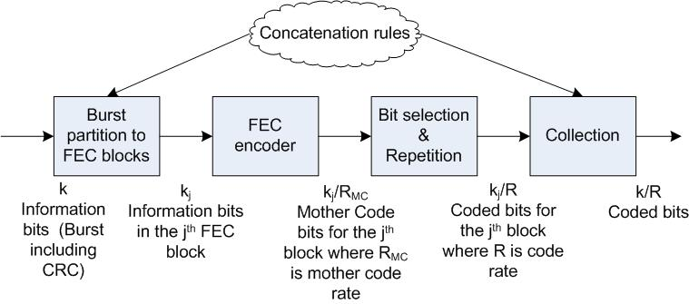
Figure 11.x.1.1.1-1 Channel coding block diagram

11.x.1.1.2 Partition into FEC blocks
When the burst size exceeds the maximum FEC block size, the burst is partitioned into a number of smaller blocks, each of which is encoded separately. The maximum FEC block size is TBD. Concatenation rules are based on the number of information bits and do not depend on the structure of the resource allocation (number of LRUs and their size). The concatenation rules are FFS. Error detection is provided at the end of the burst by appending a Cyclic Redundancy Check (CRC).

11.x.1.1.3 FEC encoding
IEEE 802.16m uses the CTC (convolutional turbo code) of code rate 1/3 and CC (convolutional code) defined in the WirelessMAN-OFDMA Reference system IEEE 802.16e standard. The code rate of the “FEC Encoder” block in Figure 11.x.1.1.1-1 is termed mother code rate R_{MC} (RMC). The use of other coding schemes and interleavers like CC and LDPC are FFS.
The CTC scheme is extended to support additional FEC block sizes. FEC block sizes larger than the legacy ones are supported. The FEC block sizes are FFS and they are independent of the transmission format, including code rate, modulation order, and resource allocation. Further, the FEC block sizes are regularly increased with pre-determined block size resolutions. The FEC block sizes which are multiple of 7 shall be removed for the tail-biting encoding structure with the detailed mechanism being FFS.
The encoder block depicted in Figure 11.x.1.1.1-1 includes the sub-block interleavers. The interleaving details are FFS.

11.x.1.1.4 Bit selection and repetition
Bit selection and repetition are used in 802.16m to achieve rate matching. Bit selection adapts the number of coded bits to the size of the resource allocation (in QAM symbols) which may vary depending on the LRU and subframe type. The Mother Code Bits after the FEC are considered as a circular buffer. Repetition is performed when the number of transmitted bits is larger than the number of Mother Code Bits (total number of information and parity bits generated by FEC encoder). The selection of coded bits is done cyclically over the buffer.

11.x.1.1.5 Modulation
Modulation constellations of QPSK, 16 QAM, and 64 QAM are supported as defined for the WirelessMAN-OFDMA Reference system legacy system. The mapping of bits to the constellation point depends on the constellation-rearrangement (CoRe) version used for HARQ re-transmission as described in Section 11.x.1.2.2 and may depend on the MIMO stream. QAM Symbols are mapped to the input of the MIMO encoder. The use of Hierarchical Modulation is FFS.

11.x.1.2 HARQ

11.x.1.2.1 Block diagram
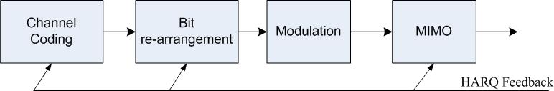
Figure 11.x.1.2.1-1 HARQ block diagram

11.x.1.2.12 HARQ IR type
Incremental redundancy Hybrid-ARQ (HARQ IR) is used in 802.16m by determining the starting position of the bit selection for HARQ retransmissions. Chase combining Hybrid-ARQ (HARQ CC) is a special case of HARQ IR and optional controlling bit is FFS. The rule for determining the starting position is FFS.

11.x.1.2.23 BitConstellation re-arrangement
Bit Constellation re-arrangement (BitCo-Re) is supported in 802.16m. Bit re-arrangement includes a bit-level interleaver and an inverter. For each transmitted burstbit, the CoBitRe-version is selected by the transmission number of this burstbit. The specific bit-level interleaver and invreterselection mechanism is FFS.

11.x.1.2.34 Adaptive HARQ
The resource allocation in each retransmission in both downlink and uplink can be fixed or adaptive according to control signaling. The support of adaptive HARQ and the specific mechanism for adaptive HARQ are FFS, while the reduction of signaling overhead should be considered as an important criterion for those studies.

11.x.1.2.45 Exploitation of frequency diversity
In HARQ re-transmissions, the bits or symbols are transmitted in a different order to exploit the frequency diversity of the channel. The mechanism is FFS.

11.x.1.2.56 MIMO HARQ
For HARQ subpacket retransmission, the mapping of bits or modulated symbols to spatial streams may be applied to exploit spatial diversity with given mapping pattern, depending on the type of IR. In this case, the predefined set of mapping patterns should be known to both transmitter and receiver. The specific mechanism is FFS and it should be determined with the consideration of MIMO architecture and data processing for IEEE 802.16m.
[Note: cited from reflector]
Dynamic data-antenna mapping should be used for HARQ subpacket (re)transmission. In dynamic data-antenna mapping, data symbols at the output of MIMO precoder/beamformer are mapped to transmit antennas differently for every (re)-transmission according to a selected mapping pattern by transmitter from a predefined set of mapping patterns. The predefined set of mapping patterns and selection order should be known to both transmitter and receiver.
The support STC subpacket combining is FFS

11.x.1.2.67 HARQ feedback
A multi-state HARQ feedback channel is used in 16m. Basic ACK/NACK HARQ feedbacks are supported. The number of state is FFS.
Dropping HARQ feedback (RESTART) is used to avoid buffer outage and restart HARQ process when control signaling is missed.
Detaining HARQ feedback (DET) regulates the buffer usage and is FFS

A basic ACK/NAK channel to transmit 1-bit feedback is supported.
An enhanced ACK/NAK control channel with some additional information is FFS. For example, HARQ feedback messages may include a message to indicate that a NACK-to-ACK error has occurred.

11.x.1.2.8 Modulation
Modulation constellations of QPSK, 16 QAM, and 64 QAM are supported as defined for the WirelessMAN-OFDMA Reference system. The use of Hierarchical Modulation is FFS.

