Project | IEEE 802.16 Broadband Wireless Access Working Group <http://ieee802.org/16>
Title | Enhance Location update efficiency using LBS with GIS
Date Submitted | 2008-10-31
Source(s) | Shih-Lin Wu, Jui-Te Chang, Shiou-Wen Wang  Chang Gung University, Department of Computer Science and Information Engineering , Kwei-Shan Tao-Yuan, Taiwan,  Yu-Chee Tseng, Jen-Jee Chen  National Chiao-Tung University, Department of Computer Science, Hsin-Chu, 30010, Taiwan  Yang-Han Lee, Yih-Guang Jan, Ming-Hsueh Chuang, Hsien-Wei Tseng  Tamkang University, Department of Electrical Engineering, Tamsui, Taiwan | Voice:+886-3-211-8800 ext.5320  mailto: slwu@mail.cgu.edu.tw  Voice: +886-3-571-2121 ext.54747  mailto: chencz@cs.nctu.edu.tw  Voice: +886-2-2625-2303  mailto: hwtseng@ee.tku.edu.tw
Re: | IEEE 802.16m-08/040, “Call for Contributions and Comments on Project 802.16m System Description Document (SDD)”. In response to the following topics:  - TGm SDD: Other
Abstract | This contribution presents the scenarios of enhancing idle mode location update efficiency with LBS and GIS supports.
Purpose | To be discussed and adopted by TGm for the 802.16m SDD.
Notice | This document does not represent the agreed views of the IEEE 802.16 Working Group or any of its subgroups. It represents only the views of the participants listed in the “Source(s)” field above. It is offered as a basis for discussion. It is not binding on the contributor(s), who reserve(s) the right to add, amend or withdraw material contained herein.
Release | The contributor grants a free, irrevocable license to the IEEE to incorporate material contained in this contribution, and any modifications thereof, in the creation of an IEEE Standards publication; to copyright in the IEEE’s name any IEEE Standards publication even though it may include portions of this contribution; and at the IEEE’s sole discretion to permit others to reproduce in whole or in part the resulting IEEE Standards publication. The contributor also acknowledges and accepts that this contribution may be made public by IEEE 802.16.
Patent Policy | The contributor is familiar with the IEEE-SA Patent Policy and Procedures:  <http://standards.ieee.org/guides/bylaws/sect6-7.html#6> and <http://standards.ieee.org/guides/opman/sect6.html#6.3>.  Further information is located at <http://standards.ieee.org/board/pat/pat-material.html> and <http://standards.ieee.org/board/pat>.
Enhance Location update efficiency using LBS with GIS

Introduction
In the legacy IEEE 802.16e, MS performs idle mode location update if any of location update evaluation condition (paging group update, timer update, power down update, and MAC Hash skip threshold update) is met. In this proposal, we propose that, by exploiting LBS and GIS (Geographic Information System) in IEEE 802.16m, an MS can report more accurate and efficient idle mode location update in IEEE 802.16m. The main objective of this proposal is that an MS can report more efficient and accurate location update and then can conserve more power in idle mode.

Proposal
IEEE 802.16m LBS is to provide support for high resolution location determination. Some people propose that we can use the location information to predict the possible shortest time an idle mode MS may leave its current location area. The possible shortest time t= (shortest distance from current location to the location area boundary)/(moving speed of the MS). Then, t can be one of important reference for the MS to check and report location information [2]. However, at most of the time, the shortest distance is not a path that an MS can use. For example, in Fig.1, some shortest distances have to go through a lake, an obstacle, a high building, or a high way. In these cases, the MS will avoid these paths and use other walkable or drivable routes. So, we propose to use LBS+GIS to predict a usable and accurate shortest route that an MS can leave the current location area (Fig.2 shows the possible route that the MS may drive out of the location area). By the route, we can predict the possible shortest time t that the MS will leave the current location area. So, we can set a timer T_{SLLA}=t, which can be an important reference that the MS has to do location area checking. By this way, we can conduct an efficient location update and save more power for idle mode MSs.
Figure1. The shortest distance an MS may leave its current location area by using only LBS.

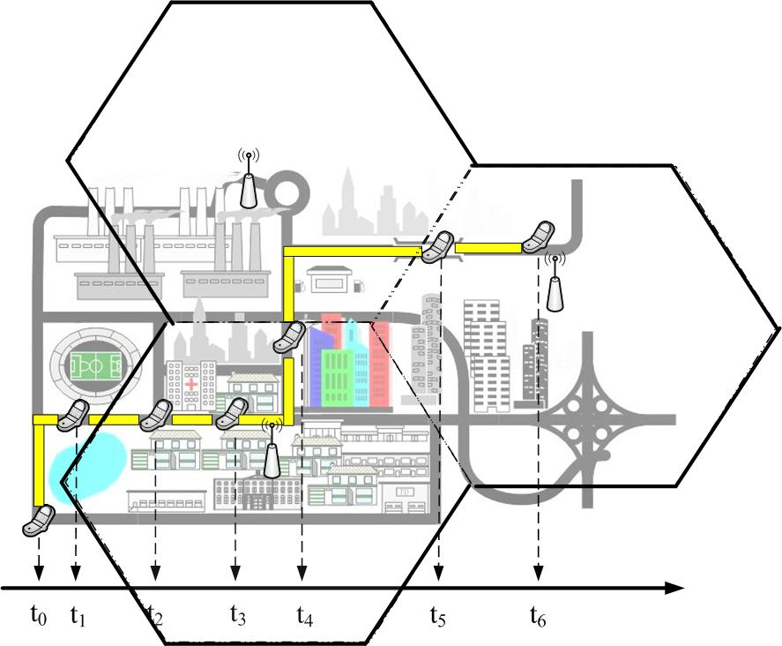
Figure2. The shortest route an MS may leave its current location area by using GIS+LBS.

Conclusion
Using LBS and GIS, we can effectively predict the time an idle mode MS may leave its current location area. By this information, we can conduct a more efficient and power conserving idle mode location update. So, we propose to enhance idle mode location update efficiency by exploiting LBS and GIS.

Proposed Text for SDD
[-------------------------------------------------Start of Text Proposal---------------------------------------------------]
[Adopt the following text in the 802.16m System Description Document (SDD)]

10.x.2.3.2.2 Timer based location update

MS shall periodically perform location update process prior to the expiration of idle mode timer. At every location update including paging group location update, idle mode timer is reset to 0 and restart. MS can exploit LBS to maintain a timer T_{SLLA}, which predicts the shortest possible time the MS will leave its current location area. T_{SLLA} can be an important reference for the MS to perform location update.

[-------------------------------------------------End of Text Proposal----------------------------------------------------]

References
- IEEE P802.16Rev2/D6(July 2008), DRAFT Standard for Local and metropolitan area networks, Part 16: Air Interface for Broadband Wireless Access System, IEEE, New York, July 2008.
- Eunkyung Kim, Namsuk Lee, Kyung Soo Kim, “Location Update using Location Based Service (LBS) in IEEE 802.16m,” IEEE C80216m-08/952r1, September 2008.

