Project | IEEE 802.16 Broadband Wireless Access Working Group <http://ieee802.org/16>
Title | Blind Area Detection
Date Submitted | 2008-10-31
Source(s) | Libra Xiao, Changhoi Koo, Lei Jin  Huawei Technologies Co., Ltd | E-mail:  ckoo@huawei.com  jinlei60020191@huawei.com,  *<http://standards.ieee.org/faqs/affiliationFAQ.html>
Re: | Support for Self Organizing Networks (SON). In response to the TGm Call for Contributions 802.16m-08/040 for Session 58
Abstract | This contribution provides the mechanism of blind area detection and proposes the SDD text.
Purpose | For discussion and approval by TGm
Notice | This document does not represent the agreed views of the IEEE 802.16 Working Group or any of its subgroups. It represents only the views of the participants listed in the “Source(s)” field above. It is offered as a basis for discussion. It is not binding on the contributor(s), who reserve(s) the right to add, amend or withdraw material contained herein.
Release | The contributor grants a free, irrevocable license to the IEEE to incorporate material contained in this contribution, and any modifications thereof, in the creation of an IEEE Standards publication; to copyright in the IEEE’s name any IEEE Standards publication even though it may include portions of this contribution; and at the IEEE’s sole discretion to permit others to reproduce in whole or in part the resulting IEEE Standards publication. The contributor also acknowledges and accepts that this contribution may be made public by IEEE 802.16.
Patent Policy | The contributor is familiar with the IEEE-SA Patent Policy and Procedures:  <http://standards.ieee.org/guides/bylaws/sect6-7.html#6> and <http://standards.ieee.org/guides/opman/sect6.html#6.3>.  Further information is located at <http://standards.ieee.org/board/pat/pat-material.html> and <http://standards.ieee.org/board/pat>.
Blind Area Detection
Libra Xiao, Changhoi Koo, Lei Jin
Huawei Technologies Co., Ltd.

Introduction
In the CfC document for the IEEE 802.16m Session #58, 80216m-08_040.pdf, it requests the contributions about the topic of “Support for Self Organizing Networks (SON)” for this session, so the contribution will discuss and provide one proposal use case in SON topic and suggests the proposal text in 16m SDD
In the SRD “80216m-07_002r5.pdf”, the description of self-optimization is as below:
“Self-optimization: means allowing automated or autonomous optimization of network performance with respect to service availability, QoS, network efficiency and throughput.”
To provide the solution for self-optimization in terms of service availability, QoS, network efficiency and throughput, we propose the solution for blind area detection.

Discussion
There may be blind area where the MS has a lack of enough signals or no signals from any BS due to geographical environment, abnormal case and proper radio parameters etc. This blind area seriously affect to the performance of the cell. Therefore, blind area should be recovered to provide secure coverage and capacity maximization of the cell.
This contribution suggests that MSs should judge the blind area and report to the BS according to some parameters. To judge the blind area, we propose following threshold and parameters.
[RSSI_{min}]=R, [SINR_{min}]=S , [I_{margin}]=I , [INR_{min}]=log₁₀10^{(I/10)}-1=N
RSSI : Receive Signal Strength Indication
SINR : Signal and Interference Noise Raio
I : Interference
INR : Interference and Noise Radio

For dealing with the use case, there are two kinds of circumstances which are intra-BS blind area type and the inter-BS blind area type.
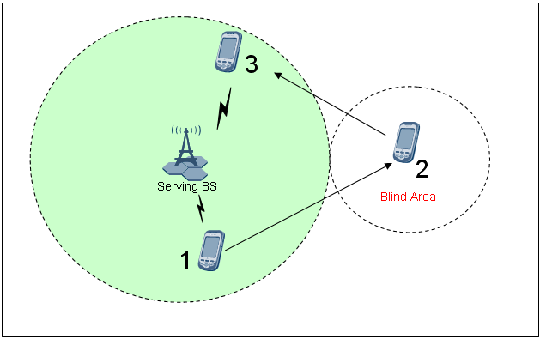
Figure 1 The intra-BS blind area type use case
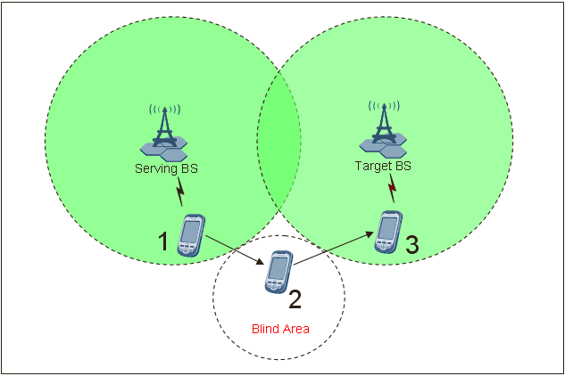
Figure 2 The inter-BS blind area type use case
For the circs of the use case, the concrete description is illustrated as below:
Location 1: When a MS enters the network, it should negotiate that it is able to check blind area and it has store neighbor BSs list, serving BS ID and RTD and some thresholds for SNR, RSSI and INR.
Location 2: When a MS enters the blind area, it should restore and measure the parameters for confirming position of the blind area
Location 3: When MS enters the network, it feedbacks the information measured to the target BS in inter-BS case and serving BS in intra BS case. Then the target/serving BS can get and record a lot of reports from many MSs so that it can analyzes the collected information and optimizes the coverage and capacity.
Figure 3 shows the simple call flow to report blind area detection information.
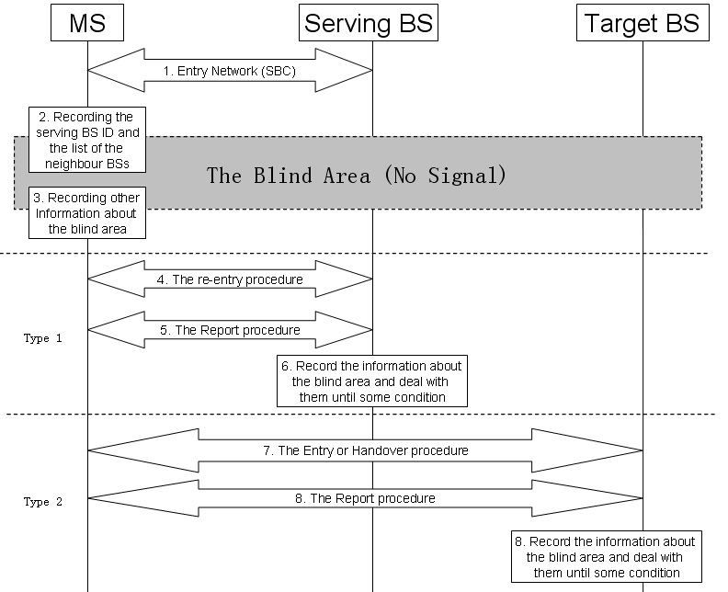
Figure 3 The procedure for checking the blind area
Note:
Type 1: the non inter-BS blind area type
Type 2: the inter-BS blind area type
The step for the proposal procedure is as below:
Step 1: MS and BS negotiate blind area detection capability during SBC procedures
Step 2: When MS enters the blind area with no signal, it records information to report the blind area;
Step 3: When the MS re-entries into the area with the signal of the target BS or the original BS, it records the related information that is helpful for checking the blind area (e.g. location information, etc)
Step 4, 5, 7, 8: For type 1, the MS performs the re-entry procedure and the report procedure in which the MS reports the related information to the network,
Step 6: The network analyze and evaluate the information in the report message from the MS

Conclusion

The blind area detection scheme and reporting procedures should be considered in the self-organization in 16m in order to enhance the system performance, QoS support, network capacity enhancement and throughput improvement.

Proposal

Add the text into section “18 Support for Self-organization”:
------------------------------------------- Start of Proposed SDD Text ------------------------------------------------------
18 Support for Self-organization
……
18.1 Self-Configuration
……
18.2 Self-Optimization
……
18.2.x Coverage and Capacity Optimization
18.2.x.x Blind Area Detection
There may be blind area where MS can’t receive the enough signal strength from any BSs due to poor environment, severe interference and any reason. When the MS enters and leaves the blind area, it should judge the blind area based on RSSI, SINR, I and INR and store location information, and its serving BS and neighbor BSs information in order to report to the network. When the MS re-enters the 16m network, it will report those information to network on demand from the 16m network.
……
------------------------------------------- End of Proposed SDD Text ------------------------------------------------------

