Project | IEEE 802.16 Broadband Wireless Access Working Group <http://ieee802.org/16>
Title | MAC header design for IEEE 802.16m system
Date Submitted | 2008-10-31
Source(s) | Jeongki Kim, Kiseon Ryu, Youngsoo Yuk, and Ronny Yongho Kim  LG Electronic Inc. LG R&D Complex, 533 Hogye-1dong, Dongan-gu, Anyang, 431-749, Korea | Voice: +82-31-450-2067  E-mail: chegal@lge.com, ksryu@lge.com, sixs@lge.com, and ronnykim@lge.com
Re: | TGm SDD: Other; in response to the IEEE 802.16m-08/040, Call for Comments and Contributions on Project 802.16m System Description Document (SDD)
Abstract | This contribution provides the formats of generic MAC header, extended subheader, and compressed MAC header for IEEE802.16m systems.
Purpose | To be discussed and adopted by TGm for use in the IEEE 802.16m SDD
Notice | This document does not represent the agreed views of the IEEE 802.16 Working Group or any of its subgroups. It represents only the views of the participants listed in the “Source(s)” field above. It is offered as a basis for discussion. It is not binding on the contributor(s), who reserve(s) the right to add, amend or withdraw material contained herein.
Release | The contributor grants a free, irrevocable license to the IEEE to incorporate material contained in this contribution, and any modifications thereof, in the creation of an IEEE Standards publication; to copyright in the IEEE’s name any IEEE Standards publication even though it may include portions of this contribution; and at the IEEE’s sole discretion to permit others to reproduce in whole or in part the resulting IEEE Standards publication. The contributor also acknowledges and accepts that this contribution may be made public by IEEE 802.16.
Patent Policy | The contributor is familiar with the IEEE-SA Patent Policy and Procedures:  <http://standards.ieee.org/guides/bylaws/sect6-7.html#6> and <http://standards.ieee.org/guides/opman/sect6.html#6.3>.  Further information is located at <http://standards.ieee.org/board/pat/pat-material.html> and <http://standards.ieee.org/board/pat>.
MAC header design for IEEE802.16m system
Jeongki Kim, Kiseon Ryu, Youngsoo Yuk, and Ronny Yongho Kim
LG Electronics

Introduction

As shown in figure 1, the generic MAC header (GMH) in IEEE 802.16Rev2 is 6 bytes including several fields. Some fields in GMH can be removed to optimize the GMH in 802.16m. For example, a EC field is set to 1 only when MAC PDU is encrypted. A CI field is set to 1only when MAC CRC is appended in MAC PDU. However, in most cases, PHY CRC is enabled so that CI field is usually set to 0. And a HCS can be omitted when HARQ is enabled in the physical layer. Therefore, the generic MAC header in 802.16m can be more optimized than the GMH in 802.16e.
A GMH in 802.16e has fixed format regardless of packet size. The GMH results in MAC overhead for short packets such as VoIP packets. IEEE 802.16m system should design the Compressed MAC headers for special resource allocation or short packets to reduce MAC overhead.
Connection identifier (flow id in 802.16m) can be omitted in MAC header for MAC management message because there is no function of flow id (or CID) in the MAC header for MAC management message except for the function to distinguish between data and MAC management messages.

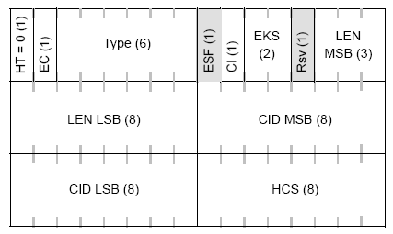
Figure 1 Generic MAC header format in IEEE 802.16Rev2

Proposed MAC header design
2.1 Generic MAC header (GMH)
HT(Header type) field indicates whether the MAC header is a signaling header. CH(Compressed header) field indicates whether the MAC header is a compressed MAC header. FPI (Fragmentation/Packing indicator) is included in the GMH. All subheaders except for packing/fragmentation subheader will be transmitted by using the ESH.
Figure 2 shows the proposed GMH format. HT and CH fields are set to 0. GMH does not contain the EC field because whether the encryption for a connection is enabled or disabled can be determined during service creation procedure. The description of GMH fields is shown in the table 1.

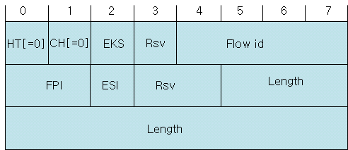
Figure 2 GMH format for data

Table 1 The description of GMH fields

Field (bit) | Description
HT (1) | HT(Header type)  Indicates whether the MAC header is signaling header (1) or not (0)
CH (1) | CH (Compressed Header)  Indicates whether the MAC header is compressed MAC header (1) or not (0)
EKS(1) | EKS(Encryption key sequence)  - 0 or 1: Two key sequences (For transition from old key to new key)
Flow id (4) | Flow identifier
FPI (2) | FPI (Fragmentation/packing indicator)  Indicates if there is fragmentation, packing or not  - 00: No fragmentation and packing  - 01: fragmentation subheader  - 10: packing subheader  - 11: reserved
ESI(1) | Extended subheader indicator
Length | The length in bytes of the MAC PDU including the MAC header and the CRC if present.
Rsv | Reserved field

2.2 Exended Subheader (ESH)
If the ESI field in the generic MAC header is set to 1, the extended subheader header follows the GMH. Figure 3 shows the extended subheader format. ESH consists of Ext, Type, and body. The Ext field indicates whether another ESH follows the current ESH. Type field indicates the type of extended subheader. Contents of ESH body and the size of ESH body (ESHB) part depend on the ESH type.
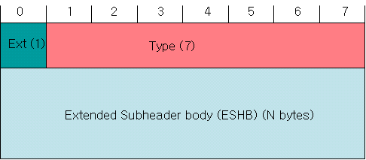
Figure 3 Extended subheader format

Figure 4 shows the example of using an extended subheader .
Figure 4 Example of MAC PDU with an extended subheader
Because one ESH is included in the MAC PDU, Ext field in ESH is set to 0.

Figure 5 shows the example of using multiple extended subheaders.
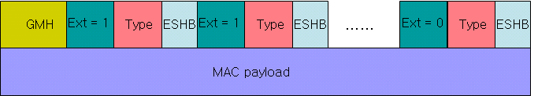
Figure 5 Example of MAC PDU with multiple extended subheaders
When multiple ESHs are included in MAC PDU, Ext fields of all ESHs except for last ESH are set to 1. Ext field of last ESH is set to 0.

2.3 Compressed MAC header (CMH)
The compressed MAC header (CMH) is used for transmitting the short data packets (MAC payload) like VoIP packets or TCP ACK and MAC management messages. The field for fragmentation/packing is removed in CMH because fragmentation or packing does not frequently occur in short packets. If packing or fragmentation occurs at short packets, the CMH contains the ESH for them (e.g. Packing ESH, fragmentation ESH). The CMH is divided into two types according to its usage. One is used for packets transmitted via persistent resource region (e.g. VoIP packets) and the other is used for short packets (e.g. TCP ACK or MAC management messages) except for packets transmitted via persistent resource region. The CMH should contain the EKS field to prevent illegal overhearing for packets.

2.3.1 CMH Type 1
Persistent scheduling is a method used to reduce MAP overhead for connections with periodic traffic pattern and with relatively fixed payload size. MAC PDUs transmitted through the persistent resource region includes always the Compressed MAC header (CMH) Type 1. Therefore CMH Type 1 doesn’t need to be differentiated from other MAC headers (e.g. GMH, signaling header, CMH Type 2). When the flow id is included in the DL control message (e.g. USCCH) for persistent resource allocation, it can be removed from the MAC header.
Figure 6 shows the format of compressed MAC header (CMH) Type 1.

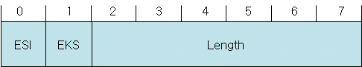
Figure 6 CMH Type 1 format (for persistent scheduling)

2.3.2 CMH Type 2
The compressed MAC header (CMH) Type 2 is used for transmitting the short data packets except for short data packets (VoIP) transmitted via the persistent resource region and MAC management messages. CMH Type2 can be distinguished from other MAC headers (GMH, Signaling header, etc.) by including HT and CH field in the header. CMH Type2 is divided into CMH Type 2 for MAC management messages and CMH Type 2 for short data packets. CMH Type 2 includes a MH (MAC management Header) field in order to differentiate CMH Type 2 for MAC management message from that for other short data packets.
Figure 7 shows the CMH Type 2 format for short data packets.

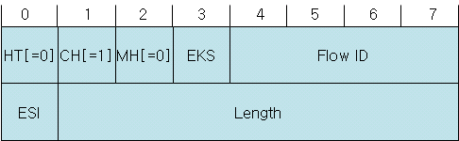
Figure 7 CMH Type 2 format (for short data packets)
HT and MH fields are set to 0 and CH filed is set to 1.
Figure 8 shows the CMH Type 2 format for MAC management message.
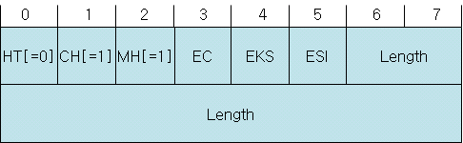
Figure 8 CMH Type 2 format (for MAC management message)
HT field is set to 0 and CH and MH fields are set to 1. CMH Type 2 for MAC management contains the EC field to support the selective encryption for MAC management messages.

Text Proposal for the 802.16m SDD

============================== Start of Proposed Text =================================

10.2 MAC header format
10.2.1 Generic MAC header
HT(Header type) field indicates whether the MAC header is a signaling header. CH(Compressed header) field indicates whether the MAC header is a compressed MAC header. FPI (Fragmentation/Packing indicator) is included in the GMH. All subheaders except for packing/fragmentation subheader will be transmitted by using the ESH.
Figure 2 shows the proposed GMH format. HT and CH fields are set to 0. GMH does not contain the EC field because whether the encryption for a connection is enabled or disabled can be determined during service creation procedure. The description of GMH fields is shown in the table 1.

Figure 2 GMH format for data

Table 1 The description of GMH fields

Field (bit) | Description
HT (1) | HT(Header type)  Indicates whether the MAC header is signaling header (1) or not (0)
CH (1) | CH (Compressed Header)  Indicates whether the MAC header is compressed MAC header (1) or not (0)
EKS(1) | EKS(Encryption key sequence)  - 0 or 1: Two key sequences (For transition from old key to new key)
Flow id (4) | Flow identifier
FPI (2) | FPI (Fragmentation/packing indicator)  Indicates if there is fragmentation, packing or not  - 00: No fragmentation and packing  - 01: fragmentation subheader  - 10: packing subheader  - 11: reserved
ESI(1) | Extended subheader indicator
Length | The length in bytes of the MAC PDU including the MAC header and the CRC if present.
Rsv | Reserved field

10.2.2 Exended Subheader (ESH)
If the ESI field in the generic MAC header is set to 1, the extended subheader header follows the GMH. Figure 3 shows the extended subheader format. ESH consists of Ext, Type, and body. The Ext field indicates whether another ESH follows the current ESH. Type field indicates the type of extended subheader. Contents of ESH body and the size of ESH body (ESHB) part depend on the ESH type.
Figure 3 Extended subheader format

10.2.3 Compressed MAC header (CMH)
The compressed MAC header (CMH) is used for transmitting the short data packets (MAC payload) like VoIP packets or TCP ACK and MAC management messages. The field for fragmentation/packing is removed in CMH because fragmentation or packing does not frequently occur in short packets. If packing or fragmentation occurs at short packets, the CMH contains the ESH for them (e.g. Packing ESH, fragmentation ESH). The CMH is divided into two types according to its usage. One is used for packets transmitted via persistent resource region (e.g. VoIP packets) and the other is used for short packets (e.g. TCP ACK or MAC management messages) except for packets transmitted via persistent resource region. The CMH should contain the EKS field to prevent illegal overhearing for packets.

10.2.3.1 CMH Type 1
Persistent scheduling is a method used to reduce MAP overhead for connections with periodic traffic pattern and with relatively fixed payload size. MAC PDUs transmitted through the persistent resource region includes always the Compressed MAC header (CMH) Type 1. Therefore CMH Type 1 doesn’t need to be differentiated from other MAC headers (e.g. GMH, signaling header, CMH Type 2). When the flow id is included in the DL control message (e.g. USCCH) for persistent resource allocation, it can be removed from the MAC header.
Figure 6 shows the format of compressed MAC header (CMH) Type 1.
Figure 6 CMH Type 1 format (for persistent scheduling)

10.2.3.2 CMH Type 2
The compressed MAC header (CMH) Type 2 is used for transmitting the short data packets except for short data packets (VoIP) transmitted via the persistent resource region and MAC management messages. CMH Type2 can be distinguished from other MAC headers (GMH, Signaling header, etc.) by including HT and CH field in the header. CMH Type2 is divided into CMH Type 2 for MAC management messages and CMH Type 2 for short data packets. CMH Type 2 includes a MH (MAC management Header) field in order to differentiate CMH Type 2 for MAC management message from that for other short data packets.
Figure 7 shows the CMH Type 2 format for short data packets.
Figure 7 CMH Type 2 format (for short data packets)
HT and MH fields are set to 0 and CH filed is set to 1.
Figure 8 shows the CMH Type 2 format for MAC management message.
Figure 8 CMH Type 2 format (for MAC management message)
HT field is set to 0 and CH and MH fields are set to 1. CMH Type 2 for MAC management contains the EC field to support the selective encryption for MAC management messages.

============================== End of Proposed Text =================================

