Project | IEEE 802.16 Broadband Wireless Access Working Group <http://ieee802.org/16>
Title | Peak-to-Average Power Ratio Issue of Beamforming/Precoding Schemes
Date Submitted | 2008-11-4
Source(s) | ¹ Hsuan-Jung Su, Chung-Pi Lee, Wei-Shun Liao, NTU  Ren-Jr Chen, Chung-Lien Ho, Chang-Lan Tsai, Zheng Yan-Xiu, ITRI | Voice:  ¹+886-2-33663600  E-mail:  ¹hjsu@cc.ee.ntu.edu.tw  *<http://standards.ieee.org/faqs/affiliationFAQ.html>
Re: | IEEE 802.16m-08/040 Call for Comments and Contributions on Project 802.16m SDD  TGm SDD: MIMO (DL Transmission Scheme)
Abstract | This contribution raises the point that most multiple input multiple output (MIMO) beamforming/precoding schemes increase the peak to average power ratio (PAPR) on the transmit antennas. Using a 4×4 MIMO system with singular value decomposition (SVD) based precoding and 64 QAM as an example, it is shown that 1% of the time the peak power is 6 dB higher than the average. Thus, it is suggested that PAPR be included as a criterion when beamforming/precoding schemes are proposed to 802.16m. In addition, a general remedy to the PAPR issue without introducing signal distortion or side information feeding forward should be considered in 802.16m. A method based on constellation shaping is provided in this contribution as an example of such general remedies. This method is shown to reduce the PAPR to almost always under 5 dB. In addition, it can be added to any existing beamforming/precoding schemes without changing the signal properties and degrading the performance.
Purpose | For discussion by IEEE 802.16m TG
Notice | This document does not represent the agreed views of the IEEE 802.16 Working Group or any of its subgroups. It represents only the views of the participants listed in the “Source(s)” field above. It is offered as a basis for discussion. It is not binding on the contributor(s), who reserve(s) the right to add, amend or withdraw material contained herein.
Release | The contributor grants a free, irrevocable license to the IEEE to incorporate material contained in this contribution, and any modifications thereof, in the creation of an IEEE Standards publication; to copyright in the IEEE’s name any IEEE Standards publication even though it may include portions of this contribution; and at the IEEE’s sole discretion to permit others to reproduce in whole or in part the resulting IEEE Standards publication. The contributor also acknowledges and accepts that this contribution may be made public by IEEE 802.16.
Patent Policy | The contributor is familiar with the IEEE-SA Patent Policy and Procedures:  <http://standards.ieee.org/guides/bylaws/sect6-7.html#6> and <http://standards.ieee.org/guides/opman/sect6.html#6.3>.  Further information is located at <http://standards.ieee.org/board/pat/pat-material.html> and <http://standards.ieee.org/board/pat>.
Peak-to-Average Power Ratio Issue of Beamforming/Precoding Schemes

Hsuan-Jung Su, Chung-Pi Lee, Wei-Shun Liao,
National Taiwan University (NTU)
Ren-Jr Chen, Chung-Lien Ho, Chang-Lan Tsai, Zheng-Yan Xin,
ITRI

Introduction
In the most recently issued SDD (IEEE 802.16m-08/003r5) [1], the multiple input multiple output (MIMO) architecture of the system adopted the methods which are based on beamforming/precoding as its close-loop MIMO solution. However, beamforming/precoding related methods usually result in increase of the peak-to-average power ratio (PAPR). As a result, the system performance is degraded when the power amplifier (PA) nonlinearity is present.
In this contribution, we use a 4×4 MIMO system with singular value decomposition (SVD) based precoding as an example to demonstrate the PAPR issue. It is suggested that PAPR be included as a criterion when beamforming/precoding schemes are proposed to 802.16m. In addition, a general remedy to the PAPR issue without introducing signal distortion or side information feeding forward should be considered in 802.16m. A method based on constellation shaping is provided in this contribution as an example of such general remedies.

PAPR Issue of Beamforming/Precoding Schemes and a Remedy
When beamforming/precoding across antennas is performed, PAPR on each transmit antenna will increase due to random combining of the information streams. For example, for MIMO systems with SVD based precoding at the transmitter, each information stream is transmitted on an eigen mode which distributes the information stream over all transmit antennas according to a certain set of weights obtained via SVD. The weighted information streams are then combined and transmitted on the antennas. In the worst case, these weighted information streams will add constructively and result in high peak power. The PAPR in general increases with the number of transmit antennas.
High PAPR results in signal distortion and degraded performance when the PA linear range is not large enough. Thus, in order to achieve a better performance, the PAPR issue should be considered in the design of signal constellation and beamforming/precoding schemes. In this contribution, we propose a general solution to the PAPR issue of beamforming/precoding which can be added to any beamforming/precoding schemes without changing the beamforming/precoding structure and introducing signal distortion. Moreover, unlike some PAPR reduction methods which require certain parameters to be fed forward from the transmitter to the receiver, this solution does not need such side information and additional forward channel bandwidth. With these advantages, the proposed method can simply become an add-on component to any existing beamforming/precoding schemes. The basic idea of the proposed method is summarized as follows. The detailed derivation and algorithms can be found in [2].
Considering that for a regular single-antenna system using square QAM constellations, the PAPR approaches 3 when the constellation is large, if the boundaries of the constellations on each transmit antenna of a precoded MIMO system can also be made square (i.e., in cubic shape), PAPR as low as 3 can be expected. To do so, and assuming that QAM constellations are used for the information streams before precoding, the QAM constellation of each information stream can be tessellated over the plane to form cosets with the original constellation points as the coset leaders. With precoding, a point from the coset corresponding to each stream’s data is selected such that after the weighted combining on each transmit antenna due to precoding, the constellation boundary of the combined sing is approximately cubic. This is equivalent to changing the QAM boundary of each information stream to a different shape. In order not to destroy the structure and properties of the precoded signals, a reversible integer-to-integer mapping derived from the precoding matrix has to be used. In [2], several such methods were proposed.
In practice, there are a limited number of possible precoding matrices due to limited channel condition feedback. In this case, the integer-to-integer mapping can be computed offline and stored in a lookup table to reduce the real-time computational complexity.

Simulation Results
In the simulation, we consider SVD based precoding for a 4×4 MIMO system with 64 QAM for each information stream. The elements of the channel matrix are assumed i.i.d. Raleigh and quasi-static. The channel condition feedbacks are assumed perfect, and the precoding matrix, as well the proposed integer-to-integer mapping, are derived from the channel condition.
In Figure 1, the complementary cumulative distribution functions (CCDF) of the PAPR values for the SVD based precoding with and without the proposed PAPR reduction shaping are both shown. It can be seen that, without shaping, there is about 1% probability the peak power is 6 dB higher than the average. With shaping, the PAPR is almost always below 5 dB. It also can be seen that the CCDF of SVD based precoding with PAPR reduction is almost the same as that of single antenna system (no precoding).
Figure 1: CCDF of SVD precoding with and without PAPR reduction function.

Conclusions
In this contribution, we addressed the high PAPR issue related to MIMO beamforming/precoding schemes. Using a 4×4 MIMO system with SVD based precoding and 64 QAM as an example, it was shown that precoding indeed increases the PAPR. Thus, it was suggested that PAPR be included as a criterion when beamforming/precoding schemes are proposed to 802.16m. In addition, a general remedy to the PAPR issue without introducing signal distortion or side information feeding forward should be considered in 802.16m. A method based on constellation shaping was also provided in this contribution as an example of such general remedies.
It is proposed that the 802.16m systems should include the PAPR reduction functionality in the MIMO beamforming/precoding schemes, and the SDD should adopt the proposed texts listed as follows.
Proposed Text:

11.8.1 DL MIMO Architecture and Data Processing
In Figure 40 “MIMO Architecture”, add a “PAPR Reduction” block below the “Precoding Vector/Matrix” block.
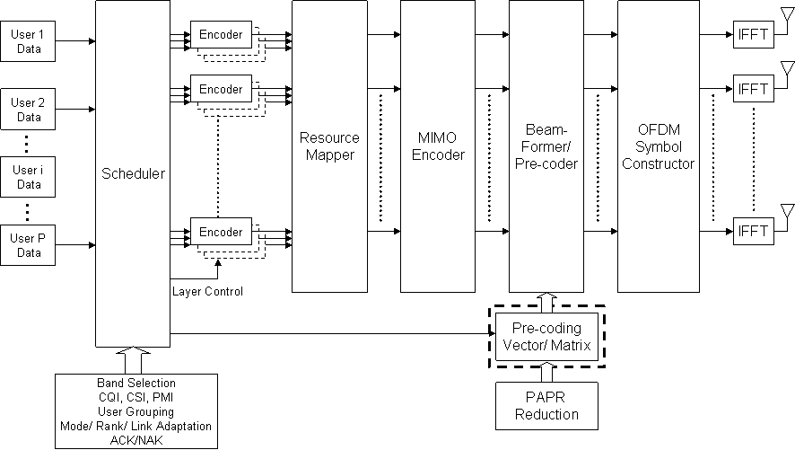
Figure 40 MIMO Architecture

Add the following text to line 9 on page 76.

The Beamformer/Precoder block should have the PAPR reduction functionality.

11.12.1 UL MIMO Architecture and Data Processing
In Figure 42 “MIMO Architecture”, add a “PAPR Reduction” block below the “Precoding Matrix” block.
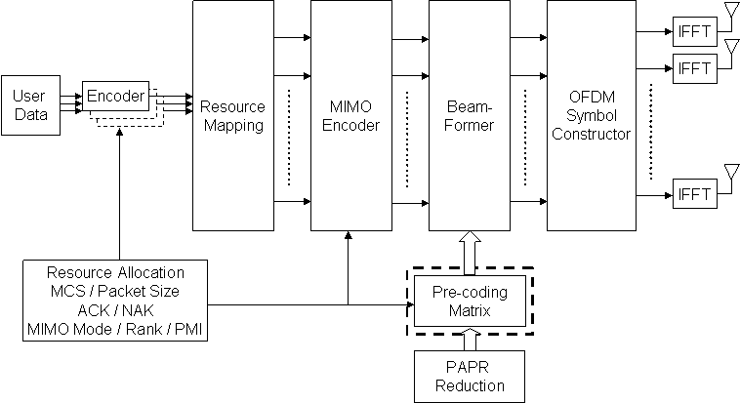
Figure 42 MIMO Architecture

Add the following text to line 7 on page 95.

The Precoder block should have the PAPR reduction functionality.

References
- IEEE 802.16m-08/003r5, “802.16m System Description Document”.
- C.–P. Lee, H.–J. Su, “Peak to Average Power Ratio Reduction of Space-Time Codes That Achieve Diversity-Multiplexing Gain Tradeoff,” IEEE International Symposium on Personal, Indoor and Mobile Communications, September 2008.

