Project | IEEE 802.16 Broadband Wireless Access Working Group <http://ieee802.org/16>
Title | Performance evaluation of DL OL SU-MIMO Transmit Scheme
Date Submitted | 2008-10-31
Source(s) | Yinggang Du, Yin Wei Zhao, Hongjie Si, Xin Chang, Yang Tang  Huawei  Ying Du  CATR | E-mail:  duyinggang@huawei.com  duying@mail.ritt.com.cn
Re: | IEEE 802.16m-08/040: Call for Comments and Contributions on Project 802.16m System Description Document (SDD)  Target Topic: TGm SDD: Other (for contributions in support of a comment)
Abstract | We propose a 4Tx antennas rate2 scheme to be included in the SDD document.
Purpose | For discussion and approval by TGm.
Notice | This document does not represent the agreed views of the IEEE 802.16 Working Group or any of its subgroups. It represents only the views of the participants listed in the “Source(s)” field above. It is offered as a basis for discussion. It is not binding on the contributor(s), who reserve(s) the right to add, amend or withdraw material contained herein.
Release | The contributor grants a free, irrevocable license to the IEEE to incorporate material contained in this contribution, and any modifications thereof, in the creation of an IEEE Standards publication; to copyright in the IEEE’s name any IEEE Standards publication even though it may include portions of this contribution; and at the IEEE’s sole discretion to permit others to reproduce in whole or in part the resulting IEEE Standards publication. The contributor also acknowledges and accepts that this contribution may be made public by IEEE 802.16.
Patent Policy | The contributor is familiar with the IEEE-SA Patent Policy and Procedures:  <http://standards.ieee.org/guides/bylaws/sect6-7.html#6> and <http://standards.ieee.org/guides/opman/sect6.html#6.3>.  Further information is located at <http://standards.ieee.org/board/pat/pat-material.html> and <http://standards.ieee.org/board/pat>.
Performance evaluation of DL OL SU-MIMO Transmit Scheme
Yinggang Du, Hongjie Si, Yinwei Zhao, Xin Chang, Yang Tang
Huawei
Ying Du
CATR

1. Introduction
We propose a 4Tx antennas rate2 scheme to be included in the SDD document.

2. Multiplexing scheme with 4 TX antennas and rate 2
Here we provide our simulation results on different rate 2 OL SU MIMO schemes: Double Space Time Transmit Diversity (DSTTD), Random Beamforming(RBF), and Spatial Multiplexing with Antenna Hopping (SM+AH).

2.1 Simulation assumptions
The simulation assumptions as following：
Parameters |  | Value
FFT Size |  | 1024
Bandwidth |  | 10M
Carrier frequency |  | 2.5G
Number of transmit antennas |  | 4
Number of receiver antennas |  | 2
Resource block |  | 18subcarriers X 6 OFDM symbols
Channel encoding |  | CTC as in IEEE 802.16e
Modulation |  | QPSK
Code rate |  | 1/2
Receiver Type |  | L-MMSE
The channel estimation |  | Linear interruption
Channel Model |  | PED B-3km/hr and VEH A -60km/hr
The correlation of channel |  | Uncorrelated and correlated (According to EMD profile specified in 3.2.8.)
Pilot pattern and density |  | According to SDD pilot specified in the following
Simulation  Scheme | DSTTD
Simulation  Scheme | Antenna Hopping
Simulation  Scheme | RBF | P(k) = D(k)W(k). [1] [2]

[1] Description RBF as following：
- Precoded demodulation pilot shall be used for OL-SU-MIMO, in other words, demodulation pilots (channel estimation purpose) are precoded with same precoder, P(k) = D(k)W(k)
- W(k) should be chosen based on CL-SU-MIMO codebook （DFT or 16e codebook）or its subset
- Size of u should be one or multiple of P_{sc} (18 contiguous subcarriers)
- θ₀ = 0, θ₁ = -2πD/N_{fft}, θ₂ =2θ₁, θ₃ =3θ₁, with D should be zero or small number (e.g. 2 or 4) where N_{fft} is FFT size. The value of D adopts 2 in simulation.
- Size of k should be 1

[2] Codebook for 4-antenna BS in DL

The Matrix codebook is a DFT codebook with QPSK and 8PSK alphabet and a block diagonal structure.

Let us define the rotation matrix and QPSK DFT matrix as
and

The codebook matrices are , , , , and .
Mapping from Matrix codebook to transmit SU MIMO codebook is specified in Table A.2.

Table A.2 – SU MIMO Codebook for 4-antenna BS in DL
Transmit Codebook Index | Rank 1 | Rank 2 | Rank 3 | Rank 4
1 | C_{1,1} =W1(:,2) | C_{1,2} =W1(:,12) | C_{1,3} =W1(:,123) | C_{1,4} =W1(:,1234)
2 | C_{2,1} =W1(:,3) | C_{2,2} =W1(:,13) | C_{2,3} =W1(:,124) | C_{2,4} =W2(:,1234)
3 | C_{3,1} =W1(:,4) | C_{3,2} =W1(:,14) | C_{3,3} =W1(:,134) | C_{3,4} =W3(:,1234)
4 | C_{4,1} =W2(:,2) | C_{4,2} =W1(:,23) | C_{4,3} =W1(:,234) | C_{4,4} =W4(:,1234)
5 | C_{5,1} =W2(:,3) | C_{5,2} =W1(:,24) | C_{5,3} =W2(:,123) | C_{5,4} =W5(:,1234)
6 | C_{6,1} =W2(:,4) | C_{6,2} =W1(:,34) | C_{6,3} =W2(:,124) | C_{6,4} =W6(:,1234)
7 | C_{7,1} =W3(:,1) | C_{7,2} =W2(:,13) | C_{7,3} =W2(:,134) | n/a
8 | C_{8,1} =W4(:,1) | C_{8,2} =W2(:,14) | C_{8,3} =W2(:,234) | n/a
9 | C_{9,1} =W5(:,1) | C_{9,2} =W2(:,23) | C_{9,3} =W3(:,123) | n/a
10 | C_{10,1} =W5(:,2) | C_{10,2} =W2(:,24) | C_{10,3} =W3(:,134) | n/a
11 | C_{11,1} =W5(:,3) | C_{11,2} =W3(:,13) | C_{11,3} =W4(:,123) | n/a
12 | C_{12,1} =W5(:,4) | C_{12,2} =W3(:,14) | C_{12,3} =W4(:,134) | n/a
13 | C_{13,1} =W6(:,1) | C_{13,2} =W4(:,13) | C_{13,3} =W5(:,123) | n/a
14 | C_{14,1} =W6(:,2) | C_{14,2} =W4(:,14) | C_{14,3} =W5(:,134) | n/a
15 | C_{15,1} =W6(:,3) | C_{15,2} =W5(:,13) | C_{15,3} =W6(:,124) | n/a
16 | C_{16,1} =W6(:,4) | C_{16,2} =W6(:,24) | C_{16,3} =W6(:,234) | n/a

2.2 Simulation Results

2.2.1 PB3 (UnCo-CH)

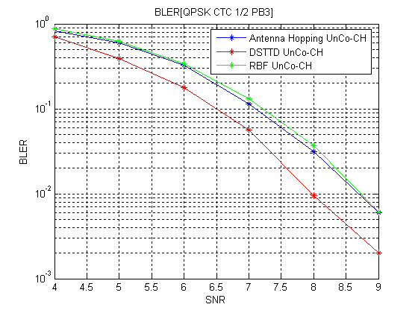
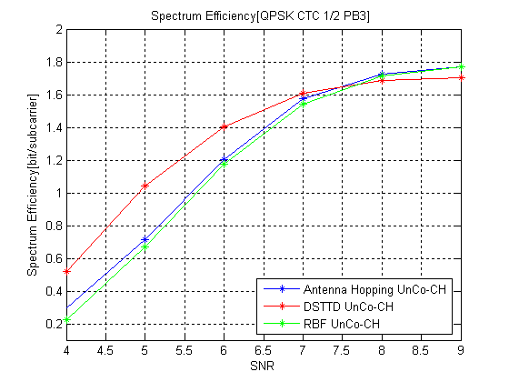

2.2.2 PB3 (Co-CH)
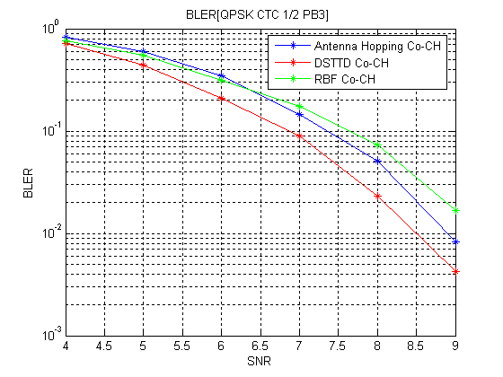
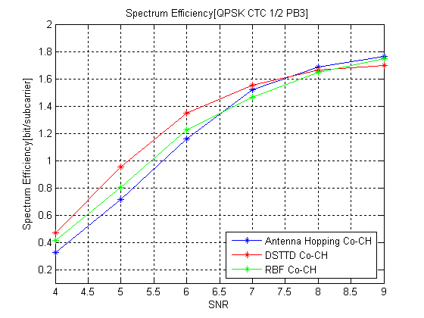

2.2.3 VA60 (UnCo-CH)
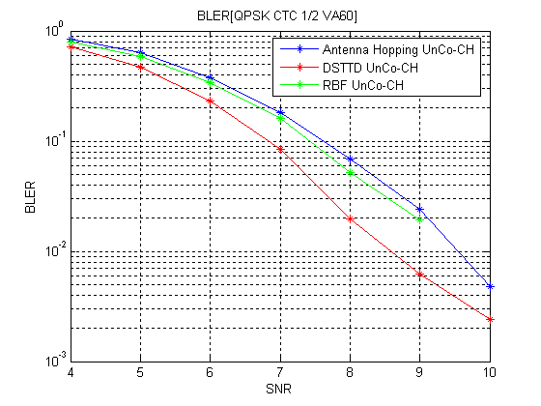
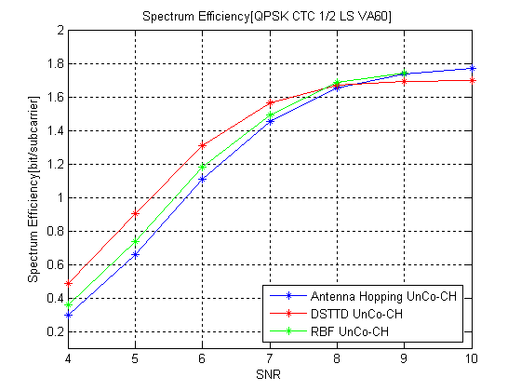

2.2.4 VA60 (Co-CH)
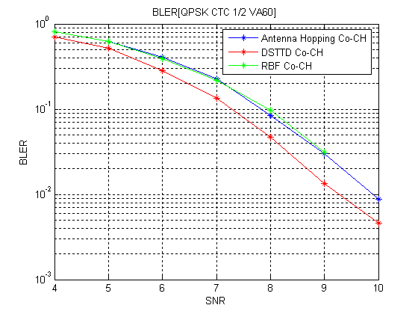
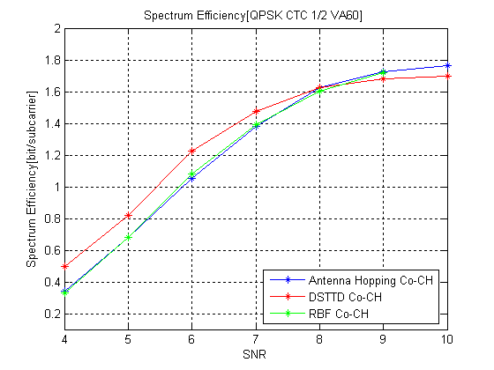

3. Conclusions
With the simulation results, it can be found that D-STTD is the best in both correlated and un-correlated channel. D-STTD is the relatively complicated one but the complexity is only about 2 times of SM+AH.

Text Proposal modification to SDD
(L18, P79 of IEEE 802.16m-08/003r5)

Open-loop SU-MIMO
NT | Rate | M | NF
2 | 1 | 1 | 1
2 | 1 | 2 | 2
4 | 1 | 1 | 1
4 | 1 | 2 | 2
8 | 1 | 1 | 1
8 | 1 | 2 | 2
2 | 2 | 2 | 1
4 | 2 | 2 | 1
4 | 2 | 4 | 2
8 | 2 | 2 | 1
4 | 3 | 3 | 1
8 | 3 | 3 | 1
4 | 4 | 4 | 1
8 | 4 | 4 | 1
Table 5 Matrix dimensions for open-loop SU-MIMO modes

(L5, P81 of IEEE 802.16m-08/003r5)

Spatial Multiplexing

The following spatial multiplexing modes are supported for open-loop single-user MIMO:
- Rate-2 spatial multiplexing modes:
  - 2Tx rate-2: rate 2 SM
  - 4Tx rate-2: rate 2 D-STTD
  - 8Tx rate-2: rate 2 D-STTD

- Rate-3 spatial multiplexing modes:
  - 4Tx rate-3: rate 3 SM with precoding
  - 8Tx rate-3: rate 3 SM with precoding
- Rate-4 spatial multiplexing modes:
  - 4Tx rate-4: rate 4 SM
  - 8Tx rate-4: rate 4 SM with precoding

For the rate-2 spatial multiplexing modes, the input to the MIMO encoder is represented as a 2 × 1 vector
$x=\left[\begin{matrix}s_{1} \\ s_{2}\end{matrix}\right]$, Equation 1

The output of the MIMO encoder is a 2 × 1 vector
$z=x$, Equation 2

For the 2Tx rate-2 mode, the output of the precoder is a 2 × 1 vector
$y=z$. Equation 3

$y=W×z$

$y=W×z$

For 4Tx antennas rate2 mode, the input to the MIMO encoder is represented as a 4 × 1 vector
$$x=\left[\begin{matrix}s_{1} \\ s_{2} \\ s_{3} \\ s_{4}\end{matrix}\right]$$
The output of the MIMO encoder is a 4 × 2 matrix
$$z=\left[\begin{matrix}s_{1} & −s_{2}^{} \\ s_{2} & s_{1}^{} \\ s_{3} & −s_{4}^{} \\ s_{4} & s_{3}^{}\end{matrix}\right]$$
the output of the precoder is a 4 × 2 matrix
$y=W×z$,
where W is a 4 × 4 unitary precoder.

When using Antenna Hopping, $W$ is a set of 3 antenna circulation matrices, i.e.,
$W=\left[\begin{matrix}1 & 0 & 0 & 0 \\ 0 & 1 & 0 & 0 \\ 0 & 0 & 1 & 0 \\ 0 & 0 & 0 & 1\end{matrix}\right],\left[\begin{matrix}1 & 0 & 0 & 0 \\ 0 & 0 & 1 & 0 \\ 0 & 1 & 0 & 0 \\ 0 & 0 & 0 & 1\end{matrix}\right],\left[\begin{matrix}1 & 0 & 0 & 0 \\ 0 & 0 & 1 & 0 \\ 0 & 0 & 0 & 1 \\ 0 & 1 & 0 & 0\end{matrix}\right]$.
$W$ can be changed every pair of tones or symbols.

For 8Tx antennas rate2 mode, the input to the MIMO encoder is represented as a 4 × 1 vector
$$x=\left[\begin{matrix}s_{1} \\ s_{2} \\ s_{3} \\ s_{4}\end{matrix}\right]$$
The output of the MIMO encoder is a 4 × 2 matrix
$$z=\left[\begin{matrix}s_{1} & −s_{2}^{} \\ s_{2} & s_{1}^{} \\ s_{3} & −s_{4}^{} \\ s_{4} & s_{3}^{}\end{matrix}\right]$$
the output of the precoder is a 4 × 2 matrix
$y=W×z$,
where W is defined as follows:

$W=W_{1}×W_{2}$.

$W_{1}$ is a 8x4 matrix which is implementation specific, $W_{2}$ is a 4 × 4 unitary precoder.

When using Antenna Hopping, $W_{2}$ is a set of 3 antenna circulation matrices, i.e.,
$W=\left[\begin{matrix}1 & 0 & 0 & 0 \\ 0 & 1 & 0 & 0 \\ 0 & 0 & 1 & 0 \\ 0 & 0 & 0 & 1\end{matrix}\right],\left[\begin{matrix}1 & 0 & 0 & 0 \\ 0 & 0 & 1 & 0 \\ 0 & 1 & 0 & 0 \\ 0 & 0 & 0 & 1\end{matrix}\right],\left[\begin{matrix}1 & 0 & 0 & 0 \\ 0 & 0 & 1 & 0 \\ 0 & 0 & 0 & 1 \\ 0 & 1 & 0 & 0\end{matrix}\right]$.
$W$ can be changed every pair of tones or symbols.
For the rate-3 spatial multiplexing modes, the input to the MIMO encoder is represented as a 3 × 1 vector
$x=\left[\begin{matrix}s_{1} \\ s_{2} \\ s_{3}\end{matrix}\right]$, Equation 6

The output of the MIMO encoder is a 3 × 1 vector
$z=x$, Equation 7

For the 4Tx rate-3 mode, the output of the precoder is a 4 × 1 vector
$y=W×z$, Equation 8

where W is a 4 × 3 precoder. Note that W may be frequency and/ or time dependent as described in section Error: Reference source not found.
For the 8Tx rate-3 mode, the output of the precoder is a 8 × 1 vector
$y=W×z$, Equation 9

where W is a 8 × 3 precoder. Note that W may be frequency and/ or time dependent as described in section Error: Reference source not found.

For the rate-4 spatial multiplexing modes, the input to the MIMO encoder is represented as a 4×1 vector
$x=\left[\begin{matrix}s_{1} \\ s_{2} \\ s_{3} \\ s_{4}\end{matrix}\right]$, Equation 10

The output of the MIMO encoder is a 4 × 1 vector
$z=x$, Equation 11

For the 4Tx rate-4 mode, the output of the precoder is a 4 × 1 vector
$y=z$, Equation 12

For the 8Tx rate-4 mode, the output of the precoder is a 8 × 1 vector
$y=W×z$, Equation 13

where W is a 8 × 4 precoder. Note that W may be frequency and/ or time dependent as described in section Error: Reference source not found.

------------------------------------End text proposal------------------------------------

