Project | IEEE 802.16 Broadband Wireless Access Working Group <http://ieee802.org/16>
Title | Comments on Data Forwarding in Project 802.16m System Description Document (Draft 5)
Date Submitted | 2008-11-07
Source(s) | Yang Liu, Yuqin Chen, Hongyun Qu, Mary Chion, Huiying Fang, Li Wang  ZTE Corporation  706/4, Liantang Pengji Industrial Park, Shenzhen, P.R.China 518004  Gamini Senarath,  Nortel  Xiaolu Dong, Ying Du, Daning Gong  CATR  Xin Su, Xiaofeng Zhong  Tsinghua Univ.  Gang Shen, Kaibin Zhang  Alcatel-Sbell | Voice: +86-755-26773000-6630  E-mail: liu.yang8@zte.com.cn  dongxiaolu,duying@mail.ritt.com.cn  suxin@mail.tsinghua.edu.cn  gang.a.shen@alcatel-sbell.com.cn
Re: | [TGm SDD] [Relay] IEEE 8022.16m-08/040: Call for Comments and Contributions on Project 802.16m System Description Document (SDD)
Abstract | This contribution proposes modifications on 16m protocol architecture to enable relay functions
Purpose | For acceptance into the SDD.
Notice | This document does not represent the agreed views of the IEEE 802.16 Working Group or any of its subgroups. It represents only the views of the participants listed in the “Source(s)” field above. It is offered as a basis for discussion. It is not binding on the contributor(s), who reserve(s) the right to add, amend or withdraw material contained herein.
Release | The contributor grants a free, irrevocable license to the IEEE to incorporate material contained in this contribution, and any modifications thereof, in the creation of an IEEE Standards publication; to copyright in the IEEE’s name any IEEE Standards publication even though it may include portions of this contribution; and at the IEEE’s sole discretion to permit others to reproduce in whole or in part the resulting IEEE Standards publication. The contributor also acknowledges and accepts that this contribution may be made public by IEEE 802.16.
Patent Policy | The contributor is familiar with the IEEE-SA Patent Policy and Procedures:  <http://standards.ieee.org/guides/bylaws/sect6-7.html#6> and <http://standards.ieee.org/guides/opman/sect6.html#6.3>.  Further information is located at <http://standards.ieee.org/board/pat/pat-material.html> and <http://standards.ieee.org/board/pat>.

Comments on Data Forwarding in Project 802.16m System Description Document (Draft 5)

Yang Liu, Yuqin Chen, Hongyun Qu, Mary Chion, Huiying Fang, Li Wang
ZTE Corporation

Gamini Senarath
Nortel

Introduction
Currently, the SDD defines Data communications happen between a BS and RS/MS. However, in local forwarding transmission, MSs belonged to one RS may communicate with each other and the data is forwarded only by the RS. The simulation results show that the local forwarding mode increases the system throughput with various system configurations.

Motivation
It is noticed that local area communication plays a more and more important role in daily life. For instances, people in a village may contact each other more frequently than to outside world, students in one campus shall communicate with classmates more than that with friends out of the campus, and staff in one company have to exchange large size files very often. A local forwarding design in such scenarios is expected to decrease the delay or increase the throughput.

Proposed Solution
Local forwarding means MSs belonged to one RS communicate with each other while the data is forwarded only by the RS.
Take a single cell with OFDMA/TDD multihop topology (Figure 1) as an example. In local forwarding mode, data between MS2 and MS3 is forwarded by RS2. Accordingly, BS will not receive or transmit the data but perform control signaling if necessary.
Figure 1. Cellular system model with fixed RSs

To find a numerical result for local forwarding, we list the simulation parameters as follows. Here AMC is used in the system. The mode of adaptive modulation and coding is shown in table 1.
Table 1. The mode of adaptive modulation and coding[1]
Data_rate  ID | Modulation and coding mode(code rate) | Data bits  /symbol | Data bits  /slot | Rate of data/slot（kbps） | SNR
1 | QPSK（1/2） | 1 | 48 | 233.24 | 5.0
2 | QPSK（3/4） | 1.5 | 72 | 349.86 | 8.0
3 | 16QAM（1/2） | 2 | 96 | 466.48 | 10.5
4 | 16QAM（3/4） | 3 | 144 | 699.71 | 14.0
5 | 64QAM（2/3） | 4 | 192 | 932.95 | 18.0
6 | 64QAM（3/4） | 4.5 | 216 | 1049.57 | 20.0

The signal to noise ratio without neighbor interference is
$\text{SNR}(\text{db})=P_{t}−\text{PathLoss}−\text{ShadowFading}−P_{N}$ （1）
Where is transmission power and is the noise power.
The receiver noise power can be found by
$\text{Receiver noise floor}(\text{dbm})=−\text{174}+\text{NF}+\text{10}{\text{log}}_{\text{10}}\text{Bandwidth}(\text{Hz})$ （2）
where$\text{Bandwidth}(\text{Hz})$ is the bandwidth for one sub channel。
In the simulation, the channel model for BS and RS is WINNER B5a(LOS), while other channels are modeled by WINNER C2(LOS/NLOS). The details are listed as follows.
For WINNER B5a model, we have
$\text{PL}=\text{23}\text{.}5{\text{log}}_{\text{10}}(d)+\text{42}\text{.}5+\text{20}{\text{log}}_{\text{10}}({f_{c}}/5\text{.}0)\begin{matrix} & σ=4\text{dB},\begin{matrix} & \text{30}m<d<8\text{km}\end{matrix}\end{matrix}$ （3）
Where d is the distance between transmitter and receiver, $f_{c}$is the system central frequency in GHz, the shadowing follows lognormal distribution with a standard difference.
In addition, WINNER C2 can be classified into LOS model and NLOS model. The channel will be modeled by one of them with a certain probability.
In details, the LOS is modeled by
（4）
And the NLOS model is
（5）
The probability of LOS can be modeled as
（6）
The height of antenna is$h_{\text{BS}}=\text{25}m$，$h_{\text{RS}}=\text{15}m$，$h_{\text{MS}}=1\text{.}5m$，while the effective antenna height is $h_{\text{BS}}^{'},h_{\text{MS}}^{'}$ by considering a civil effect antenna height factor 1.0m:
（7）
（8）
Here $c=3×{\text{10}}^{8}m/s$ is the radio speed.
The topology of simulation is shown in figure 1. One base station (BS) is in the center of the cell and six fixed relay stations (RS) are evenly distributed around the BS. The distance of each RS to the BS is 2/3 of the cell radius. The number of user is 400 and all the users are assumed uniformly distributed in the cell.
The rest parameters used are listed as follows. A round robin manner scheduling is adopted.
Table 2. Simulation parameters for system model [2]
Parameter name | Value | Units
Side to side | 1000 | m
Carrier frequency | 3.5 | GHz
Channel bandwidth | 10 | MHz
FFT size | 1024
Subcarrier number | 1024(  92 low-end guard Subcarrier,  91 high-end guard Subcarrier，  1 DC Subcarrier)
Frame duration | 5 | ms
UL/DL duplexing scheme | TDD (28 symbols for DL,  9 symbols for UL,  11 symbols for frame overhead)
Subcarrier permutation mode | PUSC
Number of subchannels DL | 30
Sub-carrier frequency spacing | 10.94 | kHz
Useful Symbol Time（Tb） | 91.4 | us
Guard Time(Tg=Tb/8) | 11.4 | us
OFDMA symbol duration（Ts＝Tb＋Tg） | 102.9 | us
BS transmit power | 46 | dbm
RS transmit power | 38 | dbm
BS Antenna height | 25 | m
RS Antenna height | 15 | m
MS Antenna height | 1.5 | m
Minimum distance | BS and MS | >= 35 meters
Minimum distance | RS and MS | >= 10 meters
Thermal noise spectral density | -174 dBm/Hz

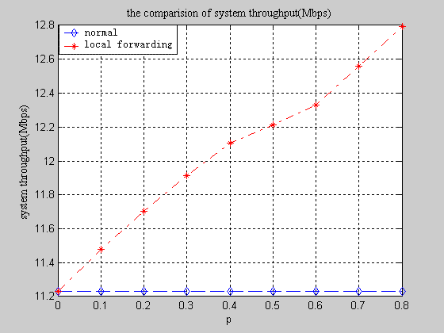
Figure 2. DL throughput (defined in [3] )with p ranges form 0.1 to 0.8
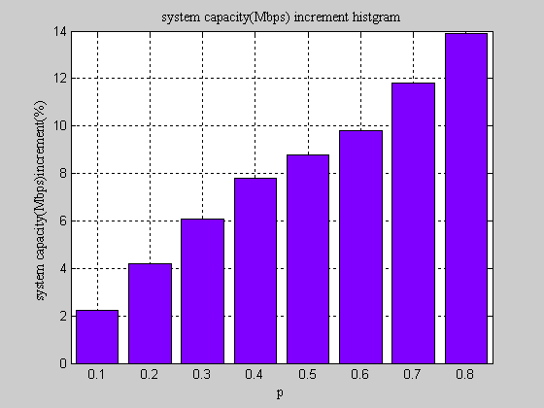
Figure 3. System throughput Increment (%) with p ranges from 0.1 to 0.8

Assuming that p is the probability of local forwarding cases in one MS, Figure 2 and Figure 3 shows the system throughput enhancement with a saturated traffic model. It can be observed that DL throughput increases with various p. For instance, when p is 0.6, the throughput increment is about 10%. And the gain is especially rich when most of the transmission happens inside the same cell.

Therefore, local forwarding mode benefits the system.

Proposed Changes
[Modify the description of the Data Forwarding on Page 28, line 12, as indicated:]
The Data Forwarding block performs forwarding functions on the path between BS and RS/MS, and the path between RS and the attached MS.

[Add the following description for local forwarding mode on Page 104 as indicated:]

15 Support for multi-hop relay
15.x Local Forwarding Mode
In local forwarding mode, MSs directly attached to one RS communicate with each other while the data is forwarded only by the RS. The BS supporting multi hop relay shall schedule the resource for the RS when centralized scheduling is adopted. While in distributed scheduling, the RS may schedule for local forwarding all by itself.
The MAC addressing process of the MAC PDU in local forwarding mode is FFS.

Reference
- The Relay Task Group of IEEE 802.16, IEEE Standard for Local and metropolitan area networks Part 16: Air Interface for Fixed and Mobile Broadband Wireless Access Systems Amendment 2:Physical and Medium Access Control Layers for Combined Fixed and Mobile Operation in Licensed Bands and Corrigendum 1. IEEE Std 802.16e™-2005 and IEEE Std 802.16™-2004/Cor 1-2005.
- Jeffrey G. Andrews, Arunabha Ghosh, Rias Muhamed. Fundamentals of WiMAX——Understanding Broadhand Wireless Networking. Prentice Hall Communications Engineering and Emerging Technologies Series..
- IEEE 802.16m-08/004r3, IEEE 802.16m Evaluation Methodology Document (EMD), Sep. ,2008

