Project | IEEE 802.16 Broadband Wireless Access Working Group <http://ieee802.org/16>
Title | Suggested Remedies for 802.16m System Description Document
Date Submitted | 2008-03-16
Source(s) | Chie Ming Chou, Richard Li, Frank Ren, Chun-Yen Wang, ITRI  Wern-Ho Sheen, NCTU/ITRI | Voice: +886-3-591-7596  E-mail: chieming@itri.org.tw  richard929@itri.org.tw
Re: | IEEE 802.16m-08/005 - Call for Contributions on Project 802.16m System Description Document (SDD); shoot for the content of Sections 4, 5, and 8 of IEEE 802.16m-08/003
Abstract | This contribution shows remedies for 802.16m SDD section 4 and 5.
Purpose | For discussion and approval by TGm
Notice | This document does not represent the agreed views of the IEEE 802.16 Working Group or any of its subgroups. It represents only the views of the participants listed in the “Source(s)” field above. It is offered as a basis for discussion. It is not binding on the contributor(s), who reserve(s) the right to add, amend or withdraw material contained herein.
Release | The contributor grants a free, irrevocable license to the IEEE to incorporate material contained in this contribution, and any modifications thereof, in the creation of an IEEE Standards publication; to copyright in the IEEE’s name any IEEE Standards publication even though it may include portions of this contribution; and at the IEEE’s sole discretion to permit others to reproduce in whole or in part the resulting IEEE Standards publication. The contributor also acknowledges and accepts that this contribution may be made public by IEEE 802.16.
Patent Policy | The contributor is familiar with the IEEE-SA Patent Policy and Procedures:  <http://standards.ieee.org/guides/bylaws/sect6-7.html#6> and <http://standards.ieee.org/guides/opman/sect6.html#6.3>.  Further information is located at <http://standards.ieee.org/board/pat/pat-material.html> and <http://standards.ieee.org/board/pat>.
Suggested Remedies for 802.16m System Description Document
Chie Ming Chou, Richard Li, Frank Ren, Chun-Yen Wang, ITRI
Wern-Ho Sheen, NCTU/ITRI

- Introduction
In response to Call for Comments on Section 4, 5, and 8 in 802.16m SDD, we have certain concern on the Figure 2 and Figure 3. This contribution presents our suggested remedies for the two figures, corresponding to our submitted comments.

- Suggested Remedies
- Remedy for Figure 2 in 802.16m SDD
According to current SRD description on Relay support and in order to avoid confusion, the relay station in Figure 2 is supposed to be an 802.16m RS. In addition, whether the 802.16m RS can support 802.16e MS is FFS, hence we suggest revising Figure 2 as follows to reflect the real understanding so far.

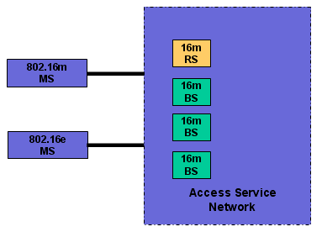
Figure 2 The 16m RS in overall network architecture

- Remedy for Figure 3 in 802.16m SDD
We suggest renaming as an “802.16m Entity” for consistency. The modified figure is shown as follows.
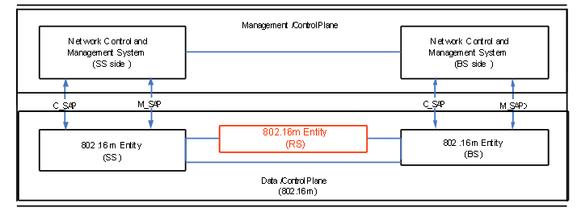
Figure 3 System Reference Model

- Proposed Text
Our proposal is to replace Figure 2 and 3 in the current SDD using the two in this contribution to reflect the current status of 802.16m network and system views exactly.

---- Start of the proposed text ----------------------------------------------------------------------------------------
<Replace the Figure 2 and its caption by the following figure and caption.>

Figure 2 The 802.16m RS in overall network architecture

---- End of the proposed text ----------------------------------------------------------------------

---- Start of the proposed text ----------------------------------------------------------------------------------------
<Replace the Figure 3 by the following figure.>

Figure 3 System Reference Model

---- End of the proposed text ----------------------------------------------------------------------

