Project | IEEE 802.16 Broadband Wireless Access Working Group <http://ieee802.org/16>
Title | Configuration of Sleep Window for IEEE 802.16m Sleep Mode Operation
Date Submitted | 2008-10-31
Source(s) | Chung-Hsien Hsu, Yih-Shen Chen, I-Kang Fu, and Paul Cheng  MediaTek Inc.  No.1, Dusing Rd. 1, HsinChu Science-Based Industrial Park, HsinChu, Taiwan 300, R.O.C. | Stanley.Hsu@mediatek.com  Yihshen.Chen@mediatek.com  IK.Fu@mediatek.com  Paul.Cheng@mediatek.com
Re: | 802.16m-08/040, “Call for Contributions and Comments on Project 802.16m System Description Document (SDD)”  - TGm SDD: Other
Abstract | This contribution presents the configuration of sleep window for sleep mode operation.
Purpose | To be discussed and adopted by TGm for the 802.16m SDD.
Notice | This document does not represent the agreed views of the IEEE 802.16 Working Group or any of its subgroups. It represents only the views of the participants listed in the “Source(s)” field above. It is offered as a basis for discussion. It is not binding on the contributor(s), who reserve(s) the right to add, amend or withdraw material contained herein.
Release | The contributor grants a free, irrevocable license to the IEEE to incorporate material contained in this contribution, and any modifications thereof, in the creation of an IEEE Standards publication; to copyright in the IEEE’s name any IEEE Standards publication even though it may include portions of this contribution; and at the IEEE’s sole discretion to permit others to reproduce in whole or in part the resulting IEEE Standards publication. The contributor also acknowledges and accepts that this contribution may be made public by IEEE 802.16.
Patent Policy | The contributor is familiar with the IEEE-SA Patent Policy and Procedures:  <http://standards.ieee.org/guides/bylaws/sect6-7.html#6> and <http://standards.ieee.org/guides/opman/sect6.html#6.3>.  Further information is located at <http://standards.ieee.org/board/pat/pat-material.html> and <http://standards.ieee.org/board/pat>.
Configuration of Sleep Window for IEEE 802.16m Sleep Mode Operation
Chung-Hsien Hsu, Yih-Shen Chen, I-Kang Fu, and Paul Cheng
MediaTek Inc.

1. Introduction and Problem Statement
In order to enhance the power conservation, the power saving class (PSC) shall be designed to imitate the traffic pattern as much as possible. In the 802.16e-2005 standard [1], three types of PSCs are specified to support real-time, non-real-time, and multicast connections respectively. According to the 16m SDD specification for the sleep mode [2], a single PSC is managed to handle all the active connections per MS. We think that some basic sleep patents should be considered for different traffic types even though a single PSC is considered in 16m system. The conventional PSC of type I and II are reasonable to be considered as the basic sleep patterns for non-real-time and real-time connections respectively.

In some case, however, the PSC of type I may increase the unnecessary energy waste and latency. Figure 1 illustrates the sleep mode operation of PSC of type I, which includes the concept of listening window extension. When the MS is in the sleep duration, it wakes up to listen DL command with exponentially expanded window. From the figure, it can be observed that there is energy wasting if the arrival interval of bursty data is long. Moreover, long latency is induced if the DL packet is generated within two listening windows.

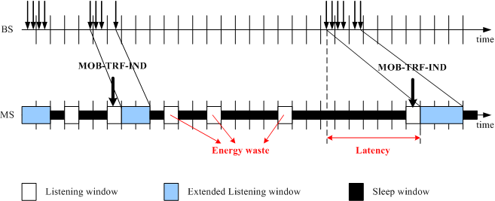
Figure 1: Illustration of sleep mode operation of PSC of type I.

2. Proposed Scheme
Some types of non-real-time traffic, such as the HTTP and FTP, have bursty characteristic and between two consecutive bursts, there is a long silence period, i.e., reading time. It is power-wasting when the exponential sleep window starts off right after a DL data reception. In this contribution, we propose to modify the sleep window of the conventional PSC of type I by inserting an idle offset period, to imitate the behavior of reading time. During the idle offset period, the counter of sleep window is frozen.

Figure 2 illustrates the sleep mode operation of the proposed scheme. It can be seen that the offset is insert between a DL reception and the following first listening window. If the offset is assigned appropriated (i.e., equal to the inter-burst arrival time), the energy waste and latency are eliminated as shown in Figure 2(c). Practically, it is difficult to determine the idle offset precisely. As shown in Fig 2(a) and 2(b), the offset may be slightly shorter or longer. However, in either case, the energy wasting and latency are still reduced considerably. The value of idle offset period can be estimated by statistics of on-going traffics.

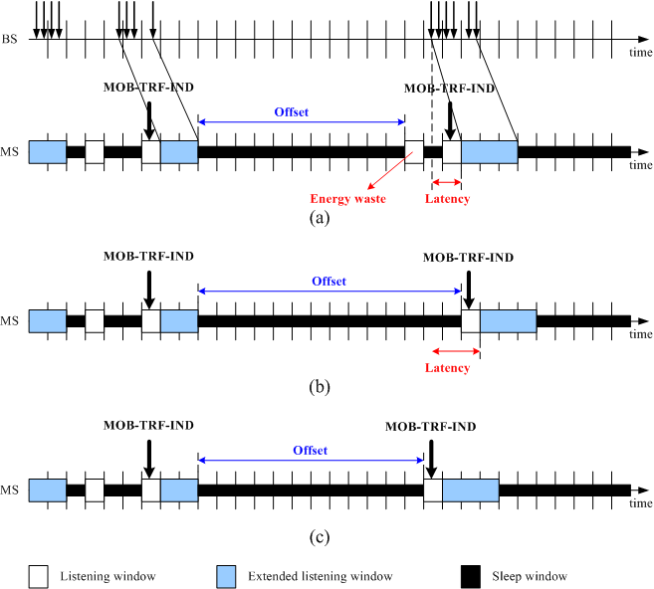
Figure 2: Illustration of sleep mode operation of PSC of type I using the offset concept.

3. Simulation Analysis
In the simulation, the BE type of traffic which follows an on/off traffic pattern (e.g., HTTP and FTP) is simulated. Only the DL traffic is simulated since the typically UL traffic is minimal in these applications. Therefore, the MS-initial sleep mode is adapted, which is triggered after 20 ms of observed inactivity. The start frame of sleep duty cycle follows the MOB-SLP-REP message immediately. The total simulation time is 10 minutes.

Figure 3 shows the performance comparison of listening window radio between conventional PSC of type I (16e-w/o-offset) and the proposed method (16e-w/-offset) under different mean reading time (burst inter-arrival time). It is observed that the listening ratio is decreased while the mean reading time is increased. This can be explained by the characteristic of exponentially extended sleep window which will reduce the number of listening window. In Figure 3, it also can be seen that the 16-e-w/-offset outperforms the 16e-w/o-offset under different mean reading time, especially for the shorter reading time. This is because that the idle offset imitates the traffic pattern as much as possible and the number of unused listening window is reduced successfully.

Figure 4 shows the performance comparison of latency between two schemes under different mean reading time (burst inter-arrival time). It is observed that the latency is increased while the mean reading time is extended. Actually the longer sleep window may increase the longer latency. When the reading time is extended, the length of the last sleep window is longer and the latency is increased. However, it can be observed that the 16e-w/-offset always outperforms 16e-w/o-offset and the latency is reduced about 100 frames under different mean reading time. It can be explained by that the 16e-w/-offset scheme moves the repeated maximum sleep windows from the end to the head of the sleep mode, as shown in Figure 5. The length of the last sleep window is shorter than the maximum value and consequently reduces the latency.

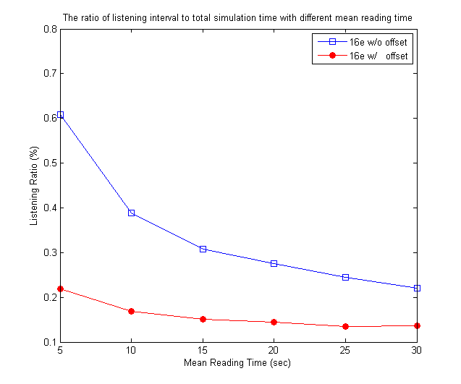
Figure 3: Performance comparison of listening ratio under different mean reading time (burst inter-arrival time).

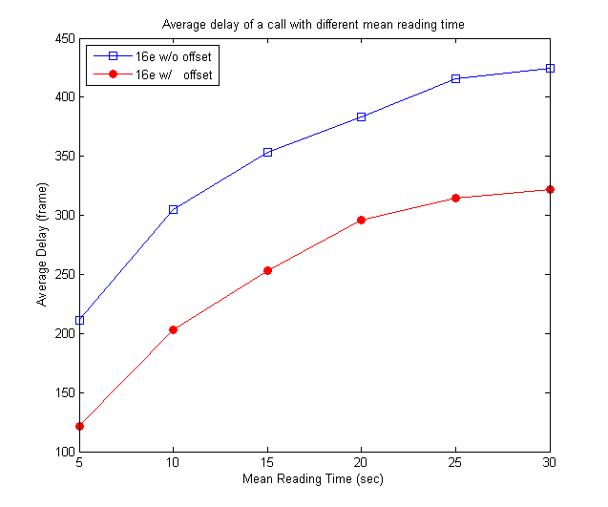
Figure 4: Performance comparison of average delay under different mean reading time (burst inter-arrival time).

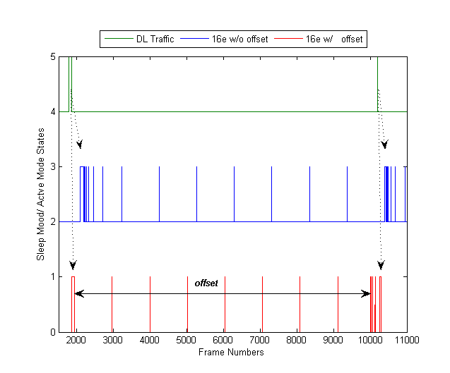
Figure 5: MS state with longer reading time (longer burst interval-arrival time)

4. Conclusion
In 16m system, a single PSC is managed to handle all the active connections per MS. However, some basic sleep patterns should be considered for different traffic types to imitate the traffic pattern as much as possible. The conventional PSC of type II is reasonable to be considered as the basic sleep pattern for real-time connections. As for the non-real-time connections, the conventional PSC of type I with idle offset is suggested to be considered. It reduces the unused listening windows and latency successfully. Algorithm for estimating the offset length is outside of the scope of the standard.

5. Proposed Text for SDD
------------------------------- Text Start --------------------------------------------------------------------------------------
[Modify Section 10.4.1.1 in IEEE 802.16m-08/003r5 as follows]
10.4.1.1 Introduction
Sleep mode is a state in which an MS conducts pre-negotiated periods of absence from the serving BS air interface. Per MS, a single power saving class is managed in order to handle all the active connections of the MS. Sleep mode may be activated when an MS is in the connected state. When Sleep Mode is active, the MS is provided with a series of alternate listening window and sleep windows. The listening window is the time in which MS is available to receive and send signaling and/or data from and to the BS.
The IEEE 802.16m provides a framework for dynamically adjusting the duration of sleep windows and listening windows within a sleep cycle based on changing traffic patterns and HARQ operations. The duration of sleep window can be exponentially expanded or fixed.
Sleep windows and listening windows can be dynamically adjusted for the purpose of transport data as well as MAC control signaling transmission. MS can send and receive transport data and MAC control signaling without deactivating the sleep mode.
------------------------------- Text End ---------------------------------------------------------------------------------------

6. References
- IEEE Std. 802.16e-2005, IEEE Standard for Local and metropolitan area networks, Part 16: Air Interface for Fixed and Mobile Broadband Wireless Access Systems, Amendment 2: Physical and Medium Access Control Layers for Combined Fixed and Mobile Operation in Licensed Bands, and P802.16Rev2/D7 (October 2008).
- IEEE 802.16m-08/003r5, The Draft IEEE 802.16m System Description Document.

