Project | IEEE 802.16 Broadband Wireless Access Working Group <http://ieee802.org/16>
Title | Downlink Control Design for 16m Hierarchical Frame Structure
Date Submitted | 2008-03-10
Source(s) | Ming-Hung Tao, Mamadou Kone, Ying-Chuan Hsiao, Richard Li  ITRI | E-mail: mhtao@itri.org.tw, richard929@itri.org.tw
Re: | IEEE 802.16m-08/005 - Call for Contributions on Project 802.16m System Description Document (SDD), shoot for “Downlink Control Structures” topic.
Abstract | This contribution proposes design concept for the 16m downlink control structure.
Purpose | For discussion and approval by TGm.
Notice | This document does not represent the agreed views of the IEEE 802.16 Working Group or any of its subgroups. It represents only the views of the participants listed in the “Source(s)” field above. It is offered as a basis for discussion. It is not binding on the contributor(s), who reserve(s) the right to add, amend or withdraw material contained herein.
Release | The contributor grants a free, irrevocable license to the IEEE to incorporate material contained in this contribution, and any modifications thereof, in the creation of an IEEE Standards publication; to copyright in the IEEE’s name any IEEE Standards publication even though it may include portions of this contribution; and at the IEEE’s sole discretion to permit others to reproduce in whole or in part the resulting IEEE Standards publication. The contributor also acknowledges and accepts that this contribution may be made public by IEEE 802.16.
Patent Policy | The contributor is familiar with the IEEE-SA Patent Policy and Procedures:  <http://standards.ieee.org/guides/bylaws/sect6-7.html#6> and <http://standards.ieee.org/guides/opman/sect6.html#6.3>.  Further information is located at <http://standards.ieee.org/board/pat/pat-material.html> and <http://standards.ieee.org/board/pat>.
Downlink Control Design for 16m Hierarchical Frame Structure
Ming-Hung Tao, Mamadou Kone, and Ying-Chuan Hsiao
ITRI

1. Introduction
As mentioned in IEEE 802.16m System Requirement Document (SRD) [1], the overhead, including overhead for control signaling as well as overhead related to bearer data transfer, for all applications shall be reduced as far as feasible without compromising overall performance and ensuring proper support of system features. This contribution proposes a downlink control design with minimum control overhead based on the 16m frame structure proposed in IEEE C802.16m-08/118 [2]. The proposed design of downlink control contains a Super-frame control structure called Super-MAP and a Sub-frame control structure called Sub-MAP. These control structures reduce a lot of control overhead and redundancy as compared to the WirelessMAN-OFDMA Reference System while maintaining the proper functionalities and features of the 16m system.

2. The proposed downlink control structure
The scope of this contribution is to propose a downlink control structure based on the TDD frame structure proposed in IEEE C802.16m-08/118 [2]. The proposed control structure tries to minimize the control overhead, and facilitates other functions such as synchronization, power saving, and handover. Each Super-frame begins with a new 16m preamble, followed by a Super-frame Control Header (SFCH) and a Super-MAP. Each Sub-frame may have either one or no Sub-MAP, and each Sub-MAP describes resource allocation for one or more Sub-frames. Figure 1 illustrates the Super-frame structure and the position of Super-MAPs and Sub-MAPs. The following subsections describe the detailed design of the Super-MAP and Sub-MAP.

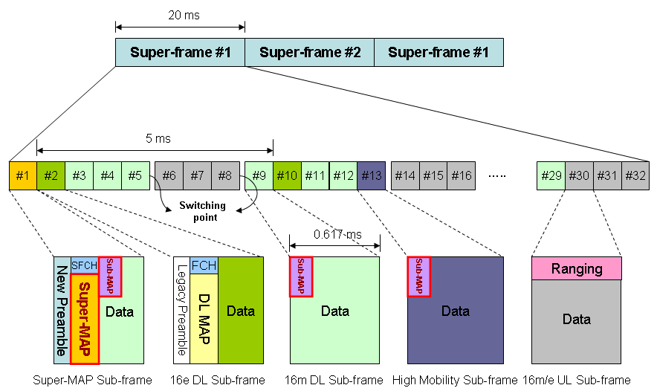

Figure 1. Position of Super-MAP and Sub-MAP.

2.1 Super-MAP design
The Super-MAP is located in the first Sub-frame of a Super-frame (which is called the Super-MAP Sub-frame) and is responsible to broadcast system information and Sub-frame configurations. Since different Sub-frames may support different functions, modes, and modulation/coding schemes for particular mobile stations, Super-MAP shall describe these features for all Sub-frames distinctly. The descriptor, Sub-frame Usage Code (SUC), is proposed for this purpose. By referring to the SUC of each Sub-frame, mobile stations will know precisely the properties of Sub-frames and will access the Sub-frames of their interests more efficiently. Furthermore, Super-MAP shall describe the information of each Sub-MAP residing in the current Super-frame, e.g., the location of a Sub-MAP, the modulation/coding scheme used by a Sub-MAP and so on. Table 1 gives the format of the Super-MAP.

Table 1. The format of Super-MAP.

Syntax | Size (bits) | Notes
Super-MAP_message_format() { | - | -
Management Message Type | TBD | -
PHY Synchronization Field | Variable | -
DCD Count | 8 | -
Base Station ID | 48 | -
No. Sub-frames | TBD | Number of Sub-frames.
Sub-frame Length | TBD | Number of OFDMA symbols in a Sub-frame.
for (i=0; i<No. Sub-frames; i++) { | - | -
SUC | 4 | Sub-frame usage code.  0=DCD/UCD Sub-frame  1=16m Short-distance DL Sub-frame  2=16m Mid-distance DL Sub-frame  3=16m Long-distance DL Sub-frame  4=16e DL Sub-frame  5=16m UL Sub-frame  6=16e UL Sub-frame  7=High Mobility Sub-frame  8=Relay Sub-frame  9=E-MBS Sub-frame  10…15=Reserved
} | - | -
No. Sub-MAPs | TBD | Number of Sub-MAPs.
for (i=0; i<No. Sub-MAPs; i++) { | - | -
Sub-MAP_Info() | Variable | See Table 2.
} | - | -
if !(byte boundary) { | - | -
Padding Nibble | 4 | Padding to reach byte boundary.
} | - | -
} | - | -

PHY Synchronization
The PHY synchronization field is dependent on the PHY specification used. The encoding of this field is given in each PHY specification separately.
DCD Count
Matches the value of the configuration change count of the DCD, which describes the DL burst profiles that apply to this map.
Base Station ID
The Base Station ID is a 48-bit long field identifying the BS.
No. Sub-frames
This field describes the number of Sub-frames in the current Super-frame.
Sub-frame Length
This field describes the length (in number of OFDMA symbols) of each Sub-frame.
SUC (Sub-frame Usage Code)
The Sub-frame Usage Code indicates the mode, function, and modulation/coding scheme supported by a Sub-frame.
No. Sub-MAPs
This field describes the number of Sub-MAPs resided in the current Super-frame.

Sub-MAP_Info contains the prefix and location/management information of a Sub-MAP. The format of this field is given in Table 2.

Table 2. The format of Sub-MAP_Info.

Syntax | Size (bits) | Notes
Sub-MAP_Info() { | - | -
FEC Code and Modulation Type | 6 | The FEC code and modulation type used by a Sub-MAP.
Repetition_Coding_Indication | 2 | -
MAP_Position | TBD | Indicate which Sub-frame the Sub-MAP is located at.
No. Sub-frames_Under_Control | 3 | Number of Sub-frames controlled by the Sub-MAP.
for (i=0; i<No. Sub-frames_Under_Contro; i++) { | - | -
Sub-frame_Sequence_No. | TBD | The sequence number of the Sub-frame controlled by the Sub-MAP.
} | - | -
Sub-MAP_Length | 8 | -
} | - | -

FEC Code and Modulation Type
This field indicates the FEC code and modulation type used by a Sub-MAP. The values defined in this field shall be the same as that defined in the DCD burst profile encoding.
Repetition_Coding_Indication
This field indicates the repetition code used for the Sub-MAP.
MAP_Position
This field indicates which Sub-frame the Sub-MAP is located at.
No. Sub-frames_Under_Control
This field indicates the number of Sub-frames controlled by the Sub-MAP.
Sub-frame_Sequence_No.
This field indicates the sequence number, e.g., from 1 to 32, of the Sub-frame controlled by the Sub-MAP.
Sub-MAP_Length
This field defines the length in slots of the burst which contains only Sub-MAP message.

2.2 Super-MAP design with SUC Profile
To reduce the length of Super-MAP, the following fields, No. Sub-frames, Sub-frame Length, and all SUCs, can be replaced by one profile called SUC_Profile, which contains some predefined Sub-frame configurations and SUC assignments. Figure 2 illustrates some scenarios defined by of the SUC Profile. The presence of SUC_Profile will facilitate the synchronization between base stations, and also facilitate mobile stations to select targeted base stations during network entry or handoff procedures. The format of Super-MAP after introducing the SUC-Profile is shown in Table 3.

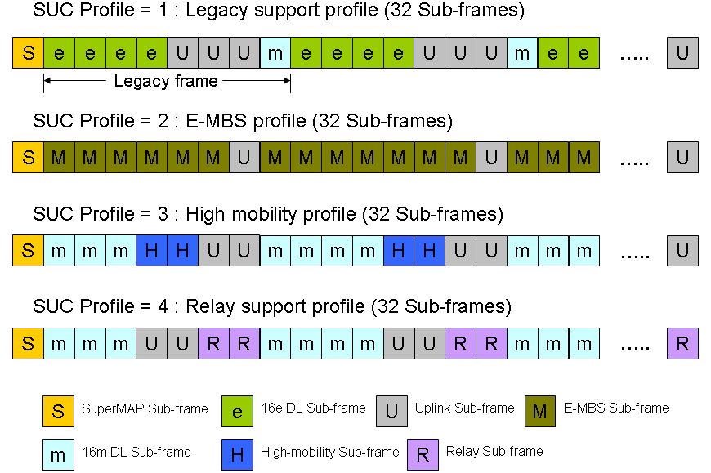

Figure 2. The SUC Profile indicating some predefined Sub-frame configurations.

Table 3. The format of Super-MAP with SUC-Profile.

Syntax | Size (bits) | Notes
Super-MAP_message_format() { | - | -
Management Message Type | TBD | -
PHY Synchronization Field | Variable | -
DCD Count | 8 | -
Base Station ID | 48 | -
Available_Profile | 1 | Available_Profile (1 bit) indicates whether SUC_Profile is available or not.
If (Available_Profile == 1) { | - | -
SUC_Profile | TBD | Predefined combinations of different Sub-frame configurations and SUCs.
} else { | - | -
No. Sub-frames | TBD | Number of Sub-frames.
Sub-frame Length | TBD | Number of OFDMA symbols in a Sub-frame.
for (i=0; i<No. Sub-frames; i++) { | - | -
SUC | 4 | Sub-frame usage code.
} | - | -
} | - | -
No. Sub-MAPs | TBD | Number of Sub-MAPs.
for (i=0; i<No. Sub-MAPs; i++) { | - | -
Sub-MAP_Info() | Variable | See Table 2.
} | - | -
if !(byte boundary) { | - | -
Padding Nibble | 4 | Padding to reach byte boundary.
} | - | -
} | - | -

Similar to Downlink Burst Profile, the mapping between the SUC_Profile values and the predefined configurations shall be broadcast as system information by embedding the field SUC Profile Mapping into DCD, as shown in Table 4. The SUC Profile Mapping TLV format is shown in Table 5.

Table 4. Embedding SUC Profile Mapping field into DCD.

Name | Type (1 byte) | Length | Value (variable length)
Downlink_Burst_Profile | 1 | variable | May appear more than once.
BS EIRP | 2 | 2 | Signed in units of 1 dBM.
… | … | … | …
… | … | … | …
SUC Profile Mapping | TBD | - | Describes the mapping between SUC profiles and the predefined configurations. May appear more than once.

Table 5. SUC Profile Mapping TLV format.

Syntax | Size (bit) | Note
SUC Profile Mapping { | - | -
Type = TBD | 8 | -
Length | 8 | -
SUC_Profile | 4 | -
TLV_Encoded_Information | 8 | 0 = Default profile  1 = Legacy support profile  2 = 16m Short-distance profile  3 = 16m Mid-distance profile  4 = 16m Long-distance profile  5 = High mobility profile  8 = E-MBS profile  9 = Relay support profile  10 = Coexistence profile  11…255 = Reserved
} | - | -

3. Proposed text for SDD
[Insert the following into section 11 of [3]]
--------------------------------------- Text start ---------------------------------------------
11.x Downlink Control Structures
Each Super-frame begins with a new 16m preamble, followed by a Super-frame Control Header (SFCH) and a Super-MAP. Each Sub-frame may have either one or no Sub-MAP, and each Sub-MAP describes resource allocation for one or more Sub-frames.
11.x.1 Super-MAP message fields
The Super-MAP is located in the first Sub-frame of a Super-frame and is responsible to broadcast system information and Sub-frame configurations. Super-MAP shall also describe the information of each Sub-MAP residing in the current Super-frame, e.g., the location of a Sub-MAP, the modulation/coding scheme used by a Sub-MAP and so on. The format of Super-MAP is shown in Table 11.x-1.
11.x.1.1 Sub-frame Usage Code
Since different Sub-frames may support different functions, modes, and modulation/coding schemes for particular mobile stations, Super-MAP shall describe these features of each Sub-frame distinctly. The descriptor, Sub-frame Usage Code (SUC), is utilized for this purpose. By referring to the SUC of each Sub-frame, mobile stations will know precisely the properties of Sub-frames and will access the Sub-frames of their interests.
11.x.1.2 SUC Profile
To reduce the length of Super-MAP, a profile named SUC_Profile which contains some predefined Sub-frame configurations and SUC assignments is utilized.

Table 11.x-1. The format of Super-MAP.
Syntax | Size (bits) | Notes
Super-MAP_message_format() { | - | -
… | . | System and synchronization information.
Available_Profile | 1 | Available_Profile (1 bit) indicates whether SUC_Profile is available or not.
If (Available_Profile == 1) { | - | -
SUC_Profile | TBD | Predefined combinations of different Sub-frame configurations and SUCs.
} else { | - | -
No. Sub-frames | TBD | Number of Sub-frames.
Sub-frame Length | TBD | Number of OFDMA symbols in a Sub-frame.
for (i=0; i<No. Sub-frames; i++) { | - | -
SUC | 4 | Sub-frame usage code.  0=DCD/UCD Sub-frame  1=16m DL Sub-frame  2=16e DL Sub-frame  3=16m UL Sub-frame  4=16e UL Sub-frame  5=Relay Sub-frame  6=E-MBS Sub-frame  7…15=Reserved
} | - | -
} | - | -
No. Sub-MAPs | TBD | Number of Sub-MAPs.
for (i=0; i<No. Sub-MAPs; i++) { | - | -
Sub-MAP_Info() | Variable | See Table 2.
} | - | -
… | - | -
} | - | -

No. Sub-frames
This field describes the number of Sub-frames in the current Super-frame.
Sub-frame Length
This field describes the length (in number of OFDMA symbols) of each Sub-frame.
SUC (Sub-frame Usage Code)
The Sub-frame Usage Code indicates the mode, function, and modulation/coding scheme supported by a Sub-frame.
SUC_Profile
This field contains some predefined Sub-frame configurations and SUC assignments. The mapping between the SUC_Profile values and the predefined configurations shall be broadcast as system information in DCD.
No. Sub-MAPs
This field describes the number of Sub-MAPs resided in the current Super-frame.

Sub-MAP_Info contains the prefix and location/management information of a Sub-MAP. The format of this field is given in Table 11.x-2.

Table 11.x-2. The format of Sub-MAP_Info.

Syntax | Size (bits) | Notes
Sub-MAP_Info() { | - | -
FEC Code and Modulation Type | 6 | The FEC code and modulation type used by a Sub-MAP.
Repetition_Coding_Indication | 2 | -
MAP_Position | TBD | Indicate which Sub-frame the Sub-MAP is located at.
No. Sub-frames_Under_Control | 3 | Number of Sub-frames controlled by the Sub-MAP.
for (i=0; i<No. Sub-frames_Under_Contro; i++) { | - | -
Sub-frame_Sequence_No. | TBD | The sequence number of the Sub-frame controlled by the Sub-MAP.
} | - | -
Sub-MAP_Length | 8 | -
} | - | -

FEC Code and Modulation Type
This field indicates the FEC code and modulation type used by a Sub-MAP. The values defined in this field shall be the same as that defined in the DCD burst profile encoding.
Repetition_Coding_Indication
This field indicates the repetition code used for the Sub-MAP.
MAP_Position
This field indicates which Sub-frame the Sub-MAP is located at.
No. Sub-frames_Under_Control
This field indicates the number of Sub-frames controlled by the Sub-MAP.
Sub-frame_Sequence_No.
This field indicates the sequence number, e.g., from 1 to 32, of the Sub-frame controlled by the Sub-MAP.
Sub-MAP_Length
This field defines the length in slots of the burst which contains only Sub-MAP message.

11.x.2 Sub-MAP message fields
--------------------------------------- Text end -----------------------------------------------

References

[1] IEEE 802.16m-07/002r4, “IEEE 802.16m System Requirements”, October 2007.
[2] IEEE C802.16m-08/118r1, “Proposed 802.16m Frame Structure Baseline Content suitable for Use in the 802.16m SDD”, February 2008.
[3] IEEE C80216m-07/320r1, “Draft Table of Content for the IEEE 802.16m System Description Document”, November 2007.

