Project | IEEE 802.16 Broadband Wireless Access Working Group <http://ieee802.org/16>
Title | New Zone with High-Mobility Support for TGm Frame Structure
Date Submitted | 2008-03-17
Source(s) | Yu-Tao Hsieh, Lai-Huei Wang, Jen-Yuan Hsu, Rong-Terng Juang, Pang-An Ting, Ren-Jr Chen, Yang-Xiu Zheng, Richard Li  ITRI  195,Sec. 4, Chung Hsing Rd.  Chutung, Hsinchu, Taiwan 310, R.O.C  Hsi-Pin Ma, Yeong-Luh Ueng  NTHU | Voice: + 886 3 5915642  E-mail: richard929@itri.org.tw
Re: | Call for Comments on C802.16m-08/118r1
Abstract | This contribution proposes a mechanism to improve system performance in high mobility environments with high-mobility zones in the new 802.16m frame structure.
Purpose | For 802.16m discussion and adoption
Notice | This document does not represent the agreed views of the IEEE 802.16 Working Group or any of its subgroups. It represents only the views of the participants listed in the “Source(s)” field above. It is offered as a basis for discussion. It is not binding on the contributor(s), who reserve(s) the right to add, amend or withdraw material contained herein.
Release | The contributor grants a free, irrevocable license to the IEEE to incorporate material contained in this contribution, and any modifications thereof, in the creation of an IEEE Standards publication; to copyright in the IEEE’s name any IEEE Standards publication even though it may include portions of this contribution; and at the IEEE’s sole discretion to permit others to reproduce in whole or in part the resulting IEEE Standards publication. The contributor also acknowledges and accepts that this contribution may be made public by IEEE 802.16.
Patent Policy | The contributor is familiar with the IEEE-SA Patent Policy and Procedures:  <http://standards.ieee.org/guides/bylaws/sect6-7.html#6> and <http://standards.ieee.org/guides/opman/sect6.html#6.3>.  Further information is located at <http://standards.ieee.org/board/pat/pat-material.html> and <http://standards.ieee.org/board/pat>.
New Zone with High-Mobility Support for TGm Frame Structure
Yu-Tao Hsieh, Lai-Huei, Wang, Jen-Yuan Hsu, Rong-Terng Juang,
Pang-An Ting ,Ren-Jr Chen, Yang-Xiu Zheng, Richard Li
ITRI
Hsin-Pin Ma, Yeong-Luh Ueng
NTHU

Introduction
The 802.16m system requirements [1] cover the performance demand for subscriber stations at high mobility environments. However, the WirelessMAN-OFDMA Reference system supports only limited link performance for subscriber stations at moderate or high mobility scenarios. To improve system performance for subscriber stations at higher mobility (e.g., 350 km/hr), this contribution proposes a new transmission frame structure, which has two major modifications compared to 16e specifications. First, the symbol duration is suggested to be reduced [2]. Second, the length of cyclic prefix (CP) is extended to greatly cancel the inter-carrier interference (ICI) [3]. This contribution presents more numerical simulations of performance comparison for the proposed high-mobility zone. In terms of system throughput, simulation results show that the new zone with high-mobility support outperforms 802.16e systems with subscriber stations using 64QAM modulation at 350 km/hr.

Numerology for the New Zone with High-Mobility Support
The TGm Frame Structure Rapporteur Group has drafted an initial version of frame structure [4]. Table 1 shows the OFDMA parameters for the frame structure in [4]. This contribution proposes another set of parameters suitable for the high-mobility zone, as shown in Table 2. In high-mobility zone, the symbol duration is reduced to one half of the normal symbol, and the CP ratio is extended to 1/2 the new symbol duration. Note that the proposed architecture conforms the length of the original sub-frame. Although the system overhead of the proposed new zone design is higher compared to the original design, the ICI resistance of the proposed architecture introduces less packet errors and hence results in higher system throughput.
Table 1. Regular OFDMA parameters
Nominal Channel Bandwidth (MHz) |  | 5 | 7 | 8.75 | 10 | 20
Over-sampling Factor |  | 28/25 | 8/7 | 8/7 | 28/25 | 28/25
Sampling Frequency (MHz) |  | 5.6 | 8 | 10 | 11.2 | 22.4
FFT Size |  | 512 | 1024 | 1024 | 1024 | 2048
Sub-Carrier Spacing (kHz) |  | 10.94 | 7.81 | 9.77 | 10.94 | 10.94
Tu (us) |  | 91.4 | 128 | 102.4 | 91.4 | 91.4
Cyclic Prefix (CP) | Ts (us) | Number of OFDM Symbols per Frame |  |  |  | Idle Time (us)
Tg=1/8 Tu | 91.4 +11.42= 102.82 (for 5, 10, 20 MHz) | 48 (for 5, 10, 20 MHz) |  |  |  | 62.86
Tg=1/8 Tu | 128+16=144 (for 7 MHz) | 34 (for 7 MHz) |  |  |  | 104
Tg=1/8 Tu | 102.4+12.8=115.2  (for 8.75 MHz) | 43 (for 8.75 MHz) |  |  |  | 46.40

Table 2. OFDMA parameters for the high-mobility zone
Nominal Channel Bandwidth (MHz) |  | 5 | 7 | 8.75 | 10 | 20
Over-sampling Factor |  | 28/25 | 8/7 | 8/7 | 28/25 | 28/25
Sampling Frequency (MHz) |  | 5.6 | 8 | 10 | 11.2 | 22.4
FFT Size |  | 256 | 512 | 512 | 512 | 1024
Sub-Carrier Spacing (kHz) |  | 21.88 | 15.62 | 19.54 | 21.88 | 21.88
Tu (us) |  | 45.7 | 64 | 51.2 | 45.7 | 45.7
Cyclic Prefix (CP) | Ts (us) | Number of OFDM Symbols per Frame |  |  |  | Idle Time per Frame (us)
Tg=1/2 Tu | 45.71+22.86= 68.57 (for 5, 10, 20 MHz) | 72 (for 5, 10, 20 MHz) |  |  |  | 62.86
Tg=1/2 Tu | 64+32=96 (for 7 MHz) | 52 (51) (for 7 MHz) |  |  |  | 8 (104)
Tg=1/2 Tu | 51.2+25.6=76.8  (for 8.75 MHz) | 65 (64) (for 8.75 MHz) |  |  |  | 8 (84.8)

Simulation Results
This section presents performance comparisons of SISO PUSC permutation zones. Table 3 shows the setup of link level simulations. The two dimensional DL sub-frame is divided into 5 partitions of 66 slots each. Each partition is considered as a separate packet. The control overhead of 6 symbols as indicated in the Evaluation Methodology document [5] is not accounted for in the calculation of throughput. The frame duration if set as 5 ms. Figure 1 shows the subcarrier allocation for the high-mobility zone. It can be seen that the subcarrier permutation and allocation for 5 MHz was applied to the proposed high-mobility zone for channel bandwidth of 10 MHz. The effective subcarrier spacing is thus doubled to 21.88 kHz. Figure 2 shows the PER (Packet Error Rate) performance with user velocity of 350 km/hr for the WirelessMAN OFDMA system and the proposed approach. The PER is defined by the number of erroneous packets (including the first and re-transmitted ones) divided by the number of total transmitted packets. The link performance of the reference system with 16QAM-1/2 is better than the three cases with 64QAM modulation. The PER deteriorates drastically in the case of 64QAM due to severe ICI resulting from high user mobility. However, by using the proposed zone, the ICI can be significantly suppressed such that the PER can be decreased even with 64QAM modulation. The target PER of 30% for the 64QAM-2/3 or 64QAM-3/4 can be achieved under the region of SNR>30 dB. Figure 3 shows throughput performance. As far as the reference system is concerned, the superior performance of 16QAM-1/2 may be attributed to its better PER and thus less packet re-transmission. From the simulation results, the peak throughput of the reference system can reach around 13.5 Mbps with code rate of 16QAM-1/2. On the other hand, thanks to the superior PER of 64QAM for the proposed architecture, the throughput can be increased to be more than 23Mbps using 64QAM-3/4.

Table 3. Simulation setup for the proposed new zone
Channel Bandwidth | 10 MHz
Number of DL symbols | 22 (WirelessMAN OFDMA reference system)  32 (high-mobility zone)
FFT size | 512
Number of data subcarriers | 360
Number of pilots | 60
Number of clusters | 30
Frequency reuse | 1x3x3
Permutation | PUSC
Number of packets per frame | 5
Channel model | Modified Vehicular-A
Channel coding | Convolutional code
HARQ type | Chase Combining
Maximum HARQ re-transmission | 4
User velocity | 350 km/hr
Channel estimation | MMSE

14
1
Pilot subcarrier
Data subcarrier
Figure 1. Subcarrier allocation for the proposed zone
Figure 2. Performance comparison for PER.
Figure 3. Performance comparison for single-user throughput.
Table 4 lists the parameters of system level simulation. The physical abstraction is performed using the simulated results collected by the PER curves from Figure 2 or Figure 3 instead of analytical prediction. The PER mapping with HARQ is conducted using the PER performance curve with HARQ in the figures. Figure 4 shows the received signal power of 19 cells system-level simulation layout. Figures 5, 6 and 7 plot the histograms of sector MAC throughputs for 16QAM-1/2, 64QAM-2/3, and 64QAM-3/4 at 120 Km/hr, respectively, while Figures 8, 9 and 10 plot the histograms of sector MAC throughputs for 16QAM-1/2, 64QAM-2/3, and 64QAM-3/4 at 350 Km/hr, respectively. Table 5 lists the average sector throughputs. The proposed high-mobility zone design outperforms the reference system up to 88% and 112% with 64QAM-2/3 and 64QAM-3/4, respectively.

Table 4 Parameters of Link-level Simulation for the Downlink
Site-to-Site distance | 2.0 km
Carrier Frequency | 2.5GHz
Operating Bandwidth | 10MHz
BS Height | 32 m
BS Tx Power | 46 dBm
MS Height | 1.5 m
Path Loss Model | Loss (dB) = 130.62 + 37.8log10(R), R in km
Lognormal Shadowing Deviation | 8 dB
Correlation Distance for Shadowing | 50 m
Mobility | 120 km/hr and 350km/hr
Channel | ITU Veh A
Frequency Reuse | 1x3x3
Interference Model | Frequency selective interference model for PUSC, no interference awareness at receiver
Scheduling | Proportional Fairness for full buffer data only  [ 10 active users per sector, fixed control overhead of 6 symbols, 22 symbols for data, 5 partitions of 66 slots each, latency timescale 1.5s ]

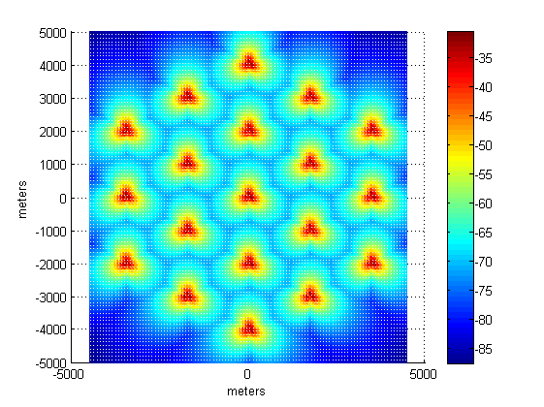
Figure 4. Received Signal Power of Multi-cell Simulation Layout
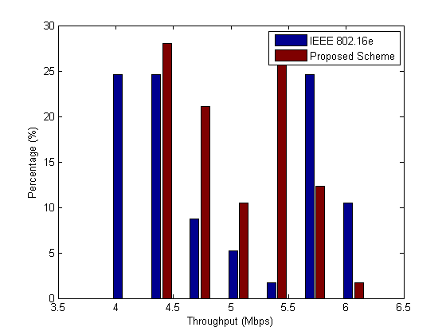
Figure 5. Histogram of Sector MAC Throughput for 16QAM1/2 at 120Km/h
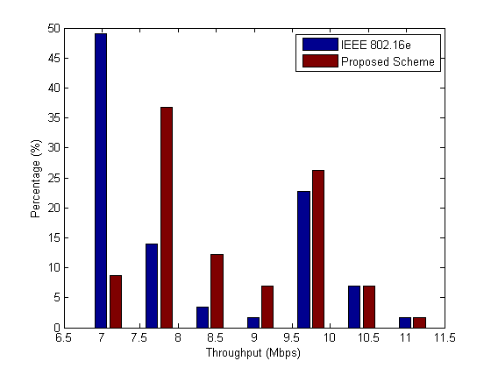
Figure 6. Histogram of Sector MAC Throughput for 64QAM2/3 at 120Km/h
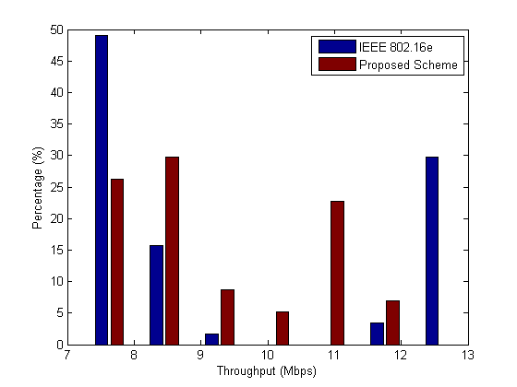
Figure 7. Histogram of Sector MAC Throughput for 64QAM3/4 at 120Km/h
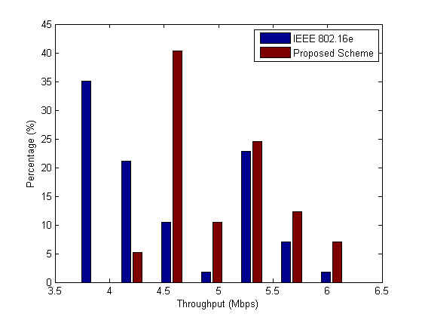
Figure 8. Histogram of Sector MAC Throughput for 16QAM1/2 at 350Km/h
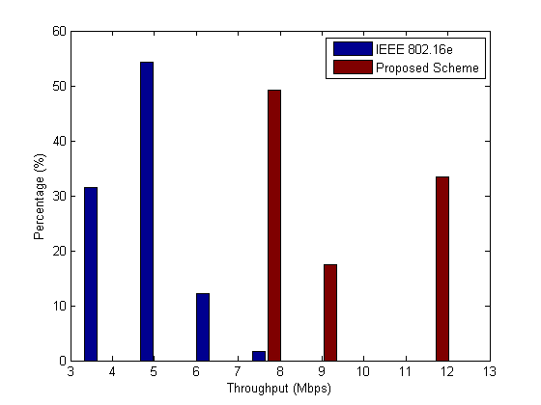
Figure 9. Histogram of Sector MAC Throughput for 64QAM2/3 at 350Km/h
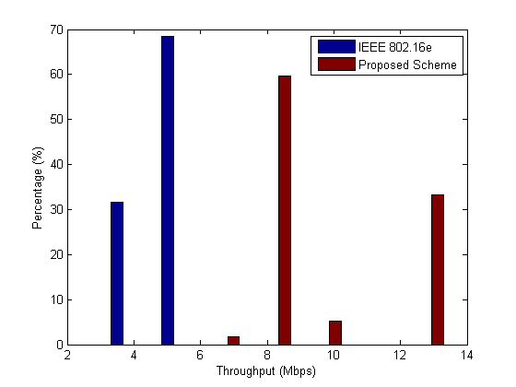
Figure 10. Histogram of Sector MAC Throughput for 64QAM3/4 at 350Km/h

Table 5. Average Sector Throughput for High-Mobility Zone (Mbps)
 | Average Sector Throughput for User at 120Km/h Mobility |  |  | Average Sector Throughput for User at 350Km/h Mobility
 | 16e | Proposed Scheme | Improvement  (%) | 16e | Proposed Scheme | Improvement  (%)
16QAM1/2 | 4.92 | 5.05 | 2.64 | 4.48 | 5.01 | 11.83
64QAM2/3 | 8.11 | 8.66 | 6.78 | 4.77 | 8.99 | 88.47
64QAM3/4 | 9.31 | 9.16 | -- | 4.53 | 9.62 | 112.36

Proposed Text
------------------------------------------------------- Start of the proposed text ------------------------------------------------
11.3 OFDMA parameters
The proposed table for OFDMA parameters of the new zone with high-mobility support is given in Table 6.

Table 6. OFDMA parameters for the high-mobility zone
Nominal Channel Bandwidth (MHz) |  | 5 | 7 | 8.75 | 10 | 20
Over-sampling Factor |  | 28/25 | 8/7 | 8/7 | 28/25 | 28/25
Sampling Frequency (MHz) |  | 5.6 | 8 | 10 | 11.2 | 22.4
FFT Size |  | 256 | 512 | 512 | 512 | 1024
Sub-Carrier Spacing (kHz) |  | 21.88 | 15.62 | 19.54 | 21.88 | 21.88
Tu (us) |  | 45.7 | 64 | 51.2 | 45.7 | 45.7
Cyclic Prefix (CP) | Ts (us) | Number of OFDM Symbols per Frame |  |  |  | Idle Time per Frame (us)
Tg=1/2 Tu | 45.71+22.86= 68.57 (for 5, 10, 20 MHz) | 72 (for 5, 10, 20 MHz) |  |  |  | 62.86
Tg=1/2 Tu | 64+32=96 (for 7 MHz) | 52 (51) (for 7 MHz) |  |  |  | 8 (104)
Tg=1/2 Tu | 51.2+25.6=76.8  (for 8.75 MHz) | 65 (64) (for 8.75 MHz) |  |  |  | 8 (84.8)
------------------------------------------------------- End of the proposed text ------------------------------------------------

References
[1] M. Cudak, “802.16m System Requirements,” IEEE 802.16m-07/002r4
[2] R.-J. Chen, et al, “OFDMA Frame Structures with Scalable Bandwidth and High-Mobility Support for IEEE 802.16m,” IEEE 802.16m-07/295r1.
[3] Y.-T. Hsieh et al, “Extended Cyclic Prefix for High-Mobility Support of IEEE 802.16m Frame Structure,” IEEE 802.16m-08/025r3
[4] S. Ahmadi et al, “Initial Document output of the IEEE 802.16 TGm Frame Structure Rapporteur Group,” IEEE 802.16m-08/118r1
[5] R. Srinivasan, et al, “Draft IEEE 802.16m Evaluation Methodology, ” IEEE 802.16m-07/037r2.

