Project | IEEE 802.16 Broadband Wireless Access Working Group <http://ieee802.org/16>
Title | Cooperative Relay for IEEE802.16m
Date Submitted | 2008-10-31
Source(s) | Andreas F. Molisch, Zhifeng (Jeff) Tao, Philip V. Orlik, Jinyun Zhang  Mitsubishi Electric Research Lab  Toshiyuki Kuze  Mitsubishi Electric Corp | Voice: 617-621-{7558,7570, 7557, 7595}  Fax: 617-621-7550  {tao, molisch, porlik, jzhang}@ merl.com  Voice: +81-467-41-2885  Fax: +81-467-41-2486  Kuze.Toshiyuki@ah.MitsubishiElectric.co.jp
Re: | Response to the Call for Comments and Contributions on Project 802.16m System Description Document (SDD) (IEEE 802.16m-08/040): TGm SDD Relay
Abstract | This contribution describes a relay station cooperation architecture and demonstrates its benefit for 802.16m system description document (SDD).
Purpose | To adopt the relay station cooperation architecture proposed herein into IEEE 802.16m system description document (SDD).
Notice | This document does not represent the agreed views of the IEEE 802.16 Working Group or any of its subgroups. It represents only the views of the participants listed in the “Source(s)” field above. It is offered as a basis for discussion. It is not binding on the contributor(s), who reserve(s) the right to add, amend or withdraw material contained herein.
Release | The contributor grants a free, irrevocable license to the IEEE to incorporate material contained in this contribution, and any modifications thereof, in the creation of an IEEE Standards publication; to copyright in the IEEE’s name any IEEE Standards publication even though it may include portions of this contribution; and at the IEEE’s sole discretion to permit others to reproduce in whole or in part the resulting IEEE Standards publication. The contributor also acknowledges and accepts that this contribution may be made public by IEEE 802.16.
Patent Policy | The contributor is familiar with the IEEE-SA Patent Policy and Procedures:  <http://standards.ieee.org/guides/bylaws/sect6-7.html#6> and <http://standards.ieee.org/guides/opman/sect6.html#6.3>.  Further information is located at <http://standards.ieee.org/board/pat/pat-material.html> and <http://standards.ieee.org/board/pat>.

Cooperative Relay for IEEE802.16m

Andreas. F. Molisch, Zhifeng (Jeff) Tao, Philip V. Orlik, Jinyun Zhang
Mitsubishi Electric Research Lab

Toshiyuki Kuze
Mitsubishi Electric Corp

Introduction
Base station (BS) cooperation, which is also known as multi-cell MIMO, has been discussed in IEEE802.16m and accepted into the current version of SDD text [1]. As shown in many IEEE802.16m contributions [2][3], base station cooperation is such a new technology that, by leveraging advanced MIMO technique, enables multiple base stations to cooperatively transmit in the downlink to multiple mobile stations at cell edge, thereby achieving immense interference suppression and substantial capacity enhancement. Essentially, the BS cooperation can be deemed as a “virtual MIMO system”, where the antenna elements of all the collaborating BSs are the elements of the MIMO array that transmits to the MSs, thus taking advantage of additional spatial diversity and increasing system capacity (since each channel use now carries additional information to multiple users)

In this contribution, we will show that the notion of BS cooperation can be naturally migrated to relay station domain, and demonstrate the significant gain obtained thereby.

Cooperative Relay Architecture
As shown in Figure 1 for a two hop system as an example, data in downlink is sent from one BS to one of its subordinate RS (e.g., RS1), and then from RS1 to its associated MS (e.g., MS1), when no relay cooperation is enabled.

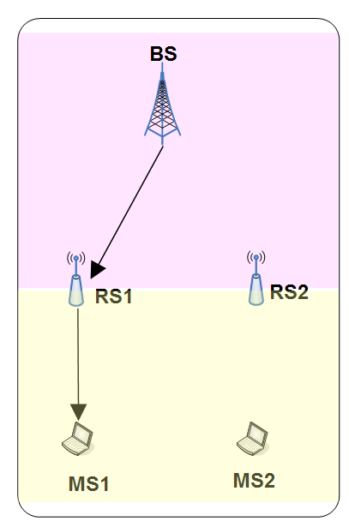
Figure 1 Regular data flow from BS to MS (without relay cooperation)

As shown in Error: Reference source not found, data in downlink is sent from one BS to multiple of its subordinate RS (e.g., RS1, RS2, etc.), and then from some of these RSs (e.g., RS1, RS2, etc.) to the destination MS (e.g., MS1)

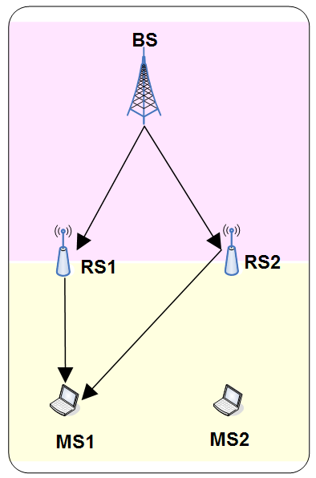
Figure 2 Data flow from BS to MS via two RSs (with relay cooperation- case 1)

Another possible relay cooperation architecture is shown in Figure 3, where the data in downlink is sent from one BS to multiple RSs (e.g., RS1, RS2, etc.), and then from some of these RSs (e.g., RS1, RS2, etc.) to multiple MSs. Note that the transmission on the second hop is similar to the base station cooperation operation, except that RSs instead of BSs are communicating with MSs.

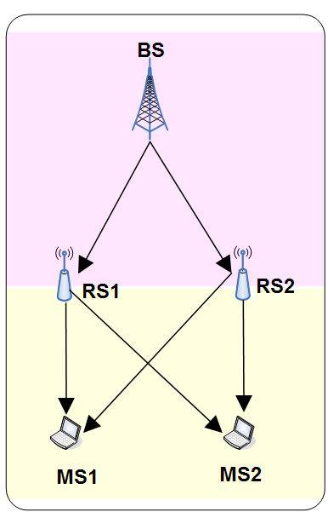

Figure 3 Data flow from BS to MS via two RSs (with relay cooperation – case 2)

Last but not the least, full cooperation can occur at both the stage when multiple BS communicates with RSs concurrently, and when multiple RSs communicate with multiple MSs simultaneously. This is illustrated in Figure 4.
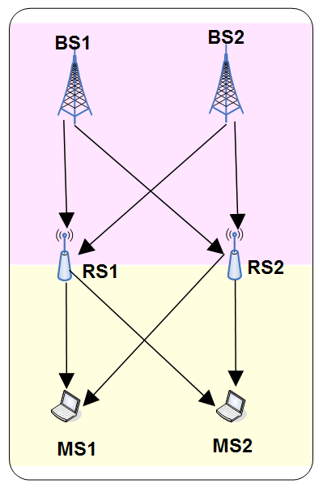
Figure 4 Data flow from BS to MS via two RSs (with relay cooperation – case 3)

Principle of Relay Station Cooperation
In this and the subsequent section, we concentrate on the case depicted in Fig. 3, namely one BS forwarding information to two relay stations, which in turn cooperatively communicate with two MSs. We consider a particular implementation that was recently shown [Devroye et al. 2008] to be highly efficient and greatly increase throughput compared to the “standard” multihop scenario where each MS communicates only with a single relay.

In the first phase, the messages are transmitted by the BS to the relays in a TDMA fashion, which is throughput-optimal for a single antenna broadcast channel. In the second phase, the relays cooperate together in transmitting the received message(s) to the MSs. An important and, hitherto ignored, fundamental notion of asymmetric cooperation inevitably arises in such scenarios. This asymmetry arises because the relays might receive unequal (but overlapping) amounts of data from the BS in the first phase. The extent of this asymmetry depends on the differences in the fading states of the BS to relay channels and the duration and rate of BS transmission.

To give more details, transmission from the BS to the MSs takes place in two phases: during phase 1 the BS broadcasts the messages 1 and 2 sequentially in a TDMA fashion. The TDMA structure is simple to implement, and is optimal, in terms of maximizing throughput, in the single-antenna scenario we consider. The relays decode the messages in phase 1 and re-encode them for phase 2. Unlike phase 1 in which each message is transmitted in an interference-avoiding TDMA fashion from one transmitter, in phase 2, both relays simultaneously transmit linearly precoded versions of the messages they received in phase 1. While the simultaneous transmission increases data rates, it also leads to interference, which has to be mitigated through careful precoding. For the simulations in Sec. 4, we consider linear precoding, but other precoding methods are feasible as well.

The system setup for phase 2 resembles standard space division multiple access (SDMA) with linear precoding
schemes. However, there is one critical difference: depending on the channel gains and the phase 1 transmission parameters, the relays may obtain different subsets of messages. This imposes constraints on some elements of the linear precoding matrix. This is shown in more detail in Fig. 5.
Fig. 5: Symmetric and asymmetric cooperation.

Fig. 6: Impact of asymmetric message knowledge on the precoding matrix

Performance of Relay Station Cooperation
Some preliminary results are shown in this section to demonstrate the performance improvement that can be achieved by relay station cooperation. There are a number of variables that can be optimized in this system: the rate, and time, for the transmission of the messages during phase 1, as well as the precoding matrix and the transmission time for phase 2. Ref. [Devroeye et al. 2008] provides detailed equations for the implementation Simulated results can be obtained based on those equations.

Fig. 8 CDF of sum throughput under max-throughput criterion; random placement of MS in the cell.

Fig. 7: Percentage of the time the single-message case is chosen, as well as the 4 dual-message cases are chosen. Random placement of MS in the cell.

The relays are placed along the arc of radius 5 units, and are separated by 40 degree. We consider a geometric model for the placement of the MSs: the MSs are randomly placed in the shaded slice covering the distance between 5 and 10 from the BS. The channels are flat Rayleigh fading. The throughput is computed according to capacity equations.

Fig. 7 demonstrates the fraction of the time each of the four cases of Fig. 6, as well as the single message case (for maximum throughput only) are optimal under the max throughput (black) and extreme fairness (grey) constraints (extreme fairness means that both MSs get the same number of bits. We can see that under the max throughput criterion, it is optimal to send a single message roughly half of the time. The symmetric Case 1 is never selected, while the asymmetric Cases 2 and 3 are each optimal roughly 20% of the time, and the fully symmetric Case 4 is optimal roughly 5% of the time. Thus, when it is optimal to transmit 2 messages, the asymmetric scenarios are almost always optimal. Full cooperation is especially desirable when two equal length messages must be transmitted. Thus, the selection of the best relay cooperation case is highly dependent on the criterion being optimized.

We next compare the gains from relay cooperation with two conventional non-cooperative schemes. For this purpose, we show the cumulative distribution functions (CDFs) of the overall throughput. Plotting the CDF allows the visual and numerical comparison of the performance of different schemes which depend on random quantities (in this case the MS placement and/or the fading), and illustrates the spread the performance of a particular scheme is around its average. The first baseline scheme is the round-robin with relay scheme, in which the BS transmits to each MS in a round robin fashion, transmitting each message via the relay that has the
best channel to the MS for which the message is intended. The second relevant baseline scheme that we consider is the best two-hop scheme in which the two-hop BS – relay j – MS i path, which takes the minimal time to transmit one unit of data, is chosen. For the extreme fairness criterion, one message is sent to each MS along the best 2 hop path to that MS, while for the maximum throughput criterion, only one message is sent along the best two-hop path of the best MS. The results are shown in Fig. 8. We can see that relay cooperation, even after taking all the transmission phases into account, does result in higher sum-throughputs than the non-cooperative baselines.

Proposed SDD Text

15 Support for multi-hop relay

[Insert the following paragraph in this subclause]

15.x Multi-Relay MIMO

Multi-RS MIMO techniques are supported for improving system throughput and cell-edge throughput through collaborative precoding, coordinated beamforming, or interference nulling that involve multiple RSs.

Both open-loop and closed-loop multi-RS MIMO techniques can be considered. For closed-loop multi-RS MIMO, CSI feedback via codebook based feedback or sounding channel will be used. Mode adaptation between single-RS MIMO and multi-RS MIMO is utilized.

Reference
[1] Shkumbin Hamiti, “The Draft IEEE 802.16m System Description Document”, IEEE 802.16m-008/003r5

[2] Andreas F. Molisch, Philip V. Orlik, Zhifeng (Jeff) Tao, Ramesh Annavajjala, Jinyun Zhang, Lun Dong, Toshiyuki Kuze, “Base Station Cooperation”, IEEE C802.16m-08/817

[3] Keying WU, Yang SONG, et al. “Multiple Base Station MIMO” IEEE 802.16m-08/423

[4] Natasha Devroye, Neelesh B. Mehta and Andreas F. Molisch, “Asymmetric Cooperation Among Wireless Relays with Linear Precoding,” IEEE Globecom 2007.

