Project | IEEE 802.16 Broadband Wireless Access Working Group <http://ieee802.org/16>
Title | Super-MAP for broadcasting system information
Date Submitted | 2008-3-10
Source(s) | Jeongki Kim, Youngsoo Yuk,  and Kiseon Ryu  LG Electronic Inc. LG R&D Complex, 533 Hogye-1dong, Dongan-gu, Anyang, 431-749, Korea | Voice: +82-31-450-2067  E-mail: chegal@lge.com, sixs@lge.com and ksryu@lge.com
Re: | IEEE 802.16m-08/005: Call for Contributions on Project 802.16m System Description Document (SDD)  Specific Topic: “Downlink Control Structures”
Abstract | This contribution covers the considerations about the Super-MAP design in downlink control channel.
Purpose | To be discussed and adopted by TGm for use in the IEEE 802.16m SDD
Notice | This document does not represent the agreed views of the IEEE 802.16 Working Group or any of its subgroups. It represents only the views of the participants listed in the “Source(s)” field above. It is offered as a basis for discussion. It is not binding on the contributor(s), who reserve(s) the right to add, amend or withdraw material contained herein.
Release | The contributor grants a free, irrevocable license to the IEEE to incorporate material contained in this contribution, and any modifications thereof, in the creation of an IEEE Standards publication; to copyright in the IEEE’s name any IEEE Standards publication even though it may include portions of this contribution; and at the IEEE’s sole discretion to permit others to reproduce in whole or in part the resulting IEEE Standards publication. The contributor also acknowledges and accepts that this contribution may be made public by IEEE 802.16.
Patent Policy | The contributor is familiar with the IEEE-SA Patent Policy and Procedures:  <http://standards.ieee.org/guides/bylaws/sect6-7.html#6> and <http://standards.ieee.org/guides/opman/sect6.html#6.3>.  Further information is located at <http://standards.ieee.org/board/pat/pat-material.html> and <http://standards.ieee.org/board/pat>.
Super-MAP for broadcasting system information
Jeongki Kim, Youngsoo Yuk and Kiseon Ryu
LG Electronics

Introduction
The IEEE 802.16m frame structure will consist of three kinds of frame structures such as super frame, frame and sub-frame as discussed at the last session #53 meeting in IEEE 802.16m[1]. The length of a frame is 5ms and a frame is divided into several sub-frames which consist of several symbols. A super frame also consists of multiple frames. Figure 1 shows an example of the frame structure in IEEE 802.16m.
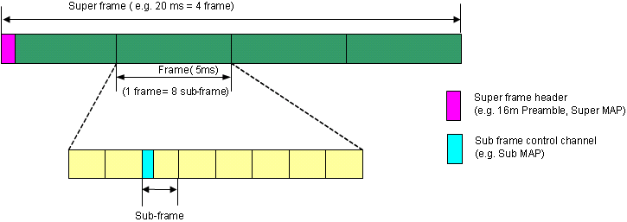
Figure 1: An example of basic frame structure in IEEE 802.16m
In figure 1, a super frame consists of 4 frames and the size of the super frame is 20ms since the length of one frame is 5ms. A frame consists of 8 sub-frames. A super frame header is located in the beginning of the super-frame and contains a preamble for downlink synchronization and a Super-MAP for the delivery of the system configuration information. There exist still many decision points for the designing of the super frame header in IEEE 802.16m.
In this contribution, we will discuss the super frame header in terms of the Super-MAP structure, logical system information structure and the Super-MAP elements.

Super-MAP structure and elements
A super frame header consists of a preamble and a Super-MAP as shown in Figure 2. The preamble is mainly used for downlink synchronization and channel estimation by MSs and the Super-MAP is to deliver the system configuration information to MSs. In the legacy system, a BS delivers the system information to MSs by DCD, UCD, DL-MAP, and UL-MAP messages [2]. If the Super-MAP contains all the system information (e.g. system information carried by DCD, UCD, and DL/UL-MAP messages in the legacy system) and is transmitted every super-frame period(e.g. 20ms), it will result in very large resource waste. In order to deliver the system information to MSs efficiently, the length of Super-MAP should be properly reduced and thus, we need to choose the proper elements for a Super-MAP. Therefore the other elements except for the Super-MAP elements should be alternatively transmitted by using MAC messages or other structures (e.g. BSDs in Figure 2).
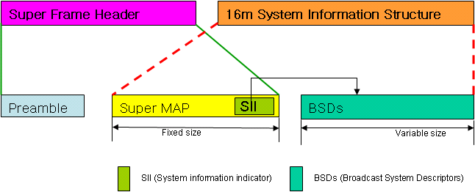
Figure 2: Super frame header and system information structure for IEEE 802.16m
Figure 2 shows the proposed super frame header concept and logical system information structure for IEEE 802.16m. The 16m system information structure is logically divided into a Super-MAP and Broadcast System Descriptors (BSDs). A Super-MAP is transmitted every super frame period by using QPSK 1/2 with 6 repetitions for cell edge users. The Super-MAP includes the essential system information for sub-frame and super-frame configurations such as frame number, BS ID, DL/UL-ratio, and so on. The Super-MAP also contains the information for the legacy system support and System Information Indicator (SII) which is the information for configuring the BSDs and contains the type of BSDs, the scheduling information for the BSDs and version information of BSDs. The Super-MAP elements are explained in more detail in Table 1.
BSDs contain the system information elements except for the system information elements included in the Super-MAP. Futhermore the BSDs will come with serveral types which contain different information from each other [3].

We select Super-MAP elements in terms of sub-frame configurations, super frame configurations, system information indicator (or configuration of BSDs) and legacy system supports as shown in Table 1.
Table 1. Super-MAP elements
Category | Name | Notes
Frame configuration information | System frame number | Super frame number
Frame configuration information | TTG | The size of TTG
Frame configuration information | RTG | The size of RTG
Frame configuration information | DL/UL ratio | Shall be represented as a unit of a sub-frame.  Shall contain information about DL/UL switching points
Frame configuration information | BS ID | Identification of the base station
Frame configuration information | Number of BS’s antennas | Two or four antennas
Frame configuration information | Various TTI information | Indicates how many frames a TTI is configured with  Shall be represented as a unit of a sub-frame  It can be changed at the specific sub-frame.
Frame configuration information | System Bandwidth | The size of bandwidth supported by this system in case a scalable bandwidth is supported  Shall be needed if the bandwidth for preamble is fixed regardless of system bandwidth (e.g. 5MHz)
Frame configuration information | HARQ ACK delay for DL or UL bursts | Indicates the HARQ ACK delay for DL bursts or UL bursts  Shall be represented as a unit of a sub-frame  HARQ ACK delay may be different according to sub-frames.
Frame configuration information | Basic UL timing relevance | Indicates the start time of UL allocation defined by the UL scheduling information  Shall be represented as a unit of a sub-frame.  It can be changed at the specific sub-frame.
Frame configuration information | Basic MCS level for sub-frame | Indicates the default MCS level of DL control channel for resource allocation in sub-frame
Frame configuration information | MBS allocation information | Indicates the location of sub-frames in which MBS bursts are allocated
The Information for supporting the legacy system | Legacy system indicator | Indicates whether this system supports the legacy system
The Information for supporting the legacy system | DL/UL ratio information for the legacy system | Indicates in which DL sub-frame and UL sub-frame the legacy system are located.  Shall be represented as a unit of a sub-frame
The Information for supporting the legacy system | Bandwidth information of the legacy system | Bandwidth used by the legacy system
The Information for supporting the legacy system | Frequency information of the legacy system | Center frequency used by the legacy system  Shall contain both DL and UL frequency information for FDD or H-FDD system
System Information Indicator (SII) (or configuration information of BSDs)  [3] | Type of BSDs | Type of BSDs
 | Resource allocation information of the BSDs | Resource allocation information of the BSDs
 | Configuration change information of BSDs | Configuration change information of BSDs

References
[1] IEEE 802.16m-08/096r5, Frame structure comparison, 2008-01-24
[2] IEEE 802.16e Rev2/D2, Part 16: Air interface for Broadband Wireless Access Systems, December 2007
[3] IEEE 802.16m-08/150, Control signaling for Broadcast System Descriptor, by LGE, 2008-03-10

Text Proposal for the 802.16m SDD

============================== Start of Proposed Text =================================

11.x.y Super-MAP structure
A super frame header is located in the beginning of super frame. The super frame header consists of a preamble for downlink synchronization and a Super-MAP that includes system information. The Super-MAP shall be modulated with QPSK with coding rate 1/2 and repetition 6, and contain system information related to sub-frame and super-frame configurations, system information indicator (or configuration of BSDs) and legacy system support.
In IEEE 802.16m system, a system information structure shall be divided into a Super-MAP with fixed size and Broadcast System Descriptors(BSDs) with variable size.
Figure xxx. The logical structures of Super frame header and system information

11.x.y.1 Super-MAP elements
Super-MAP shall contain the system information as shown in Table X.
Table X. Super-MAP elements
Category | Name | Notes
Frame configuration information | System frame number | Super frame number
Frame configuration information | TTG | The size of TTG
Frame configuration information | RTG | The size of RTG
Frame configuration information | DL/UL ratio | Shall be represented as a unit of a sub-frame.  Shall contain the information about DL/UL switching points
Frame configuration information | BS ID | Identification of the base station
Frame configuration information | Number of BS’s antennas | Two or four antennas
Frame configuration information | Various TTI information | Indicates how many frames a TTI is configured with  Shall be represented as a unit of a sub-frame  It can be changed at the specific sub-frame
Frame configuration information | System Bandwidth | The size of bandwidth supported by this system in case a scalable bandwidth is supported  Shall be needed if the bandwidth for preamble is fixed regardless of system bandwidth (e.g. 5MHz)
Frame configuration information | HARQ ACK delay for DL or UL bursts | Indicates the HARQ ACK delay for DL bursts or UL bursts  Shall be represented as a unit of a sub-frame  HARQ ACK delay may be different according to sub-frames.
Frame configuration information | Basic UL timing relevance | Indicates the start time of UL allocation defined by the UL scheduling information  Shall be represented as a unit of a sub-frame.  It can be changed at the specific sub-frame.
Frame configuration information | Basic MCS level for sub-frame | Indicates the default MCS level of DL control channel for resource allocation in sub-frame
Frame configuration information | MBS allocation information | Indicates the location of sub-frames in which MBS bursts are allocated
The Information for supporting the legacy system | Legacy system indicator | Indicates whether this system support the legacy system
The Information for supporting the legacy system | DL/UL ratio information for legacy system | Indicates in which sub-frames DL sub-frame and UL sub-frame the legacy system are located.  Shall be represented as a unit of a sub-frame
The Information for supporting the legacy system | Bandwidth information of legacy system | Bandwidth used by legacy system
The Information for supporting the legacy system | Frequency information of legacy system | Center frequency used by legacy system  Shall contain both DL and UL frequency information for FDD or H-FDD system
System Information Indicator (SII)  (or configuration information of BSDs) | Type of BSDs | Type of BSDs
 | Resource allocation information of the BSDs | Resource allocation information of the BSDs
 | Configuration change information of BSDs | Configuration change information of BSDs

============================== End of Proposed Text =================================

