Project | IEEE 802.16 Broadband Wireless Access Working Group <http://ieee802.org/16>
Title | Pilot related to DL MIMO
Date Submitted | 2008-03-10
Source(s) | Bin-Chul Ihm  Jinsoo Choi  Wookbong Lee  LG Electronics Inc.  LG R&D Complex, 533 Hogye-1dong, Dongan-gu, Anyang, 431-749, Korea | Voice: +82-31-450-7187  E-mail: bcihm@lge.com
Re: | 802.16m-08/005 Call for contributions on project 802.16m system description document (SDD).  Specific topic : Pilot Structures as relevant to downlink MIMO
Abstract | This contribution provides the pilot for DL MIMO operation
Purpose | For discussion and approval by TGM
Notice | This document does not represent the agreed views of the IEEE 802.16 Working Group or any of its subgroups. It represents only the views of the participants listed in the “Source(s)” field above. It is offered as a basis for discussion. It is not binding on the contributor(s), who reserve(s) the right to add, amend or withdraw material contained herein.
Release | The contributor grants a free, irrevocable license to the IEEE to incorporate material contained in this contribution, and any modifications thereof, in the creation of an IEEE Standards publication; to copyright in the IEEE’s name any IEEE Standards publication even though it may include portions of this contribution; and at the IEEE’s sole discretion to permit others to reproduce in whole or in part the resulting IEEE Standards publication. The contributor also acknowledges and accepts that this contribution may be made public by IEEE 802.16.
Patent Policy | The contributor is familiar with the IEEE-SA Patent Policy and Procedures:  <http://standards.ieee.org/guides/bylaws/sect6-7.html#6> and <http://standards.ieee.org/guides/opman/sect6.html#6.3>.  Further information is located at <http://standards.ieee.org/board/pat/pat-material.html> and <http://standards.ieee.org/board/pat>.
Pilot related to DL MIMO
Bin-Chul Ihm, Jinsoo Choi and Wookbong Lee
LG Electronics

Introduction
In this paper, we propose the pilot structures for DL MIMO operations such as transmit diversity and spatial multiplexing for 802.16m with considerations of overhead, channel estimation performance and relevance to DL control channel.

MIMO Pilot structures for normal sub-frame
- Considerations for pilot design
  - Pilot spacing in time and frequency domain
Pilot spacing is tightly related to coherent time and bandwidth, and its specific value can be suggested per SRD [3] and EMD [1] saying support upto 350km/h and various fading channels. Table 1 and Table 2 guide the maximum pilot spacing in frequency and time domain respectively. Pilot patterns should be designed within these boundaries. The candidate spacing are from the pilot spacing and subcarrier spacing of LTE.
Table 1. Pilot spacing under various fading channels
Channel Model | RMS Delay Spread (ns) | Max. Delay Spread (us) | Frequency Spacing  (# of Subcarriers)   |  |  | Candidate Spacing  (# of Subcarriers)
Channel Model | RMS Delay Spread (ns) | Max. Delay Spread (us) | LTE | UMB | WiMAX | 16m
 |  |  |  |  |  | Normal | MBMS
Pedestrian A | 45 | 0.41 | 162.6 | 254.1 | 222.9 | N_{f} = 8.2 | N_{f} = 2.7
Pedestrian B | 750 | 3.7 | 18 | 28.2 | 24.7 | N_{f} = 8.2 | N_{f} = 2.7
Vehicular A | 370.4 | 2.51 | 26.6 | 41.5 | 36.4 | N_{f} = 8.2 | N_{f} = 2.7
Vehicular B | 4000 | 20 | 3.3 | 5.2 | 4.6 | N_{f} = 8.2 | N_{f} = 2.7
TU 6-ray Model | 1000 | 5 | 13.3 | 20.8 | 18.3 | N_{f} = 8.2 | N_{f} = 2.7
Table 2. Pilot spacing under various mobile speeds
MS Speed  (km/h) | Max. Doppler Spread (Hz) | Coherence  Time (ms) | Time Spacing (2GHz) (# of Symbols) |  |  |  |  | Candidate Spacing  (# of Symbols)
MS Speed  (km/h) | Max. Doppler Spread (Hz) | Coherence  Time (ms) | LTE |  | UMB |  | WiMAX | 16m
MS Speed  (km/h) | Max. Doppler Spread (Hz) | Coherence  Time (ms) | Short CP | Long CP | Short CP | Long CP | WiMAX | 2 GHZ | 6 GHz
0 ~ 15 | ~ 27.78 | 15.23 | 252 | 216 | 158 | 134.9 | 174.9 | N_{t} = 2.8 | N_{t} = 0.93
15 ~ 120 | ~ 222.22 | 1.90 | 31.5 | 27 | 19.7 | 16.9 | 21.9 | N_{t} = 2.8 | N_{t} = 0.93
120 ~ 350 | ~ 648.15 | 0.65 | 10.8 | 9.3 | 6.8 | 5.8 | 7.5 | N_{t} = 2.8 | N_{t} = 0.93

  - Identical pilot pattern for every physical resource block
Pilot spacing and numbers should consider the resource block size. If the position of the pilot symbols within a designed minimum resource block is not constant over all resource blocks in the system bandwidth, in other words, pilot subcarriers have different positions within each resource block, then the filtering operation gets complex interpolation processes in the channel estimation and data rate per each resource block may get be different.
  - Pilot density
Proper pilot overhead should be set for the improvement of data rate as well as supporting for the good channel estimation quality. We consider maximum 11.11% pilot overhead with 2 transmit antenna and less than 20% pilot overhead with 4 transmit antennas to be proper pilot densities under 3km/h~120km/h MS mobility environment.
  - Types of pilot
Pilot has two types as common and dedicated, where the former means every MS in the sector can estimate the channel using the pilot over whole band while the latter means only the pilot in the assigned resource block should be used for channel estimation. In the conventional MIMO case, the dedicated pilots are introduced when using precoding scheme. The dedicated pilots can be inserted in addition to common pilots or replaced from the common pilots.
  - Pilot power boosting
In general, pilot subcarriers have boosted power relative to data subcarriers in order to enhance the channel estimation with pilot hopping or shift. To avoid power fluctuation in symbol by symbol when using boosted pilots, it is desirable to place the pilot subcarriers evenly every symbols or to employ power stealing or puncturing from data subcarriers within a symbol.
  - Per antenna power balance
When using multiple transmit antennas, it is important to keep balanced powers across the antennas in order to employ a cheaper amplifier. Imbalanced power per antenna means that each antenna should support more peak power by using an amplifier of higher cost. For this purpose, for example, if there are two antennas, one symbol should have the same number of pilot set #1 and pilot set #2 for antenna #1 and #2.

- Pilot structure for two transmit antennas
Taking the above points into account, we propose the common pilots for 2Tx MIMO system as shown in (a) Type A (b) Type B (c) Type C. For the proposed Type A and B, pilot overhead is 11.11% and transmit power per antenna is balanced. Note that Type C which is the legacy structure has unbalanced power across antennas and symbols. Pilot powers can be boosted by 3dB relative to data subcarrier and this is done by power stealing or puncturing neighbor data subcarriers.

(a) Type A (b) Type B (c) Type C
Figure 1. Common pilot structure for 2Tx antenna
Channel estimation using common pilot affects the performance of data decoding and DL control channel decoding. Error: Reference source not found shows the decoding performances using spatial multiplexing with the proposed pilot patterns and the legacy pilot, where the proposed Type B provides the best performance under low and high mobility.
Figure 2. Channel estimation using various pilot patterns for 2Tx SM with QPSK 1/2
Figure 3 provides the link performance using transmit diversity SFBC with the Type A~C pilots. In this simulation, the Type A performs the best.
Figure 3. Channel estimation using various pilot patterns for 2Tx SFBC with QPSK 1/2
Based on Error: Reference source not found and Figure 3, we can conclude that Type A is the best among three patterns in (a) Type A (b) Type B (c) Type C. Type A shows the best performance under diversity mode and marginal performance under spatial multiplexing mode. The link performance is one of advantages of Type A over Type B and Type C, where these advantages are easy placement of DL-MAP in TDM fashion, easy build up MBS subframe, and easy forming irregular subframe of only 5symbols or 7 symbols.

  - DL control channel as relevance with pilot
With the pilot pattern of Type A, there are several candidates for placing the DL control channel such as DL-MAP as in Figure 4.

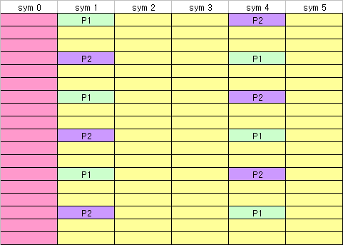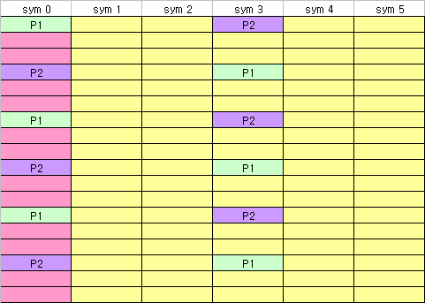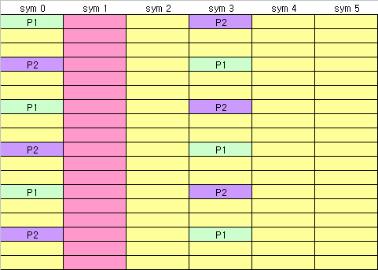
(a) Case 1 (b) Case 2 (c) Case 3
Figure 4. Location of DL control channel
In general, case 1 is the most familiar structure and the DL-MAP decoding can be helped using pilots of prior sub-frame. However, the first sub-frame in TDD has no prior sub-frame, therefore its channel estimation is inferior to the other sub-frame. To keep the identical cell coverage across sub-frames, DL-MAP can be placed between pilots as in case 2 or case 3. Figure 5 presents the simulation result using three cases to evaluate the location of DL-MAP with SFBC and effective code rate 1/12. 2D Wiener estimator is employed within the sub-frame, and case 2 and 3 are better than case 1 when using non-boosted pilots.
Figure 5. DL control channel performance of case 1~3 with QPSK 1/12.
When using pilot power boosting, case 2 is better than case 3 since power of DL-MAP is stolen for pilot power boosting in case 3. Moreover, case 2 provides more subcarriers for DL-MAP. Figure 6 gives the performance results when using pilot power boosting for case 2 and 3, here case 2 with pilot boosting presents improved performance than non-boosting scheme while case 3 shows rather performance degradation.

Figure 6. DL control channel performance of case 2 and 3 with QPSK 1/12.

- Pilot structure for four transmit antenna
Pilots for the third and fourth antennas are added to pilot structures for the first and second antenna as shown in Figure 7. Type A can provide more robust channel estimate at the cost of pilot overhead as large as 22.22% whilst Type C of the least overhead as 14.81% is suffering from worse channel estimate performance as shown in Figure 8. Type A has too large overhead, its data capacity becomes less than Type B around the general operating point 12~16dB of 4x4 SM as in Figure 9. As a conclusion, Type B is the most proper choice for four transmit antenna.
(a) Type A (b) Type B (c) Type C
Figure 7. Common pilot structure with 4 transmit antenna
Figure 8. Channel estimation using various pilot patterns for 4Tx antennas with 4x4 SM with QPSK 1/2

Figure 9. Goodput under Type A~D pilot patterns with 4x4 SM.

MIMO Pilot structures for sub-frame with less or more symbols

For 1/8 CP, 5ms TDD frame contains 47 symbols, therefore, one sub-frame in DL should have 5 symbols when DL:UL ratio is equal to 5:3. To configure the sub-frame of 5 symbols, pilot pattern for 3 and 4 are moved as shown in Figure 10-(a). 1/16 CP results in additional 3 symbols which can be used for data symbols. Each additional symbol can be attached at the end of sub-frame without modifying pilot pattern.
(a) For sub-frame of five symbols (b) For sub-frame of seven symbols
Figure 10. Symbol deletion or addition at the end of sub-frame with minor modification of pilot pattern

Text Proposal for 802.16m SDD [2]

============================== Start of Proposed Text =================================

11.x Downlink pilots

For two antenna transmission, each antenna has its own pilot pattern and these pilot patterns from two antennas are configured as in Figure xxx.

Figure xxx. Pilot patterns per sub-frame for two antenna transmission
Irregular sub-frame with five or seven OFDM symbols has modified pilot patterns as in Figure xxx-1.

Figure xxx-1. Pilot patterns of irregular sub-frame for two antenna transmission:
Left for five symbols and Right for seven symbols.

For four antenna transmission, each antenna has its own pilot pattern and these pilot patterns from four antennas are configured as in Figure yyy.

Figure yyy. Pilot patterns per sub-frame for four antenna transmission
Irregular sub-frame with five or seven OFDM symbols has modified pilot patterns as in Figure yyy-1.
Figure yyy-1. Pilot patterns of irregular sub-frame for four antenna transmission:
Left for five symbols and Right for seven symbols

=============================== End of Text Proposal ===============================

Reference

[1] IEEE 802.16m-08/004, “Project 802.16m Evaluation Methodology Document (EMD)”
[2] IEEE 802.16m-08/003, “The draft IEEE802.16m System Description Document”
[3] IEEE 802.16m-07/002r4, “IEEE 802.16m System Requirements”

