IEEE C802.16m-08/169

Project | IEEE 802.16 Broadband Wireless Access Working Group <http://ieee802.org/16>
Title | Localized and Distributed SC-FDMA and OFDMA for Uplink Multiple Access
Date Sub. | 2008-03-10
Source(s) | J Klutto Milleth  Kiran Kuchi  Vinod Ramaswamy  Dhivagar  K Giridhar  Bhaskar Ramamurthi | klutto@cewit.org.in  kkuchi@cewit.org.in  vinodr@cewit.org.in  dhiv@cewit.org.in  giri@tenet.res.in  bhaskar@tenet.res.in
Re: | IEEE C802.16m-08/005 - Call for Contributions on Project 802.16m System Description Document (SDD)
Abstract | The block error rate performances of OFDMA and SC-FDMA schemes for both localized and distributed subcarrier allocation is provided. We considered SIMO and MIMO configurations in this study.
Purpose | To be discussed by TGm to facilitate the decision on uplink multiple access technique
Notice | This document does not represent the agreed views of the IEEE 802.16 Working Group or any of its subgroups. It represents only the views of the participants listed in the “Source(s)” field above. It is offered as a basis for discussion. It is not binding on the contributor(s), who reserve(s) the right to add, amend or withdraw material contained herein.
Release | The contributor grants a free, irrevocable license to the IEEE to incorporate material contained in this contribution, and any modifications thereof, in the creation of an IEEE Standards publication; to copyright in the IEEE’s name any IEEE Standards publication even though it may include portions of this contribution; and at the IEEE’s sole discretion to permit others to reproduce in whole or in part the resulting IEEE Standards publication. The contributor also acknowledges and accepts that this contribution may be made public by IEEE 802.16.
Patent Policy | The contributor is familiar with the IEEE-SA Patent Policy and Procedures:  <http://standards.ieee.org/guides/bylaws/sect6-7.html#6> and <http://standards.ieee.org/guides/opman/sect6.html#6.3>.  Further information is located at <http://standards.ieee.org/board/pat/pat-material.html> and <http://standards.ieee.org/board/pat>.

Localized and Distributed SC-FDMA and OFDMA for Uplink Multiple Access
J Klutto Milleth, Kiran Kuchi, Vinod Ramaswamy, Dhivagar, K Giridhar, Bhaskar Ramamurthi
CEWiT, Chennai, India

The block error rate performances of OFDMA and SC-FDMA schemes for both localized and distributed subcarrier allocation are provided. We considered SIMO and MIMO configurations in this study.

- SIMO - Simulation setup
- Number of sub carriers used – 256
- OFDMA – Equi-spaced subcarriers as in SC-FDMA
- FEC – CTC as in 16e
- FEC block size – 384
- Modulation – QPSK and 16-QAM
- Code Rate – ½ and ¾
- Antenna Configuration – SISO (1x1) and SIMO (1x2)
- Receiver – MMSE with bias removed
- Channel model as in 16m EMD
  - PED B – 3 Km/hr
  - VEH A – 120 Km/hr
- Channel Estimation – Ideal

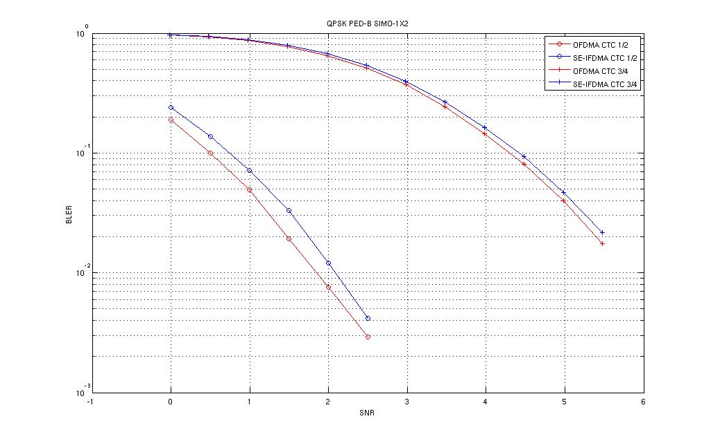
Fig. 1 - PED B, SIMO, QPSK, CTC – ½, ¾
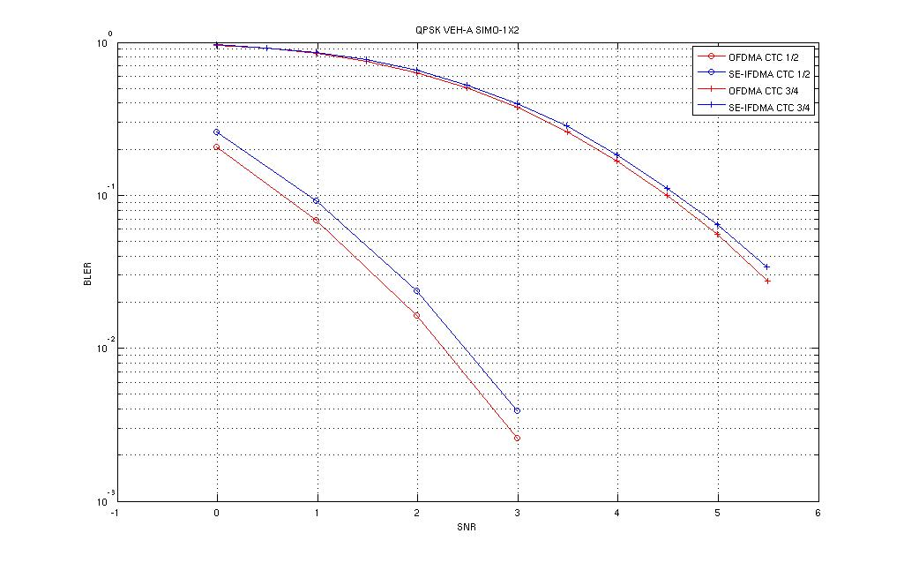
Fig. 2 - VEH A, SIMO, QPSK, CTC – ½, ¾

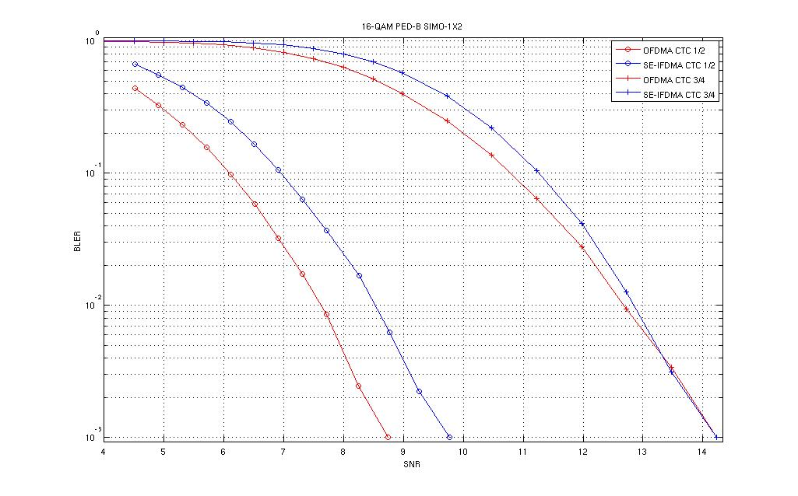
Fig. 3 - PED B, SIMO, 16-QAM, CTC – ½, ¾

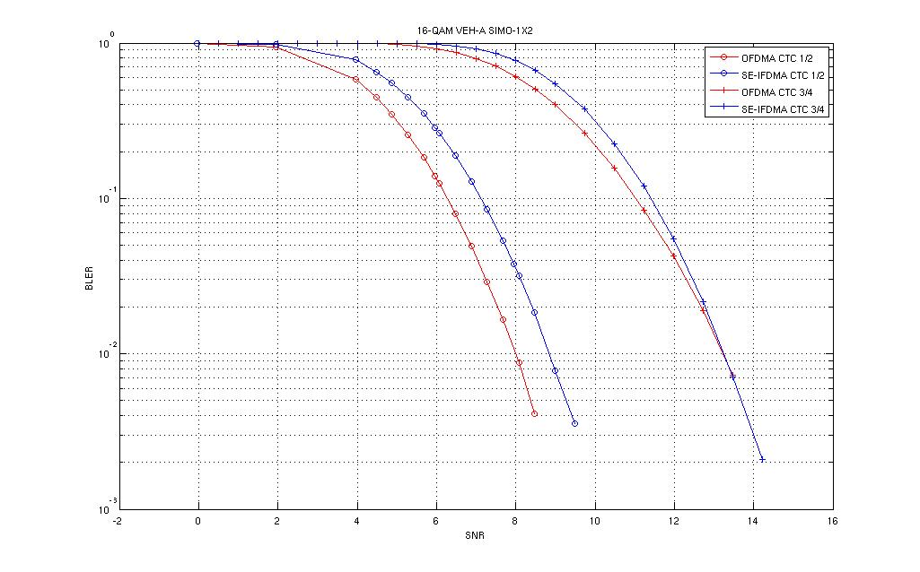
Fig. 4 - VEH A, SIMO, 16-QAM, CTC – ½, ¾

- Summary for SIMO

- SC-FDMA (Distributed) with 2 Rx antennas at BS
  - BLER performance SC-FDMA compares favourably with OFDMA
  - BLER performance difference for PED B (1% BLER)
    - less than 0.25 dB for QPSK
    - less than 0.9 dB for 16-QAM
  - BLER performance difference for VEH A (1% BLER)
    - less than 0.27 dB for QPSK
    - less than 0.85 dB for 16-QAM
- Performance gap will vanish with DFE/Turbo equalizers
- MIMO - Simulation setup
- Number of sub carriers used – 16 and 256
- OFDMA vs SC-FDMA – Distributed (equi-spaced) subcarrier allocation
- OFDMA vs SC-FDMA – Localized (contiguous) subcarriers allocation
- FEC – CTC as in 16e
- FEC block size – 384 for 256 sub carriers and 96 for 16 subcarriers
- Modulation – QPSK and 16-QAM
- Code Rate – ½ and ¾
- Antenna Configuration – MIMO (2x2)
- Receiver –
  - SC-IFDMA
    - MMSE only
    - MMSE+ML (MMSE equalizer followed by ML)
  - OFDMA
    - MMSE
    - ML
- Channel model as in 16m EMD
  - PED B – 3 Km/hr
  - VEH A – 120 Km/hr
- Channel Estimation – Ideal

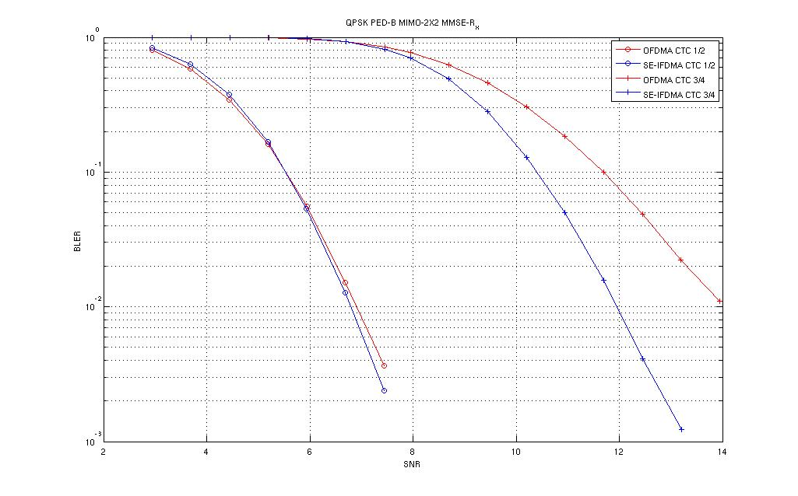
Fig. 5 – Subcarrier – 256 Distributed, PED B, QPSK, CTC – ½, ¾ with MMSE receiver

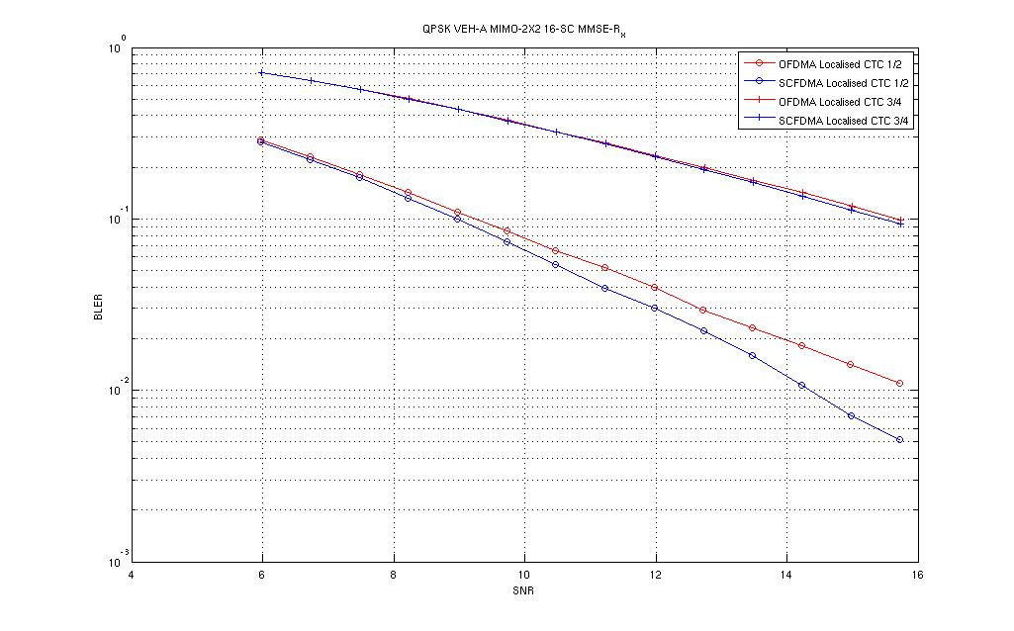
Fig. 6 - Subcarrier – 16 Localized, VEH A, QPSK, CTC – ½, ¾ with MMSE receiver

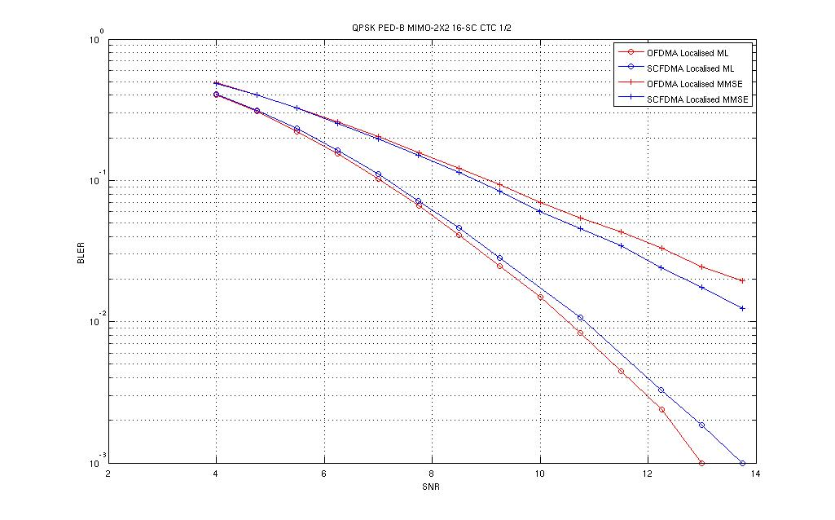
Fig. 7 - Subcarrier – 16 Localized, PED B, QPSK, CTC – ½ with ML* and MMSE

*In case of SC-FDMA, ML implies that the receiver is MMSE equalizer followed by a joint MLD with comparable ML complexity
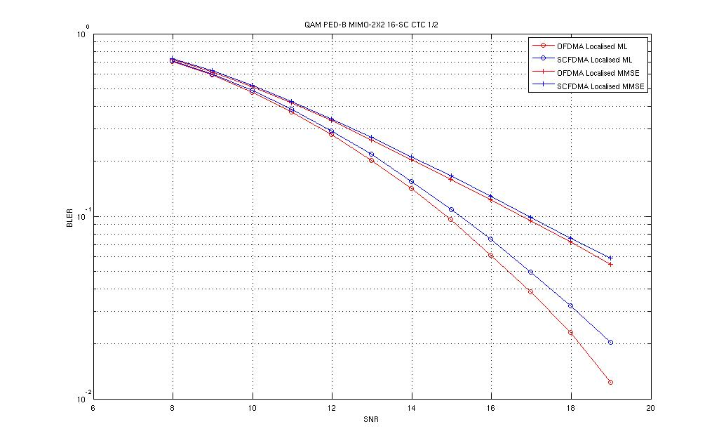
Fig. 8 - Subcarrier – 16 Localized, PED B, 16 – QAM, CTC – ½ with ML* and MMSE

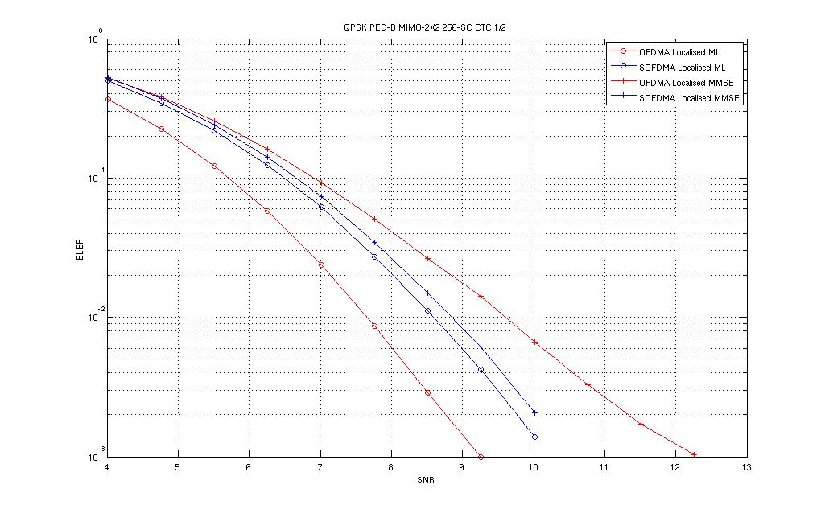
Fig. 9 - Subcarrier – 256 Localized, PED B, QPSK, CTC – ½ with ML* and MMSE
*In case of SC-FDMA, ML implies that the receiver is MMSE equalizer followed by a joint MLD with comparable ML complexity
- Summary for MIMO

- MIMO 2 x 2
- MMSE receiver as base line
  - OFDMA vs SC-FDMA (Distributed)
    - SC-FDMA is better for most cases
  - OFDMA vs SC-FDMA (Localized)
    - Similar, but in most cases localized is better
- ML receiver as base line
  - OFDMA vs SC-FDMA (Localized)
    - OFDMA performs better with ML receiver
      - Loss is within 1 dB with 16 subcarriers
      - Loss is within 1.8 dB with 256 subcarriers
- SC-FDMA ML after MMSE is not beneficial for 256 subcarriers
  - However, useful for 16 subcarriers
- The MMSE+ML complexity is comparable to OFDMA ML

- Conclusion

- Based on our simulation results, we propose SC-FDMA and OFDMA to be considered for uplink multiple access technique as separate zones in order to reap the benefits of both the schemes in different deployment scenarios
  - Link margin obtained through the low PAPR of SC-FDMA to enhance the coverage range
  - OFDMA can be used in regions of high SINR
    - Collaborative uplink MIMO can be implemented with OFDMA

