IEEE C802.16m-08/169r2

Project | IEEE 802.16 Broadband Wireless Access Working Group <http://ieee802.org/16>
Title | Localized and Distributed SC-FDMA and OFDMA for Uplink Multiple Access
Date Sub. | 2008-03-10
Source(s) | J Klutto Milleth  Kiran Kuchi  Vinod Ramaswamy  Dhivagar  K Giridhar  Bhaskar Ramamurthi | klutto@cewit.org.in  kkuchi@cewit.org.in  vinodr@cewit.org.in  dhiv@cewit.org.in  giri@tenet.res.in  bhaskar@tenet.res.in
Re: | IEEE C802.16m-08/005 - Call for Contributions on Project 802.16m System Description Document (SDD)
Abstract | Additional results are provided on link level performance with real channel estimation for localized/distributed SC-FDMA and OFDMA schemes. The PAPR differences between SC-FDMA and OFDMA are clarified.
Purpose | To be discussed by TGm to facilitate the decision on uplink multiple access technique
Notice | This document does not represent the agreed views of the IEEE 802.16 Working Group or any of its subgroups. It represents only the views of the participants listed in the “Source(s)” field above. It is offered as a basis for discussion. It is not binding on the contributor(s), who reserve(s) the right to add, amend or withdraw material contained herein.
Release | The contributor grants a free, irrevocable license to the IEEE to incorporate material contained in this contribution, and any modifications thereof, in the creation of an IEEE Standards publication; to copyright in the IEEE’s name any IEEE Standards publication even though it may include portions of this contribution; and at the IEEE’s sole discretion to permit others to reproduce in whole or in part the resulting IEEE Standards publication. The contributor also acknowledges and accepts that this contribution may be made public by IEEE 802.16.
Patent Policy | The contributor is familiar with the IEEE-SA Patent Policy and Procedures:  <http://standards.ieee.org/guides/bylaws/sect6-7.html#6> and <http://standards.ieee.org/guides/opman/sect6.html#6.3>.  Further information is located at <http://standards.ieee.org/board/pat/pat-material.html> and <http://standards.ieee.org/board/pat>.

Localized and Distributed SC-FDMA and OFDMA for Uplink Multiple Access
J Klutto Milleth, Kiran Kuchi, Vinod Ramaswamy, Dhivagar, K Giridhar, Bhaskar Ramamurthi
CEWiT, Chennai, India

In this contribution, additional results are provided for link level BLER performance and PAPR characteristics for both SC-FDMA and OFDMA schemes. Specifically, the following issues are addressed:

- We provide link level results for SIMO with real channel estimation. It is shown that:
  - With localized subcarrier allocation, link performance difference between OFDMA and SC-FDMA are small. The loss of SC-FDMA over OFDMA is less than 0.4 dB.
  - With distributed subcarrier mapping, SC-FDMA outperforms OFDMA by 1.2 dB for low velocity channels and for high velocity case, the gain is less than 0.4 dB.
- Further reduction in PAPR is feasible for distributed SC-FDMA, if the (unused) excess bandwidth that is available at the edge of the band is exploited. In addition, we propose that pi/4-QPSK should be used for SC-FDMA (both for localized and distributed cases) to reduce the PAPR.

- Link Level Results with Real Channel Estimation

The block error rate performance of OFDMA and SC-FDMA schemes are provided for both localized and distributed subcarrier allocations for SIMO configuration. In this study we considered the following slot structure for localized SC-FDMA scheme. Each slot has 18 subcarriers and six OFDM symbols, out of which one symbol is used for pilots. For high velocity channels (such as Veh-A 120 Kmph), pilots from two contiguous slots are used to do channel tracking. For OFDMA, we have used time-frequency scattered pilots, which facilitates channel tracking even with a single slot allocation. The pilot density for both SC-FDMA and OFDMA is kept same i.e., 1/6.
For distributed case, the following pilot patterns are used. For SC-FDMA, we used 72 pilots in one symbol duration of a slot with 6-OFDM symbols. In OFDMA, 72 pilots are used in two OFDM symbols of a given slot.
  - SIMO - Simulation setup
- Number of subcarriers used –36, 72 for localized and distributed cases respectively.
- FEC – CTC as in 16e
- FEC block size – 360
- Modulation – QPSK and 16-QAM
- Code Rate – ½
- Antenna Configuration –SIMO (1x2)
- Receiver – MMSE with bias removed
- Channel Estimation – Real
- Channel model as in 16m EMD
  - PED B – 3 Km/hr
  - VEH A – 120 Km/hr
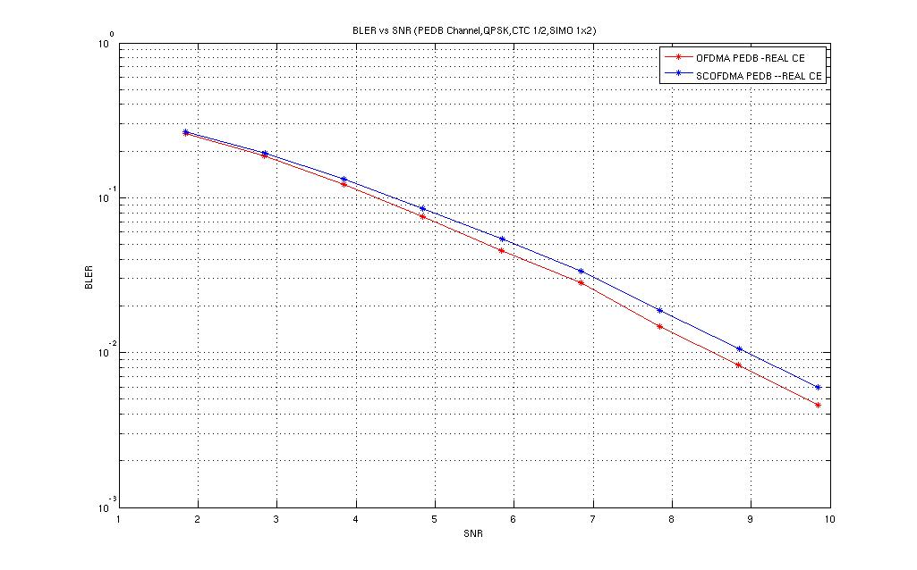
Fig. 1 – Localized, PED B, SIMO, QPSK, CTC – ½

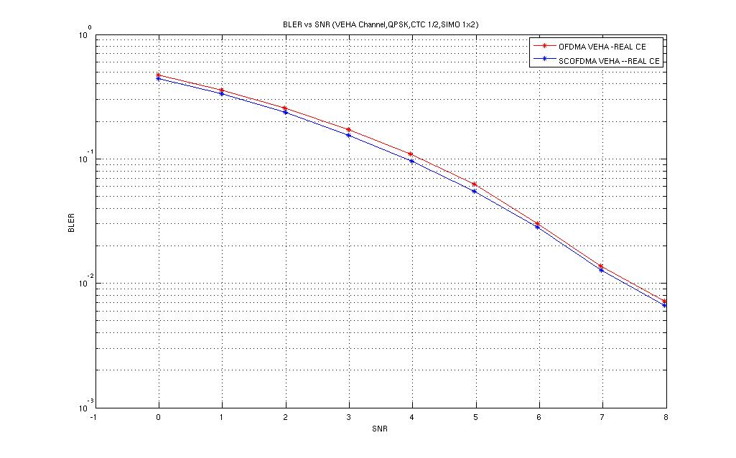
Fig. 2 – Localized, VEH A, SIMO, QPSK, CTC – ½

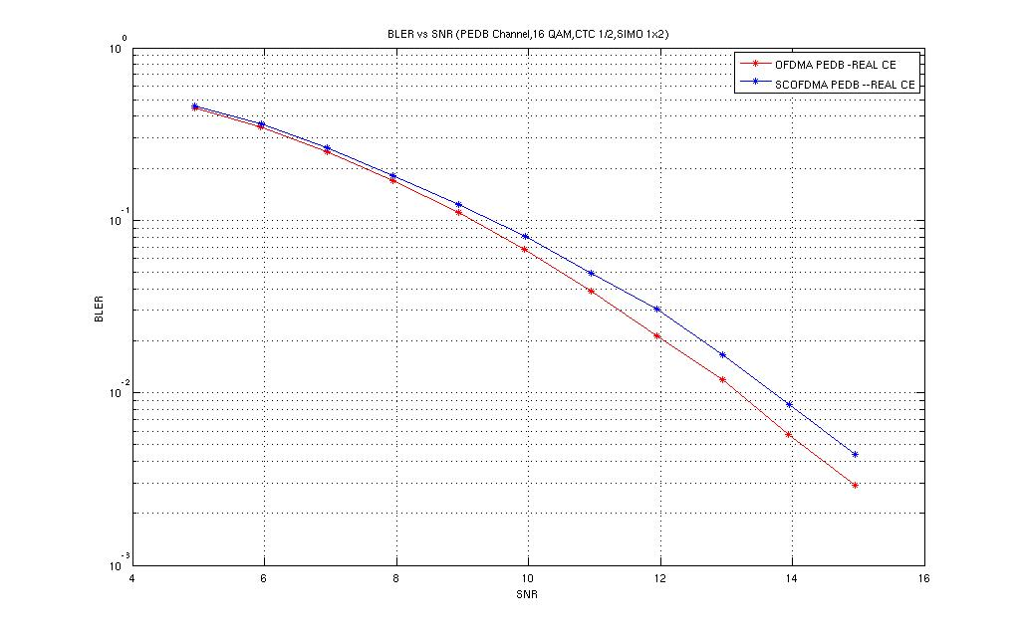Fig. 3 – Localized, PED B, SIMO, 16-QAM, CTC – ½
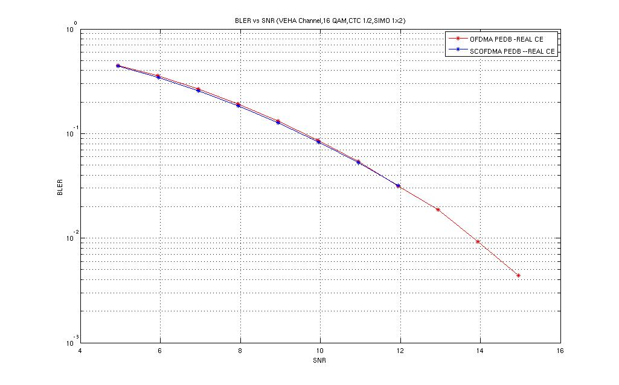Fig. 4 – Localized, VEH A, SIMO, 16-QAM, CTC – ½
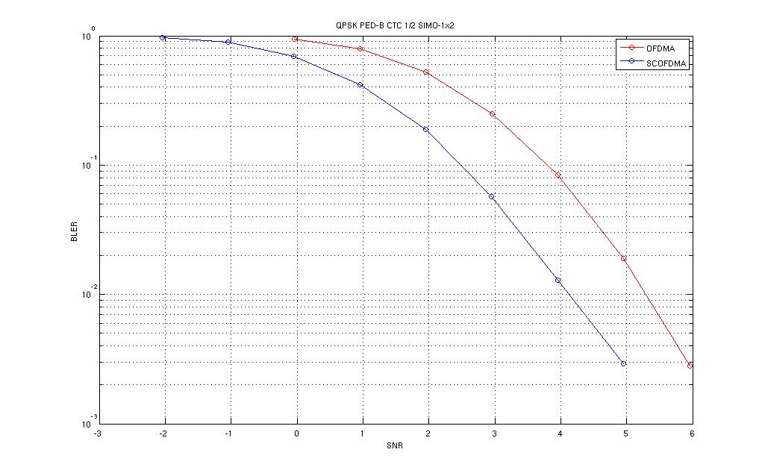
Fig. 5 – Distributed, PED B, SIMO, QPSK, CTC – ½
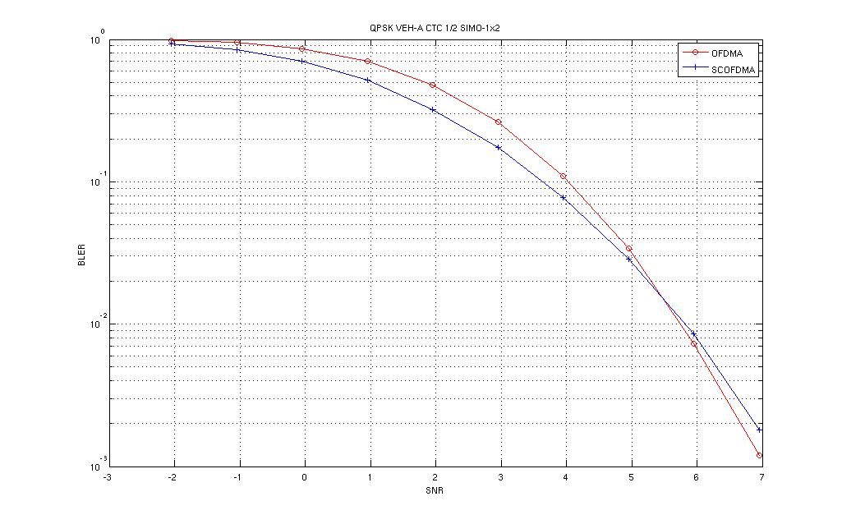
Fig. 6 – Distributed, VEH A, SIMO, QPSK, CTC – ½

- PAPR Reduction Utilizing Excess Bandwidth

The WiMAX spectrum mask for a 10-MHz channel allows nearly 15% guard band for out-of-band emissions. In this contribution, we propose that the SC-FDMA system can use a square-root-raised-cosine (SQRC) pulse shaping filter with certain excess bandwidth (EBW) to further reduce the PAPR. Since the SQRC filter frequency response decays sharply, the average power spectrum of the SQRC shaped SC-FDMA signal can be confined to the spectrum mask. We propose to use a SQRC filter with EBW on the order of 12.5%. Note that this EBW can be fully exploited by all users employing SC-FDMA with distributed allocation. For localized allocation, the EBW can be utilized only if the entire band is allocated to a single user. In Table-1 we show the PAPR of pi/4 QPSK for OFDMA and distributed SC-FDMA for an allocation of 256 subcarriers.

Table-1: PAPR of pi/4 QPSK with different excess bandwidths
 | Distributed SC-FDMA (0% EBW) | Distributed SC-FDMA (12.5% EBW) | Distributed SC-FDMA (6.25 % EBW) | OFDMA
PAPR (dB) | 6.05 | 5.16 | 5.58 | 8.3
PAPR reduction over OFDMA (dB) | 2.25 | 3.14 | 2.72 | 0

- Compared to OFDMA, a PAPR reduction of 3.14 dB is feasible when an excess bandwidth of 12.5% is used.
- Compared to the conventional case with zero-EBW, additional power gain of 0.89 dB can be obtained by exploiting the unused bandwidth at the band edges.

- Conclusion

Based on the simulation results we have the following conclusions.
- With real channel estimation:
  - Localized SC-FDMA scheme has less than 0.4 dB loss compared to OFDMA in both Ped-B 3Kmph for rate=1/2 QPSK. In Veh-A 120 Kmph, the difference is negligibly small. Similar trend can be seen in case of 16-QAM as well. The simulation results indicate that with channel tracking the difference between OFDMA and SC-FDMA becomes very small.
  - With distributed subcarrier mapping, SC-FDMA outperforms OFDMA by 1.2 dB for Ped-B 3 3Kmph case. In case of Veh-A 120 Kmph, SC-FDMA provides a gain in the range of 0.4 dB over OFDMA at 10% BLER and a loss of 0.1 dB at 1% BLER.
- The link level results with MIMO (results are given in the Appendix-A) show that SC-FDMA and OFDMA have comparable performance if basic MMSE receiver is used as baseline. When MLD is used as baseline, a sub-optimum MMSE+MLD (see Appendix-B for details) can be used for SC-FDMA whose performance compares favorably with OFDMA MLD.
- Regarding PAPR, we would like to emphasize the following:
  - Localized and distributed SC-FDMA has similar PAPR and both methods provide a minimum transmit power gain of 2.25 dB (can be further increased to 3.15 dB with SQRC pulse shaping) over OFDMA.
  - Further, we would like to point out that the localized SC-FDMA signal has same PAPR irrespective of where the signal is placed within the band. However, the localized signal which is placed at the band center will have a high PAPR if the DC carrier is removed from the localized signal spectrum. Therefore, the DC carrier should not fall within the localized allocation.

Based on our simulation results, we propose both SC-FDMA and OFDMA to be considered for uplink multiple access technique in separate zones in order to reap the benefits of respective schemes in different deployment scenarios
  - Link margin obtained through the low PAPR of SC-FDMA to enhance the coverage/range
  - OFDMA can be used in a separate zone for high SNR users

- Appendix-A

MIMO - Simulation setup
- Number of subcarriers used – 16 and 256
- OFDMA vs SC-FDMA – Distributed (equi-spaced) subcarrier allocation
- OFDMA vs SC-FDMA – Localized (contiguous) subcarriers allocation
- FEC – CTC as in 16e
- FEC block size – 384 for 256 subcarriers and 96 for 16 subcarriers
- Modulation – QPSK and 16-QAM
- Code Rate – ½ and ¾
- Antenna Configuration – MIMO (2x2)
- Receiver –
  - SC-IFDMA
    - MMSE only
    - MMSE+ML (MMSE equalizer followed by ML)
  - OFDMA
    - MMSE
    - ML
- Channel model as in 16m EMD
  - PED B – 3 Km/hr
  - VEH A – 120 Km/hr
- Channel Estimation – Ideal

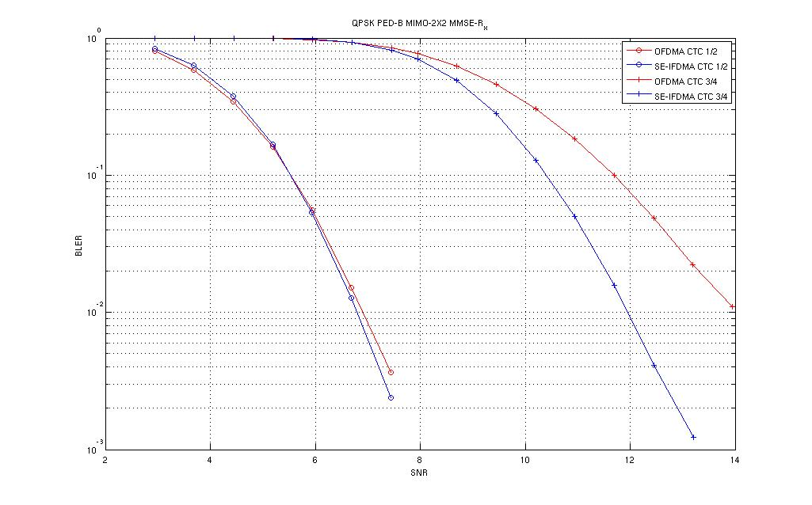
Fig. 5 – Subcarrier – 256 Distributed, PED B, QPSK, CTC – ½, ¾ with MMSE receiver

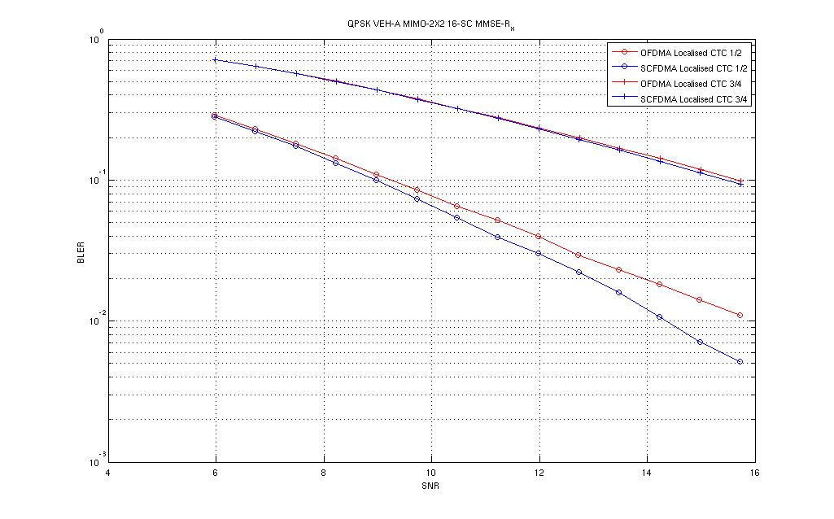
Fig. 6 - Subcarrier – 16 Localized, VEH A, QPSK, CTC – ½, ¾ with MMSE receiver

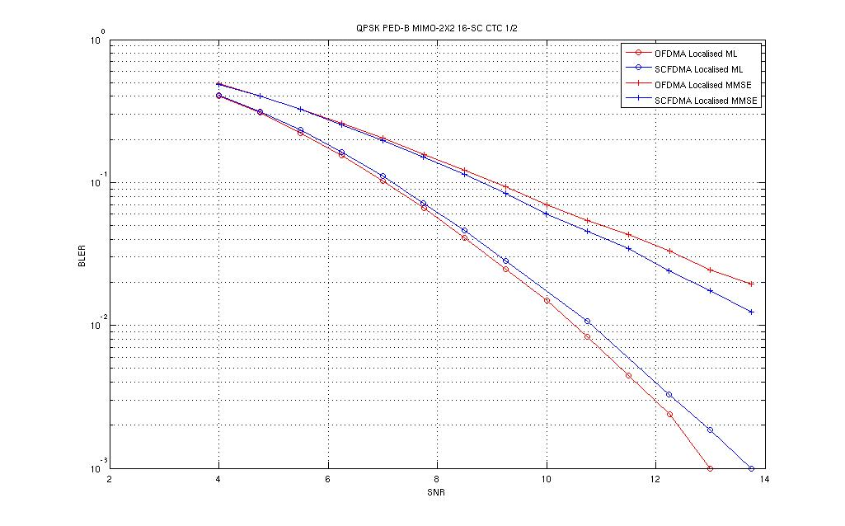
Fig. 7 - Subcarrier – 16 Localized, PED B, QPSK, CTC – ½ with ML* and MMSE

*In case of SC-FDMA, ML implies that the receiver is MMSE equalizer followed by a joint MLD with comparable ML complexity
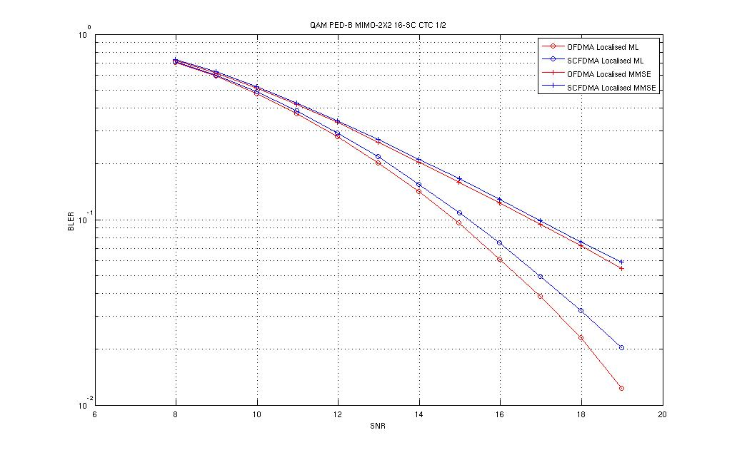
Fig. 8 - Subcarrier – 16 Localized, PED B, 16 – QAM, CTC – ½ with ML* and MMSE

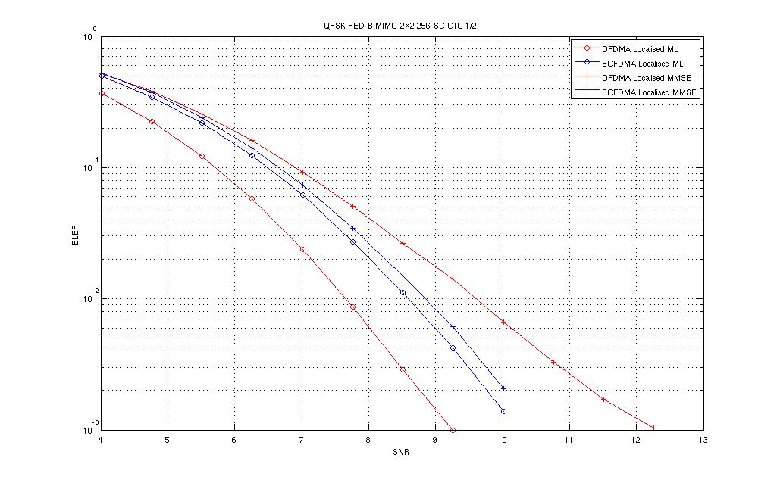
Fig. 9 - Subcarrier – 256 Localized, PED B, QPSK, CTC – ½ with ML* and MMSE
*In case of SC-FDMA, ML implies that the receiver is MMSE equalizer followed by a joint MLD with comparable ML complexity

- Appendix-B: MIMO MMSE+MLD receiver for SC-FDMA

The frequency domain signal model for SC-FDMA signal employing spatial multiplexing is given by:

$y(k)=\underset{\text{user\#1}}{\underbrace{h_{1}(k)x_{1}(k)}}+\underset{\text{user}2}{\underbrace{h_{2}(k)x_{2}(k}})+\underset{\text{AWGN}}{\underbrace{w(k)}},\begin{matrix} & k=1,2,\text{.}\text{.},N\end{matrix}$ (1)
where $k$ denotes the sub-carrier index. In Eq-(1), the frequency domain channel vectors $h_{1}(k),h_{2}(k)$denote row vectors of size $\text{Nr}$ where $\text{Nr}$ is the total number of receiver antennas at the BS. In the above signal model, $x(k)$ is the DFT of the time domain modulation sequence:$x(n)$. Using vector-matrix notation, the signal model can be re-written as:
$y(k)=H(k)x(k)+w(k)$
where $H(k)≃\left[\begin{matrix}h_{1}(k) & h_{2}(k)\end{matrix}\right]$ and $x(k)≃\left[\begin{matrix}x_{1}(k) \\ x_{2}(k)\end{matrix}\right]$. Now, we consider a matrix-valued MMSE filter $W(k)$ which minimizes the MSE term: $R_{\text{ee}}=\frac{1}{N}\sum_{k=1}^{N}{e(k)e^{}(k)}$ where $e(k)=W(k)y(k)−x(k)$ is the error vector between the MMSE filtered signal and the frequency-domain data vector and $()^{}$ denotes the conjugate-transpose operation. The optimum filter which minimizes either the trace or determinant of $R_{\text{ee}}$is given by:
$$W(k)=[N_{0}I+H^{}(k)H(k)]^{−1}H^{}(k)$$
where $N_{0}$ denotes the noise variance per dimension and the variance of each data of each user is assumed to be unity. The minimum MSE for this case can be shown to be:
$R_{\text{ee}}=\frac{1}{N}\sum_{k=1}^{N}{[N_{0}I+H^{}(k)H(k)]^{−1}}$.
Let $z(k)=W(k)y(k)$ denote the MMSE filtered signal. After MMSE filtering, data demodulation is done by taking IDFT of $z(k)$which gives a time domain MMSE filtered signal denoted as $z(n)$. Note that in the proposed receiver structure, the MMSE linear equalizer jointly suppresses the ISI and CCI by equalizing the signal is space-time (or frequency) dimensions. However, at the MMSE filter output significant spatial correlation remains between the users. This residual spatial correlation can be exploited by modeling the residual (time domain) noise at the MMSE filter output as a multi-variate Gaussian noise with covariance given by $R_{\text{ee}}$. Optimum decision metric for this case is given by the joint MLD as : $\hat{x}(n)={\text{min}}_{x(n)}δ^{}(n)R_{\text{ee}}^{−1}δ(n)$ where$δ(n)=z(n)−x(n)$ and $x(n)$ is the time domain data vector. Since the receiver contains an MLD after he MMSE filter we denote this receiver as MMSE-MLD. If data decisions are made at the MMSE filter output using standard SISO demodulators, we denote such an approach as basic MMSE. In typical frequency selective channels, when the user is confined to a narrow band (i.e., when frequency selectivity of the channel is not high) MMSE+MLD provides a significant gain over basic MMSE. However, for a broadband channel (with high frequency selectivity) $R_{\text{ee}}$ takes values close to a scaled identity matrix. In this MMSE+MLD has same performance as basic MMSE.

