Project | IEEE 802.16 Broadband Wireless Access Working Group <http://ieee802.org/16>
Title | Subframe Structure with Variable-length CP
Date Submitted | 2008-3-07
Source(s) | Dong Li, Hongwei Yang, Xiaolong Zhu, Liyu Cai, Keying Wu,  Alcatel-Lucent | Voice: + 86-21-50554550; Fax:+ 86-21-50554554  mailto: {dong.li, hongwei.yang, xiaolong.zhu, liyu.cai, keying.wu}@alcatel-sbell.com.cn
Re: | IEEE 802.16m-08/005 Call for Contributions on Project 802.16m System Description Document (SDD)
Abstract | As per the requirement of 16m system, the contribution proposes several solutions for the frame structure design with legacy support
Purpose | For 802.16m discussion, adoption into the SDD and eventual adoption for standardization
Notice | This document does not represent the agreed views of the IEEE 802.16 Working Group or any of its subgroups. It represents only the views of the participants listed in the “Source(s)” field above. It is offered as a basis for discussion. It is not binding on the contributor(s), who reserve(s) the right to add, amend or withdraw material contained herein.
Release | The contributor grants a free, irrevocable license to the IEEE to incorporate material contained in this contribution, and any modifications thereof, in the creation of an IEEE Standards publication; to copyright in the IEEE’s name any IEEE Standards publication even though it may include portions of this contribution; and at the IEEE’s sole discretion to permit others to reproduce in whole or in part the resulting IEEE Standards publication. The contributor also acknowledges and accepts that this contribution may be made public by IEEE 802.16.
Patent Policy | The contributor is familiar with the IEEE-SA Patent Policy and Procedures:  <http://standards.ieee.org/guides/bylaws/sect6-7.html#6> and <http://standards.ieee.org/guides/opman/sect6.html#6.3>.  Further information is located at <http://standards.ieee.org/board/pat/pat-material.html> and <http://standards.ieee.org/board/pat>.

Subframe Structure with Variable-length CP
Dong Li, Hongwei Yang, Xiaolong Zhu, Liyu Cai, Keying Wu
Alcatel-Lucent

1. Introduction
In the initial proposal drafted by the Frame Structure Rapporteur group [1], the concepts of superframe and subframe are introduced on the basis of legacy frame structure. In one of the two basic frame structures proposed (proposal-1), a fixed-length CP is assumed and each subframe contains 6 OFDM symbols.
In this contribution, based on the frame structure framework outlined in [1], a new subframe structure with variable-length CP is proposed, which can not only adapt to the environments efficiently but also provide better support for broadcast/multicast services.

2. Subframe structure with fixed-length CP
One candidate frame structure (proposal-1) for TDD is shown in Figure 1 [1]. In this structure, each superframe contains 4 consecutive frames and each frame is divided into 8 subframes. Each subframe is composed of 6 OFDM symbols, and each OFDM symbol takes a fixed-length CP of 1/8-Tu, where Tu is the OFDMA symbol duration without CP. Hence, each subframe has a duration of 0.617ms. The 1/8-Tu duration seems a good choice considering simplicity and backward compatibility, however, it has the following drawbacks:
- 1/8-Tu accounts for a duration of 11.43us, which might be too large for some operating environments, leading to resource waste in such scenarios;
- This CP length may be not sufficient for some large delay spread environments, particularly this CP is not suitable to support multicast/broadcast services.
To effectively adapt to environments with different delay spreads and simultaneously provide support for the MBSFN service and the legacy system, support of multiple CP lengths is desired. This is also a common view by many companies [2].
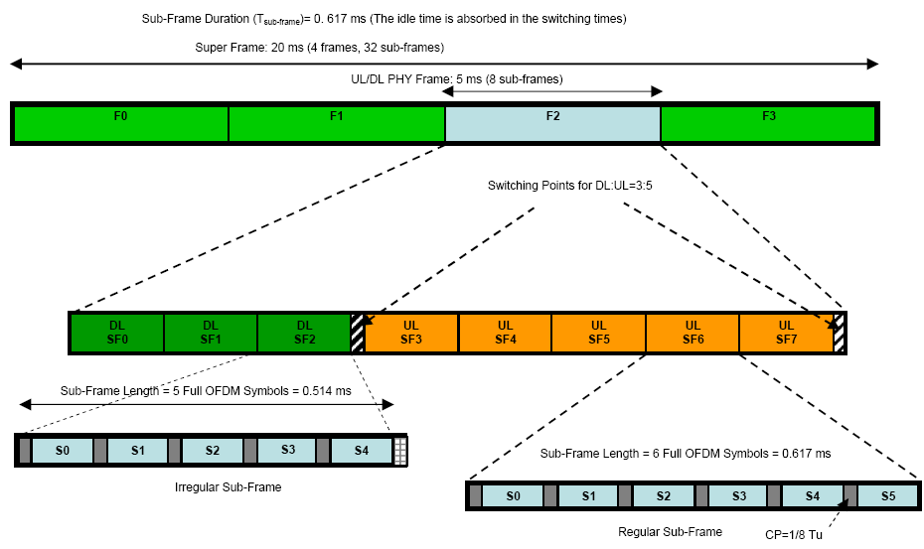
Figure 1: Basic frame structure (proposal-1) for TDD in [1]

3. Proposed subframe structure with variable-length CP

-----------------------------------------Start of Text Proposal for SDD------------------------------------------

X.X Frame Structure
X.X.X Basic frame structure

X.X.X.X Subframe structure

The subframe structure with variable-length CP is shown in Figure xx. In general, three types of CP modes are configurable for each subframe, that is, long CP, normal CP and short CP, refer to Table yy.

The normal CP mode is the default one and in this CP configuration, there are totally 6 OFDM symbols in each subframe, each with a CP length of 1/8-Tu, where Tu is the OFDMA symbol duration without CP.

For the long CP configuration, two options are provided here. Very long CP is set in option 1 and each subframe is composed of 5 OFDM symbols, while for the option 2, a generally long CP is specified and a subframe contains 5.5 OFDM symbols. For the short CP mode, each subframe contains 6.5 OFDM symbols.

Note that in the short CP mode and option 2 of long CP mode, half an OFDM symbol which is typically located at the end of the subframe can be implemented simply by only using the even (or odd) numbered subcarriers and removing the other half of the time waveform after IDFT modulation at the transmitter.
Note also that the CP length in Table yy is in unit of samples and a sampling frequency of 11.2MHz for bandwidth of 10MHz is assumed. These values can be easily extended to the other bandwidths such as 5MHz and 20MHz.

The following principles can be used as guidelines for the application of the subframe structure
- The CP length configuration can be performed subframe by subframe. That is, the subframes within one superframe can be configured differently according to subframe allocations.
- The configuration information within each superframe can be conveyed in the superframe header (SFH)
- The first subframe in each superframe is configured to normal CP mode.
- The subframe structure can be applied to both the FDD and TDD modes.
- In TDD mode, for the subframe immediately before the DL/UL or UL/DL switching point, some resource will be reserved and used as RTG/TTG as follows
  - If the subframe is in normal CP mode or long CP-option1 mode, the last OFDM is reserved;
  - If the subframe is in short CP mode or long CP-option2 mode, the last symbol (i.e., the half OFDM symbol) and half of the second last OFDM symbol will be reserved. For example, the samples after the first half of S5 will be used as the gap in short CP case.
Figure xx: Proposed subframe structure with variable CP lengths

Table yy: Numerology for the proposed subframe structure
CP type | CP duration (us) | Number of samples per each OFDM symbol
CP type | CP duration (us) | 0 | 1 | 2 | 3 | 4 | 5 | 6
Normal CP | 11.43 | 128/1024 | 128/1024 | 128/1024 | 128/1024 | 128/1024 | 128/1024 | N/A
Long CP(option1) | 32 | 358/1024 | 358/1024 | 358/1024 | 358/1024 | 360/1024 | N/A | N/A
Long CP(option2) | 18.75 | 214/1024 | 214/1024 | 214/1024 | 214/1024 | 214/1024 | 210/512 | N/A
Short CP | 3.2 | 36/1024 | 36/1024 | 36/1024 | 36/1024 | 36/1024 | 36/1024 | 40/512
Note:
- These values are for sampling frequency of 11.2MHz for 10MHz BW and can be extended straightforwardly to BWs of 5MHz and 20MHz.
- A/B: A denotes the CP length and B denotes the useful OFDM symbol length, both in samples.

---------------------------------------------- End of Text Proposal for SDD---------------------------------------------

4. References
- C80216m-08_118r1, “Proposed 802.16m Frame Structure Baseline Content suitable for use in the 802.16m SDD”
- IEEE C80216m-08/096r10
- IEEE C802.16m-07/246, “Enhanced frame structure for effective coexistence of unicast and multicast-broadcast”

