Project | IEEE 802.16 Broadband Wireless Access Working Group <http://ieee802.org/16>
Title | 802.16m Downlink Control Structures: Quick Paging Signal
Date Submitted | 2008-03-19
Source(s) | Havish Koorapaty, Per Ernström  Ericsson AB  SE-164 80 Stockholm, Sweden | Voice: +1 – 919-472-7524  mailto:havish.koorapaty@ericsson.com  *<http://standards.ieee.org/faqs/affiliationFAQ.html>
Re: | IEEE 802.16m-08/005 - Call for Contributions on Project 802.16m System Description Document. Topic: Downlink Control Structures
Abstract | This contribution proposes a design for a quick paging signal for IEEE 802.16m
Purpose | Discuss and Adopt
Notice | This document does not represent the agreed views of the IEEE 802.16 Working Group or any of its subgroups. It represents only the views of the participants listed in the “Source(s)” field above. It is offered as a basis for discussion. It is not binding on the contributor(s), who reserve(s) the right to add, amend or withdraw material contained herein.
Release | The contributor grants a free, irrevocable license to the IEEE to incorporate material contained in this contribution, and any modifications thereof, in the creation of an IEEE Standards publication; to copyright in the IEEE’s name any IEEE Standards publication even though it may include portions of this contribution; and at the IEEE’s sole discretion to permit others to reproduce in whole or in part the resulting IEEE Standards publication. The contributor also acknowledges and accepts that this contribution may be made public by IEEE 802.16.
Patent Policy | The contributor is familiar with the IEEE-SA Patent Policy and Procedures:  <http://standards.ieee.org/guides/bylaws/sect6-7.html#6> and <http://standards.ieee.org/guides/opman/sect6.html#6.3>.  Further information is located at <http://standards.ieee.org/board/pat/pat-material.html> and <http://standards.ieee.org/board/pat>.

802.16m Downlink Control Structures: Quick Paging Signal
Havish Koorapaty, Per Ernström
Ericsson AB

Summary
In this document, we propose a design for a quick paging signal in IEEE 802.16m. The quick paging signal notifies a subset of MS of whether to read a full paging message in the near future, and thus helps improve standby time. We propose a design based on a bi-orthogonal Walsh-Hadamard code to be used in the preamble part of the frame. The performance of this design is evaluated and the design is found to work effectively without causing any noticeable effects on legacy users.
We propose that a section on quick paging be added in the Downlink Control Structures section of the system description document. We recommend that the proposal in this contribution be included in the System Description Document (SDD) as the method to achieve the quick paging functionality.

Proposed SDD Text

[Section] Downlink Control Structures

[Section] Quick Paging Signal

A quick paging signal is provided to send an early indication to a group of MS of the need to read the full paging signal in the assigned paging frame. The quick paging signal is sent on the unused subcarriers in the preamble portion of an earlier frame than the assigned paging frame. The quick paging signal is sent at a lower power than the preamble signal; the power difference is broadcast in the DCD message. Each group of MS is assigned a Walsh-Hadamard codeword, and the quick paging signal consists of the codeword masked by a subset of a PN sequence, the subset being specific to the cell. If an MS detects that its assigned codeword has been sent, it shall read the full paging message in a subsequent frame.

Introduction
A quick paging signal is used in systems such as CDMA2000 and WCDMA in order to extend the battery life. The quick paging signal provides an indication to selected mobiles to read the full paging message that occurs in a subsequent frame. Due to the significantly shorter duration of the quick paging message, the wake-up time of the MS is lowered, thereby saving battery life.
The quick paging mechanism is not currently available in the IEEE 802.16e-2005 standard [2]. A similar quick paging concept for IEEE 802.16m has been proposed in [2]. In this contribution, we propose a design for the quick paging signal using the unused part of the preamble portion of the downlink frame. We use a signal that is significantly lower in power than the preamble signal in order to minimize effects on legacy equipment, and in order not to affect common functions for which the preamble is needed. The signal is designed to be received reliably in spite of the low signal level. We perform a detailed performance analysis of the signal using link and system simulations, and demonstrate its efficacy.

Background
The frame structure as specified in IEEE 802.16e, is shown in Figure 1.
Figure 1 Frame Structure Used in IEEE 802.16e
Each frame starts with a preamble signal that consists of a known binary signal sent every third OFDM tone. In the specification, the preamble signal is defined by the segment (i.e., one of the three sets of tones to be used), and the parameter IDCell. Mobile stations use the preamble for initial synchronization to the system, and to determine the location of the FCH message, which gives further information on the signal parameters. Mobile stations also use the preambles in neighbor cell signals in order to synchronize to them for purposes of measurement for handover. The use of every third tone for the preamble signal allows for a 1/3 reuse of the preamble signal, thereby improving its reception for the mobile stations. The use of every third tone also implies a repetitive structure in the time domain, which can be used by mobiles for initial acquisition. The DL-MAP signal contains downlink assignments in time and frequency for identified mobile stations, which can then receive the data in the particular location. The structure of the preamble in the frequency domain for a 2048-FFT system is shown in Figure 2.
Figure 2 Structure of Preamble in Frequency Domain. Every third tone (or subcarrier) is occupied.
Sleep modes are used in IEEE 802.16e to extend battery life. A mobile station requests sleep mode from the system, which assigns it a sleep time and a particular cycle of frame numbers on which to wake up and listen for a paging message. In order to maximize the use of paging resources, it makes sense for the system to form groups with multiple MS in each group and have the MS in a group wake up during a particular frame in order to receive a paging message. On waking up, a MS has to receive the preamble, then decode the FCH and the DL-MAP message to determine whether it has an assignment in the particular frame, and decode the message if it finds an assignment in the DL-MAP. The DL-MAP may be quite long, especially if a significant number of assignments are carried in it.
The quick paging message is used to minimize the wake-up time of the MS in order to extend battery life. In general, the probability of having a paging message addressed to the MS is quite low, but it needs to read the paging message in order not to miss pages which can occur at any time. Instead, if a message of a short duration is provided that indicates whether the MS can expect a page, and thus has to read the full paging message at a subsequent block, then the MS only reads the ‘quick paging’ message, and can avoid reading the full paging message most of the time. Due to its shorter duration, receiving the quick paging message lowers the power consumption at the MS.

Signal Design
In this contribution, we propose a quick paging message that can be implemented during the duration of the preamble message. As stated before, the preamble utilizes only every third OFDM tone, thus there are empty spaces available to utilize for the quick paging message. For example, in Figure 2, the quick paging message would be used on subcarriers 1, 2, 4, 5 and so on. However, care has to be taken not to affect any of the essential functions of the preamble, which are mainly for initial acquisition, and for neighbor cell measurement purposes. Thus, any quick paging signal implemented in the duration of the preamble needs to have very low power compared to the preamble signal. This will be the focus of the design of a quick paging signal.
The quick paging signal needs to operate at a very low signal to noise ratio. However, it can rely on good channel estimates that can be obtained using the preamble signal, and the significant amount of frequency coherence that can be expected even in a highly dispersive channel. In addition, the quick paging signal should be able to address a large number of users. For example, it should be possible to divide the pool of MS into many groups, and signal the identity of the group of the MS that needs to read the full paging message. By using many such groups, the number of users that need to read a full paging message can be minimized.
It is well known that orthogonal codes perform well at low signal to noise ratios [3]. In addition, an orthogonal code of a long length can provide many codewords that can be used to address multiple groups. For example, an orthogonal code of length 512 can address 512 groups of users. In addition, due to the presence of reliable channel information obtainable from the preamble, we can choose a bi-orthogonal code that uses both a code and its inverse. The distance between a codeword and its inverse is large, and the use of reliable channel information helps make discrimination between these codewords highly reliable. Thus, 1024 groups of users can be addressed using codewords of length 512.
Of the orthogonal codes, the best known are the Hadamard code, which exist for all lengths that are multiples of 4, though lengths that are a power of 2 (i.e., the Walsh-Hadamard codes) are most popular. The use of a Walsh-Hadamard code permits the use of a Fast Walsh Transform in the decoding, so that the relative merit of many codewords can be assayed with low complexity.
We thus propose the use of a Walsh-Hadamard code as the signal for quick paging. With a 10 MHz WiMAX channel (using a FFT of length 1024), the preamble used is of length 284 bits. Thus, we have 568 unused positions that can be used for the quick paging signal, and a Walsh-Hadamard code of length 512 fits well. For a 5 MHz 802.16e channel, the FFT size is 512, the preamble used is of length 143, and 286 unused positions are available for the quick paging signal, thereby suggesting a Walsh-Hadamard code of length 256.
However, we also note that the Walsh-Hadamard codewords do not have particularly desirable spectral properties. For example, the all zeros codeword has a spectral line at zero frequencies. To whiten the spectrum, we suggest applying a pseudo-random masking sequence to the codeword. This masking sequence could be chosen as a subsequence of a length 1023 PN-sequence that can be generated using a shift register. Different cells in the system can use different shifts of the PN-sequence. Alternatively, each cell can use a periodically varying subsequence with different cells starting at different indices.
The quick paging signal indicates the possible presence of a page in the next frame to an MS that belongs to the group for which a quick paging signal is sent. The one frame delay allows a further reduction in the wake-up time thereby enhancing the power savings that may be obtained using the quick paging signal.

Performance Evaluation
We characterize the performance of the proposed quick paging signal using a combination of link and system simulations. Using a system simulation, including path loss, antenna patterns and shadow fading, we obtain the path losses from all base stations (3 sectors per site) in the system to a set of mobile stations uniformly distributed through the system. A wrap-around procedure is used to eliminate edge-effects. The losses for segments of the base stations are also logged. For each such mobile station, we generate the preamble with a randomly chosen IDCell, and a quick paging codeword at a specified power level below the preamble, and apply the composite path loss to the whole signal. For the interfering sectors, we generate different preambles at a signal level lower than the serving cell preamble, as obtained from the system simulation, in the corresponding segments, and quick paging signals in the rest of the tones at a similar offset to that between the serving cell preamble and the serving cell codeword. Additive white Gaussian noise is also added at a level corresponding to a given noise figure. The signals from the different BS to the MS pass through different radio channels. This is assumed true for different sectors from the same site also, since the transmit antennas used are different. The channel is applied to the signal from each BS, and the combined signal is then received by the MS. Since the relative signal levels from the system simulation, corresponding to a BS transmit power, are used, the average CINR achieved is fixed. For each set of channel realizations from the different base stations, many noise realizations are used for averaging, and multiple sets of channel realizations are also used.
Three receiver algorithms are used in the evaluation: (1) A conventional receiver based on correlations, similar to an MRC receiver (2) An interference-cancelling MMSE-based receiver that exploits the structure of the signal and (3) An enhanced interference-cancelling receiver that uses knowledge of the two strongest neighbor cell preambles to subtract them before applying the MMSE-based receiver algorithm. A threshold can be used to determine if an assigned codeword has been detected. The relative power of the quick paging codeword to the preamble signal in the same cell is assumed to be known. This information can be sent in the DCD message.
The performance of the scheme is characterized in terms of the Missed Detection probability and the False Alarm probability. A missed detection occurs when the BS sends the assigned codeword to a MS, but the MS does not detect the codeword. Thus, the MS will not read the full page intended to it, thus a missed detection is detrimental to the paging performance of the system. A false alarm occurs when the MS detects that its assigned codeword has been sent when the BS sent a different codeword. A false alarm will cause the MS to read the full paging message. A false alarm is not detrimental to the paging performance of the system, though it does reduce the battery life savings obtained from use of the quick paging signal. The probability of missed detection and the probability of false alarm can be traded off by choosing appropriate thresholds for detection of the assigned codeword.
The parameters used in the simulation are shown in Table 1.
Aspect | Value
Number of Cells/Sites | 57/19
Reuse | 1/1 (1/3 for preamble)
Path Loss Model | 20 +35 log(d) (Similar to ITU Vehicular)
Site-to-Site Distance | 2.8km
Penetration Loss | None
Shadowing Standard Deviation | 8dB
Shadowing Correlation Distance | 100m
Bandwidth | 10 MHz
FFT Size | 1024
Transmit Power (for Preamble) | 20 W
Noise Figure | 9 dB
Channel Model | Pedestrian B
Relative Power of Paging Signal | -20dB
Codeword Size | 512
Table 1 Simulation Parameters
The geometry characteristics of the simulation are shown in Figure 3, assuming full occupancy of the signal and the noise. The interference-limited nature of the environment is clearly seen, the signal to noise ratio is quite high in most cases.
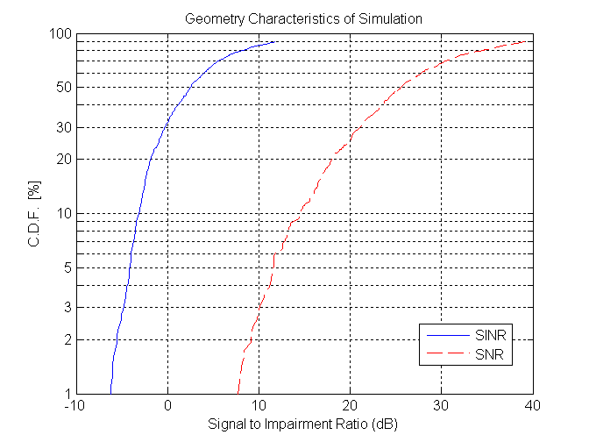
Figure 3 Geometry Characteristics of Simulation Used for Quick Paging Evaluation
The results of this evaluation are shown in Figure 4. The CDF of the probability of missed detection and the probability of false alarm are shown with the traditional receiver (denoted AWGN in the figure, since it makes an AWGN assumption for the impairment), the interference cancelling receiver (denoted Blind IC in the figure, since it assumes no knowledge of the interferer preambles), and the enhanced interference cancelling receiver are shown. The results are shown for three different threshold values. With more relaxed threshold values, the probability of missed detection is reduced at the price of an increased probability of false alarm.
With the traditional receiver, a significant number of users seem to experience missed detection probabilities of 10% or above. This would be unacceptable in a practical system. For example, we see that 20-25% of the users employing a traditional receiver experience missed detection probabilities of 10% or above. The probability of missed detection improves with the degree of interference cancellation used. With the blind interference cancelling receiver, we see that only 6-10% of the users have missed detection probabilities of 10% or above. With the enhanced interference cancelling receiver, we see that 4-6% of the users have missed detection probabilities of 10% or above. It is seen from the figure that the probability of false alarm is maintained at around 1% or below for all users. Using more relaxed thresholds, the probability of missed detection can be improved further with an increase in the probability of false alarm.
Finally, we note that the improved performance of the enhanced interference cancelling receiver also indicates that the benign effect of the quick paging signal on the performance of neighbor cell preamble measurements. The improvement indicates that the neighbor cell preamble can be detected reliably. The reliable detection leads to a reliable subtraction, which improves the performance.

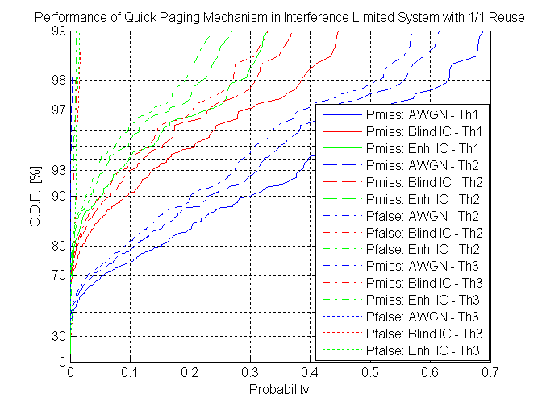

Figure 4 Performance of Quick Paging Mechanism

Conclusions
We have presented a design for a quick paging signal in IEEE 802.16m that utilizes the unoccupied space available in the preamble signal to send an indication of a full paging signal in a succeeding frame. We also proposed multiple receivers for the reception of such a scheme. The performance of this scheme was evaluated using a combination of link and system simulations for multiple types of receivers. By utilizing the structure of the interferer, it is possible to achieve significant gains in performance and arrive at low probabilities of missed detection along with acceptable probabilities of false alarm. In addition, due to its low power, the proposed scheme has negligible impact on the other functionalities that require the preamble, a fact that was confirmed by the results of the simulation. Thus, the proposed scheme is a viable candidate for implementing the quick paging functionality in IEEE 802.16m.

References
[1] IEEE Std 802.16e-2005, “IEEE Standard for local and metropolitan area networks, Part 16: Air Interface for Fixed and Mobile Broadband Wireless Access Systems, Amendment 2: Physical and Medium Access Control Layers for Combined Fixed and Mobile Operation in Licensed Bands.’’
[2] S. Shawn Tsai, Stefan Lindgren, and Sten Sjöberg, `Wake-up Signal for 802.16m OFDMA Idle Mode,’ IEEE C802.16m07/217r1.
[3] John G. Proakis, `Digital Communications.’

Appendix 1
In this appendix, we briefly explore the extent of standby energy savings possible by using a quick paging signal as proposed in this contribution. With normal paging, the MS needs to wake up, read the preamble, the FCH, DL-MAP and a certain number of subsequent symbols by which time it could verify whether it has an assignment. Let us assume that this can be done in ‘n’ symbol times. The energy needed to have the RF portion of the receiver on for each symbol, integrated over the wake-up cycle, is denoted E. Thus, the energy expended in regularly reading the full paging signal is nE.

With the quick paging signal, the RF portion of the receiver needs to be awake only for one symbol if there is no indication of a full paging message, or for 1+n symbols if there is an indication of a full paging signal. If the probability that a MS will be paged in a paging slot is p, then the probability that at least 1 out of M mobiles will be paged is s=1 - (1-p)^{M}, where M is the number of MS in the paging group. For very small p, we have s~Mp. A reasonable p may be of the order of one thousandth or lower. Thus, the energy consumption with the full paging signal is given by
E_{tot}= E + (1+n)E.s ~E+(1+n)EMp

With n of the order of 10 and M of the order of 10, we see that the energy consumption is about 10E without quick paging, and 1.11E with quick paging, a savings by a factor of about 9. Note that this calculation has ignored other aspects of energy consumption at the MS.

If the total number of MS (in the paging area) was N, and the number of paging groups is P, then M=N/P. If an average of q mobiles is paged in every paging slot, then we have p= q/N. Thus, Mp = (N/P).(q/N) = q/P. In terms of the average number of MS paged per paging slot, the expression can be rewritten as

E_{tot}= E + (1+n)E.s ~E+(1+n)Eq/P.

Figure 5 shows the fraction of power that may be saved when quick paging is used as a function of n, the number of symbols the MS needs to be awake without the quick paging scheme. The total number of mobiles in the paging area is assumed to be N=250*57=14250. The probability that an MS will be paged is set to 0.001 and the number of paging groups P is set to 512. The figure shows that more than 60% of the power currently used may be saved when the MS needs to stay awake for 3 symbols to read a page which leads to significant savings in energy consumption. Higher savings are likely when there are a high number of users that need to be scheduled in a frame such as in VoIP scenarios.
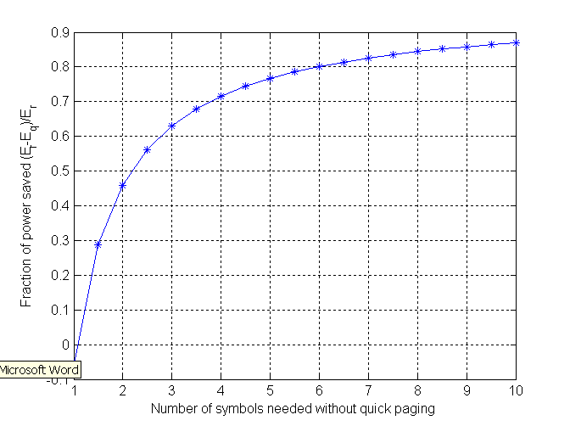
Figure 5: Energy savings with quick paging

Appendix 2
In this appendix, we show further system simulation results evaluating the CINR on the various preamble signals expected to be received by a MS, and how it may degrade due to the use of the quick paging signal. As seen in Figure 5, the degradation is minimal. Note that the CINRs seen here take the 1/3 reuse of the preamble into account.

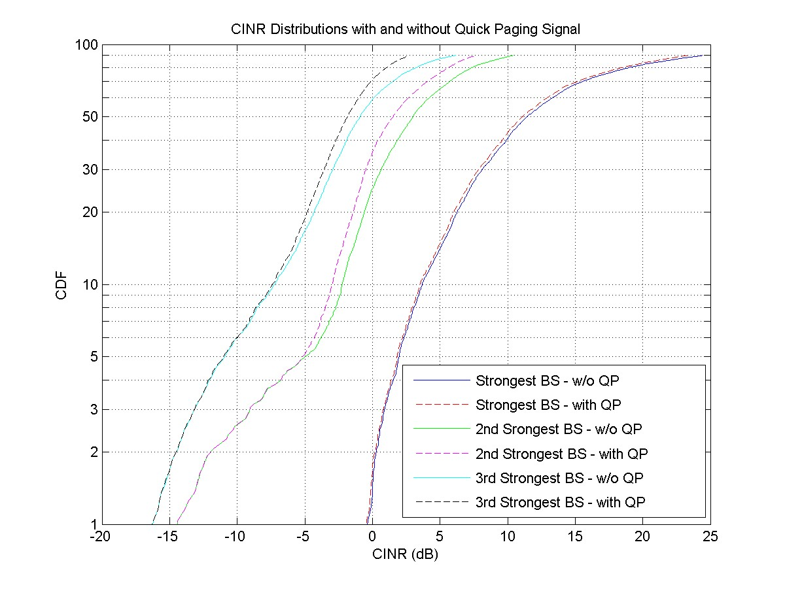
Figure 6: CINR Distribution for various Preambles

