Project | IEEE 802.16 Broadband Wireless Access Working Group <http://ieee802.org/16>
Title | Downlink MIMO Schemes for IEEE 802.16m
Date Submitted | May 5, 2008
Source(s) | David Mazzarese, Taeyoung Kim, Eun Yong Kim, Jerry Pi, Hokyu Choi, Heewon Kang  Samsung Electronics  Bruno Clerckx  Samsung Advanced Institute of Technology | d.mazzarese@samsung.com  bruno.clerckx@samsung.com
Re: | Call for Contributions on IEEE 802.16m-08/003r1 System Description Document (SDD)  Topic: Downlink MIMO schemes
Abstract | Proposal for IEEE 802.16m downlink MIMO schemes
Purpose | Discussion and approval
Notice | This document does not represent the agreed views of the IEEE 802.16 Working Group or any of its subgroups. It represents only the views of the participants listed in the “Source(s)” field above. It is offered as a basis for discussion. It is not binding on the contributor(s), who reserve(s) the right to add, amend or withdraw material contained herein.
Release | The contributor grants a free, irrevocable license to the IEEE to incorporate material contained in this contribution, and any modifications thereof, in the creation of an IEEE Standards publication; to copyright in the IEEE’s name any IEEE Standards publication even though it may include portions of this contribution; and at the IEEE’s sole discretion to permit others to reproduce in whole or in part the resulting IEEE Standards publication. The contributor also acknowledges and accepts that this contribution may be made public by IEEE 802.16.
Patent Policy | The contributor is familiar with the IEEE-SA Patent Policy and Procedures:  <http://standards.ieee.org/guides/bylaws/sect6-7.html#6> and <http://standards.ieee.org/guides/opman/sect6.html#6.3>.  Further information is located at <http://standards.ieee.org/board/pat/pat-material.html> and <http://standards.ieee.org/board/pat>.

Downlink MIMO Schemes for IEEE 802.16m
David Mazzarese et al.
Samsung Electronics

Introduction
This contribution provides a proposal for downlink MIMO schemes, including open-loop and closed-loop MIMO, single-user and multi-user MIMO, downlink common pilots for MIMO measurements to support feedback of CQI and information for closed-loop MIMO, low overhead downlink dedicated pilots for multi-user MIMO, and uplink feedback channels to support the proposed MIMO schemes.

Definitions and List of Abbreviations
Open-loop MIMO (OL MIMO) is intended to refer to MIMO schemes for which the feedback information contains no more information than ESINR and selected MIMO scheme.
Closed-loop MIMO (CL MIMO) is intended to refer to MIMO schemes for which the feedback information contains information that allows to form at least one beam.
The transmission rank in single-user mode is defined as the number of columns in the precoding matrix. It depends on the MIMO scheme selected in OL MIMO, or on the number of beams formed in CL MIMO.

OL: open-loop
CL: closed-loop
SU: single-user
MU: multi-user
CQI: channel quality information (i.e. CINR or ESINR)
PMI: preferred codebook matrix index
PVI: preferred codebook vector index
PCI: preferred codebook index (i.e. PVI or PMI)

Scope of MIMO Schemes Supported in 802.16m
IEEE 802.16m is intended to become a global standard, and as such it should support a wide range of deployments including uncorrelated, correlated and cross-polarized antenna arrays at the base station.
Likewise, MIMO should be efficiently designed to support MS at low and high SNR, as well as fixed, nomadic and high speed MS.
MIMO offers flexibility to adapt the system operation to targeted performance measures, including high user throughput and high sector throughput. High user throughput is best supported by SU MIMO schemes, while high sector throughput is best supported by MU-MIMO schemes.
Closed-loop MIMO schemes shall be optimized for fixed and nomadic users as stated in the System Requirements Document [1], for both TDD and FDD deployments.
For the sake of simplicity and optimality of the standard, an effort has been made to limit the number of MIMO schemes and their structure to support all the above mentioned scenarios

Transmitter Architecture for MIMO Processing at the Base Station
The IEEE 802.16m transmitter structure is illustrated in Figure 1.

Figure 1 IEEE 802.16m transmitter structure
The MIMO encoding and mapping block is illustrated in Figure 2. The number of arrows at inputs and outputs of processing blocks is illustrative of one particular configuration with transmission rank 2 using 4 transmit antennas.

Codeword to layer mapping

Mapping of precoded symbols to a resource unit

Mapping of resource units to sub-channels

One modulated codeword for one MS
One modulated codeword for one MS
Transmission rank
Physical antennas
OFDMA framing
Mapping of dedicated pilot symbols to a resource unit
1 Resource Unit
1. Tx div modulation
2. Layer permutation
3. No operation

Spatial modulation block
Pilot symbols
Precoding block
1. OL MIMO
fixed precoder

2. CL MIMO
adaptive
precoder

(1 matrix)

Figure 2 MIMO encoding and mapping block
The number of MS as well as the number of codewords and layers per MS served in one resource unit is flexibly adapted at the transmitter.
The space-time modulation block shall perform one of three operations:
- Optional space-time or space-frequency block coding (negation, conjugation)
- Optional layer permutation (circulation of input layers over all antennas)
- No operation on the input layers

The precoding block shall perform one of two operations:
- Precoding by a fixed (pre-determined) matrix in OL MIMO for transmission rank adaptation
- Precoding by an adaptive matrix in CL MIMO to form one or more beams according to the feedback of channel conditions from one or more MS

The fixed and adaptive precoders, for OL MIMO and CL MIMO respectively, shall not be concatenated.

The proposed transmitter processing of downlink pilots is the following:
- The downlink dedicated pilots shall be processed by the same precoding matrix as applied to the data.
- The downlink common pilots, which are used for measuring the downlink MIMO channel in order to estimate the CQI and possible PCI to feedback, shall not be processed by this precoding matrix, no matter whether one or more subscribers may be assigned OL or CL MIMO downlink transmissions.

The rationale for the requirements on the two precoders and on downlink common pilots is the following:
- Concatenation of fixed and adaptive precoders may have a negative impact on the performance of CL MIMO schemes designed with no fixed precoding in mind, even if the fixed precoding matrix is unitary.
- For example, the CL MIMO precoding matrix may be taken from a codebook of matrices whose elements have constant modulus to guarantee the balance of the power transmitted from all physical antennas at the base station. The concatenation of such a matrix with another matrix cannot guarantee that the resulting matrix product will still ensure the balance of the power transmitted from all physical antennas.
- Moreover, a codebook precoding matrix optimized for specific antenna configurations (e.g. such as ±45º or vertically-horizontally cross-polarized antennas, correlated channels with linear arrays,…) may lose its good properties once the statistics of the channel are arbitrarily changed by a fixed precoder.
- The joint optimization of the fixed and adaptive precoders has been studied in the past, but it is complex, and it usually benefits only in very limited scenarios.
- The requirement to use a fixed precoder is intended to avoid the implementation-dependent fixed precoding which would degrade the performance of the system due to the above-mentioned reasons.
- The requirement not to apply the fixed precoder to common pilots is to avoid unnecessary complexity at the MS, which would need to reconstruct the physical channel from the estimated precoded channel before being able to compute their CQI.

The mapping of precoded symbols within a resource block will be specified at a later stage than the SDD.

Open-Loop Single-User Downlink MIMO Schemes
The fixed (pre-determined) precoder is used in OL MIMO for adapting the transmission rank according to MIMO scheme selected for transmission to the MS, while ensuring transmit power balance among the power amplifier for each transmit antenna at the base station.
With N transmit antennas at the base station, a pre-determined N×N fixed precoding matrix is used for transmissions with rank 1 to N. For transmission rank r, the first r columns of the precoding matrix are used to process the input layers, and to produce symbols for each of the N transmit antennas.

The desired properties of the fixed precoder are:
- It is a unitary matrix whose elements have a constant modulus
- It is fixed in time
- Pre-determined: it shall be known at the MS, such that CQI estimation can be appropriately performed for MS receiving OL MIMO transmissions.
- Frequency-dependent: it shall vary according to the transmission subband, in a way compatible with FFR groups, localized and diversity resource groups. This is to exploit the full spatial diversity in diversity subchannels and enhance the BER of MS that experiences a frequency-flat channel.

The fixed precoder shall always be applied to the data and dedicated pilots with all OL MIMO schemes, including transmit diversity and spatial multiplexing.

For a base station with 8 transmit antennas, the rank (i.e. the number of layers) will be limited to 4.

The maximum number of layers supported in open-loop SU MIMO depends on the number of transmit and receive antennas, and the type of resource channels, as shown in Table 1.
Table 1. Maximum number of layers supported for OL SU MIMO
TX × RX | Localized channels | Diversity channels
2 × 2 | 2 | 2
4 × 4 | 4 | 4
8 × 8 | 4 | 4

Closed-Loop Downlink MIMO Schemes
The adaptive precoder is used for CL MIMO. It is adapted based on feedback received at the base station from a MS. We propose that 802.16m supports two types of feedback mechanisms:
- Uplink sounding (for TDD channels with channel reciprocity between downlink and uplink)
- Codebook-based feedback (for cases when channel reciprocity is not available)

Closed-Loop Single-User Downlink MIMO Schemes
When uplink sounding is used as a feedback mechanism, the base station is free to choose the complex weights in the precoding matrix (which could be a simple vector) according to any appropriate algorithm. The downlink dedicated pilots shall be processed by the same precoding matrix as used on the data. The demonstration of the good performance of such an algorithm is presented in section 11.

The other class of proposed CL SU MIMO schemes is based on unitary precoding matrices taken from a codebook. The adaptation is based on feedback from a MS. Among all possible precoders (whose size vary from [Nt×1] to [Nt×r] with r = min{ Nt, Nr }) in the codebook, the MS estimates its preferred precoder. The index of the preferred precoder in the codebook is feedback to the BS along with the corresponding CQI(s). The downlink dedicated pilots shall be processed by the same precoding matrix as used on the data.

The codebook shall be composed of a combination of DFT matrices and precoding matrices optimized for cross-polarized channels. The codebook size according to the number of transmit antennas at the base station is:
- 3 bits with 2 transmit antennas
- 4 bits with 4 transmit antennas
- 3 bits with 8 transmit antennas (same codebook vectors as for MU MIMO)

Desired properties of SU-MIMO codebook:
- as long as it does not impact significantly performance in uncorrelated channels and polarized channels, we suggest to design precoders as much constant modulus as possible. Note that in correlated channels, constant modulus is a desired and mandatory property to achieve higher performance.
- simple codebook that reduces as much as possible the complexity of codebook search and CQI calculation.
- small memory size requirements
- good performance in uncorrelated, correlated and dual-polarized channels.

The standardization of multiple codebooks optimized for several scenarios is recommended if significant performance improvement is obtained compared to the use of a universal codebook.

802.16m should also consider differential codebooks for SU MIMO to further reduce the feedback overhead and increase the accuracy of the feedback for fixed and nomadic users.

The good performance of these matrices over 802.16e codebooks is demonstrated in section 11.

Closed-Loop Multi-user Downlink MIMO Schemes
When uplink sounding is used as a feedback mechanism, the base station is free to choose the complex weights in the precoding matrix (which could be a simple vector) according to any appropriate algorithm. The downlink dedicated pilots shall be processed by the same precoding matrix as used on the data. The demonstration of the good performance of such an algorithm is presented in section 11.

The other class of proposed CL MU MIMO schemes is based on unitary precoding matrices taken from a codebook. The adaptation is based on feedback from several MS. Each MS sends an index of one vector in a unitary matrix from the codebook over a feedback channel, along with the appropriate CQI. The base station collects the feedback from several MS and schedules a number of MS that use different vectors in the same unitary precoding matrix over the same resource unit. The CQI shall capture the effect of the precoder, which also includes a measure of the interference from the other vectors in the same unitary matrix. The downlink dedicated pilots shall be processed by the same unitary precoding matrix as used on the data.

The codebook shall be composed of a combination of DFT matrices. The codebook size according to the number of transmit antennas at the base station is:
- 2 bits with 2 transmit antennas (2 unitary matrices)
- 3 bits with 4 transmit antennas (2 unitary matrices)
- 3 bits with 8 transmit antennas (1 unitary matrix)

The maximum number of MS shall be scheduled on the same resource unit with MU MIMO is 4. Moreover, no more than 1 precoding vector shall be assigned to one MS over one resource unit in MU MIMO.

The base station shall be able to adapt the number of beams. This means that:
- 1 to 2 MS may be scheduled with MU MIMO when the base station has 2 transmit antennas,
- 1 to 4 MS may be scheduled with MU MIMO when the base station has 4 transmit antennas,
- 1 to 4 MS may be scheduled with MU MIMO when the base station has 8 transmit antennas.

No more than one beam shall be sent to each MS in MU MIMO transmissions.

Downlink Reference Signals for CQI Measurements
The baseline configuration of 802.16m on the downlink is using two transmit antennas at the base station. The 802.16m downlink control channels may or may not contain common pilots transmitted from the two physical antennas, and if it does these pilots may or may not be appropriately distributed in time and frequency to allow for efficient measurements of the downlink MIMO channel.
When the base station supports more than two physical transmit antennas, even the presence of common pilots in control channels would not allow to estimate the downlink channel for more than two antennas, since the control channels should be transmitted according to the baseline downlink configuration 2×2.
Therefore, there is a need for 802.16m to support downlink common pilots with a regular pattern in frequency and time. These reference signals (i.e. common pilots) shall support 2, 4 and 8 physical antennas at the base station. The reference signals shall appear in one subframe every frame.

For the localized channels, the downlink common pilots are used for CQI and PMI measurement purpose. The measurement pilots are regularly spaced and avoid all the possible dedicated pilot positions. Note the set of all possible dedicated pilot positions depend on the maximum number of layers supported, which in turn depends on the number of transmit antennas.

The measurement pilot will only occur once per 5ms to reduce the bandwidth overhead of the measurement pilot. As a result, the measurement pilot will likely be boosted to increase its accuracy.

Low Overhead Downlink Dedicated Pilots for Demodulation
Some class of CL MU MIMO schemes allow to form beams that will be orthogonal at the receivers of several MS that share a resource unit with dedicated pilots. While it is possible to allocate distinct pilot positions to distinct users, it is beneficial to superimpose the dedicated pilots of two or more users in order to reduce the downlink pilot overhead and increase the number of data tones in a resource unit. The standard should support such a feature with appropriate signaling by the base station.

Feedback Information
The feedback information for OL MIMO schemes shall consist of the following:
- CINR
- ESINR for selected codewords
- MIMO scheme, which determines the number of selected layers (i.e. transmission rank).

The feedback information for CL MIMO schemes shall consist of the following:
- CINR
- ESINR for selected codewords
- Preferred precoder index, (which consists of a matrix index and possibly one or several vector indexes).

The ESINR may represent the channel quality over the entire FFT or over one subband.

Subband ESINR may be differentially encoded
- in the frequency domain with respect to wideband ESINR
- in the spatial domain with respect to another spatial dimension

Feedback Channels
An uplink sounding symbol shall be specified in the standard, either as 802.16e uplink sounding symbol, or an enhanced version of it, to exploit the channel reciprocity between downlink and uplink in TDD channels.
A CQI channel (CQICH) with a robust modulation and coding scheme shall be supported to carry a varying number of feedback bits. This CQICH shall convey CQI and PCI as appropriately signaled in downlink control channels.
Feedback using a feedback header or sub-header shall also be supported.

Performance Evaluation Results
Simulation conditions

Transmission bandwidth | 20 MHz
Centre frequency | 2.5 GHz
Subframe duration | 0.6171 ms
Subcarrier spacing | 10. 938 kHz
FFT size | 1024
Number of occupied subcarriers | 1008
Number of OFDM symbols per subframe | 6
Number of subcarriers per Resource Unit | 18
Spatial channel environment | Modified PedB channel, 3 km/h, uncorrelated at MS  - Uncorrelated case: 4 wavelengths spacing and 15 degree angular spread at the base station  - Correlated case: ½ wavelength spacing and 3 degree angular spread at the base station  - Dual polarized case: +/-45 → V-H, ½ wavelength spacing and 3 degree angular spread at the base station
CQI feedback | 6 subframes delay, error-free
Uplink sounding | 18 dB power difference between DL and UL
Feedback load | Full feedback (for every resource unit), 10 users
Downlink pilot overhead | 2 Tx: 11.11%, 4 Tx: 22.22%
Channel estimation | Ideal
MIMO detection method | Linear MMSE
Modulation and coding | 10 MCS levels
HARQ | Chase Combining, non-adaptive, 8 subframes retransmission delay, maximum 4 retransmissions

Beamforming weights at the base station:
- Feedback with uplink sounding: Coordinated Beamforming weights [2] with 1 beam per user (MU MIMO) with adaptation of the number of scheduled users, and dynamic rank adaptation (SU MIMO).
- Feedback of codebook index: unitary precoding matrix from codebook with 1 beam per user (MU MIMO) with adaptation of the number of scheduled users, and dynamic rank adaptation (SU MIMO).

Figure 3 shows the spectral efficiency of MU MIMO achievable with uplink sounding using channel reciprocity. The highest spectral efficiency allowed by the highest MCS level is achievable at high SNR. The use of a powerful beamforming algorithm at the base station can fully benefit from the accurate feedback offered by uplink sounding.

Figure 4 shows the spectral efficiency of MU MIMO achievable with codebook feedback. It is noticeable that 802.16e codebook is not robust in correlated channels, and it is not better in general than a DFT codebook with the same number of bits in uncorrelated channels. To keep the feedback overhead within reasonable limits, a DFT codebook offers a better trade-off than 802.16e codebook. Feedback using a codebook index is robust at low SNR, but suffers from quantization errors at high SNR where the highest spectral efficiency allowed by the highest MCS level is not achieved in 4x2 and 4x4 configurations.

Based on these two set of curves, we recommend that both uplink sounding and codebook feedback be considered in 802.16m. We further recommend that the codebook size be small, and that the codebook contains DFT matrices for robust performance in both uncorrelated and correlated channels.

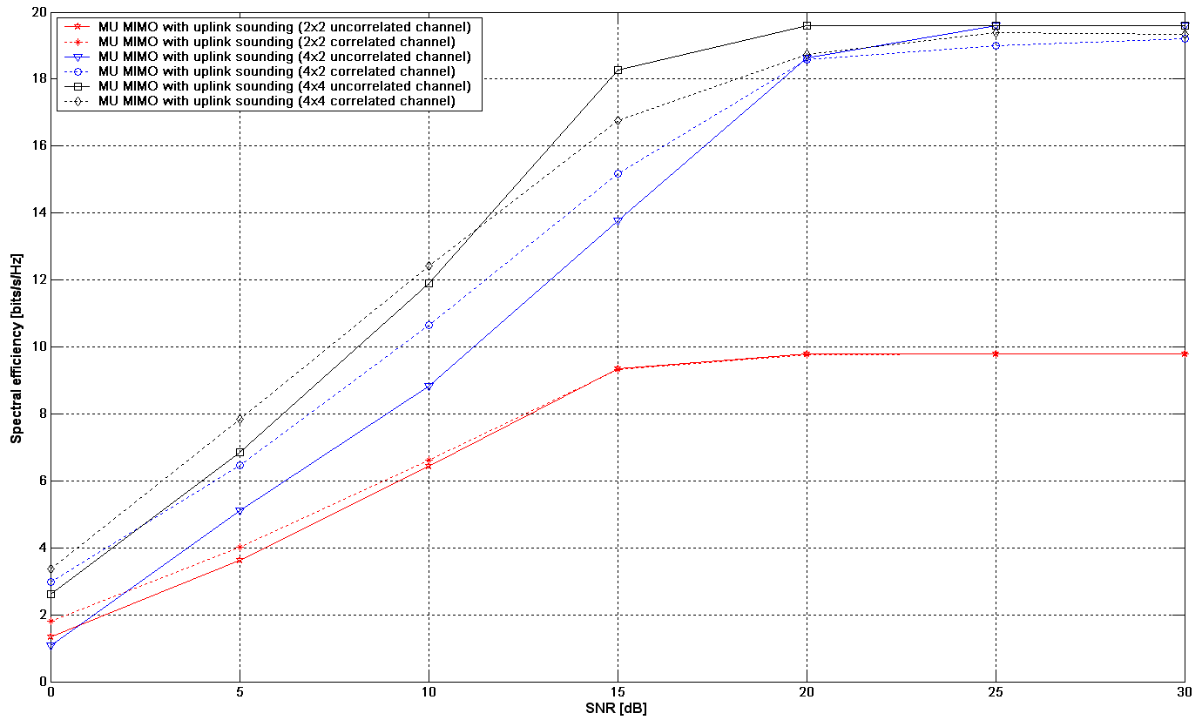
Figure 3. MU MIMO with Coordinated Beamfomring [2] in TDD with uplink sounding

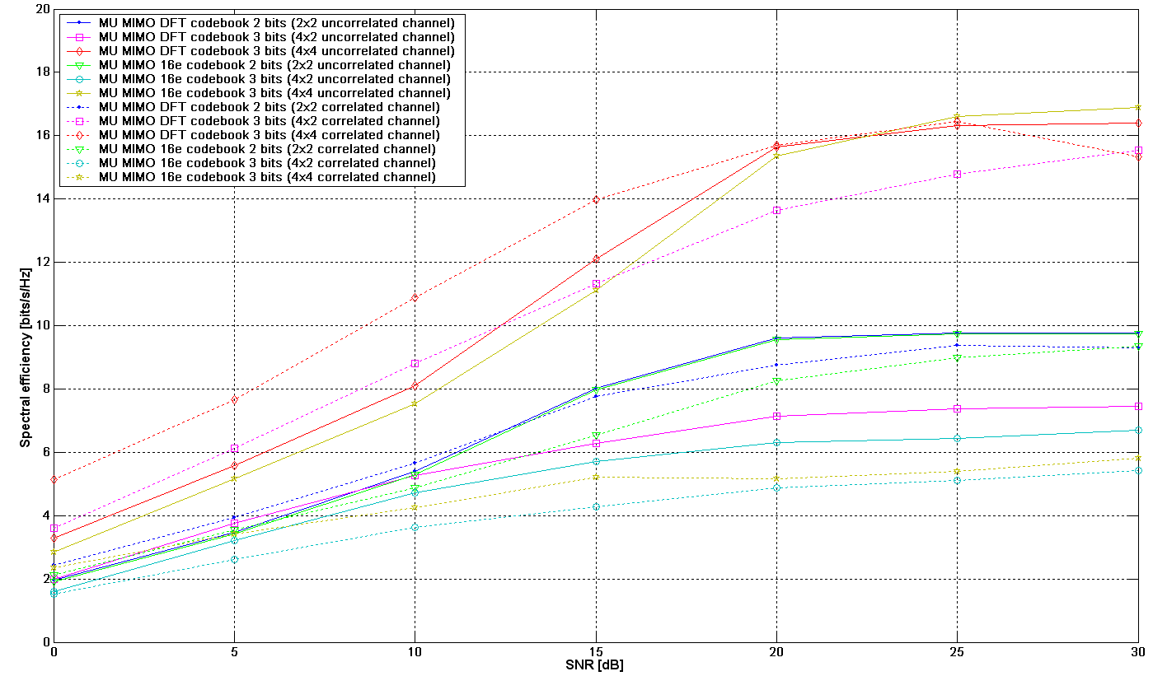
Figure 4. MU MIMO in FDD with codebook feedback

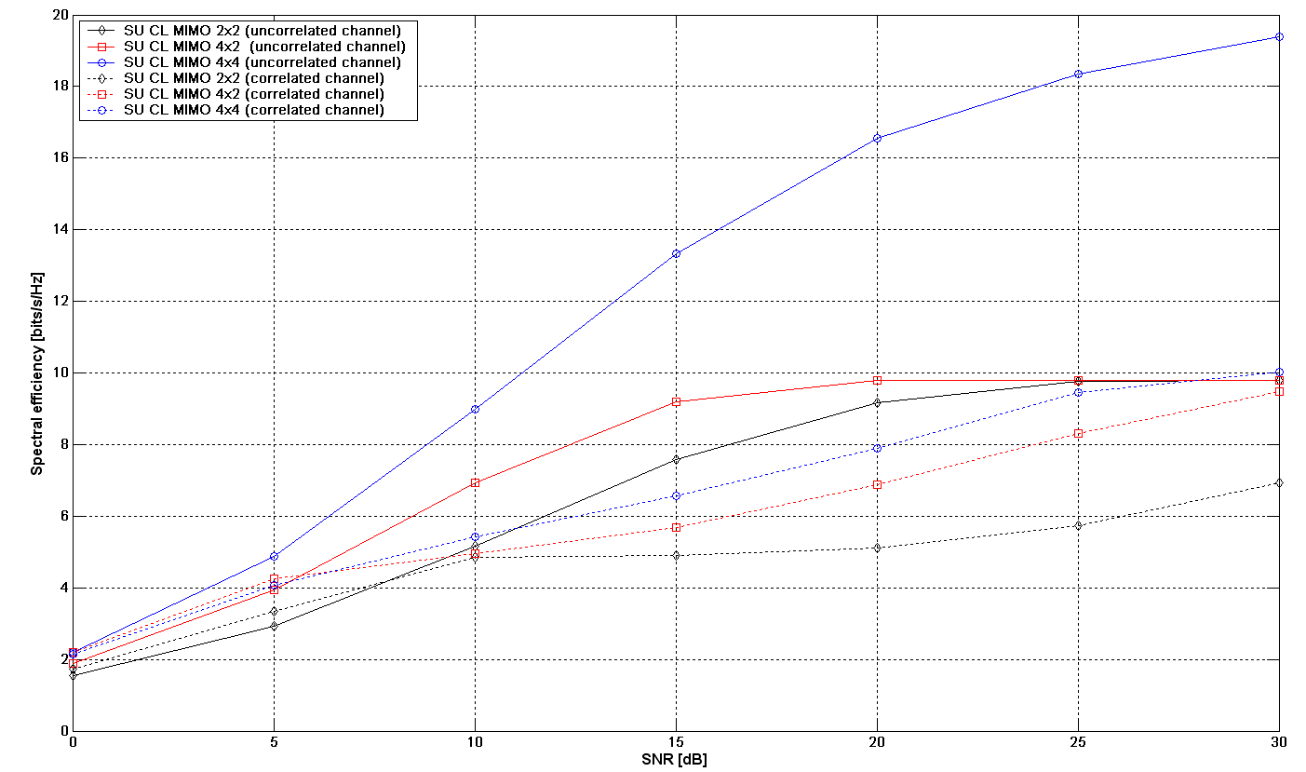
Figure 5. SU MIMO in TDD with uplink sounding

Figure 5 shows the spectral efficiency of SU MIMO achievable with uplink sounding using channel reciprocity. A higher spectral efficiency than with codebook-based feedback can be achieved in the medium to high SNR regions.

Figure 6 shows the spectral efficiency of SU MIMO achievable with codebook feedback. It can be seen that a smaller codebook than 802.16e codebook can achieve comparable performance in all scenarios. In order to limit the feedback overhead, we recommend to reduce the size of the codebook compared to 802.16e.

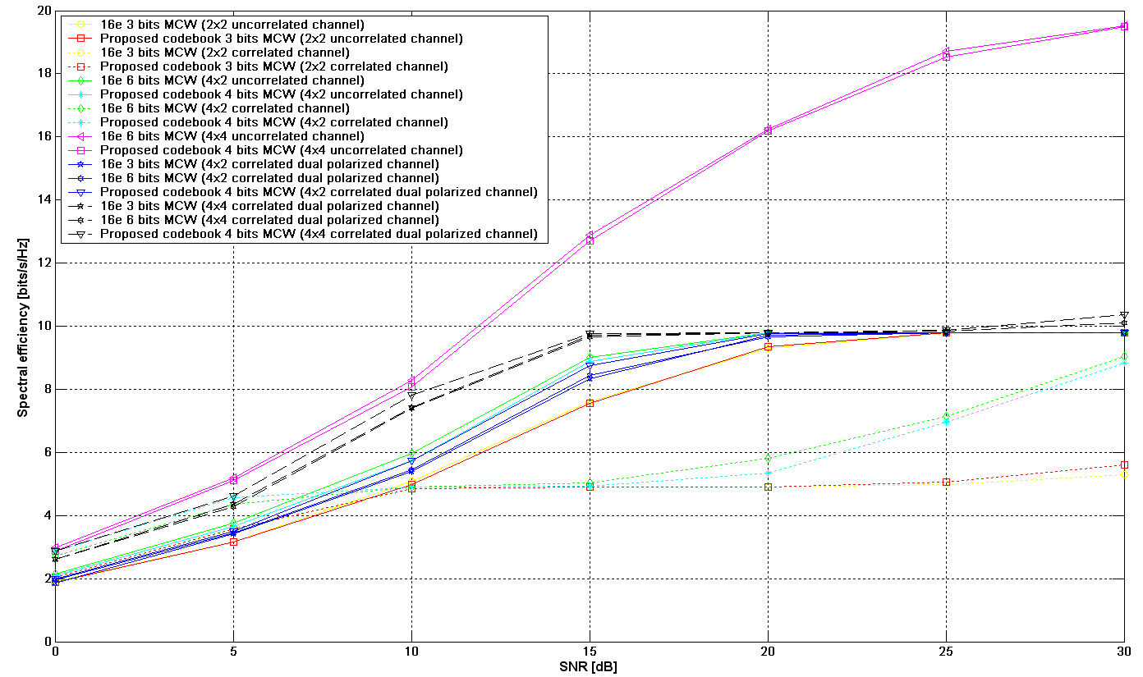
Figure 6. SU CL MIMO in FDD with codebook feedback

Proposed Text for SDD
Insert the following text into Physical Layer sub-clause (i.e. Chapter 11 in [3]):
------------------------------- Text Start ---------------------------------------------------
11.x. Downlink Transmission Schemes

11.x.1. Transmitter Blocks for MIMO Processing
The transmitter processing blocks for MIMO transmission shall be composed of the following steps to be applied to codewords of QAM modulated symbols:
- codewords to layers mapping
  - multiple layers may be mapped to the same codeword
- optional layer permutation and spatial modulation
  - layer permutation
  - STBC or SFBC modulation may be applied at this stage, which consists of conjugation and negation operations.
- precoding
  - a pre-determined matrix (for open-loop MIMO) or an adaptive matrix (for closed-loop MIMO) shall be applied to map the layers to physical antennas.
  - The fixed and adaptive precoders shall not be concatenated.

11.x.1. Single User Open Loop MIMO Schemes
11.x.1.1. Fixed Precoding
A pre-determined precoder fixed in time shall be applied to the layers of spatially modulated symbols, which produces the complex symbols that will be sent through the physical antennas. The size of that precoder shall be adapted to the rank r of transmission (number of layers), by selecting r columns of a pre-determined N×N matrix.

This fixed precoder shall always be applied to all open-loop downlink dedicated pilots and data transmissions. It shall not be applied with closed-loop MIMO dedicated pilots and data transmissions.

It shall also be applied to open-loop downlink control transmissions to transform the channel into the baseline configuration with two effective transmit antennas at the base station. The baseline transmission scheme

The fixed precoder has the following properties:
- It is a unitary matrix whose elements have a constant modulus,
- fixed in time,
- pre-determined: it shall be known at the MS, such that CQI estimation can be appropriately performed at MS receiving OL MIMO transmissions,
- frequency-dependent: it shall vary according to the transmission subband (the number of subbands should be small, e.g. 6 or 12 TBD), in a way compatible with FFR groups, localized and diversity resource groups.. This is to exploit the full spatial diversity in diversity subchannels to enhance the BER of MS that experience a frequency-flat channel.

11.x.1.2. Single User Open Loop MIMO
TBD transmit diversity schemes may be applied over the fixed precoder.
Spatial multiplexing schemes with rank r are applied over the fixed precoder, with TBD number of codewords per layer, and TBD number of codewords per MS.

11.x.2. Single User Closed Loop MIMO Schemes
11.x.2.1. Implementation-Dependent Adaptive Precoding
An implementation-dependent adaptive precoder may be applied at the base station by exploiting the channel information collected from the uplink sounding symbol or other uplink transmissions. The downlink dedicated pilots shall be processed by the same adaptive precoding matrix as used on the data.

11.x.2.2. Unitary Adaptive Precoding
The codebook shall be composed of a combination of DFT matrices and other unitary matrices optimized for cross-polarized channels.

The codebook size according to the number of transmit antennas at the base station is:
- 3 bits with 2 transmit antennas
- 4 bits with 4 transmit antennas
- 3 bits with 8 transmit antennas

The use of differential codebooks for SU MIMO should also be considered to further reduce the feedback overhead and increase the accuracy of the feedback for fixed and nomadic users.

11.x.3. Multiuser MIMO Schemes
11.x.3.1. Implementation-Dependent Adaptive Precoding
An implementation-dependent adaptive precoder may be applied at the base station by exploiting the channel information collected from the uplink sounding symbol or other uplink transmissions. The downlink dedicated pilots shall be processed by the same adaptive precoding matrix as used on the data.

11.x.3.2. Unitary Adaptive Precoding
The codebook shall be composed of a combination of unitary matrices, including DFT matrices.
The matrices of the multiuser MIMO codebook compose a subset of the matrices of the single-user closed-loop MIMO codebook.
The MS codebook is the same as the BS codebook.

The codebook size according to the number of transmit antennas at the base station is:
- 2 bits with 2 transmit antennas (2 unitary matrices)
- 3 bits with 4 transmit antennas (2 unitary matrices)
- 3 bits with 8 transmit antennas (1 unitary matrix)

The maximum number of MS that can be scheduled on the same resource unit with MU MIMO transmissions is 4.
Moreover, No more than one beam shall be sent to each MS in MU MIMO transmissions.

The base station shall be able to adapt the number of scheduled users to channel conditions:
- 1 to 2 MS may be scheduled with MU MIMO when the base station has 2 transmit antennas,
- 1 to 4 MS may be scheduled with MU MIMO when the base station has 4 transmit antennas,
- 1 to 4 MS may be scheduled with MU MIMO when the base station has 8 transmit antennas.

11.y. Downlink Measurements
11.y.1. Downlink Reference Signals for MIMO Measurements
IEEE 802.16m supports downlink reference signals with a regular pattern in frequency and time. These reference signals (i.e. common pilots or midamble) shall support measurements of the signals from 2, 4 and 8 physical antennas at the base station. The reference signals appear in one subframe every frame (5 ms).

11.y.1. Downlink CQI and PCI measurements at the MS
The MS shall compute the CQI on the basis of the same codebook composed of unitary matrices as used by the base station for closed-loop MIMO transmissions, assuming that the base station will use a column of a unitary matrix (whose index is reported to the base station along with the CQI) for transmitting its data, and that other columns of the same unitary matrix will be used for transmitting data to other MS.

11.z. Uplink Feedback Schemes

11.z.1. Uplink Sounding
An uplink sounding symbol is supported in 802.16m to obtain the channel information at the base station over a Physical Resource Unit.

11.z.2. Quantized Feedback in Uplink CQI Channel
A CQI channel with a robust modulation and coding scheme at the cell edge shall support the feedback of a certain number of bits to represent the CQI and PCI.

11.z.3. Quantized Feedback in Uplink Header and Sub-header
Uplink packet header and sub-header shall be able to support the feedback of a certain number of bits to represent the CQI and PCI.

References

[1] IEEE 802.16m-08/002r4, “IEEE 802.16m System Requirements Document”
[2] Mazzarese D.; Chae Chan-Byoung; Heath R.W.; “Jointly Optimized Multiuser Beamforming for the MIMO Broadcast Channel with Limited Feedback”, IEEE 18th International Symposium on Personal, Indoor and Mobile Radio Communications, PIMRC 2007, 3-7 Sept. 2007 p. 1-5.
[3] IEEE 802.16m-08/003r1, “The Draft IEEE 802.16m System Description Document”

