Project | IEEE 802.16 Broadband Wireless Access Working Group <http://ieee802.org/16>
Title | ACK and NACK Feedback Schemes for HARQ Operation
Date Submitted | 2008-05-05
Source(s) | Hung-Yu Wei,  Ching-Chun Chou,  National Taiwan University  Chun-Yen Wang,  Richard Li,  ITRI | Voice:  E-mail: hywei@cc.ee.ntu.edu.tw  f95921098@ntu.edu.tw  ChunYen@itri.org.tw  richard929@itri.org.tw
Re: | IEEE 802.16m-08/016 - Call for Contributions on Project 802.16m System Description Document (SDD), shoot for “Hybrid ARQ (protocol and timing)” topic.
Abstract | This contribution proposed new NACK/ACK mechanisms for HARQ schemes in 802.16m. The contents include parallel NACK, Busy Tone NACK, and NACK-preamble schemes. These schemes provide reliable transmission from BS to MS, and could be applied on other traffic patterns.
Purpose | To be discussed and adopted by TGm for use in the IEEE 802.16m
Notice | This document does not represent the agreed views of the IEEE 802.16 Working Group or any of its subgroups. It represents only the views of the participants listed in the “Source(s)” field above. It is offered as a basis for discussion. It is not binding on the contributor(s), who reserve(s) the right to add, amend or withdraw material contained herein.
Release | The contributor grants a free, irrevocable license to the IEEE to incorporate material contained in this contribution, and any modifications thereof, in the creation of an IEEE Standards publication; to copyright in the IEEE’s name any IEEE Standards publication even though it may include portions of this contribution; and at the IEEE’s sole discretion to permit others to reproduce in whole or in part the resulting IEEE Standards publication. The contributor also acknowledges and accepts that this contribution may be made public by IEEE 802.16.
Patent Policy | The contributor is familiar with the IEEE-SA Patent Policy and Procedures:  <http://standards.ieee.org/guides/bylaws/sect6-7.html#6> and <http://standards.ieee.org/guides/opman/sect6.html#6.3>.  Further information is located at <http://standards.ieee.org/board/pat/pat-material.html> and <http://standards.ieee.org/board/pat>.
ACK and NACK Feedback Schemes for HARQ Operation
Hung-Yu Wei, and Ching-Chun Chou
Department of Electrical Engineering, National Taiwan University
Chun-Yen Wang, and Richard Li
ITRI

Introduction
This contribution describes the NACK/ACK design options for the 802.16m system. The ACK mechanism is critical in HARQ implementation. With well-designed ACK schemes, the transmission would be more reliable and the retransmission signaling could be reduced. NACK is another way of ACK, and by only reporting lost or corrupted packets, the signaling and controlling overhead for retransmission is small, saving more bandwidth for actual data traffic. With the contributed NACK/ACK schemes, it could provide reliable transmission and more flexibility to the system.

NACK Schemes
NACK is the abbreviation for Negative Acknowledgement. As usual ACK reports the reception of every packet which is expected to be received from the BS by the MS, the NACK mechanism only gives out ACK for data which are not successfully received. The BS would trigger retransmission only when receiving NACK, and other data packets are dimmed as correctly transmitted. The NACK scheme gains advantages over normal ACK as if there are fewer transmission failures than success, the ACK transmission times are less and thus resulting in less signaling for transmission. In this contribution, we proposed 3 NACK schemes: parallel NACK scheme, Busy Tone NACK scheme, and NACK-preamble scheme. These schemes could be used separately or combined to provide more efficient HARQ mechanism.
From the meaning of ACK, the ACK could be divided into two types: explicit and implicit ACK. Explicit ACK means that explicit signaling messages are sent from the receiving MS to BS, while implicit ACK does not rely on direct message transmission and uses other mechanisms to detect whether the MS has received the data packet or not. For the 3 proposed NACK schemes, parallel and Busy Tone schemes are explicit ACK and the NACK-preamble are some mixed up of the explicit and implicit ones. The details of the 3 mechanism are described in the following sections.

Parallel NACK Scheme
For the parallel NACK scheme, each MS is assigned a unique radio resource block by the BS. All the MSs which intend to transmit NACK could make the acknowledgement in the same frame. That is, different MS, owning respective radio resources, could transmit in parallel. The radio resource could be different time slot, frequency channel, CDMA coded channel, OFDM channel, or other wireless channel, depending on the system requirement criteria or traffic characteristics. The parallel NACK scheme gains advantages due to its multiple transmission method. Multiple nodes could report their packet loss in the same frame, giving the BS more information about the channel state and characteristics of the packet loss. The BS could manage more efficient retransmission in the following frames, like constructing low-cost retransmission trees from the harvested NACK info. If the transmission is for multicast/broadcast service, this would be of great help for the MBS.
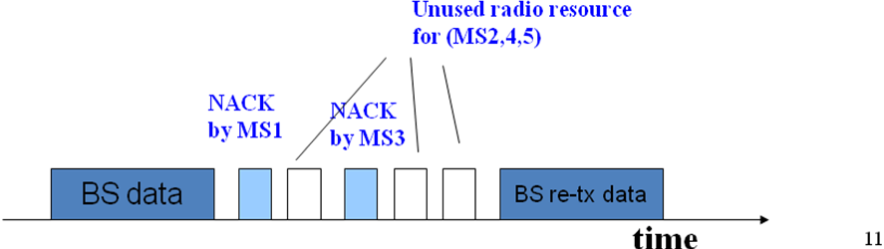
The figure above is the illustration of the parallel NACK scheme. From the figure, we could see that each MSs, from MS #1 to MS #5, are given a separate time slot for the NACK report. As MS #1 and #3 fail to receive certain packet(s), they send NACK in their own parallel NACK slot, and the BS retransmit the lost data packet in the following retransmission period. In this illustration, the time slot method is used. However, other methods which have been named above could be applied to implement parallel NACK scheme.

Busy Tone NACK Scheme
The Busy Tone is the word for a specific message. Busy Tone could be a predefined sequence/code to be transmitted at a given time, or a transmission operation over a preconfigured wireless channel. MS has to transmit Busy Tone to the BS to indicate NACK, meaning that it anticipates receiving some data block and does not. For the BS, it may receive 1 or more negative feedback, and therefore the BS knows at least 1 MS does not receive the block, which triggers the BS to perform retransmission. Utilizing the fact that any receiving Busy Tone indicates data loss, the NACK scheme is simpler and the BS could initiate the retransmission immediately. If there are necessities for distinguishing where the Busy Tone is from, different CDMA code could be used for each MS’s Busy Tone.
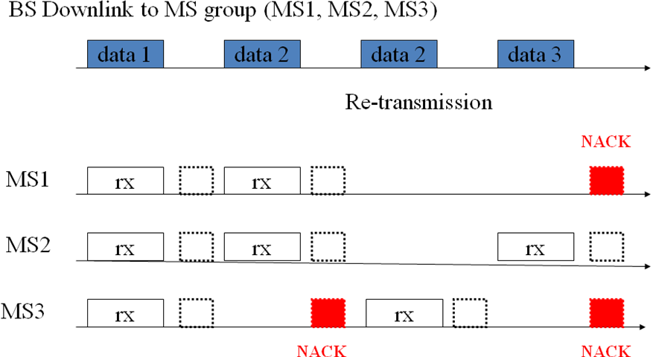
The above figure is the illustration of the Busy Tone NACK scheme. In this illustration, the Busy Tone is implemented using the prior scheme, a predefined sequence/code to be transmitted at a given time. As we could see, in the BS downlink transmission of data 1, there is no transmission error in the MS group. Therefore no Busy Tone is transmitted in the dashed-line block, and no retransmission is done. In data 2’s transmission, the MS #3 does not receive it, pushing out the Busy Tone in the red block, and the BS performs retransmission accordingly. For data 3, both MS #1 and #3 do not receive the data, and two Busy Tones are sent. As the lost packet is the same, even if the BS might receive two Busy Tones or some collided/corrupted Busy Tone, the BS still knows that it has to retransmit data 3.

NACK-preamble NACK Scheme
The NACK-preamble NACK scheme is to inject NACK-preamble into the NACK design. The NACK-preamble is a predefined sequence, indicating the NACK message which is transmitted successively. If the BS receives NACK-preamble from 1 or more MSs, then the BS knows that at least 1 MS does not receive the data block. For the following NACK Information Element, the actual NACK message, it will include the detail information of the NACK, containing data like node ID, channel state information, HARQ parameters and configuration, and other info that might be helpful for data retransmission. This scheme is much more helpful for BS’s configuration on data packet transmission, because it provides more flexibility. If the NACK IE could be successfully received, the BS could collect information from all the MSs reporting data loss and setup the retransmission more efficiently. If there are collided NACK IE, the NACK-preamble could still be received as the preamble is small in size, requires little transmission time and thus having little probability of collision. In this case, the NACK-preamble could still indicate data loss and inform the BS to initiate retransmission. The flexibility is the most powerful advantage for this scheme.
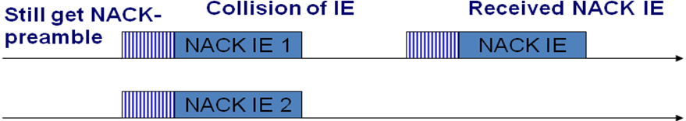
The figure above is the illustration of the NACK-preamble NACK scheme. In NACK-preamble scheme, the NACK mechanism is done by the NACK-preamble and NACK IE. The NACK-preamble indicates that there is a following NACK IE after the preamble, and the NACK IE contains the details of the NACK information. If there are some collisions or loss for the NACK IE, which is longer in data length and more likely to be wrong, as the BS could still receive the NACK-preamble, BS can know that there are one or more MS not receiving the data block and trigger the retransmission.

Positive Feedback - ACK
While NACK could save retransmission signaling cost, there are still some cases that ACK is more adequate for use, like environment with higher data block error probability. We provide 3 different ACK schemes here.
- Parallel ACK
In parallel ACK, each MS is allocated a unique radio resource block which could be used for ACK. This scheme is similar to NACK, and could be applied simultaneously with parallel NACK. The allocated radio resource block could contain either a parallel ACK or parallel NACK, depending on the channel state, traffic pattern, or system requirement. The same as the NACK one, the parallel ACK scheme benefits by the multiple ACK transmission and makes more economic retransmission.
- Polling ACK
In polling ACK, the MS transmit ACK only when the BS polls the MS for feedback mechanism. The ACK could include reception condition, like the receiving channel state, of multiple data packets that are transmitted in a time period. The polling ACK owns the advantages of flexibility in ACK reporting. If the certain MS requires more retransmission than the others, the BS could increase the frequency of polling and check if there is necessity for retransmission. Otherwise the polling period could be longer and it could save the signaling overhead.
- Periodic ACK
BS has to configure the ACK sequence for the MS. That is, according to the BS’s setting, the MS has to send ACK periodically to report the data reception status in the preconfigured time period. The periodic ACK gives more information richness. The BS is periodically informed of all subordinate MS’s reception status, like the CSI, and is therefore more capable of utilizing the radio for the transmission, like making more efficient transmission by sending data blocks to more stable nodes first. More efficient modulation and coding could be used, and the QoS class could be adjusted accordingly. If different period length is set for different nodes, the ACK overhead could also be reduced.

Combination Schemes
Although in the above sections, the NACK/ACK schemes are given separately, these mechanisms could be applied simultaneously to provide better acknowledgement efficiency and flexibility. Here we provide a combination scheme of Busy Tone NACK and periodic ACK. The two mechanisms could help each other’s operation.
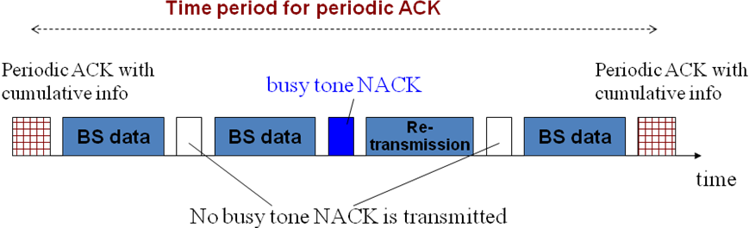
The above figure illustrates the combined scheme. With the busy tone NACK, the MS could receive the lost packet as soon as possible as the BS would perform the retransmission on receiving the Busy Tone NACK. The periodic ACK contains the cumulative info of all the transmission within the period. This would give BS more helpful information on adjusting the length of the ACK period and BS data. With better channel state, BS might gather the ACK less frequently and utilize the radio resource for data transmission.
The combination scheme would possibly acquire the advantages of the combined method and filter out the shortcoming. For example, the Busy Tone might be at disadvantages for the simple NACK scheme causing difficulties in clearly analyzing the reason for data loss, and the period ACK would suffer from bigger retransmission delay as the retransmission should be done after the end of each ACK period. Combining these two methods, the cons are compensated by each other’s pros and both methods’ advantages are still preserved.

