Project | IEEE 802.16 Broadband Wireless Access Working Group <http://ieee802.org/16>
Title | Performance comparison of MIMO schemes with variable rates
Date Submitted | 2008-05-05
Source(s) | ¹ Hsuan-Jung Su, Chung-Pi Lee, Wei-Shun Liao, NTU  Ren-Jr Chen, Chung-Lien Ho, Chang-Lan Tsai, Zheng-Yan Xin, ITRI  ² Pei-Kai Liao, Chih Yuan Lin, Ciou-Ping Wu, Paul Cheng, MediaTek Inc.  Yang-Han Lee, Yih-Guang Jan, Tamkang University (TKU) | Voice:  ¹+886-2-33663600  E-mail:  ¹hjsu@cc.ee.ntu.edu.tw  ²pk.liao@mediatek.com  *<http://standards.ieee.org/faqs/affiliationFAQ.html>
Re: | Call for Contributions on Project 802.16m System Description Document (SDD) issued on 2008-03-20 (IEEE 802.16m-08/016r1)  Topic: Downlink MIMO Schemes
Abstract | This contribution compares the throughputs of different MIMO schemes. It is shown that the coding schemes that achieve the optimal diversity-multiplexing tradeoff have the highest throughputs in both low rate and high rate regions, and they alone suffice in different application scenarios. This conclusion suggests that using only this kind of MIMO schemes can enhance the throughput while avoiding the encoder/decoder and control signaling design difficulties caused by mode switching and operation.
Purpose | For discussion by IEEE 802.16m TG
Notice | This document does not represent the agreed views of the IEEE 802.16 Working Group or any of its subgroups. It represents only the views of the participants listed in the “Source(s)” field above. It is offered as a basis for discussion. It is not binding on the contributor(s), who reserve(s) the right to add, amend or withdraw material contained herein.
Release | The contributor grants a free, irrevocable license to the IEEE to incorporate material contained in this contribution, and any modifications thereof, in the creation of an IEEE Standards publication; to copyright in the IEEE’s name any IEEE Standards publication even though it may include portions of this contribution; and at the IEEE’s sole discretion to permit others to reproduce in whole or in part the resulting IEEE Standards publication. The contributor also acknowledges and accepts that this contribution may be made public by IEEE 802.16.
Patent Policy | The contributor is familiar with the IEEE-SA Patent Policy and Procedures:  <http://standards.ieee.org/guides/bylaws/sect6-7.html#6> and <http://standards.ieee.org/guides/opman/sect6.html#6.3>.  Further information is located at <http://standards.ieee.org/board/pat/pat-material.html> and <http://standards.ieee.org/board/pat>.
Performance comparison of MIMO schemes with variable rates

Hsuan-Jung Su, Chung-Pi Lee, Wei-Shun Liao,
National Taiwan University (NTU)
Ren-Jr Chen, Chung-Lien Ho, Chang-Lan Tsai, Zheng-Yan Xin,
ITRI
Pei-Kai Liao, Chih Yuan Lin, Ciou-Ping Wu, Paul Cheng
MediaTek Inc.
Yang-Han Lee, Yih-Guang Jan
Tamkang University (TKU)

Introduction
802.16e allows several MIMO transmission schemes [1]. It is generally perceived that, at low SNR, space-time codes (STC) perform better due to their ability to exploit antenna diversity, while at high SNR, spatial multiplexing (SM) schemes are preferred for being able to support high rates with simpler modulation and demodulation. Thus, systems need to be able to switch between STC and SM modes to have good performance in both low and high SNR regions. Recent developments of the notion of diversity-multiplexing tradeoff (DMT) [2] and the STC designs that achieve the optimal DMT (e.g., [3]), however, suggest that it is possible to attain optimal diversity while having the transmission rate grow with SNR. A noteworthy feature of most of the existing optimal DMT STCs is that they consist of special transforms of QAM symbols. Given that STCs are open-loop schemes that allocate equal power to all antennas, it is possible for the transmitter to adjust its transmission rate according to the average SNR feedback through simply selecting different sizes of QAM constellations.
In this contribution, we compare the throughputs of different MIMO schemes assuming that they can adapt their rates according to the channel SNR. The same set of possible rates is used for all schemes, which means that these schemes will need the same amount of feedback for rate adaptation. Simulation results show that the optimal DMT STCs have the best throughputs in both low and high SNR regions. Thus employing this structure alone suffices for different application scenarios. This conclusion suggests that it is possible to enhance the throughput while avoiding the encoder/decoder and control signaling design difficulties due to multi-mode switching and operation.

Simulation Setting
This contribution considers the following MIMO schemes: Alamouti STC (matrix A in 802.16e), SM (matrix B in 802.16e), transmitter-receiver beam-forming with singular value decomposition (SVD), and optimal DMT STC. 2×2 and 4×4 MIMO channels are considered as examples. Thus the Golden code proposed in [3] (similar to matrix C in 802.16e) is used as the optimal DMT STC.
The Golden code is a full rate, full diversity STC which achieves the optimal DMT. It has the form of

where (QAM), , , and can be chosen from the TABLE I in [3]. If necessary, the Golden code can be used as an inner code to guarantee full diversity for any rate, and concatenated with an outer code to obtain better coding gain [4][5].
It is assumed that the transmitter can switch between the following rates: 2 bits, 4 bits, 8 bits, and 12 bits per channel use (PCU). This means that the same amount of feedback is needed by all schemes for rate adaptation. For all schemes, QPSK, 16QAM and 64QAM constellations are used to implement these rates. We simulate these rates separately and plot their throughputs on the same figure. Assuming that optimal rate adaptation is possible, the rate with the highest throughput at a given SNR is picked to show the optimal throughput achievable by a particular MIMO scheme.
In 2×2 MIMO case, the channel is assumed to be i.i.d. Rayleigh distributed on different transmit-receive antenna pairs. Within a block of 2 symbol times, the channel is fixed, while the channel changes independently from block to block. For fair comparison, it is assumed that every 48 information bits are considered a frame and CRC checked. A frame is considered lost if any information bit in it is incorrectly decoded.
For Alamouti STC, the receiver uses linear detection. For SM, zero-forcing filtering with successive interference cancellation is used. The optimal DMT STC receiver employs sphere decoding. For all schemes, the channel is assumed perfectly known at the receiver. For SVD based SM, in addition to the average SNR feedback used for rate adaptation (assuming equal transmission power and same rate on all modes), the transmitter beam-forming matrix needs to be fed back from the receiver to the transmitter as well. In order not to impose too much additional signaling overhead, the transmitter beam-forming matrix is optimally quantized with 2 bits and 4 bits, respectively. In order to overcome the inter-mode interference caused by quantization errors, the receiver of the SVD based SM performs MMSE filtering instead of using the SVD receiver beam-forming matrix.
In 4×4 MIMO case, the optimal DMT STC, Alamouti STC, and SM are compared. The simulation is processed under the same parameter settings as in 2×2 case except that 192 bits are included in one block and the channel stays static within 4 symbols. For Alamouti case, as in 16e, each time two of the four antennas are selected, while in the other two cases all the four transmission antennas are used all the time.

Simulation results
In Figure 1, the thick red line sketches the highest throughput achievable by the Golden STC, assuming rate adaptation is allowed. The thick blue and the green lines sketch the achievable throughputs of Alamouti STC and SM, respectively. From Figure 1, we can see that Golden STC outperforms the other two schemes in almost all SNR regions.
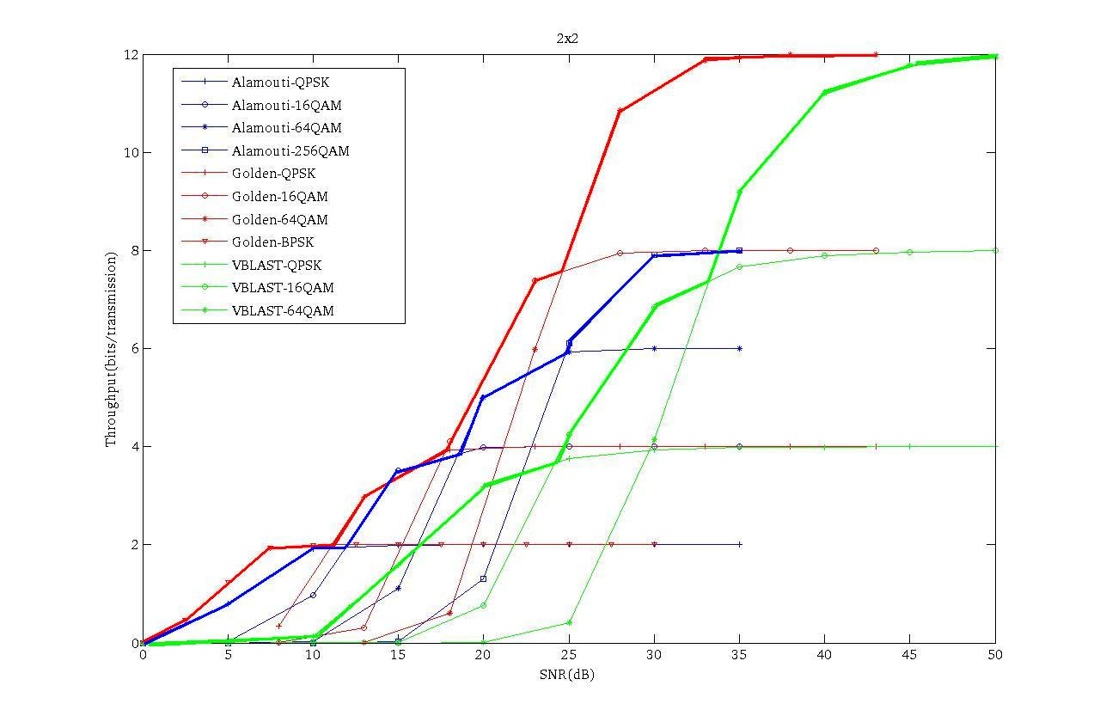
Figure 1: Comparison among Golden STC, SM, and Alamouti STC.

In Figures 2 and 3, Golden STC is compared with SVD with 2-bit and 4-bit additional transmitter beam-forming matrix feedback, respectively. Again, the achievable throughput of the Golden STC (thick red line) is higher than that of SVD in all SNR regions.
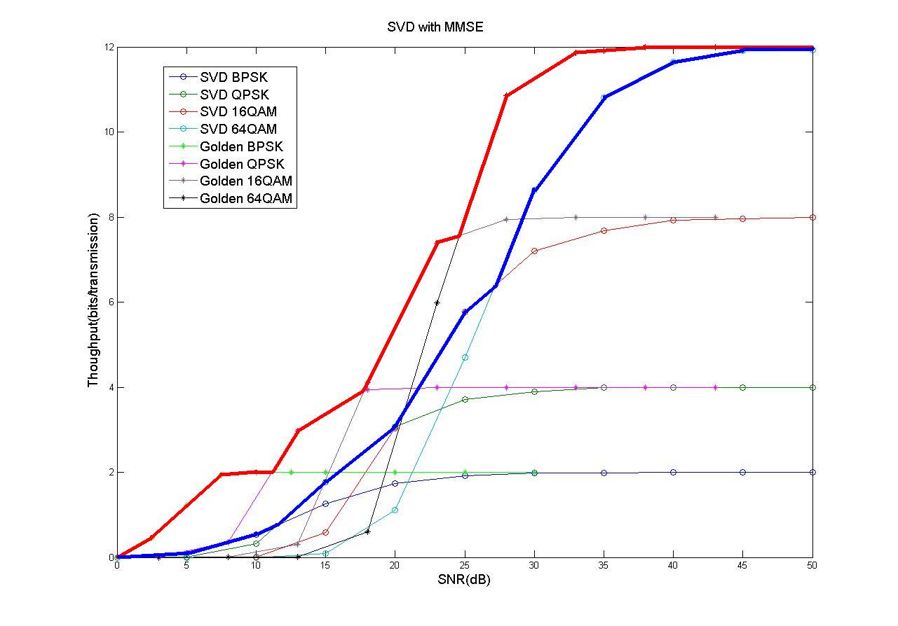
Figure 2: Comparison between Golden STC and SVD with 2-bit transmitter beam-forming matrix feedback.
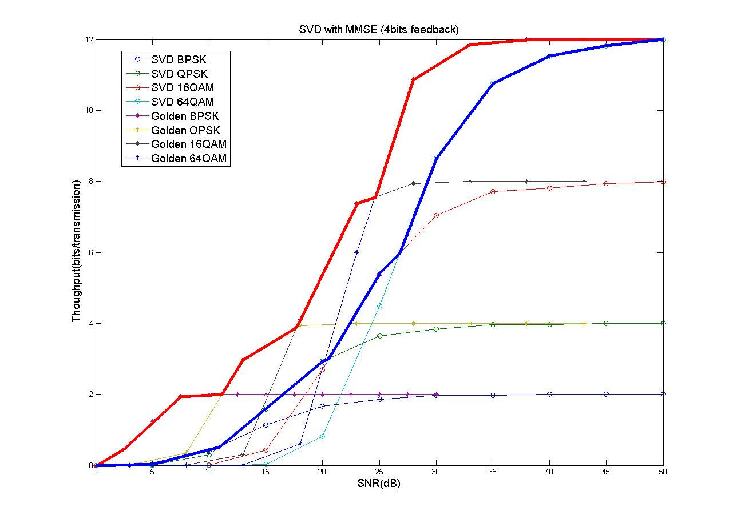
Figure 3: Comparison between Golden STC and SVD with 4-bit transmitter beam-forming matrix feedback.
In Figure 4, 4×4 MIMO channel is considered. We can see that in Figure 4 the achievable throughput of perfect STC (the thick red line) is still higher than that of the other two schemes (the thick green line for SM case and the thick blue line for Alamouti STC) in moderate and high SNR region while keeping comparable performance as that of the other two schemes.
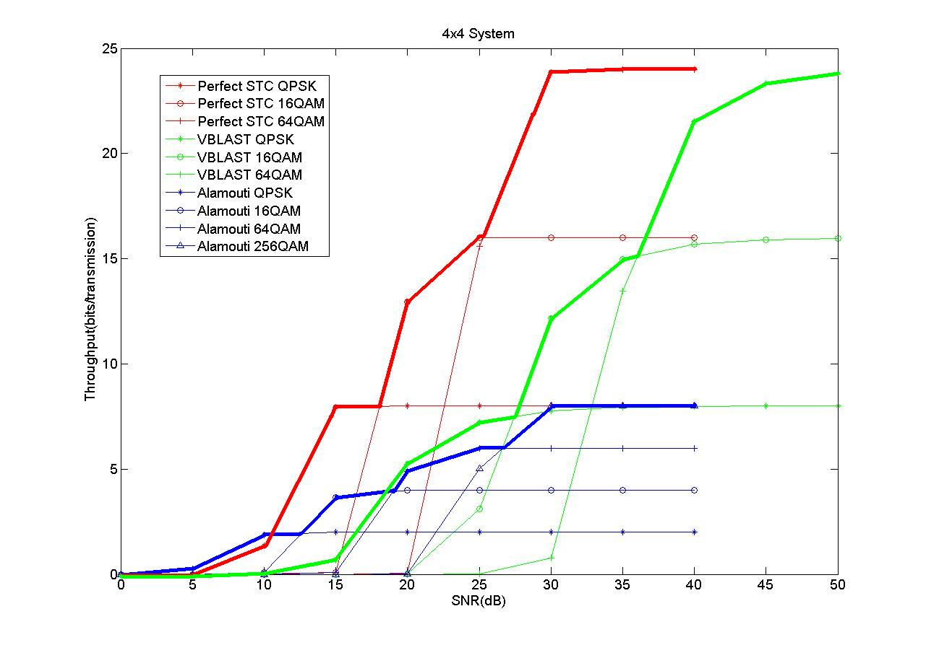
Figure 4: Comparison among 4×4 optimal DMT STC, SM, and Alamouti STC.

Conclusions
In this contribution, we compare the throughputs of different MIMO schemes (Alamouti STC, SM, transmitter-receiver beam-forming with SVD, and optimal DMT STC) assuming that they can adapt their rates according to the channel SNR. The same set of possible rates is used for all schemes, which means that these schemes will need the same amount of feedback for rate adaptation. Simulation results show that the optimal DMT STCs have the best throughputs in both low and high SNR regions. Thus employing this structure alone suffices for different application scenarios. This conclusion suggests that it is possible to enhance the throughput while avoiding the encoder/decoder and control signaling design difficulties due to multi-mode switching and operation.

References
- IEEE Standard 802.16e-2005, Amendment to IEEE Standard for Local and Metropolitan Area Networks -6 Part 16: Air Interface for Fixed Broadband Wireless Access Systems- Physical and Medium Access Control 7 Layers for Combined Fixed and Mobile Operation in Licensed Bands, February, 2006.
- L. Zheng, D. Tse, “Diversity and Multiplexing: A Fundamental Tradeoff in Multiple-Antenna Channels,” IEEE Trans. On Information Theory, vol. 49, no. 5, pp. 1073-1096, May 2003..
- J.-C. Belfiore, G. Rekaya, and E. Viterbo, “The Golden Code: A 2 × 2 full rate Space-Time Code with non vanishing Determinants,” IEEE Trans. on Inf. Theory, vol. 51, no 4, April 2005.
- D. Champion, J. –C. Belfiore, G. Rekaya, and E. Viterbo, “Partitioning the Golden Code: A Framework to the Design of Space-Time Coded Modulation,” Canadian Workshop on Info. Th., Montreal, 2005.
- Y. Hong, E. Viterbo, and J. –C. Belfiore, “Golden Space-Time Trellis Coded Modulation,” IEEE Trans. Inform. Theory, Vol. 53, No. 5, pp.1689-1705, May 2007.
- A. Hottinen, Y. Hong, E. Viterbo, C. Mehlfuhrer. And C. F. Mecklenbrauker, “A Comparison of High Rate Algebraic and Non-orthogonal STBCs,” ITG/IEEE WSA 2007, Vienna, Austria, February 2007.
- S. D. Howard, S. Sirianunpiboon, and A. R. Calderbank, “Fast Decoding of the Golden Code by Diophantine Approximation,” ITW 2007, Lake Tahoe, California, U.S.A., September 2007.
- B. Cerato, G. Masera, and E. Viterbo, “Decoding the Golden Code: a VLSI Design,” November 2007.

