Project | IEEE 802.16 Broadband Wireless Access Working Group <http://ieee802.org/16>
Title | Enhancing CTC HARQ performance by bit rearrangement
Date Submitted | 2008-05-05
Source(s) | Yu-Chuan Fang, Ren-Jr Chen,  Zheng Yan-Xiu, Chung-Lien Ho,  Chang-Lan Tsai, Chi-Fang (Richard) Li, ITRI  Wern-Ho Sheen, NCTU/ITRI | Voice:  E-mail: YCFang@itri.org.tw  richard929@itri.org.tw
Re: | IEEE 802.16m-08/016r1—Responds to Call for Contributions on Project 802.16m System Description Document (SDD)  Topic: HARQ
Abstract | A new HARQ method utilizing bit rearrangement is presented in this contribution, where the inter-symbol rearrangement is employed for retransmission and the soft combining is adopted at the receiver to combine the received symbols to gain the constellation and frequency diversities and improve the error performance. The proposed method has shown significant gain over the conventional HARQ schemes specified in IEEE 802.16e. It is proposed to adopt the technique in the IEEE 802.16m SDD HARQ section for further investigation.
Purpose | For 802.16m discussion and adoption
Notice | This document does not represent the agreed views of the IEEE 802.16 Working Group or any of its subgroups. It represents only the views of the participants listed in the “Source(s)” field above. It is offered as a basis for discussion. It is not binding on the contributor(s), who reserve(s) the right to add, amend or withdraw material contained herein.
Release | The contributor grants a free, irrevocable license to the IEEE to incorporate material contained in this contribution, and any modifications thereof, in the creation of an IEEE Standards publication; to copyright in the IEEE’s name any IEEE Standards publication even though it may include portions of this contribution; and at the IEEE’s sole discretion to permit others to reproduce in whole or in part the resulting IEEE Standards publication. The contributor also acknowledges and accepts that this contribution may be made public by IEEE 802.16.
Patent Policy | The contributor is familiar with the IEEE-SA Patent Policy and Procedures:  <http://standards.ieee.org/guides/bylaws/sect6-7.html#6> and <http://standards.ieee.org/guides/opman/sect6.html#6.3>.  Further information is located at <http://standards.ieee.org/board/pat/pat-material.html> and <http://standards.ieee.org/board/pat>.
Enhancing CTC HARQ performance by bit rearrangement

Yu-Chuan Fang, Ren-Jr Chen, Zheng Yan-Xiu, Chung-Lien Ho, Chang-Lan Tsai, Chi-Fang (Richard) Li, ITRI
Wern-Ho Sheen, NCTU/ITRI

Introducation
This contribution introduces bit rearrangement concept to improve legacy HARQ performance. Contributions [5][6] mentioned the constellation rearrangement in each HARQ process and contribution [7] mentioned the adaptive frequency interleaving for HARQ. Both methods provide performance gain. Therefore, we propose the rearranger which performs the bit level permutation and bit inverting before modulation. During a HARQ process, these transmissions are rearranged in different manners if transmitter receives at least one NACK. Therefore, the rearranger can create composite constellation and frequency diversity gain for HARQ. Our simulation shows at least 1.5 dB performance gain achieved in fading channel and the gain is significant.

HARQ
HARQ (Hybrid Automatic Repetition Request) is a popular technique for communication systems. When the receiver cannot decode a data packet, it would feedback a NACK signal to request transmitter to retransmit this packet till the packet can be decoded correctly or the allowed number of transmissions is achieved. CC (Chase Combining) and IR (Incremental Redundancy) are two HARQ techniques adopted in the IEEE 802.16e [3].

Legacy transceiver architecture
Legacy transceiver architecture is shown in Fig. 1. The modulator maps several bits into a symbol of some constellation, for example, in the 16QAM modulation, four bits are mapped into a symbol. At the receiver the demodulator calculates the bit reliabilities. However, 16QAM and 64QAM used in legacy system render different level of protection on the mapping bits. Fig. 2 shows an example that b₁ and b₃ are protected better but b₀ and b₂ are not. Retransmitting identical format means coded bits protected weakly are still protected weakly at the successive transmission.

Fig. 1 Conventional transceiver architecture
More reliable: b₁ and b₃
Less reliable: b₀ and b₂
Fig. 2 16QAM constellation in IEEE 802.16e

HARQ with constellation rearrangement
Constellation rearrangement concept [1],[2] is introduced to improve HARQ performance with 16QAM and 64QAM. This concept rearranges constellation at each retransmission. Therefore, the bits protected less can be protected well at the next retransmission. The constellation effect is averaged.
However, the bits are restricted to be rearranged within a modulation symbol. Taking 16QAM for example, every four bits are rearranged to change each bit’s reliability. Over the fading channel the constellation rearrangement just may supply constellation diversity, but not support the frequency diversity. In order to acquire frequency diversity gain, inter-symbol rearrangement is introduced.

HARQ with Bit rearrangement
Fig. 3 Illustration of the transmitter with the bit rearranger

Bit rearrangement method is described in this section to prevent this case. This method rearranges coded bits across the whole subpacket. We introduce a bit rearranger before the modulator as shown in Fig. 3. If there is no the bit rearranger, the structureError: Reference source not found is identical to 802.16e transmitter [3]. Bit rearranger performs bit level interleaving and bit inverting. It applies various rearrangement patterns in different transmissions. Since bits are interleaved in different transmissions, the mapping on the 16QAM and 64QAM are different in different transmissions and protection on these coded bits would be more uniform. By the way, the coded bits mapped in the same symbol would be mapped to different symbol in the next transmission and frequency diversity gain is available.

Fig. 4 shows the receiver with the bit de-rearranger. Comparing with legacy receiver, only bit de-rearranger and controller are introduced, buffer is necessary for legacy receiver as HARQ is applied. Controller determines the operation of de-rearranger to recover the order of the received channel-coded bits.

Fig. 4 Illustration of the receiver with the bit de-rearranger

An example of bit rearranger is shown in Fig. 5 and 16 bits sequence is used. The bit rearranger performs bit interleaving and bit inverting. The bit rearranger permutes these bits on bit level and inverts several bits which are labeled by bar on the symbol.
Every time, as transmitter received NACK from the receiver, transmitter applies different bit rearrangement method to transmit coded replica. Since each retransmission applies different bit rearrangement, coded bits may be mapped from LSB to MSB or MSB to LSB corresponding to each symbol mapping. The output SNR corresponding to different transmission would vary and it provides constellation diversity gain. By the way, the bit interleaver would map identical coded bit to different carriers on different transmissions and from it provides frequency diversity gain.
random permutation
exclusive-or with a random sequence ‘1101001000010001’
1st TX
coded bits:
Inter-symbol rearrangement
Bit interleaver
Bit inverter
2nd TX:
Fig. 5 An example of the bit rearrangement performed by bit rearranger

Simulation results
Fig. 6 and Fig. 7 illustrate some simulation results. CTC (Convolutional Turbo Code) specified in IEEE 802.16e [3], 480 bits, code rate=1/2 with 16QAM and 64QAM is used. Typical urban fading channel is considered [4]. Bit interleaver and bit inverter are randomly selected in these results. The CTC decoder adopts Linear-Log-MAP and eight turbo decoding iterations. Fig. 6 shows that the bit rearrangement method outperforms the conventional CC-HARQ with 16QAM about 1.7 dB, 2.5 dB and 3 dB at FER=10⁻³ after two, three and four transmissions respectively. Fig. 7 shows that the error performance of bit rearrangement surpasses the conventional CC-HARQ with 64QAM about 2.7, 3.9, 4.6, 5.4 and 6 dB at FER=10⁻³ after two, three, four, five and six transmissions respectively. The proposed method significantly improves the capability of HARQ.

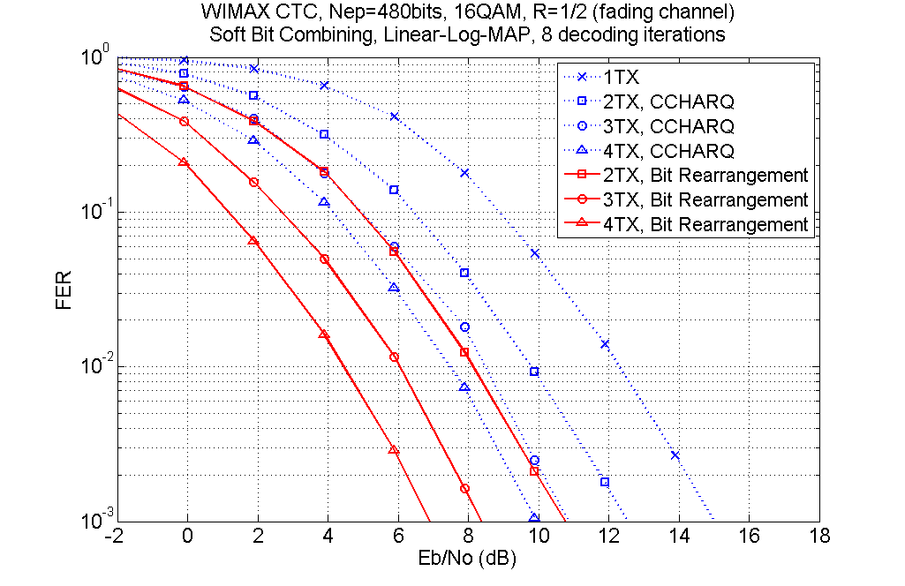
Fig. 6 Simulation result of the bit rearrangement for 16QAM over fading channel

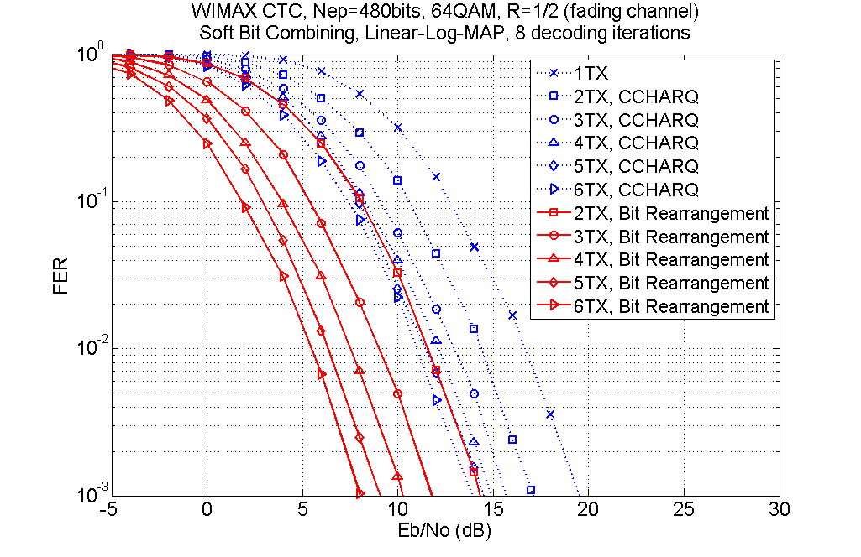
Fig. 7 Simulation result of the bit rearrangement for 64QAM over fading channel

Conclusion
Bit rearrangement provides frequency and constellation diversities which provide significant gain to HARQ performance. The proposed architecture retains modulator and possesses features receiver does not change its demodulator; minimum modification on receiver is achievable. The constellation gain mentioned in [5],[6] and the frequency diversity gain mentioned in [7] are achieved by this function. Even or QPSK transmission, our method is applicable to acquire frequency diversity gain.

References
.[1] | Panasonic (2001); “Enhanced HARQ Method with Signal Constellation Rearrangement,” TSG-RAN WG1 #19, Feb. 27-Mar. 2, 2001, Las Vegas, USA.
[2] | IEEE C802.16m-07_292r1, “Enhanced HARQ technique using Constellation Rearrangement,” Nov. 15, 2007.
[3] | P802.16Rev2/D3 (February 2008), DRAFT Standard for Local and Metropolitan Area Networks, Part 16: Air interface for broadband wireless access systems, February 2008.
[4] | IEEE 802.16m-08/004r1, “IEEE 802.16m Evaluation Methodology Document (EMD),” March 17, 2008.
[5] | IEEE C802.16m-08/412, “Hybrid-ARQ structure for IEEE 802.16m,” May 5, 2008.
[6] | IEEE C802.16m-08/377, “Enhanced Constellation Rearrangement for HARQ with Adaptive Modulation,” May 5, 2008.
[7] | IEEE C80216m-08/477, “Adaptive Frequency Interleaving for HARQ,” May 5, 2008.

Proposed SDD Text

-----------------------------Begin Proposed Text ----------------------------------------------------------------------
X.x HARQ
Bit rearrangement should be supported for HARQ retransmission. In each retransmission, coded bits are rearranged in different fashions.

X.x.x Bit rearrangement
The bit rearranger performs bit level interleaving and bit inverting on punctured code bits and output to modulator.
Fig. Y: Illustration of the transmitter with the bit rearranger

---------------------------End of Text Proposal ---------------------------------------------------------------------

