Project | IEEE 802.16 Broadband Wireless Access Working Group <http://ieee802.org/16>
Title | Proposal for Multicarrier uplink control structure
Date Submitted | 2008-05-13
Source(s) | Chie Ming Chou, Richard Li, Frank Ren, Chun-Yen Wang, ITRI  Wern-Ho Sheen, NCTU/ITRI  I-Kang Fu, Kelvin Chou, Paul Cheng, MediaTek Inc. | Voice:  E-mail: chieming@itri.org.tw  richard929@itri.org.tw  IK.Fu@mediatek.com
Re: | IEEE 802.16m-08/016r1 - Call for Contributions on Project 802.16m System Description Document (SDD)  Topic: Uplink Control Structures
Abstract | This contribution proposes the designs of uplink control structure for supporting Multicarrier operations.
Purpose | For discussion and approval by TGm
Notice | This document does not represent the agreed views of the IEEE 802.16 Working Group or any of its subgroups. It represents only the views of the participants listed in the “Source(s)” field above. It is offered as a basis for discussion. It is not binding on the contributor(s), who reserve(s) the right to add, amend or withdraw material contained herein.
Release | The contributor grants a free, irrevocable license to the IEEE to incorporate material contained in this contribution, and any modifications thereof, in the creation of an IEEE Standards publication; to copyright in the IEEE’s name any IEEE Standards publication even though it may include portions of this contribution; and at the IEEE’s sole discretion to permit others to reproduce in whole or in part the resulting IEEE Standards publication. The contributor also acknowledges and accepts that this contribution may be made public by IEEE 802.16.
Patent Policy | The contributor is familiar with the IEEE-SA Patent Policy and Procedures:  <http://standards.ieee.org/guides/bylaws/sect6-7.html#6> and <http://standards.ieee.org/guides/opman/sect6.html#6.3>.  Further information is located at <http://standards.ieee.org/board/pat/pat-material.html> and <http://standards.ieee.org/board/pat>.
Proposal for Multicarrier uplink control structure
Chie Ming Chou, Richard Li, Frank Ren, Chun-Yen Wang, Wern-Ho Sheen
ITRI, NCTU
I-Kang Fu, Kelvin Chou, Paul Cheng,
MediaTek Inc.

- Introduction
Supporting Multicarrier is one function of 802.16m. A lot of works are proposed for Multicarrier downlink (DL) control structure in last Orlando meeting. The final resolution of Multicarrier DL control is pended by DL Control Rapporteur Group. Based on the initial consensus in IEEE C802.16mDL_ctrl-08/037, this contribution proposes uplink (UL) control structure for Multicarrier. The designs of random access channels including initial ranging sub-channel, period ranging sub-channel, handover ranging sub-channel and bandwidth request (BR) ranging sub-channel are considered in this contribution. Besides, regarding UL control mechanisms such as network entry and BR process are also discussed.

- Description of the proposal
Multicarrier scheme will allow the network to operate in continuous or discontinuous frequency with different bandwidth. A separate FFT and RF module is used at each band, and one MAC entity is required to support Multicarrier functionalities. Based on MS’s capabilities, BS can serve different MS with different bandwidth. The capability of supporting Multicarrier for MS can be roughly classified into 2 main types:
  - Type 1: Single RF carrier support
  - Type 2: Multiple RF carriers support
This contribution provides a generalized UL control structure for those 2 types.

- Assumptions of Multicarrier DL control structure
Before introducing the proposal of Multicarrier UL control structure, some consensuses from DL Control Rapporteur Group are given:
  - The Multicarrier DL control channels contain the synchronization channel (SCH), broadcast channel (BCH), and unicast service control channel (USCCH).
  - SCH provides a reference signal for time, frequency, frame synchronization and BS identification. The allocation of SCH is TBD.
  - BCH provides system configuration information and additional broadcast information (ex: neighbor BS information, paging information and etc). The allocation of BCH is TBD and TDM with SCH.
  - USCCH provides resource allocation for unicast services. The allocation of USCCH is TDM with SCH and BCH.
And our assumptions for Multicarrier DL control are addressed in the following:
  - The allocation of SCH is fixed in the first sub-frame within a superframe.
  - The allocation of BCH is fixed.
  - The allocation of USCCH is variable (may appear in every sub-frame or every frame).
  - Each carrier will be classified into primary carrier or secondary carrier. A BS can have one or multiple primary carriers and one or multiple secondary carriers.
  - Primary carrier shall have SCH, BCH and USCCH. Secondary carrier may share SCH and BCH with its primary carrier (secondary may not assign SCH and BCH) and secondary carrier will have its own USCCH.

Figure 1 is an example of Multicarrier DL control structure.
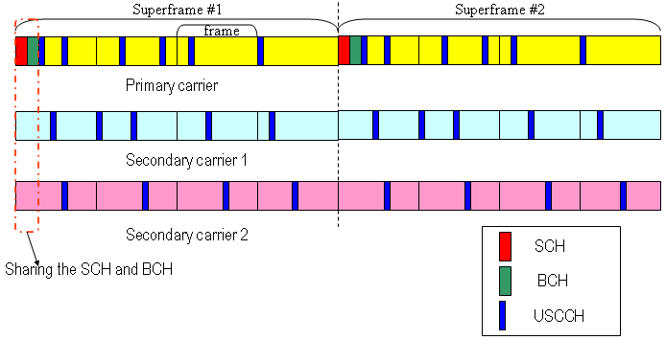
Figure 1; an example of assumed Multicarrier DL control structure

- Initial ranging sub-channel in Multicarrier
In IEEE 802.16e, initial Ranging sub-channel is used for the purpose of initial ranging process during MS’s network entry. After acquiring the DL/UL parameters from SCH and BCH, MS can identify the allocation of initial ranging sub-channel. And then MS will randomly pick up a ranging code and send it in this sub-channel. If BS receives this code, it will give a RNG-RSP to command the MS to perform regarding PHY adjustments. In response to the assumption of only primary carrier will allocate SCH and BCH, we propose that initial ranging sub-channel will be only allocated within primary carrier. As a result; both type1 and type2 MSs will perform network entry on primary carrier. To support fast initial access, the initial ranging sub-channel should be allocated in the first UL sub-frame within a superframe. Furthermore, the allocation of initial ranging sub-channel shall be fixed in every superframe.
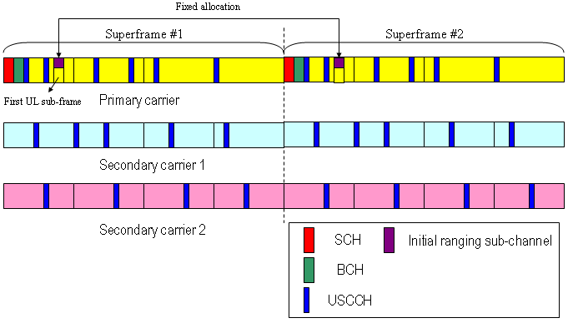
Figure 2; an example of initial ranging sub-channel in Multicarrier

- Proposal: Initial ranging sub-channel will only be allocated in primary carrier. It will statically locate in the first UL sub-frame within a superframe.

- Periodic ranging sub-channel in Multicarrier
Periodic Ranging process is employed to let MS adjust the transmission parameters so that MS can maintain UL communication with BS. To support this process, periodic ranging sub-channel is used for providing the transmission opportunities. When there is no UL-data and T3 timer timeouts, MS will randomly pick up a ranging code and send it in the periodic ranging sub-channel. Due to different carry frequency of each carrier, both primary carrier and secondary carrier need periodic ranging sub-channel to let MS performs corresponding adjustments. Besides, compared with initial ranging process, BS may be able to get well information of MSs rather than new incoming MSs. (Ex: BS can get the CQI report from serving MS). Therefore, BS may re-configure the allocation (including: size, location, cycle…and etc) of periodic ranging sub-channel in each carrier to facilitate the periodic ranging process based on some criteria. To reduce the overhead of signaling negotiations, a pre-defined pattern scheme is suggested for identifying the periodic ranging sub-channel. Table 1 is an example of pattern design for periodic ranging sub-channel.

Table 1; an example of periodic ranging sub-channel pattern
Pattern | Cycle | Size | Location
1 | Every superframe | 6 symbols | Followed by initial ranging sub-channel
2 | Every superframe | 6 symbols | In the beginning of last sub-frame within superframe
3 | Every frame | 6 symbols | In the beginning of last sub-frame within frame
4 | Every frame | 12 symbols | In the beginning of last sub-frame within frame
… | … | … | …

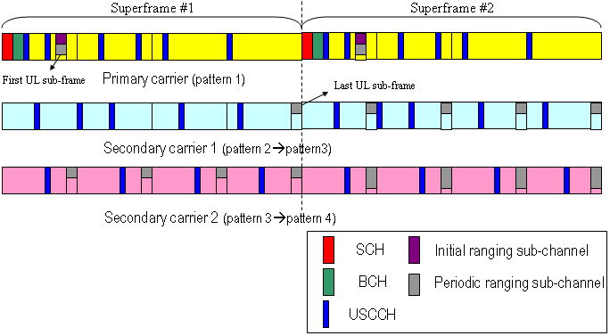
Figure 3; an example of periodic ranging sub-channel in Multicarrier

With proposed periodic ranging sub-channel in Multicarrier, MS can entry the system through primary carrier and get synchronization with primary carrier first. When BS/MS decides to use secondary carriers to serve this MS, due to well-synchronization between primary carrier and secondary carriers, MS only needs to perform adjustment through individual periodic ranging sub-channel without fully re-access.

- Proposal: Periodic ranging sub-channel will be allocated in both primary carrier and secondary carriers. The allocation of periodic ranging sub-channel in each carrier can be different and configurable based on the pre-defined patterns.

- Handover ranging sub-channel in Multicarrier
In Multicarrier, handover process is performed between switching two primary carriers; switching between primary carrier and secondary carrier for type 1 MS won’t initiate the HO process. Only primary carrier needs to allocate handover ranging sub-channel for HO ranging. The location of HO ranging sub-channel will be shared with initial ranging sub-channel which is static and appeared in the first UL sub-frame within a superframe. The codes selected from HO ranging domain will be used in HO ranging to differentiate with initial ranging process.

- Proposal: Handover ranging sub-channel will co-locate with initial ranging sub-channel in Multicarrier. The codes selected from HO ranging domain will be used in HO ranging to differentiate with initial ranging process.

- Bandwidth Request ranging sub-channel in Multicarrier
Bandwidth request process refers to the mechanism that MS requests BS for bandwidth allocation. A request may come as a stand-alone Bandwidth Request (BR) header or as a Piggyback request. When Multicarrier is supported, several connections may be created simultaneously along different carriers, and USCH in each carrier will indicate the individual allocations for this specific MS. When contention-based BR mechanism is applied in this condition, to reduce the data plane access latency and satisfy QoS, it may be required to assign a dedicated BR ranging sub-channel in short cycle to support fast response. However, it will be a big resource overhead if we always allocate BR ranging sub-channel in each carrier. Besides, a BS needs to handle frequent contention because of independent BR processes in each carrier. To resolve these problems and make BR process in Multicarrier more efficient, a new BR mechanism for Multicarrier is proposed. The details please refer to C802.16m-08_304r1. Under this design, only primary carrier will allocate bandwidth request ranging sub-channel and its location will be dynamical and indicated by USCCH.

- Proposal: Bandwidth Request ranging sub-channel will only be allocated in primary carrier. Its location is dynamical and indicated by USCCH.

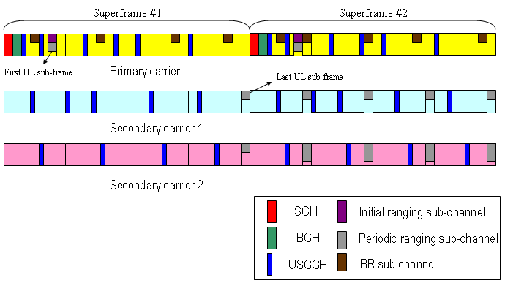
Figure 4; an example of bandwidth request ranging sub-channel in Multicarrier

- Proposed Text
---------------------------------------------Start of the text------------------------------------------------
[Insert the following text in Section 19 of IEEE 802.16m-08/003r1]
19. Support for Multicarrier
19. x. UL Control Structure

Based on different applications, the Ranging sub-channels of Multicarrier will be separately allocated.

Initial ranging sub-channel will only be allocated in primary carrier. It will be statically located in the first UL sub-frame within a superframe.

Periodic ranging sub-channel will be allocated in both primary carrier and secondary carriers. The allocation of periodic ranging sub-channel in each carrier can be different and configurable based on the pre-defined patterns.

Handover ranging sub-channel will co-locate with initial ranging sub-channel in Multicarrier. The codes selected from HO ranging domain will be used in HO ranging to differentiate with initial ranging process.

Bandwidth Request ranging sub-channel will only be allocated in primary carrier. Its location is dynamical and indicated by unicast service control channel.

---------------------------------------------End of the text------------------------------------------------

Reference
[1] C802.16mDL_ctrl-08/037 “Draft 3 of DL Control Rapporteur Group Contribution: SDD Text on Downlink Control Structure”.
[2] C802.16m-08/092r1 “Proposal for Generalized Multi-carrier Support in IEEE 802.16m Systems”.
[3] 802.16m-08/003r1 “The Draft IEEE 802.16m System Description Document”
[4] C802.16m-08/237 “Comments and Proposed SDD Text for Multi-carrier Frame Structure”.

