Project | IEEE 802.16 Broadband Wireless Access Working Group <http://ieee802.org/16>
Title | Proposal for Multicarrier Bandwidth Request Control Mechanism
Date Submitted | 2008-05-13
Source(s) | Chie Ming Chou, Richard Li, Frank Ren, Chun-Yen Wang, ITRI  Wern-Ho Sheen, NCTU/ITRI  I-Kang Fu, Kelvin Chou, Paul Cheng, MediaTek Inc. | Voice:  E-mail: chieming@itri.org.tw  richard929@itri.org.tw  IK.Fu@mediatek.com
Re: | IEEE 802.16m-08/016r1 - Call for Contributions on Project 802.16m System Description Document (SDD)  Topic: Uplink Control Structures
Abstract | This contribution proposes the designs of Bandwidth request mechanism for supporting Multicarrier operations.
Purpose | For discussion and approval by TGm
Notice | This document does not represent the agreed views of the IEEE 802.16 Working Group or any of its subgroups. It represents only the views of the participants listed in the “Source(s)” field above. It is offered as a basis for discussion. It is not binding on the contributor(s), who reserve(s) the right to add, amend or withdraw material contained herein.
Release | The contributor grants a free, irrevocable license to the IEEE to incorporate material contained in this contribution, and any modifications thereof, in the creation of an IEEE Standards publication; to copyright in the IEEE’s name any IEEE Standards publication even though it may include portions of this contribution; and at the IEEE’s sole discretion to permit others to reproduce in whole or in part the resulting IEEE Standards publication. The contributor also acknowledges and accepts that this contribution may be made public by IEEE 802.16.
Patent Policy | The contributor is familiar with the IEEE-SA Patent Policy and Procedures:  <http://standards.ieee.org/guides/bylaws/sect6-7.html#6> and <http://standards.ieee.org/guides/opman/sect6.html#6.3>.  Further information is located at <http://standards.ieee.org/board/pat/pat-material.html> and <http://standards.ieee.org/board/pat>.
Proposal for Multicarrier bandwidth request control mechanism
Chie Ming Chou, Richard Li, Frank Ren, Chun-Yen Wang, Wern-Ho Sheen
ITRI, NCTU
I-Kang Fu, Kelvin Chou, Paul Cheng,
MediaTek Inc.

- Introduction
Supporting Multicarrier is one function of 802.16m. In C802.16m-08/303, the uplink control structure for Multicarrier is proposed. Within the design, to reduce the resource and process overhead, only primary carrier will allocate bandwidth request ranging sub-channel. Therefore, a specific bandwidth request process for Multicarrier is needed. Based on this, two new types of bandwidth request are introduced in this contribution.

- Description of the proposal
In Multicarrier scheme, each carrier will be classified into primary carrier or secondary carrier. A BS can have one or multiple primary carriers and one or multiple secondary carriers. Primary carrier shall have synchronization channel (SCH), broadcast channel (BCH) and unicast service control channel (USCCH). Secondary carrier may share SCH and BCH with its primary carrier (secondary may not assign SCH and BCH) and secondary carrier will have its own USCCH.
Bandwidth request process refers to the mechanism that MS requests BS for bandwidth allocation. A request may come as a stand-alone Bandwidth Request (BR) header or as a Piggyback request. When Multicarrier is supported, several connections may be created simultaneously along different carriers, and USCCH in each carrier will indicate the allocations for this specific MS. When a piggyback request is used, MS may be able to perform BR process for associated connections which is within its serving carrier. If this request can be granted within serving carrier, then BS will allocate corresponding resources and indicated by USCCH in this serving carrier. Alternatively, if the request can’t be granted within serving carrier, BS can move this connection to other carriers.
When contention-based BR mechanism is applied, to reduce the data plane access latency and satisfy QoS, it may be required to assign a BR ranging sub-channel in short cycle to support fast response. The allocation of BR ranging sub-channel will be indicated by USCCH. There are two control structures to support this process:
- Each carrier allocates BR ranging sub-channel.
Figure 1 is an example of control structure for this application. In this structure, MS will send BR ranging code in BR ranging sub-channel on regarding carrier. As a result, a BS needs to handle frequent contention because of independent BR processes in each carrier even. This will be a big resources and process overhead. The advantage of this structure is that the BR process for Multicarrier will be the same as legacy BR process for IEEE 802.16e. No additional modifications are needed.
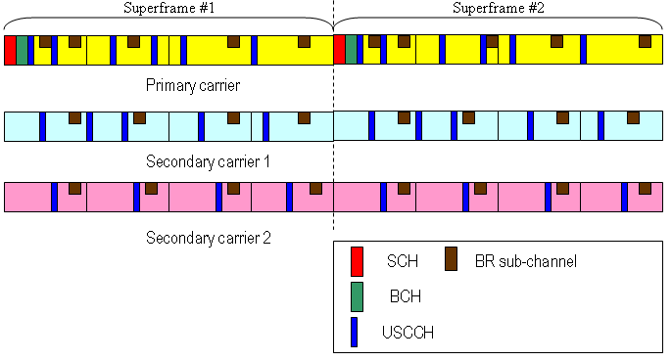
Fig.1. an example of control structure for allocating BR ranging sub-channel in each carrier.

- Only primary carrier allocates BR ranging sub-channel.
Figure 2 is an example of control structure for this application. In this structure, even multiple connections are created in different carriers, MS shall perform BR process in primary carrier for all connections. If the contention is successful, MS can request bandwidth for all its connections in different carriers. This helps reduce the resources and process overhead. Based on this, there are two types of request mechanisms: Aggregated request and multiple requests.
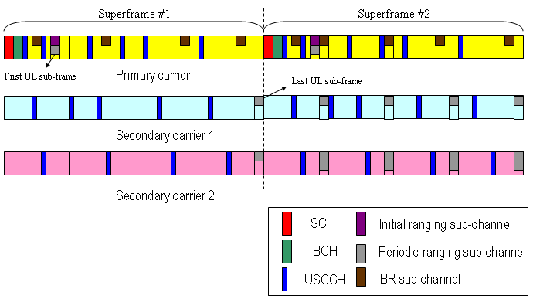
Fig.2. an example of control structure for allocating BR ranging sub-channel in primary carrier.

- Aggregated request:
When using this type request, MS can group connections with same QoS class and calculate total required bandwidth. For an instance, both connection 1 and 2 belong to the ‘nrtPS’ service flow. When connection 1 needs additional 10 bytes and connection 2 needs additional 20 bytes, MS can send one BR header with 30 bytes request. The CID placed in this header will be a group CID with mapping to the same QoS level. The format of group CID is for further study. After receiving this header, BS may allocate 30 bytes resources in one carrier (can be primary carrier or secondary carrier) and then MS can schedule of connection 1 and connection 2 in these granted resources for transmission.
- Multiple request:
Multiple requests are employed for connections with different QoS classes. BR random code domain will be partitioned into several ranges and each range will represent how many resources of BR headers are needed. When receiving code within one specific range, BS will be notified how many resources of BR headers shall be grant for later transmission and give the corresponding CDMA Allocation IE. After receiving CDMA Allocation IE, MS can send multiple BR headers regarding with individual groups or connections. The CID appeared in BR header will be a group CID or a connection CID. Hence, these connections can be different QoS levels within different carrier and BS can allocate resources for these requests on different carriers. Furthermore, it is suggested that BS may check the group CID or connection CID in BR header and find out which on-serving carrier is and try to allocate the granted resources as same carrier as possible. This can reduce the switch process for MS’s transmission.

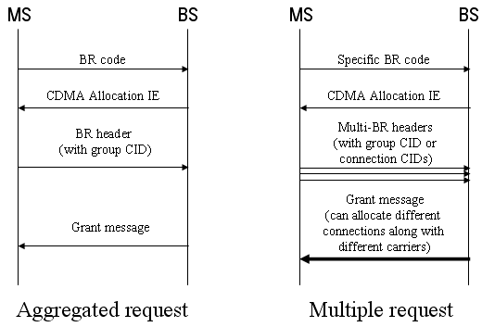
Fig 3. Aggregated BR request and multiple BR request

- Summary:
Compared with allocating BR ranging sub-channel in each carrier, only primary carrier assigns the BR ranging sub-channel will be more efficient. Therefore, we propose BR ranging sub-channel will only be allocated in primary carrier. Its location is dynamical and indicated by USCCH. Dependent on different applications, both aggregated BR request and multiple BR request is supported for Multicarrier BR mechanism.

- Proposed Text
---------------------------------------------Start of the text------------------------------------------------
[Insert the following text in Section 19 of IEEE 802.16m-08/003r1]
19. Support for Multicarrier
19. x. UL Control Structure
19. x. 1 Bandwidth allocations and request mechanisms

Bandwidth Request (BR) ranging sub-channel will only be allocated in primary carrier. Its location is dynamical and indicated by USCCH.

Two types of BR are supported in Multicarrier.

MS can group connections with same QoS class and calculate total required bandwidth. This is called aggregated request in Multicarrier. The CID placed in this header will be a group CID with mapping to one QoS class. After receiving this header, BS may grant resources and then MS can schedule connections for its transmissions.

Multiple requests are employed for connections with different QoS class. BR ranging code domain will be partitioned into several ranges and each range will represent how many resources of BR headers are needed. When receiving code within one specific range, BS will be notified how many resources of BR headers shall be grant for later transmission and give the corresponding CDMA Allocation IE. After receiving CDMA Allocation IE, MS can send multiple BR headers regarding with individual groups or connections. The CID appeared in BR header can be a group CID or a connection CID. Requested connections can belong to different QoS classes within different carrier and BS can allocate resources for these requests on different carriers.

---------------------------------------------End of the text------------------------------------------------

Reference
[1] C802.16mDL_ctrl-08/037 “Draft 3 of DL Control Rapporteur Group Contribution: SDD Text on Downlink Control Structure”.
[2] C802.16m-08/092r1 “Proposal for Generalized Multi-carrier Support in IEEE 802.16m Systems”.
[3] 802.16m-08/003r1 “The Draft IEEE 802.16m System Description Document”
[4] C802.16m-08/237 “Comments and Proposed SDD Text for Multi-carrier Frame Structure”.

