Project | IEEE 802.16 Broadband Wireless Access Working Group <http://ieee802.org/16>
Title | The analysis of HARQ maximum throughput per connection
Date Submitted | 2008-05-28
Source(s) | ¹ Zheng Yan-Xiu, Chiu Chun-Yuan, Ren-Jr Chen, Fang-Ching Ren, Chang-Lan Tsai, Chung-Lien Ho, ²Richard Li, Yu-Tao Hsieh, ITRI  Wern-Ho Sheen, NCTU/ITRI  Yong Sun, Toshiba Research Europe Limited  Tsuguhide Aoki, Mobile Communication Laboratory, Corporate R&D Center, Toshiba Corporation  Pei-Kai Liao, Chih-Yuan Lin, Ciou-Ping Wu, Paul Cheng, MediaTek  Yang-Han Lee, Yih-Guang Jan, Tamkang University (TKU)  Chun-Yen Hsu, Yoan-Tai Lee, III | Voice:  ¹+886-3-5914715  ²+886-3-5917596  E-mail:  ¹zhengyanxiu@itri.org.tw  ²richard929@itri.org.tw  *<http://standards.ieee.org/faqs/affiliationFAQ.html>
Re: | Call for Contributions on Project 802.16m System Description Document (SDD) issued on 2008-03-20 (IEEE 802.16m-08/016r1)  Topic: Hybrid ARQ
Abstract | This contribution analyzes HARQ throughput per connection. Our analysis shows that increasing maximum block size of CTC in 802.16m system comparing to reference WiMAX system improves HARQ maximum throughput. By the way, increasing number of block sizes of CTC also helps in throughput improvement.
Purpose | For discussion and approval by IEEE 802.16m TG
Notice | This document does not represent the agreed views of the IEEE 802.16 Working Group or any of its subgroups. It represents only the views of the participants listed in the “Source(s)” field above. It is offered as a basis for discussion. It is not binding on the contributor(s), who reserve(s) the right to add, amend or withdraw material contained herein.
Release | The contributor grants a free, irrevocable license to the IEEE to incorporate material contained in this contribution, and any modifications thereof, in the creation of an IEEE Standards publication; to copyright in the IEEE’s name any IEEE Standards publication even though it may include portions of this contribution; and at the IEEE’s sole discretion to permit others to reproduce in whole or in part the resulting IEEE Standards publication. The contributor also acknowledges and accepts that this contribution may be made public by IEEE 802.16.
Patent Policy | The contributor is familiar with the IEEE-SA Patent Policy and Procedures:  <http://standards.ieee.org/guides/bylaws/sect6-7.html#6> and <http://standards.ieee.org/guides/opman/sect6.html#6.3>.  Further information is located at <http://standards.ieee.org/board/pat/pat-material.html> and <http://standards.ieee.org/board/pat>.
The analysis of HARQ maximum throughput per connection
Zheng Yan-Xiu, Chiu Chun-Yuan, Ren-Jr Chen, Fang-Ching Ren,
Chang-Lan Tsai, Chung-Lien Ho, Richard Li, Yu-Tao Hsieh
ITRI
Wern-Ho Sheen,
NCTU/ITRI
Yong Sun,
Toshiba Research Europe Limited
Tsuguhide Aoki
Mobile Communication Laboratory, Corporate R&D Center, Toshiba Corporation
Pei-Kai Liao, Chih-Yuan Lin, Ciou-Ping Wu, Paul Cheng,
MediaTek
Yang-Han Lee, Yih-Guang Jan
Tamkang University (TKU)
Chun-Yen Hsu, Yoan-Tai Lee
III

Introduction
This contribution provides formula of hybrid automatic repeated request (HARQ) maximum throughput per connection or terminal and analyzes the throughput of WirelessMAN-OFDMA Reference System [1,2]. The reference system [2] adopts 480bits as its maximum convolutional turbo code (CTC) data block size. When HARQ applies the stop-and-wait protocol [1], we found that the reference system can only provide maximum 384Kbps per connection. When we adopt the 802.16m radio retransmission time in contribution [3], the per connection or terminal maximum throughput only reaches 1.786Mbps. Comparing with 802.16m system requirement document [4] 15bps/Hz or 300Mbps/20MHz, the number seems low. Our analysis indicates enlarge data block size to 4800bits and 24000bits improving the maximum throughput to 17.86Mbps and 89.3Mbps. However, it faces 17.02% and 16.25% throughput loss due to the lack of data block sizes. In order to enhance the stop-and-wait HARQ throughput and avoid throughput loss, we suggest:
  - Increasing convolutional turbo code block size
  - Increasing the maximum number of HARQ channels
  - Increasing the set of data block length for convolutional turbo code

The analysis of maximum throughput
The reference system [1,2] applies the stop-and-wait HARQ protocol. In this protocol, the transmitter sends a packet and receiver decodes the send package. If the package is correct, e.g. pass CRC detection, receiver send ACK to transmitter and transmitter the next packet. Otherwise, receiver sends NACK to transmitter and transmitter sends the same packet or the other associated redundancy version to the receiver. The process stops as the receiver sends ACK to transmitter. Since transmitter sends the next packet as it receives ACK, transmitter can not send any further information during this waiting time and this limits the throughput per transceiver pair. In order to increase the throughput, transmitter will handle parallel HARQ processes to increase the throughput per transceiver pair.
The connection-based maximum throughput of the stop-and-wait protocol [1] depends on the number of parallel HARQ channels P_{MAX}, the maximum transmitted bits per transmission N_{EP,MAX} and the minimum necessary time T_{MIN} for each HARQ transmission; the formula is shown in eqn. 1. Each connection handles maximum P_{MAX} parallel HARQ channels and each transmission in one HARQ channel carries at most to N_{EP,MAX} bits which depend on the maximum data block size of convolutional turbo code [1,2]. As previous described protocol, the minimum time for each HARQ transmission only includes the time transmitter delivering data to receiver, receiver processing time, receiver delivering ACK to transmitter and transmitter recognizing ACK. It is clearly that the maximum throughput per connection is proportional to the product of the number of parallel HARQ channels and the maximum transmitted bits per transmission and is inverse proportional to the minimum necessary time for each HARQ transmission. We have the formula as below.
$C_{\text{MAX}}[\text{Kbps}]=\frac{P_{\text{MAX}}×N_{\text{EP},\text{MAX}}}{T_{\text{MIN}}[\text{ms}]}$ (1)

Analysis of WirelessMAN-OFDMA Reference System throughput
Refer to [1,2], the P_{MAX} is 16 and N_{EP,MAX} is 480 bits. According to [3], HARQ retransmission time requires 20ms for WirelessMAN-OFDMA Reference System. Therefore we have
$C_{\text{MAX}}[\text{Kbps}]=\frac{\text{16}×\text{480}}{\text{20}}=\text{384}\text{Kbps}$ (2)
As we apply 802.16m value, retransmission time 4.3ms, in [3] and assume P_{MAX} is 16 and N_{EP,MAX} is 480 bits, we have
$C_{\text{MAX}}[\text{Kbps}]=\frac{\text{16}×\text{480}}{4\text{.}3}=\text{1786}\text{Kbps}$ (3)
Since peak rate 1Gbps per cell or 15bps/Hz (300Mbps/20MHz) [4] is our target, the maximum throughput per connection seems have a big gap to these two values. We may increase the number of connection for each terminal to reach higher throughput, but it increases more overhead or requires more information element. Furthermore one service may be divided into at least two connections if one service requires more than 2Mbps to support its service.
More maximum transmitted bits N_{EP,MAX} increases the maximum throughput efficiently and economically. Increasing the maximum number of parallel HARQ channels also enhances per user maximum throughput but it increases control bits and we have to modify the all contents of the information element relating to the HARQ. Increasing maximum data block size N_{EP,MAX} seems more attractive and block size 24Kbits has been defined in [1]. The throughput can be 19.2Mbps and 89.3Mbps per connection; the gain is significant. Table 1 provides the corresponding the analyzed results.
Table 1: Maximum throughput per connection.
 | N_{EP,MAX} =480 bits | N_{EP,MAX} =4800 bits | N_{EP,MAX} =24000 bits
802.16e | 384Kbps | 3.84Mbps | 19.2Mbps
802.16m | 1786Kbps | 17.86Mbps | 89.3Mbps

Channel coding consideration
The advantage of increasing the maximum transmitted bits per transmission is shown and applying larger code block size seems nature. Contribution [5] also indicates 8.75% average throughput improvement coming from larger data block size of CTC. 3GPP LTE [6] applies turbo code with maximum block size 6144 bits to support high throughput per user by less HARQ channels. It also reduces MAC PDU overhead. However channel coding design in [1] introduces throughput and performance issues.
Throughput issue comes from the padding applied for HARQ CTC subpacket generation. Below cited two sections in [1].
- 8.4.9.2.3.5 IR HARQ support
  - The procedure of HARQ CTC subpacket generation is as follows: padding, CTC addition, fragmentation, randomization, and CTC encoding.
- 8.4.9.2.3.5.1 Padding
  - MAC PDU (or concatenated MAC PDUs) is a basic unit processed in this channel coding and modulation blocks. When the size of MAC PDU (or concatenated MAC PDUs) is not the element in the alloowed set for HARQ, ones are padded at the end of MAC PDU (or concatenated MAC PDUs). The amount of the padding is the same as the difference between the size of the PDU (or concatenated MAC PDUs) and the smallest element is the allowed set that is not less than the size of the PDU (or concatenated MAC PDUs). The padded packet is input into the CRC encoding block.
  - The allowed set is {32, 80, 128, 176, 272, 368, 464, 944, 1904, 2864, 3824, 4784, 9584, 14384, 19184, 23984} bits.
We assume the length of MAC PDU is uniformly distributed. Under this assumption, Table 2 shows average 415 bits and 2006 bits padded for N_{EP,MAX} =4800 bits and 24000 bits respectively; it equivalent to average 17.02% and 16.25% resource wasted for the padding. Figs. 1 and 2 further show the associated throughput loss corresponding to various MAC PDU lengths for N_{EP,MAX} =4800 bits and 24000 bits respectively. In some cases, the throughput loss may be 50%. Increasing the number of allowed set (number of interleavers) reduces the throughput loss and padded bits resulted form the padding.
Table 2: Average padded bits and throughput loss corresponding to various N_{EP,MAX}.
 | N_{EP,MAX} =4800 bits | N_{EP,MAX} =24000 bits
Padded bits | 415 bits | 2006 bits
Throughput loss | 17.02% | 16.25%

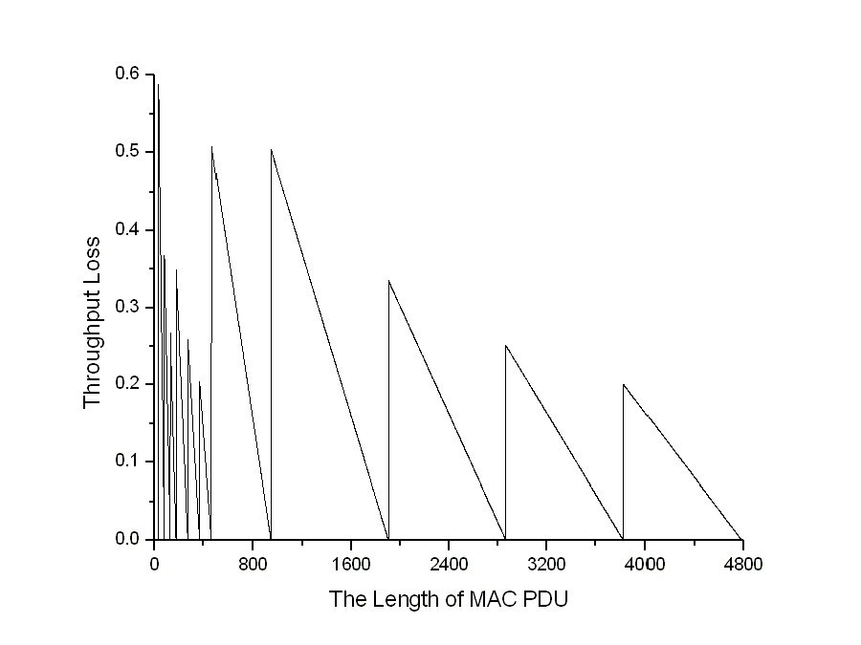
Fig. 1: Throughput loss corresponding to various length of MAC PDU ranging from 32 to 4784 bits.
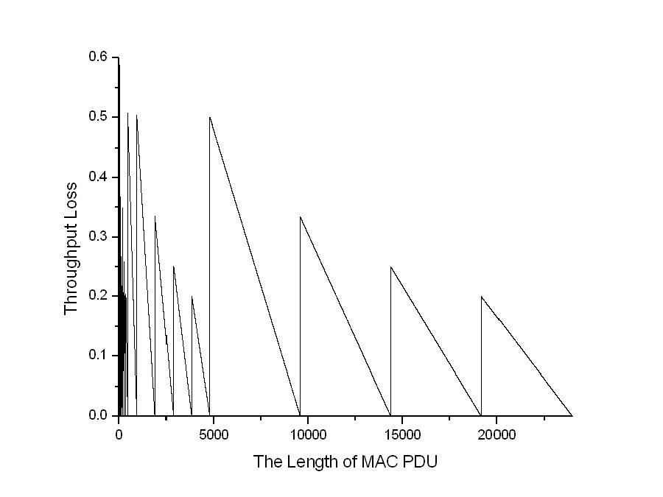
Fig. 2: Throughput loss corresponding to various length of MAC PDU ranging from 32 to 23984 bits.

Channel coding can be further improved. Contribution [7] indicates further 33% memory storage reduction with better error rate performance for the CTC with block length 960, 1920, 2880, 3840 and 4800 bits, which are allowed block lengths defined in IEEE P802.16 Draft 2007 [1]. Contribution [8] provides a coding scheme supporting flexible codeword length and this provide possibility to support flexible length of MAC PDU. Contribution [9] provides lower rate tail-biting convolutional code to render better performance for the FCH. Contribution [10] indicates that rate matching for channel coding is necessary to fit resource tile. There is still room for the enhancement of channel coding especially for the number of data block sizes, complexity and storage.

Conclusions
This contribution mentions the advantages of applying larger code block size for the stop-and-wait HARQ protocol to enhance per connection throughput. However, the number of data block sizes is not enough and it introduces throughput loss 16-17%. Furthermore the CTC performance of these defined data block size can be further improved with less decoder complexity, 33% extrinsic information storage [7]. When N_{EP,MAX} =4800 bits, the saved storage is equivalent to 10-29% HARQ downlink buffer size per channel [2]. Flexible data or code block size also avoids throughput loss. Other channel coding scheme also helps the performance improvement in FCH. We suggest early initiating channel coding discussion in case of catching following IMT-Advance submission procedure.

References

- IEEE Standard 802.16e-2005, Amendment to IEEE Standard for Local and Metropolitan Area Networks -6 Part 16: Air Interface for Fixed Broadband Wireless Access Systems- Physical and Medium Access Control 7 Layers for Combined Fixed and Mobile Operation in Licensed Bands.
- WiMAX ForumTM Mobile System Profile Release 1.0 Approved Specification, WiMAX, Certification Working Group, April 2007.
- IEEE C802.16m-08/118r4, "Proposed 802.16m Frame Structure Baseline Content Suitable for Use in the 802.16m SDD," March 2008.
- IEEE 802.16m-07/002r4, "IEEE 802.16m System Requirements," October, 2007.
- IEEE C802.16m-07/310r1, “Considerations on Channel Coding for ToC of IEEE 802.16m SDD,” LG, November 2007.
- 3GPP TS 36.212 v.8.2.0, “Multiplexing and Channel Coding,” March, 2008.
- IEEE C802.16m-07/293r1, “Reduce CTC decoder complexity and enhance error rate performance by the bit-level interleaving,” April 2008.
- IEEE C802.16m-08/074r1, “LDPC-Convolutional Codes for IEEE 802.16m FEC Scheme,” LG, January, 2008.
- IEEE C802.16m-07/216r1, “Better TBCC for FCH in 802.16m,” November 2007.
- IEEE C802.16m-08/123, “Recommendations for Downlink Data Subchannel and Pilot Format Design in IEEE 802.16m,” March 2008.

TEXT Proposal
==========================================================================
X.X H-ARQ
The set of data block length shall be large enough for HARQ to sustain higher throughput and improve throughput comparing with the WirelessMAN-OFDMA Reference System.

