Project | IEEE 802.16 Broadband Wireless Access Working Group <http://ieee802.org/16>
Title | Legacy preamble reuse methodology and its extension to wider bandwidth and multi-carrier scenarios
Date Submitted | 2008-05-05
Source(s) | ¹Zheng Yan-Xiu, Ren-Jr Chen, Fang-Ching Ren, Chang-Lan Tsai, Chung-Lien Ho, ²Richard Li, Yu-Tao Hsieh, ITRI  Wern-Ho Sheen, NCTU/ITRI  Zexian Li, Nokia,  Adrian Boariu, Shashikant Maheshwari, Nokia Siemens Networks  Yong Sun, Toshiba Research Europe Limited  Tsuguhide Aoki, Mobile Communication Laboratory, Corporate R&D Center, Toshiba Corporation  Yang-Han Lee, Yih-Guang Jan, Tamkang University (TKU)  Chun-Yen Hsu, Yoan-Tai Lee, III | Voice:  ¹+886-3-5914715  ²+886-3-5917596  E-mail:  ¹zhengyanxiu@itri.org.tw  ²richard929@itri.org.tw  *<http://standards.ieee.org/faqs/affiliationFAQ.html>
Re: | Call for Contributions on Project 802.16m System Description Document (SDD) issued on 2008-03-20 (IEEE 802.16m-08/016r1)  Topic: Preamble
Abstract | This contribution suggests adopting legacy preamble sequence as 802.16m preamble sequence. Reusing legacy preamble sequence for 802.16m saves at least 0.5% radio resource for the co-existence of the legacy and 802.16m system. It also avoids extra 802.16m preamble sequence detection circuit. Concatenating legacy preamble sequences on frequency domain further supports bandwidth scalability. If no extra and significant benefit comes from new preamble sequence and no further system design conflicts occur, reusing legacy preamble sequence should be our first consideration.
Purpose | For discussion and approval by IEEE 802.16m TG
Notice | This document does not represent the agreed views of the IEEE 802.16 Working Group or any of its subgroups. It represents only the views of the participants listed in the “Source(s)” field above. It is offered as a basis for discussion. It is not binding on the contributor(s), who reserve(s) the right to add, amend or withdraw material contained herein.
Release | The contributor grants a free, irrevocable license to the IEEE to incorporate material contained in this contribution, and any modifications thereof, in the creation of an IEEE Standards publication; to copyright in the IEEE’s name any IEEE Standards publication even though it may include portions of this contribution; and at the IEEE’s sole discretion to permit others to reproduce in whole or in part the resulting IEEE Standards publication. The contributor also acknowledges and accepts that this contribution may be made public by IEEE 802.16.
Patent Policy | The contributor is familiar with the IEEE-SA Patent Policy and Procedures:  <http://standards.ieee.org/guides/bylaws/sect6-7.html#6> and <http://standards.ieee.org/guides/opman/sect6.html#6.3>.  Further information is located at <http://standards.ieee.org/board/pat/pat-material.html> and <http://standards.ieee.org/board/pat>.
Legacy preamble reuse methodology and its extension to wider bandwidth and multi-carrier scenarios

Zheng Yan-Xiu, Ren-Jr Chen, Fang-Ching Ren, Chang-Lan Tsai, Chung-Lien Ho, Richard Li, Yu-Tao Hsieh,
ITRI
Wern-Ho Sheen,
NCTU/ITRI
Zexian Li,
Nokia
Adrian Boariu, Shashikant Maheshwari,
Nokia Siemens Networks
Yong Sun,
Toshiba Research Europe Limited
Tsuguhide Aoki
Mobile Communication Laboratory, Corporate R&D Center, Toshiba Corporation
Yang-Han Lee, Yih-Guang Jan
Tamkang University (TKU)
Chun-Yen Hsu, Yoan-Tai Lee
III

Introduction
Legacy preamble reuse for 802.16m saves redundant preamble and radio resource for the co-existence of legacy and 802.16m systems, and this concept has been presented in many contributions [1,2,3,4,5,6]. Concatenating multiple legacy preambles as a longer 802.16m preamble further supports bandwidth scaling and eliminates storage of long preamble sequence. When we consider aggregated 802.16e frame structure [6,7] which utilizes the guard band between adjacent 802.16e radio frames, 802.16e user can access through any partial preamble. Therefore reusing and concatenating preambles is naturally backward compatible without significant extra complexity. The advantages are summarized as follows:
  - At least 0.5% wastage of wireless radio resource can be saved as legacy and 802.16m systems apply identical preambles [1,2,3,6]
  - No performance degradation for handover due to less preambles per superframe especially for high mobility comparing to legacy systems [8,9,13,14]
  - No necessity of double preamble detection circuits, i.e. 802.16m and 802.16e share identical preamble detection circuit [1,6]
  - No extra storage for preamble extension in case of both widerband single carrier and multi-carrier frame structures [1,6]

Preamble and its location in 802.16m legacy support frame structure
Preamble starts from the beginning of each radio frame or super-frame as system identification. When each user enters the system, user recognizes preamble for cell search. The preamble is also capable of frequency estimation, time domain synchronization, channel estimation,…, etc. As handover occurs, user also has to detect preamble in searching other serving base stations.
802.16m-08/003r1 [11] states the legacy support frame structure “The legacy and 802.16m frames are offset by a fixed number of sub-frames to accommodate new features such as new synchronization channel (preamble),…” However, proposal of new preambles raises performance degradation concerns.

Handoff performance degradation and radio resource wastage due to unshared preamble concept
System requirement document [8] states
  - An IEEE 802.16m MS shall be able to operate with a legacy BS, at a level of performance equivalent to that of a legacy MS
  - Latency should be further reduced as compared to the WirelessMAN-OFDMA Reference System for all aspects of the system including the air link, state transition delay, access delay, and handover
  - IEEE 802.16m shall provide significantly improved coverage with respect to the WirelessMAN-OFDMA Reference System
Evaluation methodology document [9] states
  - Latency is a key metric to evaluate and compare various handover schemes as it has direct impact on application performance perceived by a user
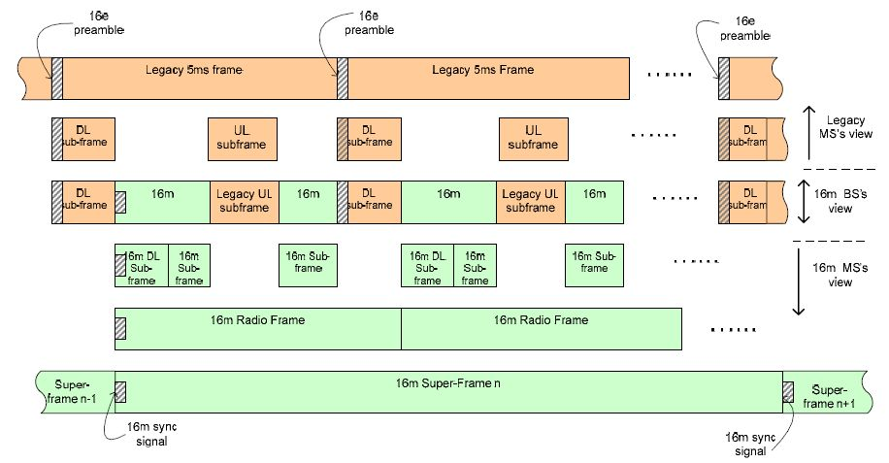
Figure 1: An example of separate preamble usage for legacy and 802.16m system.
Handover performance degrades if 802.16m system applies less preamble sequences and shorter preamble sequence in one super frame (20 ms). Fig. 1 shows that 802.16m allocates a preamble every four radio frames, the occurrence period of preamble sequence is larger than WirelessMAN-OFDMA Reference System [13,14]. Larger period enlarges the preamble acquisition time and the cell access latency increases. Therefore handover performance degrades and it violates the requirement in system requirement document [8]. Furthermore shorter 802.16m preamble shown in Fig. 1 either degrades preamble detection performance or necessitates larger transmitting power to retain preamble detection performance. 3GPP TS 36.212 [12] also states synchronization signal is placed every 5ms; the number is the same as the WirelessMAN-OFDMA Reference System [13,14]. Identical number of preamble per super-frame to the WirelessMAN-OFDMA Reference System seems necessary to 802.16m.
Introducing new peramble for 802.16m system leads higher resource wastage as both systems co-locate at identical RF carrier. Legacy system applies one preamble per radio frame and one radio frame consists of 48 OFDM symbols; 2% radio resource is used for legacy system. If 802.16m system places one preamble per super-frame, it occupies 0.5% radio resource by paying handover performance degradation; legacy and 802.16m preamble occupies 2.5% radio resource. If 802.16m system also applies four preambles per super-frame, legacy and 802.16m preambles occupy 4% radio resource. If preamble can not be shared for legacy and 802.16m systems, the redundant 802.16m preamble wastes 0.5-2% radio resource. As we consider 1Gbps system throughput, the redundant preamble is equivalent to 5-20Mbps system transmission rate per cell.
Applying legacy preamble retains handover performance without wasting radio resource. It also promises radio access delay not worse than 3GPP LTE [12].
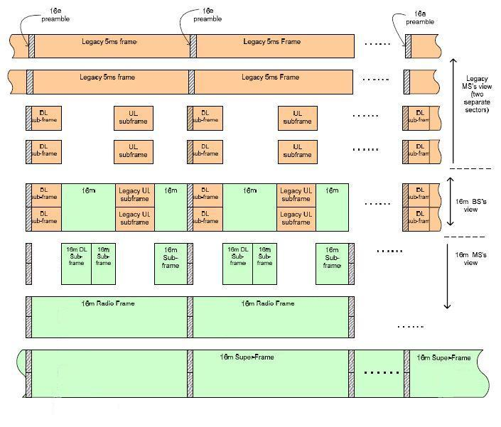
Figure 2: An example of shared preamble usage for both legacy and 802.16m with two RF carriers.

Flexible preamble extension for wider bandwidth and multi-carrier scenarios
Legacy preamble is also applicable for wider channel or multi-carrier scenarios. Fig. 2 illustrates an example of extended preamble occupying two RF carriers. Two legacy preambles are concatenated into a longer 802.16m preamble. Legacy user can access through upper or lower RF carrier. 802.16m user can access either through upper RF carrier or lower RF carrier or one wider carrier.
The extended preamble is sharable for both legacy and 802.16m systems and suits the frame structure applying guard band as radio resource [6,7]. Due to the concatenation concept, only a set of preamble for one FFT size has to be stored. The concatenation concept further supports flexible bandwidth scaling, e.g. 5 RF carriers. Contiguous band and multi-carriers are capable of using this preamble.

Conclusions
Reusing legacy preamble as 802.16m preamble reduces extra 0.5-2% system overhead for the co-existence of both legacy and 802.16m systems. The handover performance will not degrade comparing to the legacy system. Preamble extension concept further provides flexibility in constructing longer preamble to support widerband or multi-carrier scenarios. Longer preamble also promises better preamble detection performance and system coverage.

References
- IEEE C802.16m-08/113, “Legacy Preamble Sequence Reuse Methodology to Achieve Bandwidth Scalability and Avoid 802.16m Preamble Overhead,” ITRI, March, 2008.
- IEEE C802.16m-08/165r1, “DL Control Channel Structure for 16m,” Nokia Siemens Networks, March, 2008.
- IEEE C802.16m-08/180r1, “Dynamic Downlink Physical Resource Allocation for 802.16m and Legacy Users,” Toshiba, March, 2008.
- IEEE C802.16m-08/249, “Comments on Frame Structure Document C802.16m-08/118r1,” Ericsson, March, 2008.
- IEEE C802.16m-08/251, "Proposed Harmonization on IEEE 802.16m Frame Structure for Legacy Support," Nortel, March, 2008.
- IEEE C802.16m-08/021r2, “OFDMA Frame Structure with Scalable Bandwidth and High Mobility Support for IEEE 802.16m,” ITRI, January, 2008
- IEEE C802.16m-08/143r1, “Sub-carrier Alignment for IEEE 802.16m Multi-band Frame Structure,” Mediatek, March, 2008.
- IEEE 802.16m-07/002r4, "IEEE 802.16m System Requirements," October, 2007.
- IEEE 802.16m-08/004r1, "IEEE 802.16m Evaluation Methodology Document (EMD)," March, 2008.
- IEEE C802.16m-08/118r1, "Proposed 802.16m Frame Structure Baseline Content Suitable for Use in the 802.16m SDD," March, 2008.
- IEEE 802.16m-08/003r1, "Draft IEEE 802.16m System Description Document," April, 2008.
- 3GPP TS 36.211 v.8.2.0 , “Physical Channels and Modulation,” March, 2008.
- IEEE Standard 802.16e-2005, Amendment to IEEE Standard for Local and Metropolitan Area Networks -6 Part 16: Air Interface for Fixed Broadband Wireless Access Systems- Physical and Medium Access Control 7 Layers for Combined Fixed and Mobile Operation in Licensed Bands.
- WiMAX ForumTM Mobile System Profile Release 1.0 Approved Specification, WiMAX, Certification Working Group, April 2007.

TEXT Proposal
==========================================================================
11.X.2 Synchronization Channel (SCH)
Synchronization channel (e.g. preamble) is used for MS performing cell-search, handover, channel estimation, …etc. BS also applies synchronization channel as its identity or sector identity.
Synchronization channel shall be placed in the beginning of every radio frame.
802.16m system shall use legacy preamble in the synchronization channel for the co-existence of both legacy and 802.16m systems.
In order to support widerband and multi-carrier scenarios, longer 802.16m preamble sequence shall be constructed by concatenating multiple legacy preambles.

