Project | IEEE 802.16 Broadband Wireless Access Working Group <http://ieee802.org/16>
Title | HARQ Based ICI Cancellation for 802.16m
Date Submitted | 2008-05-05
Source(s) | Rong-Terng Juang, Chien-Yu Kao, Jen-Yuan Hsu, Yu-Tao Hsieh, Pang-An Ting, Richard Li  ITRI  Hsin-Piao Lin,  NTUT | Voice: + 886 3 5914854  E-mail: ythsieh@itri.org.tw
Re: | Call for Contributions of IEEE 802.16m_08/016r1 on the topic of “Hybrid ARQ”
Abstract | This contribution proposes a HARQ scheme to mitigate ICI effect introduced by Doppler shift and improve system performance in high mobility environment for 802.16m systems.
Purpose | Discussion and approval by the task group.
Notice | This document does not represent the agreed views of the IEEE 802.16 Working Group or any of its subgroups. It represents only the views of the participants listed in the “Source(s)” field above. It is offered as a basis for discussion. It is not binding on the contributor(s), who reserve(s) the right to add, amend or withdraw material contained herein.
Release | The contributor grants a free, irrevocable license to the IEEE to incorporate material contained in this contribution, and any modifications thereof, in the creation of an IEEE Standards publication; to copyright in the IEEE’s name any IEEE Standards publication even though it may include portions of this contribution; and at the IEEE’s sole discretion to permit others to reproduce in whole or in part the resulting IEEE Standards publication. The contributor also acknowledges and accepts that this contribution may be made public by IEEE 802.16.
Patent Policy | The contributor is familiar with the IEEE-SA Patent Policy and Procedures:  <http://standards.ieee.org/guides/bylaws/sect6-7.html#6> and <http://standards.ieee.org/guides/opman/sect6.html#6.3>.  Further information is located at <http://standards.ieee.org/board/pat/pat-material.html> and <http://standards.ieee.org/board/pat>.
HARQ Based ICI Cancellation for 802.16m
Rong-Terng Juang, Chien-Yu Kao, Jen-Yuan Hsu, Yu-Tao Hsieh, Pang-An Ting, Richard Li
ITRI
Hsin-Piao Lin
NTUT

Introduction
OFDM is sensitive to carrier frequency offset. The loss of orthogonality among subcarriers causes intercarrier interference (ICI) in OFDM system and results in performance degradation. The 802.16m system requirements [1] cover the performance demand for subscriber stations at high mobility up to 350km/hr. At such high mobility, the ICI caused by Doppler spread is severe and greatly reduce throughput for link with high signal to noise power ratio.
There are many methods to reduce the ICI effect. Either use a high-complexity equalizer [2] or design a modulation scheme with the mechanism of ICI self cancellation [3]. The deficiency of the former is high complexity for ICI reduction while the deficiency of the latter is only half data efficiency remained. In the contribution, we want to design a pilot scheme for channel estimation to reduce the ICI effect without additional complexity. After getting the near ICI-free channel estimation with the proposed pilot scheme, we eliminate the ICI on data sub-carriers with successive ICI cancellation (SIC) [4]. In SIC, we need to detect data symbols and then feedback decision for the ICI cancellation. Rather than using a complex equalizer, we apply a one-tap equalizer and hard decision for data decision feedback to prevent from large number of computation in the coefficients of equalizers. For ordering of SIC, we do not need complicated ordering skills. Instead, we cancel the ICI caused by pilot sub-carriers first and then cancel the ICI caused by data sub-carriers successively by the order from the sub-carriers near pilots to those far away from pilots. In addition, we cancel the ICI with linear ICI channel model, i.e. assuming the channel variation is linear to further reduce the canceling computational complexity. Overall, the ICI cancellation can be implemented with very low complexity.
In [3], two adjacent sub-carriers are modulated to be an anti-polar pair. This document proposes a HARQ scheme for 802.16m systems to mitigate the ICI effects. An ICI cancellation coding scheme is applied to retransmitted packets by permuting symbols on adjacent subcarriers in antipodal pairs. By using the proposed HARQ scheme, high-level modulation and coding schemes can be feasible under velocities up to 350 km/hr for higher data throughput.

Proposed HARQ Based ICI Cancellation
This contribution proposes a HARQ based ICI cancellation for 802.16m in high-mobility environments. The mobility information can be obtained via many methods, such as GPS or estimation based on RSSI or CINR. For example, the MS measures CINR by the common pilots broadcasted by the BS periodically. Then, the velocity information may be estimated roughly via the variation of CINR by the MS. In case high velocity is detected, the MS feedbacks the request of the high-mobility HARQ scheme to the BS. Figure 1 displays the flow chart of the proposed HARQ retransmission scheme. A packet is first appended with the cyclic redundancy check (CRC) code, which is used for error detection. Based on the CRC decoding, if the receiver decodes the packet correctly, then the receiver sends an acknowledgement (ACK) to the transmitter as a delivery confirmation signal indicating a correct reception, otherwise the receiver sends a negative acknowledgement (NACK) and request an additional retransmission to provide the receiver a successful packet reception. Conventional HARQ scheme combines the received copies of the same packet by using maximal-ratio combining (MRC) scheme, which achieves the maximum signal-to-noise power ratio. To mitigate the ICI effects, the proposed HARQ scheme permutes the retransmitted packets according the rule shown in Table 1, where$X_{m}=−X_{m+1}$for $m=0,2,4,⋯,N−2$. By combining the signals on the adjacent subcarriers, ${\hat{Y}}_{m}={\hat{Y}}_{m}−{\hat{Y}}_{m+1}$, the major ICI erect can be reduced. To compensate the rate loss, the proposed HARQ scheme uses two antennas. Table 2 shows the permutation rule for the proposed scheme.

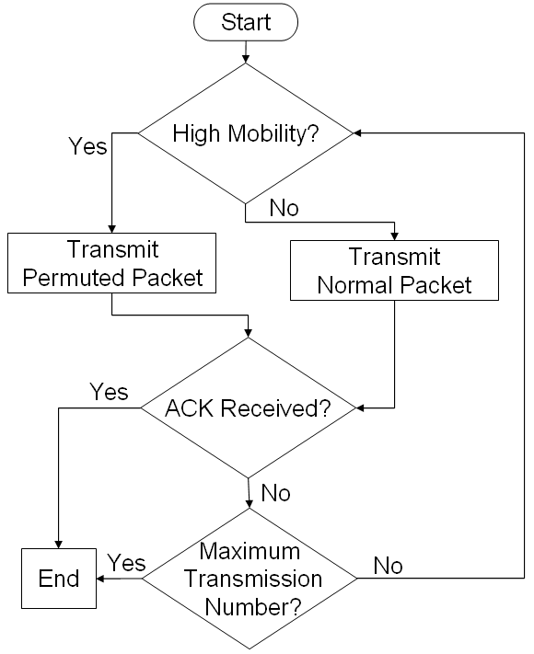
Figure 1. Flow chart of proposed HARQ scheme

Table 1. Packet Permutation Rule for the Proposed HARQ Scheme
 | f₀ | f₁ | f₂ | f₃ | … | f_{N-2} | f_{N-1}
Original packet | X₀ | $$−X_{0}$$ | X₁ | $$−X_{1}$$ | … |  | $$−X_{\frac{N}{2}−1}$$
Original packet | $$X_{\frac{N}{2}}$$ | $$−X_{\frac{N}{2}}$$ | $$X_{\frac{N}{2}+1}$$ | $$−X_{\frac{N}{2}+1}$$ | … |  | $$−X_{N−1}$$
1st Retransmitted packet | X₀ | $$−X_{0}$$ | X₁ | $$−X_{1}$$ | … |  | $$−X_{\frac{N}{2}−1}$$
1st Retransmitted packet | $$X_{\frac{N}{2}}$$ | $$−X_{\frac{N}{2}}$$ | $$X_{\frac{N}{2}+1}$$ | $$−X_{\frac{N}{2}+1}$$ | … |  | $$−X_{N−1}$$
2nd Retransmitted packet | X₀ | $$−X_{0}$$ | X₁ | $$−X_{1}$$ | … |  | $$−X_{\frac{N}{2}−1}$$
2nd Retransmitted packet | $$X_{\frac{N}{2}}$$ | $$−X_{\frac{N}{2}}$$ | $$X_{\frac{N}{2}+1}$$ | $$−X_{\frac{N}{2}+1}$$ | … |  | $$−X_{N−1}$$

Table 2. Packet Permutation Rule for the Proposed HARQ Scheme with two Antennas
 |  | f₀ | f₁ | f₂ | f₃ | … | f_{N-2} | f_{N-1}
Antenna 1 | Original packet | X₀ | $$−X_{0}$$ | X₁ | $$−X_{1}$$ | … |  | $$−X_{\frac{N}{2}−1}$$
Antenna 1 | 1st Retransmitted packet | X₀ | $$−X_{0}$$ | X₁ | $$−X_{1}$$ | … |  | $$−X_{\frac{N}{2}−1}$$
Antenna 1 | 2nd Retransmitted packet | X₀ | $$−X_{0}$$ | X₁ | $$−X_{1}$$ | … |  | $$−X_{\frac{N}{2}−1}$$
Antenna 2 | Original packet | $$X_{\frac{N}{2}}$$ | $$−X_{\frac{N}{2}}$$ | $$X_{\frac{N}{2}+1}$$ | $$−X_{\frac{N}{2}+1}$$ | … |  | $$−X_{N−1}$$
Antenna 2 | 1st Retransmitted packet | $$X_{\frac{N}{2}}$$ | $$−X_{\frac{N}{2}}$$ | $$X_{\frac{N}{2}+1}$$ | $$−X_{\frac{N}{2}+1}$$ | … |  | $$−X_{N−1}$$
Antenna 2 | 2nd Retransmitted packet | $$X_{\frac{N}{2}}$$ | $$−X_{\frac{N}{2}}$$ | $$X_{\frac{N}{2}+1}$$ | $$−X_{\frac{N}{2}+1}$$ | … |  | $$−X_{N−1}$$

Proposed Text
------------------------------------------------------- Start of the proposed text ------------------------------------------------
11.x Physical layer
11.x.y Hybrid ARQ
HARQ scheme with ICI cancellation can be considered for 802.16m systems. The proposed permutation rule of retransmitted packet is shown in the Tables.

------------------------------------------------------- End of the proposed text ------------------------------------------------

References
[1] IEEE C802.16m-07/296r1
[2] X. Cai and G. B. Giannakis, “Bounding performance and suppressing intercarrier interference in wireless mobile OFDM,” IEEE Transactions on Communications, vol. 51, no. 12, pp. 2047-2056, Dec. 2003
[3] Y. Zhao and S. G. Haggman, “Intercarrier interference self-cancellation scheme for OFDM mobile communication systems,” IEEE Transactions on Communications, vol. 49, no. 7, pp. 1185-1191, July 2001
[4] Y.S. Choi, P. J. Voltz, and F. A. Cassara, “On channel estimation and detection for multicarrier signals in fast and selective Rayleigh fading channels,” IEEE Transaction on Communications, vol. 49, pp. 1375-1387, Aug. 2001.

