Project | IEEE 802.16 Broadband Wireless Access Working Group <http://ieee802.org/16>
Title | Joint design with DL MIMO and channel coding for 802.16m
Date Submitted | 2008-05-05
Source(s) | Chien-Yu Kao, Jen-Yuan Hsu, Yu-Tao Hsieh, Pang-An Ting, Richard Li  ITRI  Wen-Rong Wu  NCTU | Voice: +886-3-5914854  E-mail: ythsieh@itri.org.tw
Re: | Call for Contributions of IEEE 802.16m_08/016 on the topic of DL MIMO schemes
Abstract | A tone-level coding-modulation scheme to improve performance for MIMO system.
Purpose | Discussion and approval by the task group.
Notice | This document does not represent the agreed views of the IEEE 802.16 Working Group or any of its subgroups. It represents only the views of the participants listed in the “Source(s)” field above. It is offered as a basis for discussion. It is not binding on the contributor(s), who reserve(s) the right to add, amend or withdraw material contained herein.
Release | The contributor grants a free, irrevocable license to the IEEE to incorporate material contained in this contribution, and any modifications thereof, in the creation of an IEEE Standards publication; to copyright in the IEEE’s name any IEEE Standards publication even though it may include portions of this contribution; and at the IEEE’s sole discretion to permit others to reproduce in whole or in part the resulting IEEE Standards publication. The contributor also acknowledges and accepts that this contribution may be made public by IEEE 802.16.
Patent Policy | The contributor is familiar with the IEEE-SA Patent Policy and Procedures:  <http://standards.ieee.org/guides/bylaws/sect6-7.html#6> and <http://standards.ieee.org/guides/opman/sect6.html#6.3>.  Further information is located at <http://standards.ieee.org/board/pat/pat-material.html> and <http://standards.ieee.org/board/pat>.
Joint Design with DL MIMO and Channel Coding for 802.16m

Chien-Yu Kao, Jen-Yuan Hsu, Yu-Tao Hsieh, Pang-An Ting, Richard Li
ITRI
Wen-Rong Wu
NCTU

Introduction

The coding method used as the mandatory scheme in 802.16e [1] system requirements will be the tail-biting
convolutional encoding, and the optional modes of encoding including block turbo coding (BTC) and
convolutional turbo codes (CTCs) shall be also supported. After coding process, the coded bits will be inserted
into a interleaver to reduce burst error problem of channel condition. And then the interleaved coded bits will be
inserted into modulator. These processes are called as the traditional bit interleaved coded modulation (BICM).
This coding-modulation scheme has a bit-level trellis relationship for MS to do decoding. Therefore, it’s observations is the interleaved bits. Now, consider another scenario that if interleaving is conducted with a block base, where the block size is the number of symbols transmitted in one short (via. all antennas). The block based interleaving process is like as the STC zone allocation in 802.16e.The coded bits are sequentially mapped to the QAM symbols and transmitted via all antennas. In this case, there is strong dependency between the QAM transmitted symbols. In other words, the transmitted symbol posses a trellis structure and bits can be directly solved through the structure without a demapper in MS. In this case, the observations of the trellis are changed to be the received symbols themselves. The overall block diagrams for BS are showed as followed. Figure 1 shows the block diagram of traditional BICM design for 802.16e system. Figure 2 shows the outer with our proposal (TICM) for
802.16m MIMO system.

Proposed tone interleaved coded modulation for STC zone with matrix B
Figure 3 shows the trellis relationship of CC/CTCs encoder in 802.16e. In contrast with Figure 3, Figure 4 illustrates the proposed trellis relationship of tone interleaved coded modulation. In this proposal, the consecutive bit-level trellis will be jointed as a tone-level trellis for all transmitted antenna. Take QPSK 1/2 2x2 Matrix B as an example, the coded bits of the first bit-level coding stage are allocated to the first antenna and the coded bits of the second bit-level coding stage are allocated to the second antenna. And then joint this two consecutive bit-level trellis as a tone-level trellis. In MS decoder, we can decode bits without a demapper to calculate branch metric (BM) in coded bit. Maybe branch metric can be calculated in MIMO detector for decoder.

Simulation Results
In the contribution, simulation results for MIMO 2x2 with Matrix B are present. In the simulations, we compare the BER performances of our proposal with coding-modulation scheme in 802.16e. The simulation parameters are set as in Table 1.
Table1 Simulation Setting
Carrier frequency | 2.5GHz
FFT size (N) | 1024
Guard Interval | 1/8
Permutation | PUSC
MS velocity | 0 km/hr
Channel Coding | CTCs
FEC Block size | QPSK 1/2 : 10 slots  16QAM 1/2 : 3 slots  64QAM 1/2 : 2 slots
STC zone | 2x2 Matrix B

Figure 5 shows the BER comparison among the three MCS schemes under a velocity of 0 km/hr. If take BER
of 10⁻⁵ as the goal BER, our proposal TICM has 2.5 dB in QPSK 1/2, 4 dB in 16QAM 1/2 and 5.5 dB in
64QAM 1/2 improvement compared with original scheme BICM in 802.16e.
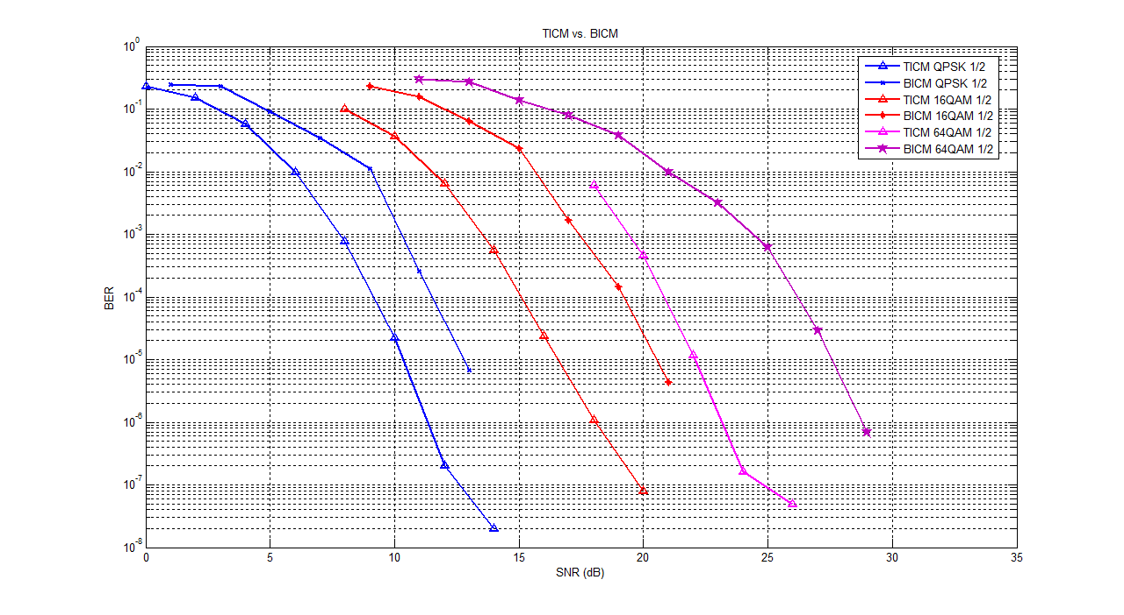
Figure 5. BER comparison between TICM and BICM scheme.

Proposed SDD Text
[Chapter] Physical Layer
………
[Section] 11.x Downlink MIMO
………
[Subsection] 11.x.y Tone Interleaved Coded Modulation (TICM)

TICM is a joint design with DL MIMO and channel coding. Fig. X gives an example of TICM
transmitter and receiver.

Figure X. An example of TICM transmitter and receiver.

Reference
[1] IEEE802[1].16e_Rev2_D3

