Project | IEEE 802.16 Broadband Wireless Access Working Group <http://ieee802.org/16>
Title | Joint design with DL MIMO and channel coding for 802.16m
Date Submitted | 2008-05-09
Source(s) | Chien-Yu Kao, Jen-Yuan Hsu, Yu-Tao Hsieh, Pang-An Ting, Richard Li  ITRI  Wen-Rong Wu  NCTU  Pei-Kai Liao, Chih-Yuan Lin, Ciou-Ping Wu, Paul Cheng  MediaTek Inc. | Voice: +886-3-5914854  E-mail: ythsieh@itri.org.tw, pk.liao@mediatek.com
Re: | Call for Contributions of IEEE 802.16m_08/016 on the topic of DL MIMO schemes
Abstract | A tone-level coding-modulation scheme to improve performance for MIMO system.
Purpose | Discussion and approval by the task group.
Notice | This document does not represent the agreed views of the IEEE 802.16 Working Group or any of its subgroups. It represents only the views of the participants listed in the “Source(s)” field above. It is offered as a basis for discussion. It is not binding on the contributor(s), who reserve(s) the right to add, amend or withdraw material contained herein.
Release | The contributor grants a free, irrevocable license to the IEEE to incorporate material contained in this contribution, and any modifications thereof, in the creation of an IEEE Standards publication; to copyright in the IEEE’s name any IEEE Standards publication even though it may include portions of this contribution; and at the IEEE’s sole discretion to permit others to reproduce in whole or in part the resulting IEEE Standards publication. The contributor also acknowledges and accepts that this contribution may be made public by IEEE 802.16.
Patent Policy | The contributor is familiar with the IEEE-SA Patent Policy and Procedures:  <http://standards.ieee.org/guides/bylaws/sect6-7.html#6> and <http://standards.ieee.org/guides/opman/sect6.html#6.3>.  Further information is located at <http://standards.ieee.org/board/pat/pat-material.html> and <http://standards.ieee.org/board/pat>.
Joint Design with DL MIMO and Channel Coding for 802.16m

Chien-Yu Kao, Jen-Yuan Hsu, Yu-Tao Hsieh, Pang-An Ting, Richard Li
ITRI
Wen-Rong Wu
NCTU
Pei-Kai Liao, Chih-Yuan Lin, Ciou-Ping Wu, Paul Cheng
MediaTek Inc.

Introduction
The coding method used as the mandatory scheme in 802.16e [1] system will be the tail-biting convolutional encoding, and the optional modes of encoding including block turbo coding (BTC) and convolutional turbo codes (CTCs) shall be also supported. After these encoding processes, the coded bits will be inserted into the interleaver and the modulator orderly. These processes are called as the traditional bit-interleaved-coded-modulation (BICM). In contrast with traditional BICM scheme, we propose a tone-level interleaver after the modulator not before the modulator in this contribution. This proposed scheme considers the relationship of multiple bit-level trellis stages in traditional BICM scheme into a tone-level trellis stage to improve system
performance.

Comparison between BICM in 802.16e [1] and our proposal
In BICM scheme, the interleaver is performed in coded bits. But our proposed interleaver is performed in a
block base, where the block size is the number of symbols transmitted in one short (via. all antennas). The block based interleaver is like as the STC zone allocation in [1]. But a little difference is that we can interleave these tones via a tone-interleaver to change the position of per tone. In this case, there is strong dependency between the QAM transmitted symbols via all antennas. In other words, the transmitted symbol posses a trellis structure and bits can be directly solved through the structure without a demapper in MS. The observations of the trellis in decoder are already changed to consider the received symbols themselves. Figure 1
illustrates the tone-interleaver based STC zone allocation.

Additionally, Figure 2 and Figure 3 show the difference between BICM scheme in 802.16e [1] and our
proposal “tone interleaved coded modulation (TICM) scheme.” The main differences are the output bits of CTCs, the used interleaver and the position of interleaver. The output bits for CTCs in BICM scheme are A, B, Y1, Y2, W1, W2. But in our proposal, only A, B after CTCs interleaver specified in [1], Y1, Y2 are considered. And the bit separation, subblock-interleaver, bit grouping and bit selection specified in
[1] before the modulator are replaced with tone interleaver based STC zone allocation after the modulator in our proposal.

Proposed trellis diagram with our proposal (TICM)
Figure 4 shows the trellis relationship of CC/CTCs encoder in [1]. In contrast with Figure 4, Figure 5 illustrates the proposed trellis relationship of tone interleaved coded modulation. In this proposal, the consecutive bit-level trellis will be grouped as a tone-level trellis for all transmitted antenna. Take QPSK 1/2 2x2 Matrix B as an example, the coded bits of the first bit-level coding stage are allocated to the first antenna and the coded bits of the second bit-level coding stage are allocated to the second antenna. And then group this two consecutive bit-level trellis as a tone-level trellis. In MS decoder, we can decode bits without a demapper to calculate branch metric (BM) in coded bit. Maybe branch metric can be calculated in MIMO detector for decoder.

Simulation Results
In the contribution, simulation results for MIMO 2x2 with Matrix B are present. In the simulations, we compare the BER performances of our proposal with coding-modulation scheme in [1]. The simulation parameters are set as in Table 1.
Table1 Simulation Setting
Carrier frequency | 2.5GHz
FFT size (N) | 1024
Guard Interval | 1/8
Permutation | PUSC
MS velocity | 0 km/hr
Channel Coding | CTCs
FEC Block size | QPSK 1/2 : 10 slots  16QAM 1/2 : 3 slots  64QAM 1/2 : 2 slots
STC zone | 2x2 Matrix B
Reference | BICM-HSD (near ML)  (Hard-output Sphere Decoder)

Figure 6 shows the BER comparison among the three MCS schemes under a velocity of 0 km/hr. If take BER
of 10⁻⁵ as the goal BER, our proposal TICM has improvement of 2.5 dB in QPSK 1/2, 4 dB in 16QAM 1/2 and
5.5 dB in 64QAM 1/2.
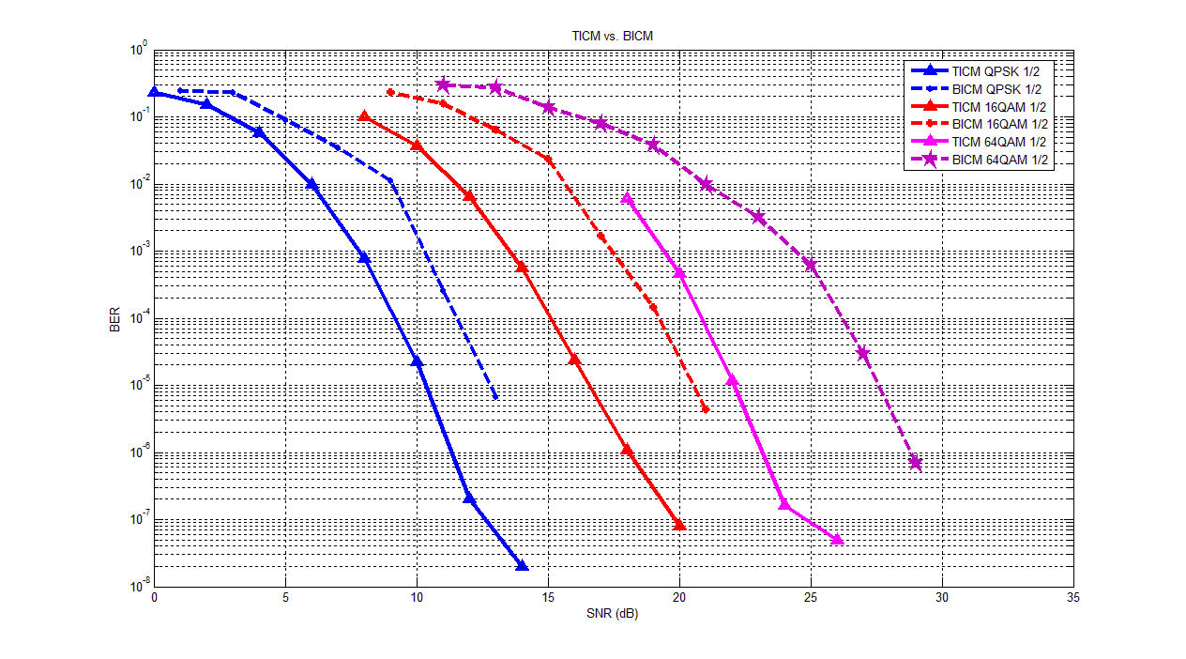
Figure 6. BER comparison between TICM and BICM scheme.

Proposed SDD Text

============== Start of proposed texts =================================================
[Chapter] 11 Physical Layer
………
[Section] 11.x Downlink MIMO
………
[Subsection] 11.x.y Tone Interleaved Coded Modulation (TICM)

TICM is a joint design with DL MIMO and channel coding. The STC zone allocation is regarded as a tone
interleaver after the modulator. And the transmit signals in the same sub-carrier via all antennas are grouped as a tone-level trellis stage for decoder. Fig. XX gives an example of TICM transmitter and Fig. YY gives an
example of TICM receiver.

============== End of proposed texts ================================================

Reference
[1] IEEE802[1].16e_Rev2_D3

