Project | IEEE 802.16 Broadband Wireless Access Working Group <http://ieee802.org/16>
Title | Joint design with DL MIMO and channel coding for 802.16m
Date Submitted | 2008-05-13
Source(s) | Chien-Yu Kao, Jen-Yuan Hsu, Yu-Tao Hsieh, Pang-An Ting, Richard Li  ITRI  Wen-Rong Wu  NCTU  Pei-Kai Liao, Chih-Yuan Lin, Ciou-Ping Wu, Paul Cheng  MediaTek Inc. | Voice: +886-3-5914854  E-mail: ythsieh@itri.org.tw, pk.liao@mediatek.com
Re: | Call for Contributions of IEEE 802.16m_08/016 on the topic of DL MIMO schemes
Abstract | A tone-level coding-modulation scheme to improve performance for MIMO system.
Purpose | Discussion and approval by the task group.
Notice | This document does not represent the agreed views of the IEEE 802.16 Working Group or any of its subgroups. It represents only the views of the participants listed in the “Source(s)” field above. It is offered as a basis for discussion. It is not binding on the contributor(s), who reserve(s) the right to add, amend or withdraw material contained herein.
Release | The contributor grants a free, irrevocable license to the IEEE to incorporate material contained in this contribution, and any modifications thereof, in the creation of an IEEE Standards publication; to copyright in the IEEE’s name any IEEE Standards publication even though it may include portions of this contribution; and at the IEEE’s sole discretion to permit others to reproduce in whole or in part the resulting IEEE Standards publication. The contributor also acknowledges and accepts that this contribution may be made public by IEEE 802.16.
Patent Policy | The contributor is familiar with the IEEE-SA Patent Policy and Procedures:  <http://standards.ieee.org/guides/bylaws/sect6-7.html#6> and <http://standards.ieee.org/guides/opman/sect6.html#6.3>.  Further information is located at <http://standards.ieee.org/board/pat/pat-material.html> and <http://standards.ieee.org/board/pat>.
Joint Design with DL MIMO and Channel Coding for 802.16m

Chien-Yu Kao, Jen-Yuan Hsu, Yu-Tao Hsieh, Pang-An Ting, Richard Li
ITRI
Wen-Rong Wu
NCTU
Pei-Kai Liao, Chih-Yuan Lin, Ciou-Ping Wu, Paul Cheng
MediaTek Inc.

Introduction
The coding method used as the mandatory scheme in 802.16e [1] system will be the tail-biting convolutional encoding, and the optional modes of encoding including block turbo coding (BTC) and convolutional turbo codes (CTCs) shall be also supported. After these encoding processes, the coded bits should be inserted into the interleaver and the QAM mapper orderly. These processes are so called the bit-interleaved-coded-modulation (BICM). In contrast with conventional BICM scheme, we propose a tone-level interleaver after the QAM mapper, not before the QAM mapper in the contribution. The proposed scheme considers the relationship of transforming multiple bit-level trellis stages in the BICM scheme into a tone-level trellis stage to improve system performance.

Comparison between BICM in 802.16e [1] and the proposed TICM
In BICM scheme, the interleaver is performed in the coded bits. But the proposed interleaver is performed in a block, where the block size is the number of symbols transmitted simultaneously through all antennas. The block based interleaver is like as the STC zone allocation in [1]. But a little difference is that we can interleave these tones via a tone-interleaver to change the position for each tone. In this case, there is strong dependency between the QAM transmitted symbols among all antennas. In other words, the transmitted symbol posses a trellis structure and the corresponding bits can be directly solved through the structure without a demapper in mobile station. In the proposed TICM scheme, we observe that the trellis structure in the decoder is already changed to consider the received symbols among all antennas.

Additionally, Figure 1 and Figure 2 show the block diagram of BICM scheme in [1] and the proposed “tone interleaved coded modulation (TICM) scheme”, respectively. The main differences are the output bits of CTCs, the used interleaver and the position where interleaver locates. The output bits of CTCs in the BICM scheme are A, B, Y1, Y2, W1, W2. But in this proposal, only A, permuted B after CTCs interleaver, Y1 and Y2 are considered. Most importantly, the original modules such as the bit separation, subblock-interleaver, bit grouping and bit selection specified in [1] before the QAM mapper are replaced with tone interleaver based STC zone allocation which locates after the QAM mapper as shown in Figure 2.

Proposed trellis diagram for TICM scheme
Figure 3 shows the trellis relationship of CC/CTCs encoder in [1]. In contrast with Figure 3, Figure 4 illustrates the proposed trellis structure of tone interleaved coded modulation. In the proposal, the consecutive bit-level trellis should be grouped as a tone-level trellis for all transmitted antenna. Take QPSK 1/2 2x2 Matrix B as an example, the coded bits of the first bit-level coding stage are allocated to the first antenna and the coded bits of the second bit-level coding stage are allocated to the second antenna. And then group these two consecutive bit-level trellises as a tone-level trellis. In the decoder of mobile station, we can decode bits without a demapper to calculate branch metric (BM) based on the coded bits. The branch metric may be calculated in a MIMO detector for purpose of outputting soft information.

Simulation Results
The simulation results for MIMO 2x2 with Matrix B are present here. In the simulations, we compare the BER performances between the BICM scheme in [1] and the proposed TICM scheme. The simulation parameters are set as in Table 1.
Table1 Simulation Setting
Carrier frequency | 2.5GHz
FFT size (N) | 1024
Guard Interval | 1/8
Permutation | PUSC
MS velocity | 0 km/hr
Channel Coding | CTCs
FEC Block size | QPSK 1/2 : 10 slots  16QAM 1/2 : 3 slots  64QAM 1/2 : 2 slots
STC zone | 2x2 Matrix B
Reference | BICM-HSD (near ML)  (Hard-output Sphere Decoder)

Figure 5 shows the BER comparison among the three MCS schemes under a velocity of 0 km/hr. If we take BER of 10⁻⁵ as the target BER, the proposed TICM has performance gains of 2.5 dB in QPSK 1/2, 4 dB in 16QAM 1/2 and 5.5 dB in 64QAM 1/2, respectively.
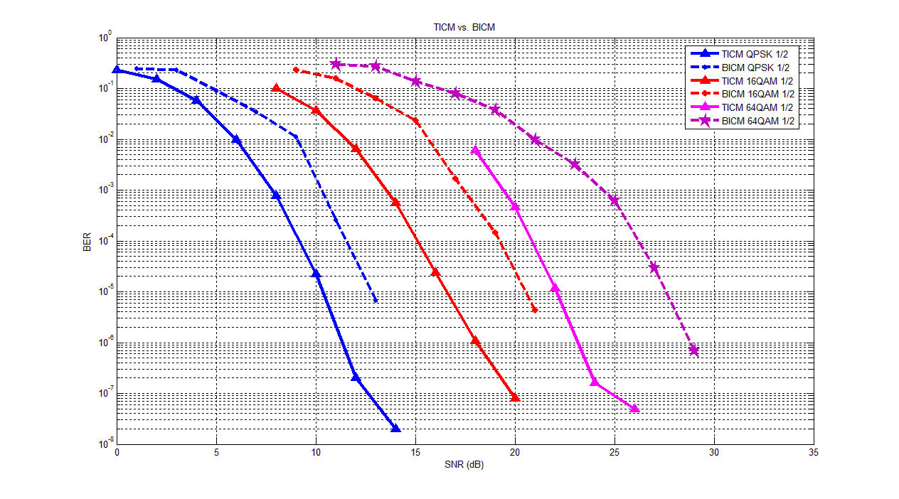
Figure 5. BER comparison between TICM and BICM scheme.

Proposed SDD Text

============== Start of proposed texts =================================================
[Chapter] 11 Physical Layer
………
[Section] 11.x Downlink MIMO
………
[Subsection] 11.x.y Tone Interleaved Coded Modulation (TICM)

A joint design of DL MIMO and channel coding, TICM, should be taken into consideration. The conventional tone allocation used in STC zone specified in [1] can be regarded as a tone interleaver after the QAM mapper. And the transmit signals in the same sub-carrier throughput all antennas are grouped as a tone-level trellis structure for decoding process. Fig. XX gives an example of TICM transmitter and Fig. YY gives an example of TICM receiver.

============== End of proposed texts ================================================

Reference
[1] IEEE802[1].16e_Rev2_D3

