Project | IEEE 802.16 Broadband Wireless Access Working Group <http://ieee802.org/16>
Title | PHY Abstraction for MIMO H-ARQA New HARQ Scheme for DL MIMO
Date Submitted | 2008-05-05
Source(s) | Cheng-Ming Chen, Jen-Yuan Hsu,  Jia-Hao Wu, Yu-Tao Hsieh,  Pang-An Ting, Richard Li,  ITRI | Voice: +886-3-5914854  E-mail: ythsieh@itri.org.tw
Re: | Call for Contributions of IEEE 802.16m_08/016r1 on the topic of “Hybrid ARQ”
Abstract | This contribution proposes a HARQ scheme for DL MIMO
Purpose | Discussion and approval by the task group.
Notice | This document does not represent the agreed views of the IEEE 802.16 Working Group or any of its subgroups. It represents only the views of the participants listed in the “Source(s)” field above. It is offered as a basis for discussion. It is not binding on the contributor(s), who reserve(s) the right to add, amend or withdraw material contained herein.
Release | The contributor grants a free, irrevocable license to the IEEE to incorporate material contained in this contribution, and any modifications thereof, in the creation of an IEEE Standards publication; to copyright in the IEEE’s name any IEEE Standards publication even though it may include portions of this contribution; and at the IEEE’s sole discretion to permit others to reproduce in whole or in part the resulting IEEE Standards publication. The contributor also acknowledges and accepts that this contribution may be made public by IEEE 802.16.
Patent Policy | The contributor is familiar with the IEEE-SA Patent Policy and Procedures:  <http://standards.ieee.org/guides/bylaws/sect6-7.html#6> and <http://standards.ieee.org/guides/opman/sect6.html#6.3>.  Further information is located at <http://standards.ieee.org/board/pat/pat-material.html> and <http://standards.ieee.org/board/pat>.
A New HARQ Scheme for DL MIMO

Cheng-Ming Chen, Jen-Yuan Hsu, Jia-Hao Wu, Yu-Tao Hsieh,
Pang-An Ting, Richard Li

ITRI

Introduction

For MIMO system with H-ARQ, the received signal can be combined before or after detectors. To combine the signal after detectors, bit-level combine is a straightforward method extended from SISO H-ARQ. Unfortunately, it’s hard for a MIMO detector to get soft bits, unless List Symbol Candidates are obtained for calculation of the LLR soft bits. Another approach is to combine the signals before MIMO detectors and do symbol combining.
In [1], it is suggested to concatenating the received channels and received signals to obtain an equivalent higher receiver number MIMO system by retransmit the same Spatial Multiplexing Signal again. This contribution describes another approach, how the MIMO CC HARQ can be done with STTD retransmission of partial signals and combine in symbol-level.

Proposed Symbol-Level Combining before MIMO Equalization
The received signal model at the original transmission for MIMO is:
,

where
is the received signal for the 0-th transmission
is the MIMO channel for the 0-th transmission,
is the transmit signal for the 0-th transmission,
is the noise plus interference vector for the 0-th transmission.
The System Block Diagram is shown as follows:

Figure 1. Original Transmission Block Diagram

In the H-ARQ scheme, we suggest the retransmission with STTD (Matrix A) for easily gaining of diversity without complexity increasing in receiver. Using STTD retransmission, the spectrum efficiency will degrade, but we do not intend to retransmit whole information, we retransmit just partial part of original signal. For example, if the original transmit signal is
,
where t and m of stands for t-th transmission and m-th constellation signal, respectively. The re-transmitted signal during two consecutive OFDMA symbols is:
in symbol 0:
,
and in symbol 1:
.
The corresponding retransmission block diagram is as follows:
Figure 2. First Retransmission Diagram

With this arrangement, the overall spectrum efficiency is the same as retransmission of the signal again. By using STTD Equalizer, we can obtain hard symbol decision of . To eliminate the interference of from , we obtain a degenerate SIMO system of signal .
.
where t and c of stand for t-th transmission and c-th column of , respectively. After SIMO Maximum Ratio Combining, we obtain hard symbol decision of , this time, we eliminate the interference of from , the degenerated SIMO system of signal is obtained. will be obtained in this degenerated SIMO system, and its soft value can be Chase-Combined with before De-mapper. The overall block diagram is shown below:
Figure 3. Symbol-Level Combining with our proposed scheme

Without complex non-linear detectors such as Sphere Decoding, we obtain with diversity 2 and with diversity 6. With the degenerated SIMO system, we can obtain the soft information of after MRC and soft De-mapper. The soft information of is also available after STTD Equalizer, MRC and soft De-mapper, thus we can easily obtain soft information of and by using our proposed scheme without complex List MIMO detectors such as List Sphere Decoding.
If the re-transmission is fail to pass the CRC check, we will retransmit STTD signal which contain the other partial part , that is we will retransmit signal contains and new signal, the soft value of after STTD equalizer may Chase-Combined with degenerated SIMO signal in the first retransmission. Hence, in the second retransmission, the signal and can obtain equal diversity with 6. The signal of latter retransmitted signal will follow this concept with CC-combining and STTD retransmission of partial signal in the original Spatial Multiplexing System.

Comparison of Various Combining Methods
In [1], it has been stated the advantage of symbol-combining before MIMO detector than other combining scheme such as bit-level combining and symbol-level combining after MIMO detector. By using ML like detector such as Sphere Decoding in [1], two streams can get equal diversity with 4 in the first retransmission, but without ML like detector, the diversity gain will degrade. Unfortunately, the complexity will be restricted by higher dimension QR decomposition and redo Sphere Decoding in each retransmission. That means, receiver design of QR decomposition should be very flexible to deal with higher dimensional QR decomposition with the increasing of retransmit times.
We state that whether the MIMO Detector is ML like, Linear or Successive Interference Cancellation Detectors, in the first retransmission, diversity 6 and 2 can be obtained easily with the help of traditional STTD equalizer, MRC equalizer and symbol-level Chase-Combining. Soft-bit is more reliable for decoder to decode the information. Our scheme does not need to implement higher complexity List Detectors such as List Sphere Detector to obtain soft bit values. To sum up, we have three advantages compare to the retransmission scheme in [1].
1. Detector Complexity is lower
2. Soft Bit Information is more easily to obtain

3. Decision Feedback can be applied to obtain higher diversity of the retransmitted stream

Simulation Results
In the contribution, simulation results for Spatial Multiplexing with 2 Tx and 2 Rx are presented. Simulation parameters are as following:

Table 1 Simulation Parameters
Carrier Frequency (GHz) | 2.5
Subcarrier Spacing (kHz) | 10.94
Channel Model | ITU-PB3, ITU-VA60
Channel Correlation | Low
FFT Size | 1024
Guard Interval | 1024/8=128
Permutation | PUSC
Channel Coding | Convolutional Turbo Coding (Vertical)
Coding Rate | id0,id1,id2,id4,id7
Packet Size | 120 slots (2 symbols by 30 subchannels)
HARQ | Chase Combining, Maximum 4 retransmission
Channel Estimation | ideal
MIMO Detector | Near ML (Sphere Decoding)
Now, let’s define the transmission and retransmission patterns.

The transmission pattern is the same as defined in 802.16e Vertical Matrix B. A simplified table is shown below:
Figure 4. Vertical Spatial Multiplexing Pattern
In each retransmission, we hope the spectrum usage is half of the first transmission, so only one-fourth of the original transmitted pattern will be retransmitted, thus the consecutive retransmission patterns are:
Figure 5. First STTD retransmission pattern

Figure 6. Second STTD retransmission pattern

Figure 7. Third STTD retransmission pattern

Figure 8. Fourth STTD retransmission pattern
Finally, let’s define the throughput as:
.
Simulation Results are shown below:
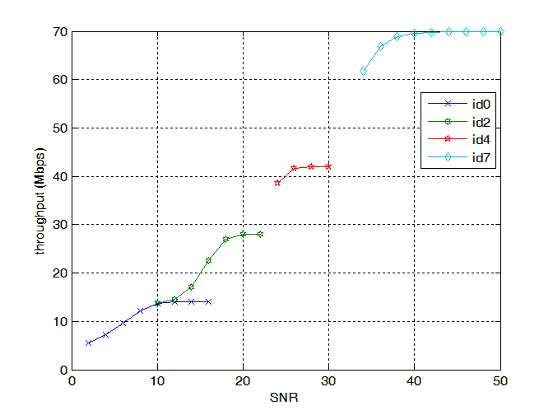
Figure 9. Throughput of PB3
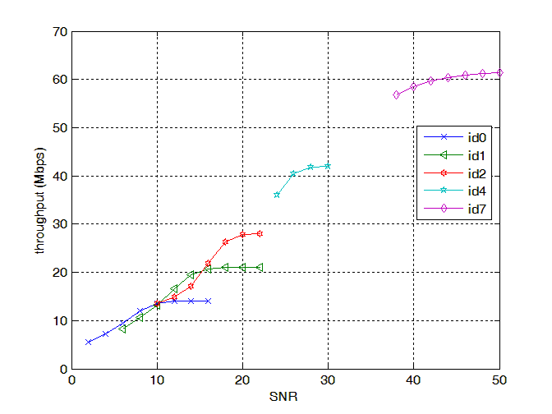
Figure 10. Throughput of VA60

Conclusion
The symbol-level combining before MIMO detector proposed in [1] will have good performance, but the receiver will face a higher complexity problem. Hence, in this contribution, we propose to retransmit partial signal with STTD and let the total retransmit spectrum efficiency the same as in [1]. The receiver design can easily get diversity gain and soft-bit is easily obtained with this scheme.

Proposed Text
------------------------------------------------------- Start of the proposed text ------------------------------------------------
11. Physical layer
11.x Hybrid ARQ
HARQ scheme with STTD retransmission can be considered for 802.16m systems. In the HARQ scheme, the retransmission is performed with STTD.

------------------------------------------------------- End of the proposed text ------------------------------------------------

Reference
[1] IEEE C802.16m-07/172

